Open Rack V3 Power Output Connector
Rev: 0.7

Author
Skip Fry Amphenol
License OCP CLA Option
Contributions to this Specification are made under the terms and conditions set forth in Open Compute Project Contribution License Agreement (“OCP CLA”) (“Contribution License”) by:

[Contributor Name(s) or Company name(s)]
You can review the signed copies of the applicable Contributor License(s) for this Specification on the OCP website at http://www.opencompute.org/products/specsanddesign
Usage of this Specification is governed by the terms and conditions set forth in Open Web Foundation Final Specification Agreement (“OWFa 1.0”).
You can review the applicable Specification License(s) executed by the above referenced contributors to this Specification on the OCP website at http://www.opencompute.org/participate/legal-documents/
Note: The following clarifications, which distinguish technology licensed in the Contribution License and/or Specification License from those technologies merely referenced (but not licensed), were accepted by the Incubation Committee of the OCP:

[insert “None” or a description of the applicable clarifications].
NOTWITHSTANDING THE FOREGOING LICENSES, THIS SPECIFICATION IS PROVIDED BY OCP "AS IS" AND OCP EXPRESSLY DISCLAIMS ANY WARRANTIES (EXPRESS, IMPLIED, OR OTHERWISE), INCLUDING IMPLIED WARRANTIES OF MERCHANTABILITY, NON-INFRINGEMENT, FITNESS FOR A PARTICULAR PURPOSE, OR TITLE, RELATED TO THE SPECIFICATION. NOTICE IS HEREBY GIVEN, THAT OTHER RIGHTS NOT GRANTED AS SET FORTH ABOVE, INCLUDING WITHOUT LIMITATION, RIGHTS OF THIRD PARTIES WHO DID NOT EXECUTE THE ABOVE LICENSES, MAY BE IMPLICATED BY THE IMPLEMENTATION OF OR COMPLIANCE WITH THIS SPECIFICATION. OCP IS NOT RESPONSIBLE FOR IDENTIFYING RIGHTS FOR WHICH A LICENSE MAY BE REQUIRED IN ORDER TO IMPLEMENT THIS SPECIFICATION. THE ENTIRE RISK AS TO IMPLEMENTING OR OTHERWISE USING THE SPECIFICATION IS ASSUMED BY YOU. IN NO EVENT WILL OCP BE LIABLE TO YOU FOR ANY MONETARY DAMAGES WITH RESPECT TO ANY CLAIMS RELATED TO, OR ARISING OUT OF YOUR USE OF THIS SPECIFICATION, INCLUDING BUT NOT LIMITED TO ANY LIABILITY FOR LOST PROFITS OR ANY CONSEQUENTIAL, INCIDENTAL, INDIRECT, SPECIAL OR PUNITIVE DAMAGES OF ANY CHARACTER FROM ANY CAUSES OF ACTION OF ANY KIND WITH RESPECT TO THIS SPECIFICATION, WHETHER BASED ON BREACH OF CONTRACT, TORT (INCLUDING NEGLIGENCE), OR OTHERWISE, AND EVEN IF OCP HAS BEEN ADVISED OF THE POSSIBILITY OF SUCH DAMAGE.

Table of Contents
1. Scope 3
2. Overview 3
3. Electrical 3
4. Environmental 3
5. Mechanical 4
5.1 Geometry 4
5.2 Mating to the ORv3 Busbar 5
6. Quality 6
7. Regulatory 8
8. Ordering Part Numbers 8
9. Revisions 8

Scope
This document defines the technical specifications for an Open Rack V3 Power Output Connector used in the Open Compute Project.

Overview
This interconnection is the power interface between Open Rack V3 Power shelves (PSU Shelf and BBU Shelf) and the Open Rack V3 48V bus bar.

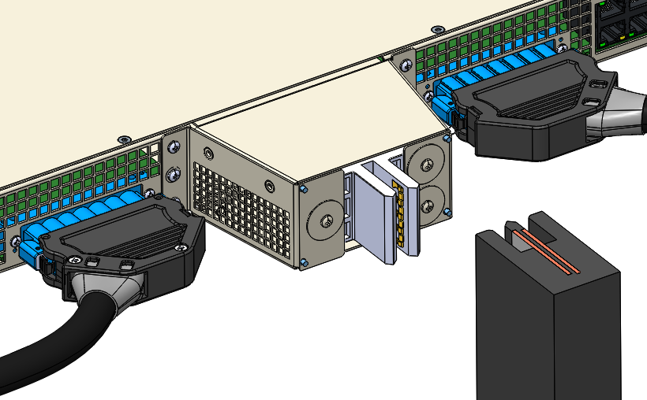
Figure 1: 1OU Power Shelf and ORv3 Busbar

Electrical
- Voltage range: 46.0V – 52.0V DC
- Max current continuous in still air: 360A
- Max current continuous in 300LFM @ 45°C airflow: 500A
- Max temperature rise: 30°C (with busbar connected, as specified in ORv3 Busbar Spec)
- Max voltage drop: 14mV @ 360A, 20mV @ 500A
- This connector is not designed for hot plug/unplug applications (no mate/break under load).

Environmental
- Operating Ambient Temperature at connector location: 15°C to 70°C
- Long-term Storage: -40C to 50C and 5-95% RH
- Short-term Storage: -20C to 65C and 10-80% RH
- Operating Humidity: 20-90%, 5C dew point minimum
- Lifetime: 5 years

Mechanical

5.1 Geometry
- The connector shall fit within the maximum height of 1 Open Rack Unit (48.00mm) including ±3.0mm vertical connector float (as defined in section 4.2).
- Wires shall resist pullout from the connector of 15kgf.
- The connector shall support a panel thickness of 1.10 to 1.32 mm.
- The connector may use tools to attach the connector to the Power shelf.
- Torque range for applicable mounting hardware shall be 0.7 - 0.9 NM.

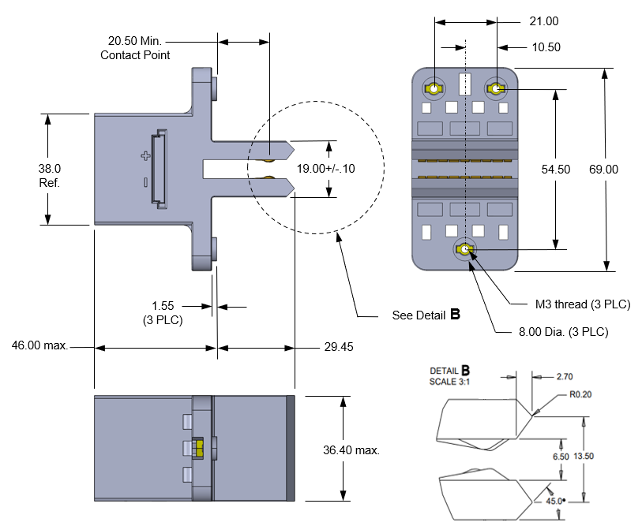

Figure 2: Power Output Connector Detail, Screw Mounted

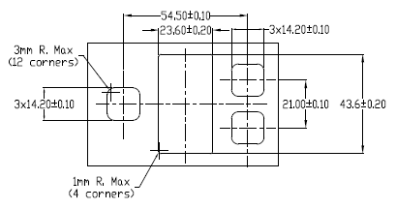
Figure 3: Panel Cutout for Screw Mounted Connector

5.2 Mating to the ORv3 Busbar
- The ORv3 48V Busbar is defined in the Open Rack Standard V3.0 specification. The busbar details shown below are provided for reference only.
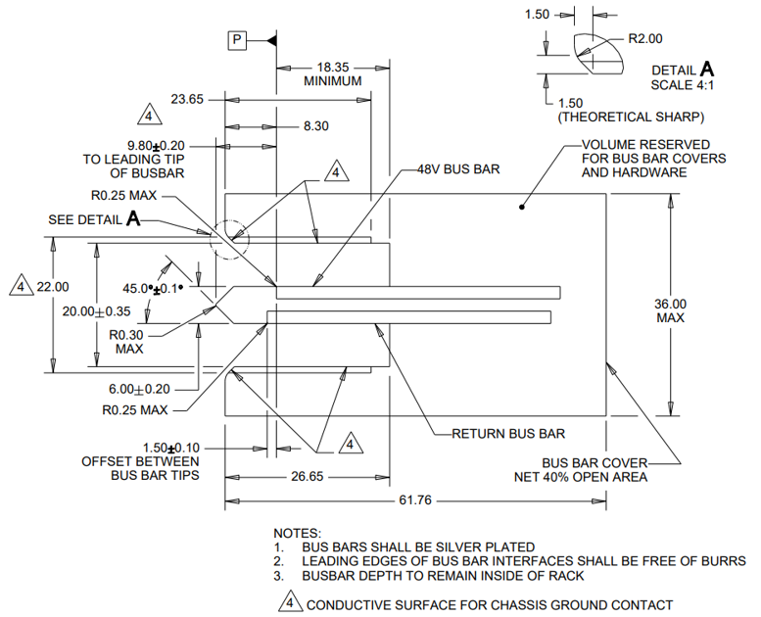

Figure 4: ORv3 Busbar Mechanical Detail (reference only)

- The connector shall support blind-mate installation of the Power Shelf connector onto the ORv3 busbar (figure 4) as defined in the Open Compute Specification Revision 3.0.
- Connector shall support +/-3mm float horizontally and vertically.
- Connector shall enable 6.4mm side-to-side gatherability.
- The max rate of the power shelf insertion into the rack will be 1 m/s.
- The mating force of the connector with the busbar shall be less than 120N.
- The power shelf will ship within the rack while connected to the rack busbar. The connector solution shall prevent damage of the power shelf and the rack busbar during the following packaged, rack-level tests (ASTM 4169 details below) while meeting the voltage drop requirements per section 6.0 and show no exposed copper of either the power shelf connector or rack busbar under SEM analysis of the interfaces.
- The rack is tested in the shipping packaging for transportation Shock and Vibration per ASTM 4169-16 Schedule E - Vehicle Vibration for 2hrs on vertical axis only for 80 minutes low level, 30 minutes medium level and 10 minutes high level.

Quality
The following tests will be conducted with three samples each per Table 1. The Test Busbar geometry is TBD.

Table 1: Testing Detail
Test | Test Standard | Test Condition/ Method | Pass/Fail Criteria | Additional Data to Collect for Review
Low level contact resistance (LLCR) | EIA-364-23 | Subject mated specimens to 100 milliamperes maximum current and 20 millivolts maximum open circuit voltage. | 10 milliohms maximum (initial)  20 milliohms maximum (final)
Contact resistance at rated current (CRRC) | EIA-364-6 | Resistance should be measured after the connector has reached thermal equilibrium, after carrying Rated load at 25°C ambient temperature. | 0.5 milliohms maximum (initial and final)
Withstanding voltage | EIA-364-20, Condition I | 1000 volts AC at sea level for power contacts. 1 minute duration. Test between adjacent contacts of specimens. | No breakdown or flashover
Durability | EIA-364-09 | Mate and un-mate specimens with mating cable assembly for 50 cycles at a maximum rate of 500 cycles per hour. | LLCR before and after  Post test surface wear examination: no exposed nickel or copper
Contact Retention | EIA-364-29, Method A | 15kgf pull force, both axial and at 45degrees, for a minimum of 6 seconds | No visible contact to housing displacement | N/A
Wire Retention (Parallel to the wire direction) | UL468 | Pull force per wire gauge as defined in the specification | No visible contact to housing displacement | N/A
Wire Retention (perpendicular to the wire direction) | N/A | Half the pull force defined in UL 486 will be applied perpendicular to the wire direction | No visible reduction in contact to contact distance | N/A
Vibration | EIA-364-28 Test condition VII, Test condition E | 15 minutes duration in each of the three mutually perpendicular direction | No discontinuities of 1 microsecond or longer duration.  No plastic deformation or contact dislodging.  In addition: LLCR before and after | post test contact wear optical examination,  SEM/EDX optional
Shock | EIA-364-27, Method A | Subject mated specimens to 50G’s half-sine shock pulses of 11 milliseconds duration.  Three shocks in each direction applied along 3 mutually perpendicular planes, 18 total shocks. | No discontinuities of 1 microsecond or longer duration.  No plastic deformation or contact dislodging. | post test contact wear optical examination,  SEM/EDX optional
Mating Force | EIA-364-13 | Measure force necessary to mate specimens at a maximum rate of 12.7 mm [.5 in] per minute. | 110 N maximum per receptacle cable assembly
Un-mating force | EIA-364-13 | Measure force necessary to un-mate specimens at a maximum rate of 12.7 mm [.5 in] per minute. | 15 N minimum per receptacle cable assembly
Temperature Life | EIA-364-17, Method A, Condition 5. | Subject mated specimens to 125°C for 500 hours. | LLCR before and after | monitor contact voltage drop during test
Thermal Shock | EIA-364-32, Method A | Test condition VII: -55C to 85C for 10 cycles with 30 minute dwell time | LLCR before and after | N/A
Humidity | EIA-364-31, Class III | Subject mated specimens to 10 cycles (10days) between 25 and 65°C at 80 to 98% RH | LLCR before and after  Dielectric withstand voltage before and after | N/A
Salt Spray | EIA-364-26C | Subject mated specimens to test for 48 hours, with a 5% solution salt spray, 35 +1/-2°C | LLCR before and after | N/A
Temperature rise vs. current | EIA-364-70, Method 3 | Attach connector to a busbar 45mm in length and heated to 85C. Stabilize at a single current level until 3 readings at 5-minute intervals are within 1°C. | Lower than 30°C | N/A

Regulatory
The connector shall comply with the latest edition, revision, and amendment of the following Standards:
- IEC 62368-1, Audio/video, information and communication technology equipment – Part 1: Safety requirements (applicable to meet anticipated effective date of December 20, 2020 for North America and Europe.)
- Halogen Free per JEDEC JS709C
- RoHS 2011/65/EU (RoHS 2)
- Material flammability: All materials shall be UL94 V-0 rated.
- Connectors shall be UL1977 recognized.

Ordering Part Numbers
Vendor | Description | P/N
Amphenol | BarKlip BK500 IO cable, screw mount | 10156914-*
Staubli Electrical Connectors | Multilam ORV3 busbar connector GSR6/LA-CUD/36.4 | tbd
TE Connectivity | BlackBox BB1000 OCP Rack Busbar Power Connector | 2204888-1

Revisions
Rev | Date | Author | Changes
0.00 | 16 Jan 2021 | Skip Fry | Preliminary Draft
0.1 | 22 Jan 2021 | Skip Fry | Revised Draft
0.2 | 29 Jan 2021 | Skip Fry | Revised Draft
0.3 | 3 Feb 2021 | Skip Fry | Revised Draft
0.4 | 18 Feb 2021 | Skip Fry | Revised Draft
0.5 | 23 Feb 2021 | Skip Fry | Revised Draft
0.6 | 9 Mar 2021 | Skip Fry | Revised Draft
0.7 | 23 Mar 2021 | Skip Fry | Revised Draft

