AT&T Open CPE Network Compute Platform Specification

Revision 1.0

Authors: Dustin Grant, John Gibbons, Tom Anschutz

Revision History

Revision | Date | Author | Description
1.0 | 4/26/2017 | Dustin Grant | Initial Release

Contents
Revision History 2
Contents 2
Licenses 4
Scope 4
Overview 4
Compute Function 5
CPU 5
Memory 5
Storage 5
Network 5
BMC 5
Ethernet Console/Mgmt Port 5
Serial Console 5
Ethernet Switch Function 5
RJ45 Ports 5
SFP+ Ports 5
Power over Ethernet 5
Modular Interface Slot 6
Redundant Power Supplies 6
Software Stack 6
Physical Overview 7
Maximum Dimensions 7
Top View 8
Front View 8
Panel LED Definitions 8
Rear View 8
System Overview 8
Main Block Diagram 8
Software Support 11
BMC support 11
ONIE (Optional CPU Module) 11
Open Network Linux 11
Overall System Software 11
General Specifications 12
Power Consumption 12
Specification Requirements 13
Safety 13
Electromagnetic Compatibility 13
ROHS 13

Licenses
All devices that may be referred to in this specification, or required to manufacture products described in this specification, will be considered referenced only, and no intellectual property rights embodied in or covering such devices shall be licensed as a result of this specification or such references. Notwithstanding anything to the contrary in the Open Compute Project Contributor License Agreement or the Open Web Foundation Final Specification Agreement (OWFa 1.0), the licenses set forth therein do not apply to the intellectual property rights included in or related to the devices identified in this specification. For clarity, no patent claim that reads on such semiconductor devices will be considered a “Granted Claim” under the applicable Open Web Foundation Final Specification Agreement (OWFa 1.0) for this specification.

To the extent of AT&T’s authorship in this specification, AT&T submits this specification to the Open Compute Project Foundation as a Contribution under the Open Compute Project Contributor License Agreement (July 13, 2014 version, available at the time of this writing, March 4, 2016, at https://rightsignature.com/forms/OMMUS-72474399-v1-db5554/token/27cfcf4a00d. AT&T agrees to make such specification available under the Open Web Foundation Final Specification Agreement (OWFa 1.0), which is available at http://www.openwebfoundation.org/legal/the-owf-1-0-agreements/owfa-1-0.
Your use of this specification may be subject to other third party rights. THIS SPECIFICATION IS PROVIDED "AS IS." No support of any kind will be provided by the contributors. The contributors expressly disclaim any warranties (express, implied, or otherwise), including implied warranties of merchantability, non-infringement, fitness for a particular purpose, completeness or title, related to the specification. The entire risk as to implementing or otherwise using the specification is assumed by the specification implementer and user. IN NO EVENT WILL ANY PARTY BE LIABLE TO ANY OTHER PARTY FOR LOST PROFITS OR ANY FORM OF INDIRECT, SPECIAL, INCIDENTAL, OR CONSEQUENTIAL DAMAGES OF ANY C H A R A C T E R FROM ANY CAUSES OF ACTION OF ANY KIND WITH RESPECT TO THIS SPECIFICATION OR ITS GOVERNING AGREEMENT, WHETHER BASED ON BREACH OF CONTRACT, TORT (INCLUDING NEGLIGENCE), OR OTHERWISE, AND WHETHER OR NOT THE OTHER PARTY HAS BEEN ADVISED OF THE POSSIBILITY OF SUCH DAMAGE.

Scope
This document defines the technical specifications for the AT&T Open CPE Network Compute Platform submitted to the Open Compute Project.

Overview
This document describes the technical specifications of the AT&T Open CPE Network Compute Platform. The system is self-contained unit that resembles a typical 1RU x86 server or Switch. The system is typically deployed at a customer premise such as an office building or datacenter and is typically installed in a rack or wiring closet.
The purpose of the system is to be able to run Virtual Machines (VM’s) containing Virtual Network Functions (VNF’s) such as a Router, Firewall, WAN Accelerator, etc. The system would typically be placed at the edge of the customer’s network to connect to the WAN and/or Internet.
The system described in this document is a hybrid of a typical x86 based server and a high performance Ethernet switch. The x86 part of the system is used to run the VNF’s, and the Ethernet switch part of the system is to provide local wire rate L2 or L3 forwarding.
Several sizes of this platform are envisioned, with a desire to maintain fundamental aspects of the device, but also allow scaling of key aspects, like CPU cores, RAM, disk, switching capacity, and throughput in and out of the CPU.
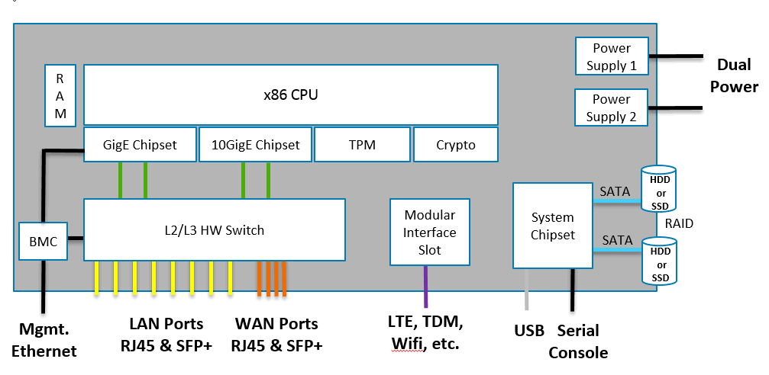
Figure 1 – System Block diagram

Compute Function

CPU

The CPU is an x86 based CPU that is ultimately responsible for running all of the software functions on the box, including the Base Operating System, Hypervisor, VNF’s and also the Control Plane for the Ethernet Switch.
NOTE: this paragraph is a placeholder for the feedback that there should be a low-end system that might use a SOC to deliver these functions, and that it may use other types of processors – like ARM. Also, there was interest from one carrier to extend this to high end consumer broadband. The latter is typically based on SOC devices – so further feedback is encouraged to develop the view on this low-end system.

At this time, we are in the middle of a transition in processor generations. In the SoC space, Intel Atom is moving from Rangeley C2000 to Denverton C3000, and we anticipate the Xeon-D Broadwell-DE to be replaced with Skylake generation CPU’s in the same timeframe as this specifications adoption.
Considerations for choice of CPU:
- Selection of a processor family that can scale from small to large CPE performance requirements (2 cores – 24 cores)
- Single socket vs Dual socket – performance impacts of using a dual socket system vs potential cost savings (ie, 2 6 core CPU’s is less expensive than a single 12 core CPU, but there is a performance cost)
- Virtualization Features (VT-x, VT-d, Hyperthreading, etc)
- SoC vs traditional CPU
- Performance
- Cost

Co-Processors

Support for co-processors for Encryption allows for offloading encryption from the main CPU, freeing the CPU to perform the higher value functions. Intel Quickassist (QAT) is an example of such a co-processor.

Memory

Memory is relatively straight forward. The memory architecture & type is largely defined by the choice of CPU. The amount of memory should be flexible and sized per the requirements of customer.

Storage

The amount and type of storage can vary widely based on the use case and size of the customer site. Storage should be modular and customizable per the customer’s requirements. The systems should support the following to support the various use cases:
- 2 Onboard M2 drive slots
- 2 External Hot-swap drive bays
- 2 Internal drive bays
- Hardware RAID support

Network

There are several types of Network Interfaces, both internal and external. Internally, the x86 Server part of the system will connect to the Ethernet Switch part of the system using Ethernet interfaces. Externally, there will be several types of interfaces: WAN interfaces, LAN interfaces, Management interfaces.
The x86 part of the system should have the following interfaces:
- 2x 10Gbps internally connected to the Ethernet switch
- 2x 1Gbps internally connected to the Ethernet switch
- 1x 1Gbps internally connected to the BMC
The Ethernet switch ports will be discussed later in this document.

BMC

The system should have a Baseboard Management Controller (BMC) to allow for remote lights out management and console access.
The most important requirement for the BMC is that it must be secure. The BMC will be connected to WAN and/or Internet connections.

Trusted Platform Module

The Trusted Platform Module is used for secure storage of keys and certificates in a hardware chip.

Serial Console

The serial console is traditionally found on network equipment and serves as a last resort for troubleshooting or recovery. With the presence of a BMC, the need for a serial console can be debated.

Ethernet Switch Function

Switch chipset

The choice of the Ethernet switching chipset should have the following considerations:
- Number of ports
- Speed of ports
- Range of product family (small to large)
- Programming API (Open vs Closed)
- Feature set (L2, L3, L4+ capabilities)

RJ45 Ports

The bulk of the interfaces will be externally facing RJ45 interfaces and will be used for both LAN (user facing) and WAN connections.
LAN connections will range from 8 – 24 ports
WAN connections will range from 2 – 4 ports

SFP+ Ports

SFP+ Ports will be used for multiple purposes:
- WAN connections (Both 10Gbps and 1Gbps)
- Downlinks to customers network
- East/West links between Open CPE platform devices when multiple are deployed to a site
SFP+ Ports will range from 2 – 6 ports

Power over Ethernet

The Ethernet ports should support Power over Ethernet to allow the attachment of Wifi AP’s, Telephones or other devices. The PoE specification should be 802.3at at a minimum.

Modular Interface Slot

The Module Interface Slot allows for the addition of an expansion card to increase the number of Ethernet ports, or to add a different type of Interface such as a TDM interface (T1/E1, T3/E3), LTE or Wifi.
The form factor and type of bus connection needs to be determined. While the standard PCIe slot available today in servers/PC’s is widely available and recognized, in comparison to network modules in use on today’s networking appliances it is much more difficult to insert/remove in the field.

Redundant Power Supplies

The system should have the option to support redundant power supplies, as well as the ability to detect and send a “dying gasp” or “last gasp” alarm when a power loss is detected.

Physical Form Factor

Maximum Dimensions

 | Inches | Millimeters
Length - | 18” or less | 406mm
Width – | 19” (Including ears) | 482.6mm
Height – | 1.75” (1RU) | 44.45mm

Software Support
The Open CPE Network Compute Platform supports a base software package composed of the following components:

BMC support
OpenBMC Is there a desire for IPMI or a true BMC?

ONIE
Initialization and firmware updates. There is a desire to be able to initialize and update firmware in the field. Is ONIE an appropriate protocol, or is something else need with different security capabilities.

Switch Abstraction Interface (SAI)
Hardware independent switch programming API – applies to the switching element in the device.

Open Network Linux
See http://opennetlinux.org/ for latest supported version (Is this feasible and appropriate? Others?)
It seems that we should allow for different OS to be used, but ONL may be one preferred approach because of the included networking capabilities on the device.

Specification Requirements

Safety
- UL/ Canada
- CB (Issued by TUV/RH)
- China CCC

Electromagnetic Compatibility
- GR-1089-CORE
- FCC Title 47, Part 15, Subpart B Class A

ROHS
Restriction of Hazardous Substances (6/6)
Compliance with Environmental procedure 020499-00 primarily focused on Restriction of Hazardous Substances (ROHS Directive 2002/95/EC) and Waste and Electrical and Electronic Equipment (WEEE Directive 2002/96/EC)

