Open Rack V3 Power Shelf Universal Input Connector
Rev: 0.4

Steve Mills Facebook
Hamid Keyhani Facebook
Natesh Kannan Positronic
Will Stewart Harting

icense (OCP CLA Option)

Contributions to this Specification are made under the terms and conditions set forth in Open Compute Project Contribution License Agreement (“OCP CLA”) (“Contribution License”) by: Natesh Kannan, Positronic Industries Inc.

You can review the signed copies of the applicable Contributor License(s) for this Specification on the OCP website at http://www.opencompute.org/products/specsanddesign
Usage of this Specification is governed by the terms and conditions set forth in Open Web Foundation Final Specification Agreement (“OWFa 1.0”)
You can review the applicable Specification License(s) executed by the above referenced contributors to this Specification on the OCP website at http://www.opencompute.org/participate/legal-documents/
Note: The following clarifications, which distinguish technology licensed in the Contribution License and/or Specification License from those technologies merely referenced (but not licensed), were accepted by the Incubation Committee of the OCP:

NOTWITHSTANDING THE FOREGOING LICENSES, THIS SPECIFICATION IS PROVIDED BY OCP "AS IS" AND OCP EXPRESSLY DISCLAIMS ANY WARRANTIES (EXPRESS, IMPLIED, OR OTHERWISE), INCLUDING IMPLIED WARRANTIES OF MERCHANTABILITY, NON-INFRINGEMENT, FITNESS FOR A PARTICULAR PURPOSE, OR TITLE, RELATED TO THE SPECIFICATION. NOTICE IS HEREBY GIVEN, THAT OTHER RIGHTS NOT GRANTED AS SET FORTH ABOVE, INCLUDING WITHOUT LIMITATION, RIGHTS OF THIRD PARTIES WHO DID NOT EXECUTE THE ABOVE LICENSES, MAY BE IMPLICATED BY THE IMPLEMENTATION OF OR COMPLIANCE WITH THIS SPECIFICATION. OCP IS NOT RESPONSIBLE FOR IDENTIFYING RIGHTS FOR WHICH A LICENSE MAY BE REQUIRED IN ORDER TO IMPLEMENT THIS SPECIFICATION. THE ENTIRE RISK AS TO IMPLEMENTING OR OTHERWISE USING THE SPECIFICATION IS ASSUMED BY YOU. IN NO EVENT WILL OCP BE LIABLE TO YOU FOR ANY MONETARY DAMAGES WITH RESPECT TO ANY CLAIMS RELATED TO, OR ARISING OUT OF YOUR USE OF THIS SPECIFICATION, INCLUDING BUT NOT LIMITED TO ANY LIABILITY FOR LOST PROFITS OR ANY CONSEQUENTIAL, INCIDENTAL, INDIRECT, SPECIAL OR PUNITIVE DAMAGES OF ANY CHARACTER FROM ANY CAUSES OF ACTION OF ANY KIND WITH RESPECT TO THIS SPECIFICATION, WHETHER BASED ON BREACH OF CONTRACT, TORT (INCLUDING NEGLIGENCE), OR OTHERWISE, AND EVEN IF OCP HAS BEEN ADVISED OF THE POSSIBILITY OF SUCH DAMAGE.

Table of Contents
License (OCP CLA Option) 2
1. Scope 5
2. Overview 5
3. Electrical 5
4. Mechanical 7
5. Environmental Requirements: 25
6. Quality 26
7. Regulatory 27
8. Revisions 29

Scope
This document defines the technical specifications for an Open Rack V3 Power Shelf Universal Input Connector used in Open Compute Project.

Overview
This power from the data center enters the power shelf through this connector set. The set is designed to allow the shelf to adjust to a wide range of input power types while allowing the cabling to the data center to adapt to regional regulatory needs.
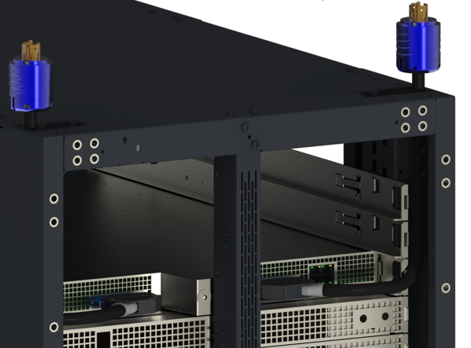
Figure 2.1 Layout of open rack power shelf in the rack assembly
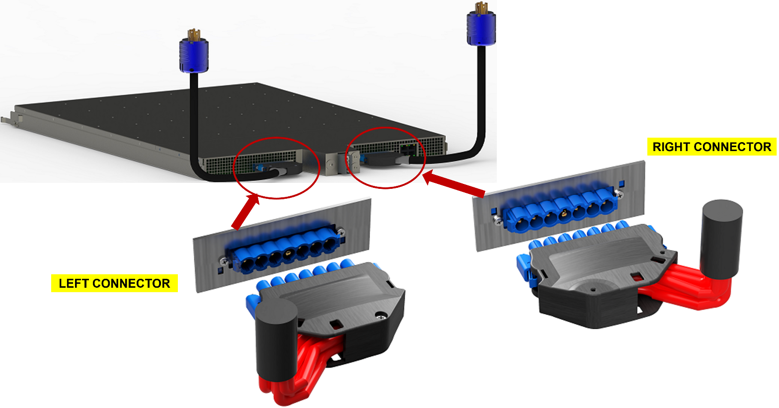
Reversible Female Connector
- 45° Cable Opening
Male Connector - Left
Male Connector - Right
Figure 2.2 Detail of open rack shelf connectors

Electrical
- Seven pin connector with three inputs, three returns, and one Ground (Earth).
- Nominal Voltage (rms) rating:
  - Pin to pin 480V AC
  - 380V DC
  - Frequency: DC, 50 Hz, 60 Hz
- Current Rating: 32A @ 30C temperature rise in still air
- Inrush current:
  - 10X for 100 micro sec
  - two times rated current for 5mS.

  - Connector wiring
Connector shall take the following input wiring:
- 3 phase, 5 wire in Star configuration.
- 3 phase, 4 wire in Delta configuration.
- 1 phase, 3 wire configurations.
- High-voltage DC, 3 wire configurations.

The following diagrams show the wiring of different configurations the connector shall support:

Mechanical
Height must fit within the envelope of a 1 RU EIA chassis (44.45mm). And pass within the cable trough of 23.8 mm minimum.

Height and width of the connector shall be sized so that a connector and a whip wire bundle of max diameter (7 X 8 AWG) high strand count) will fit into the Open Rack channel at the same time. This will allow the whip cable to be replaced without moving the rack.

The distance from the back surface of the power shelf chassis to the tip of the tangent of the <of the bend radius of the worst-case cable bundle supported> entering the cable side connector shall be less than 65mm as shown in Figure 4.1 so the whip cable will always remain inside the rack frame.

Figure 4.1 Mating Connector Maximum Dimension
The Female cable hood shall be reversible so the cable can exit the hood towards either side of the rack shown in Figure 4.2 (for 45° cable exit) and Figure 4.3 (for top cable exit).
The cable hood designed to accommodate 7 X 8 AWG to 7 X 16 AWG wires.
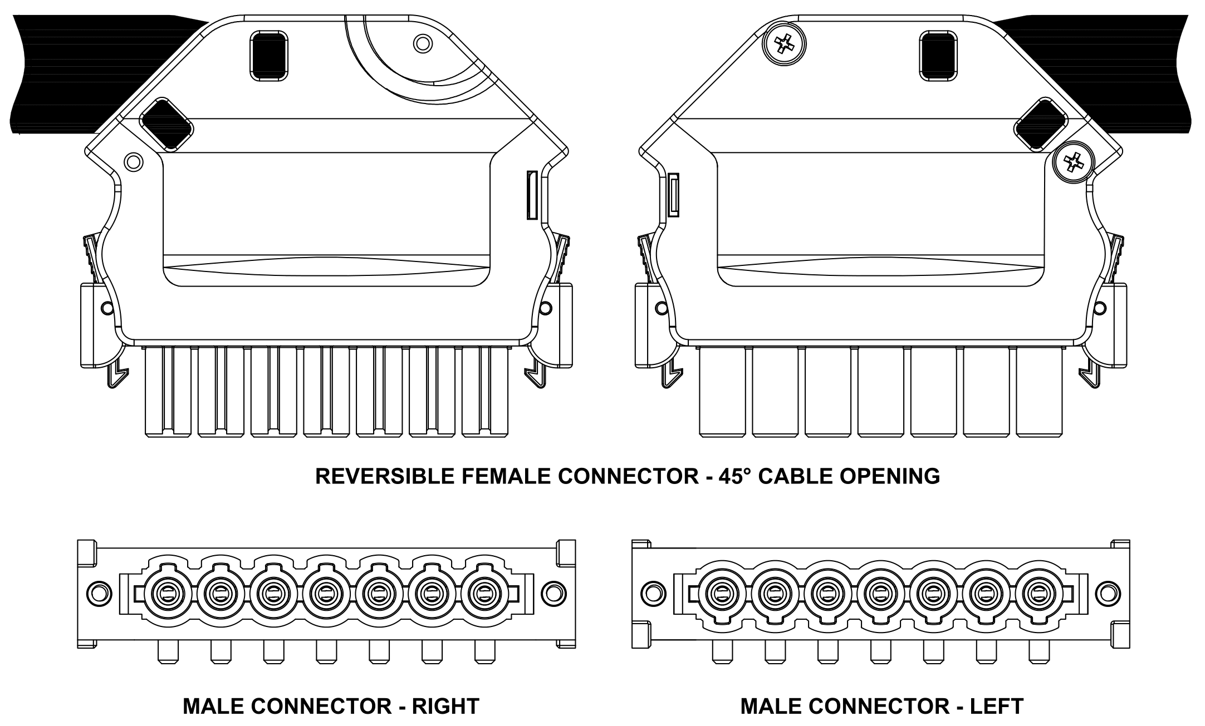
Figure 4.2 Reversible Female Connector (45° Cable Opening) with Male Connector – Right and Left

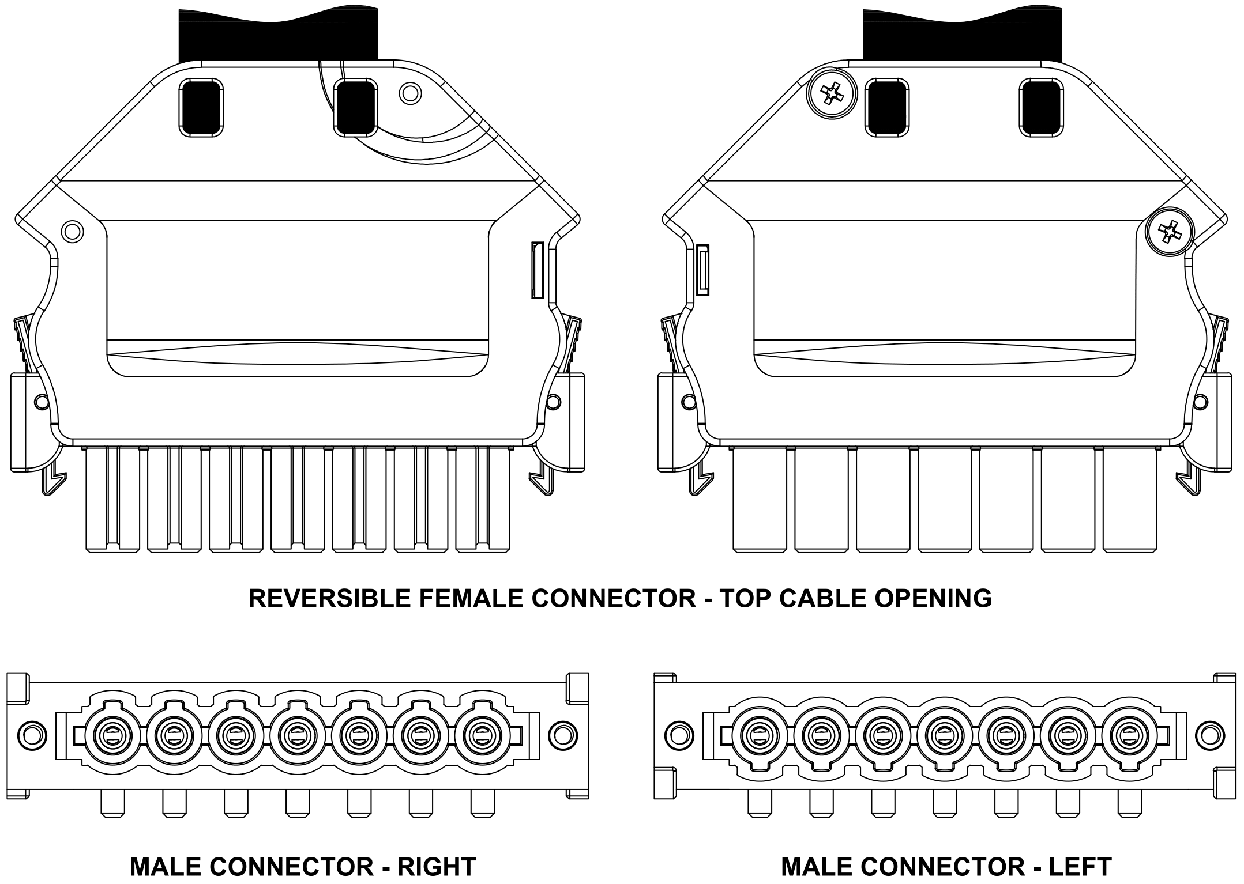
Figure 4.3 Reversible Female Connector (Top Cable Opening) with Male Connector – Right and Left

Dimensions:
Receptacle:
For details of the PCB Pin-out for each individual connector configurations:
Female Cable connector without Hood, refer to Figure 5.2 (SP10RSSS1F0001/AA-2268)
Female Cable connector with Hood (45° Cable Opening), refer to Figure 5.3
(SP10RSSS1F0W01/AA-2268)
Female Cable connector with Hood (Top Cable Opening), refer to Figure 5.4
(SP10RSSS1F0W01/AA-2372)

For details of Mating Connector, refer to Figure 5.7.

Right angle PCB contact with threaded insert screw mount:
- For Right connector, refer to Figure 5.5 (SP10RSSS48M220A1/AA-2269)
- For Left connector, refer to Figure 5.6 (SP10RSSS48RM220A1/AA-2269)

Detail of the Panel cut out for the chassis connector
- Cabled internal with strain relief to the chassis
- PCB version with strain relief
Please refer to individual connector drawings for detail panel cut out dimensions.

Receptacle Types:
- PCB straight pin
- PCB Right angle
- Crimp with or without panel mount

PCB Thickness: 1.60mm to 2.20mm
Note: Connectors can be customized for different PCB thickness.
Panel Thickness: 1.50mm to 2.30mm

Ground pin should be first mate/last break under all entry angles.
- First mate / Last break at center position as shown in Figure 5.1 for left and right connector

Figure 5.1 Male connector – Left and Right

Mounting Screws:
Thread Type | Material | Part Number | Thread Length | Recommended PCB or Panel Thickness | Recommended Torque  Value
4-40  UNC-2A | Steel | A2076-22-1-36 | 6.35±0.76 [0.250±0.030] | PCB Thickness  1.60mm to 2.00mm  Panel Thickness:  1.50mm to 2.30mm | 2.5 inches pounds to 3.5 inches pounds
 | Stainless Steel | A2076-22-3-4
Self-Tapping 2-28 Trilobular | Steel | A4546-7-1-97 |  |  | 1.3 inches pounds to 1.5 inches pounds
 | Stainless Steel | A4546-7-6-4

Female Cable Connector without Hood – Reversible for Right side and Left side (SP10RSSS1F0001/AA-2268)
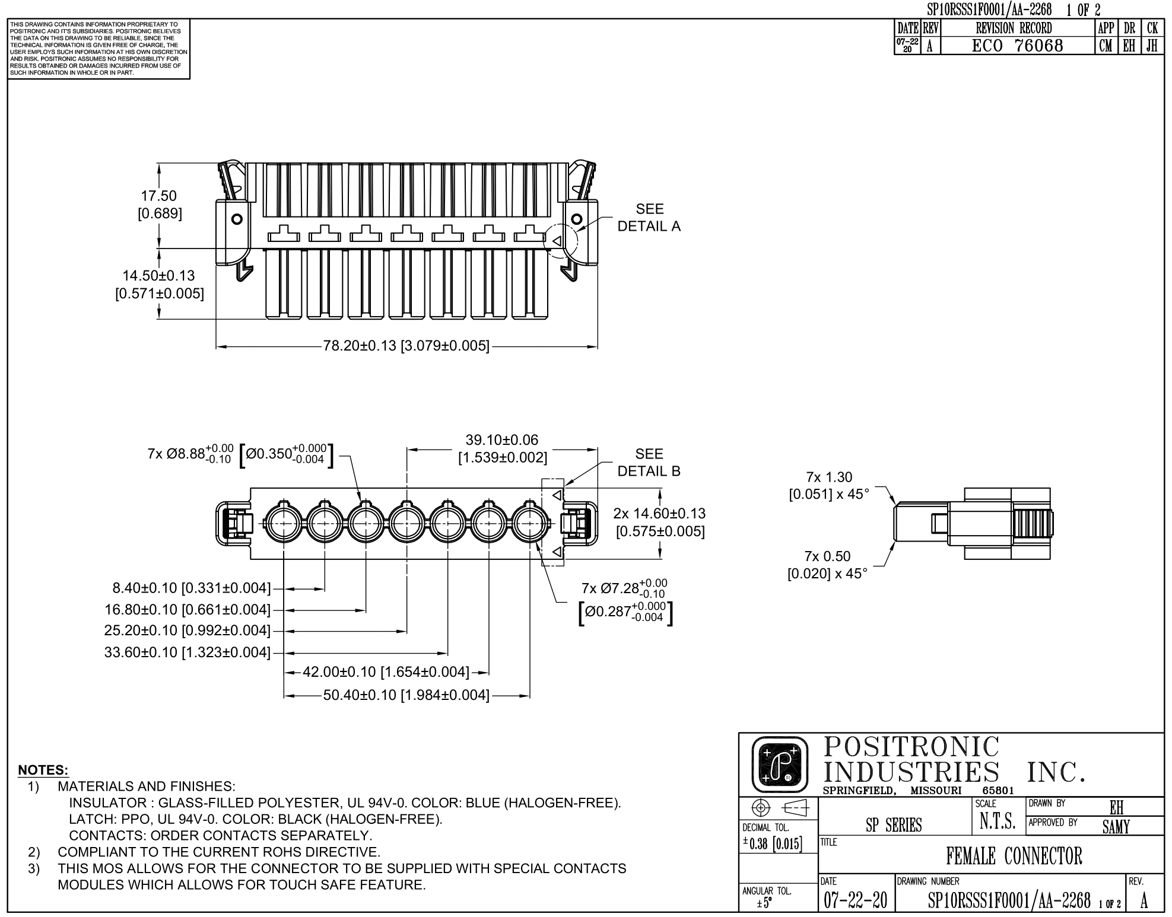
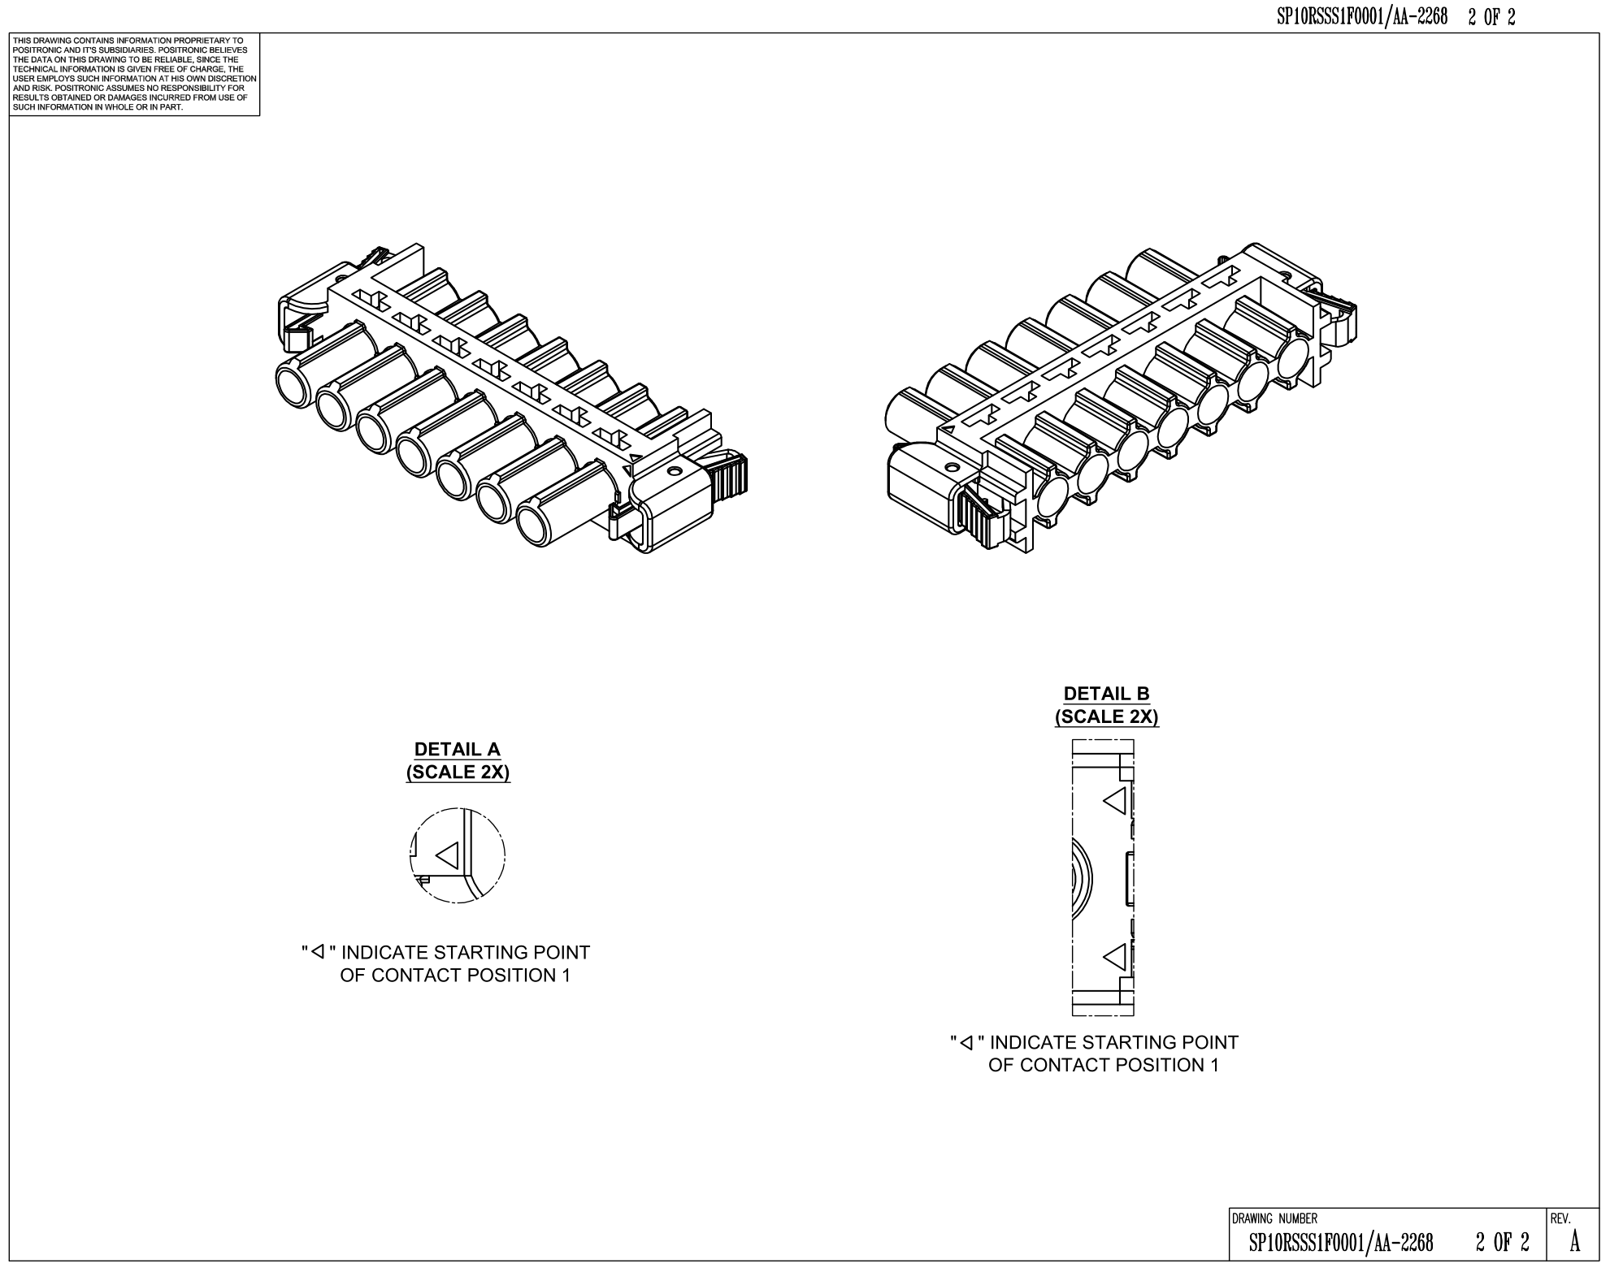
Figure 5.2 SP10RSSS1F0001/AA-2268
Female Cable Connector with Hood (45° Cable Opening) – Reversible for Right side and Left side (SP10RSSS1F0W01/AA-2268)
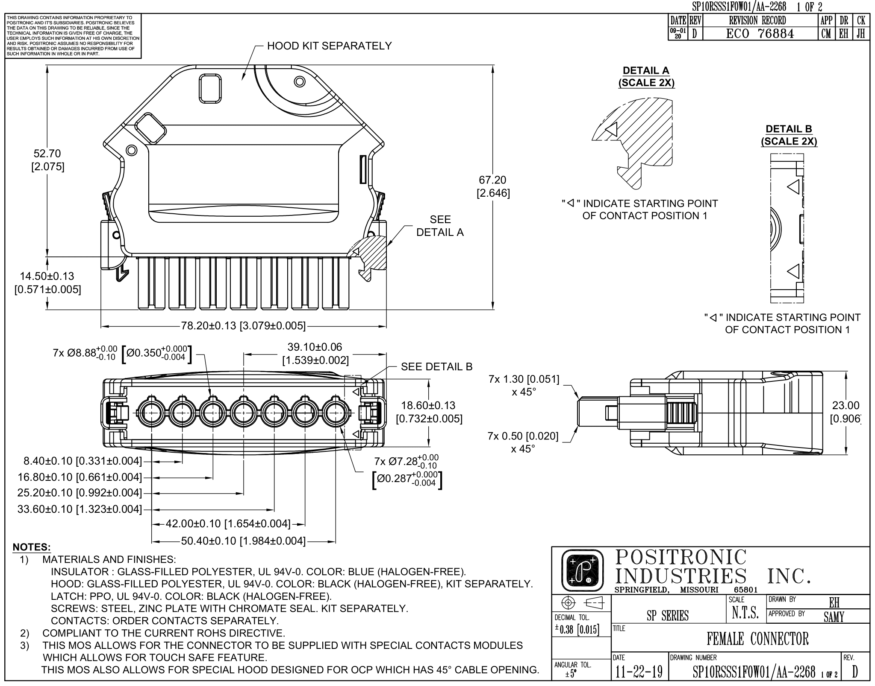
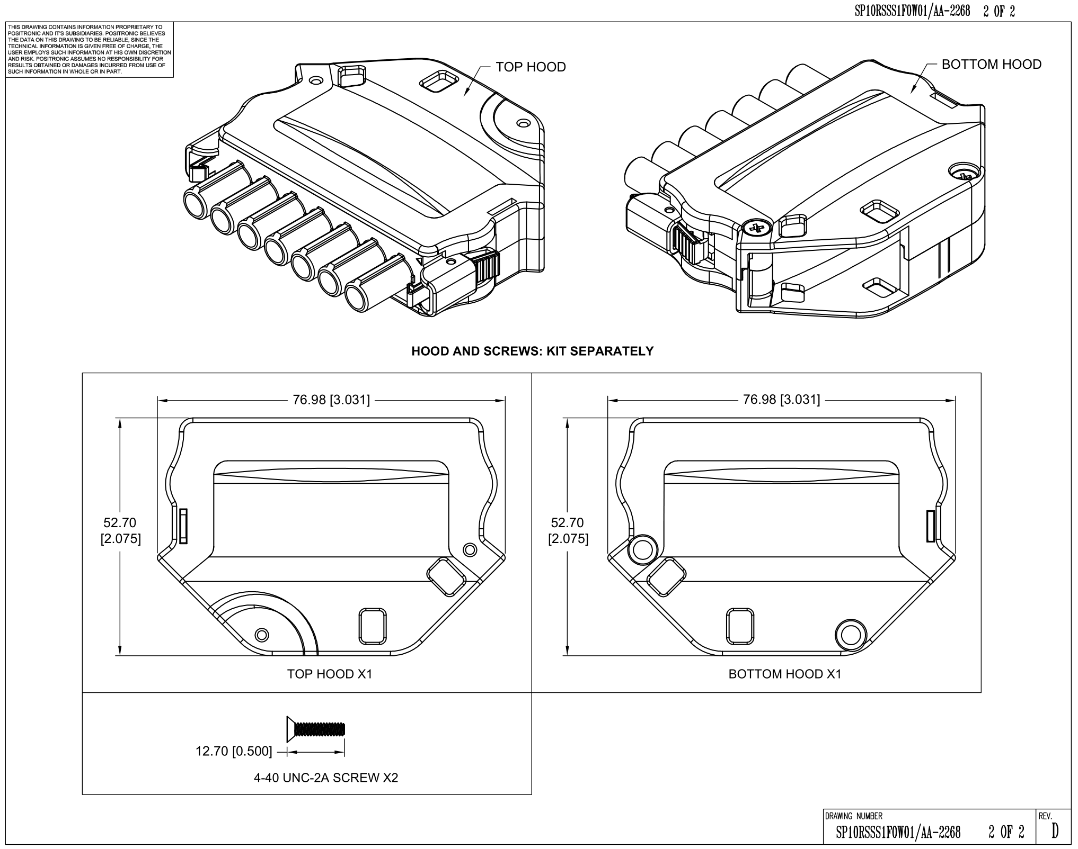
Figure 5.3 SP10RSSS1F0W01/AA-2268

Female Cable Connector with Hood (Top Cable Opening) – Reversible for Right side and Left side (SP10RSSS1F0W01/AA-2372)
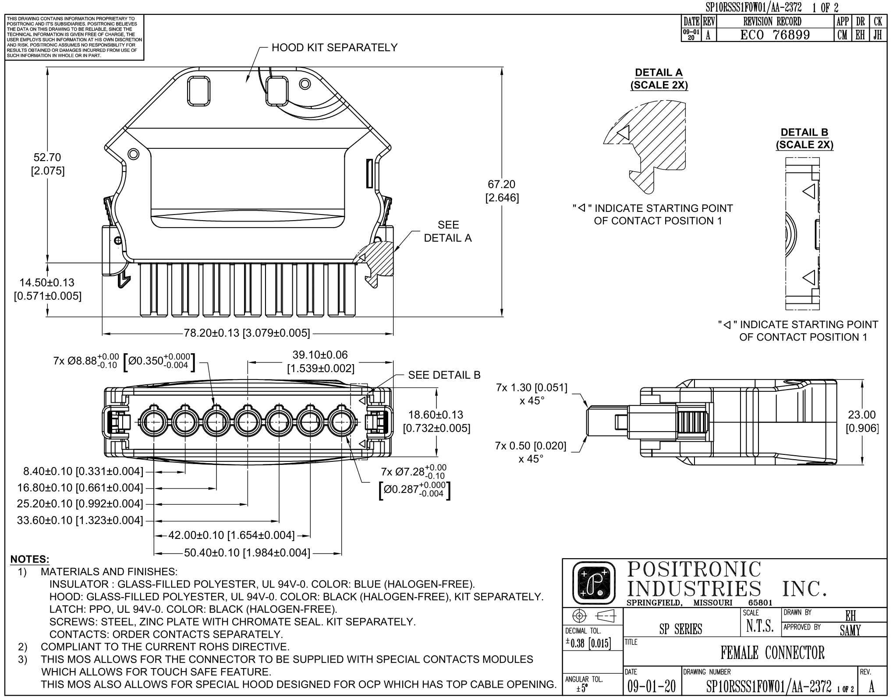
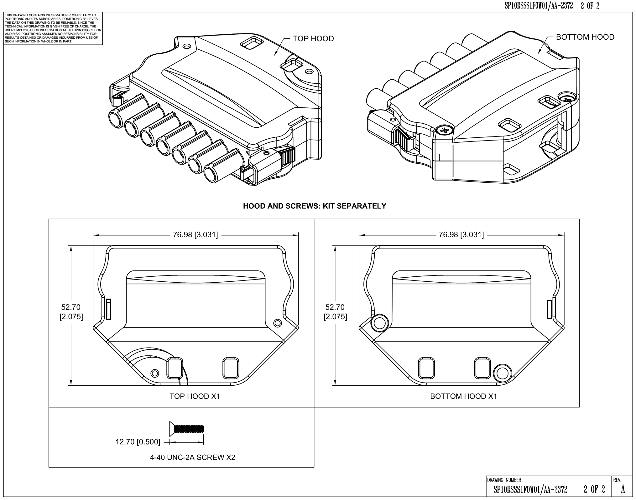
Figure 5.4 SP10RSSS1F0W01/AA-2372
Male right angle PCB Connector with threaded insert mount – Right side (SP10RSSS48M220A1/AA-2269)
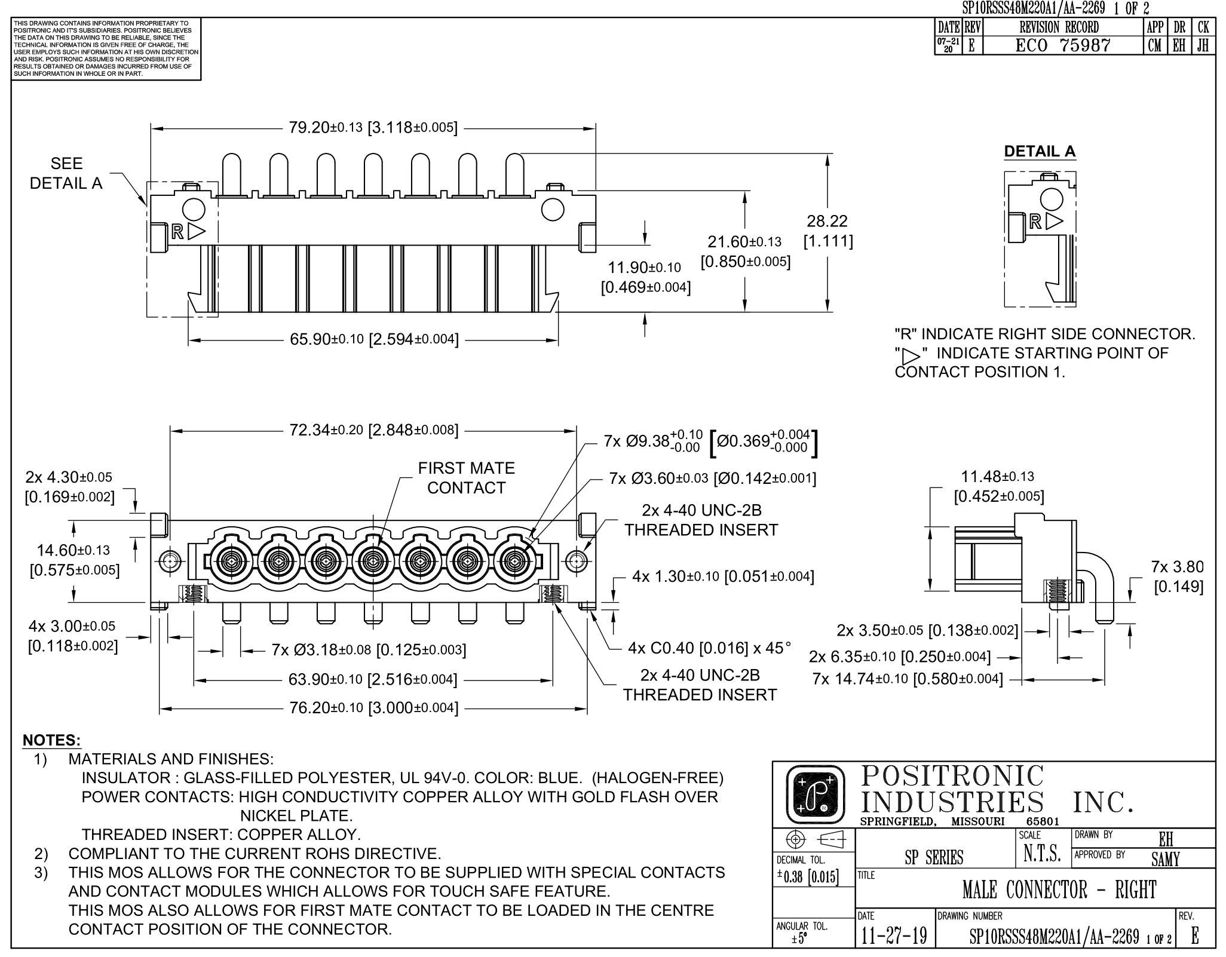
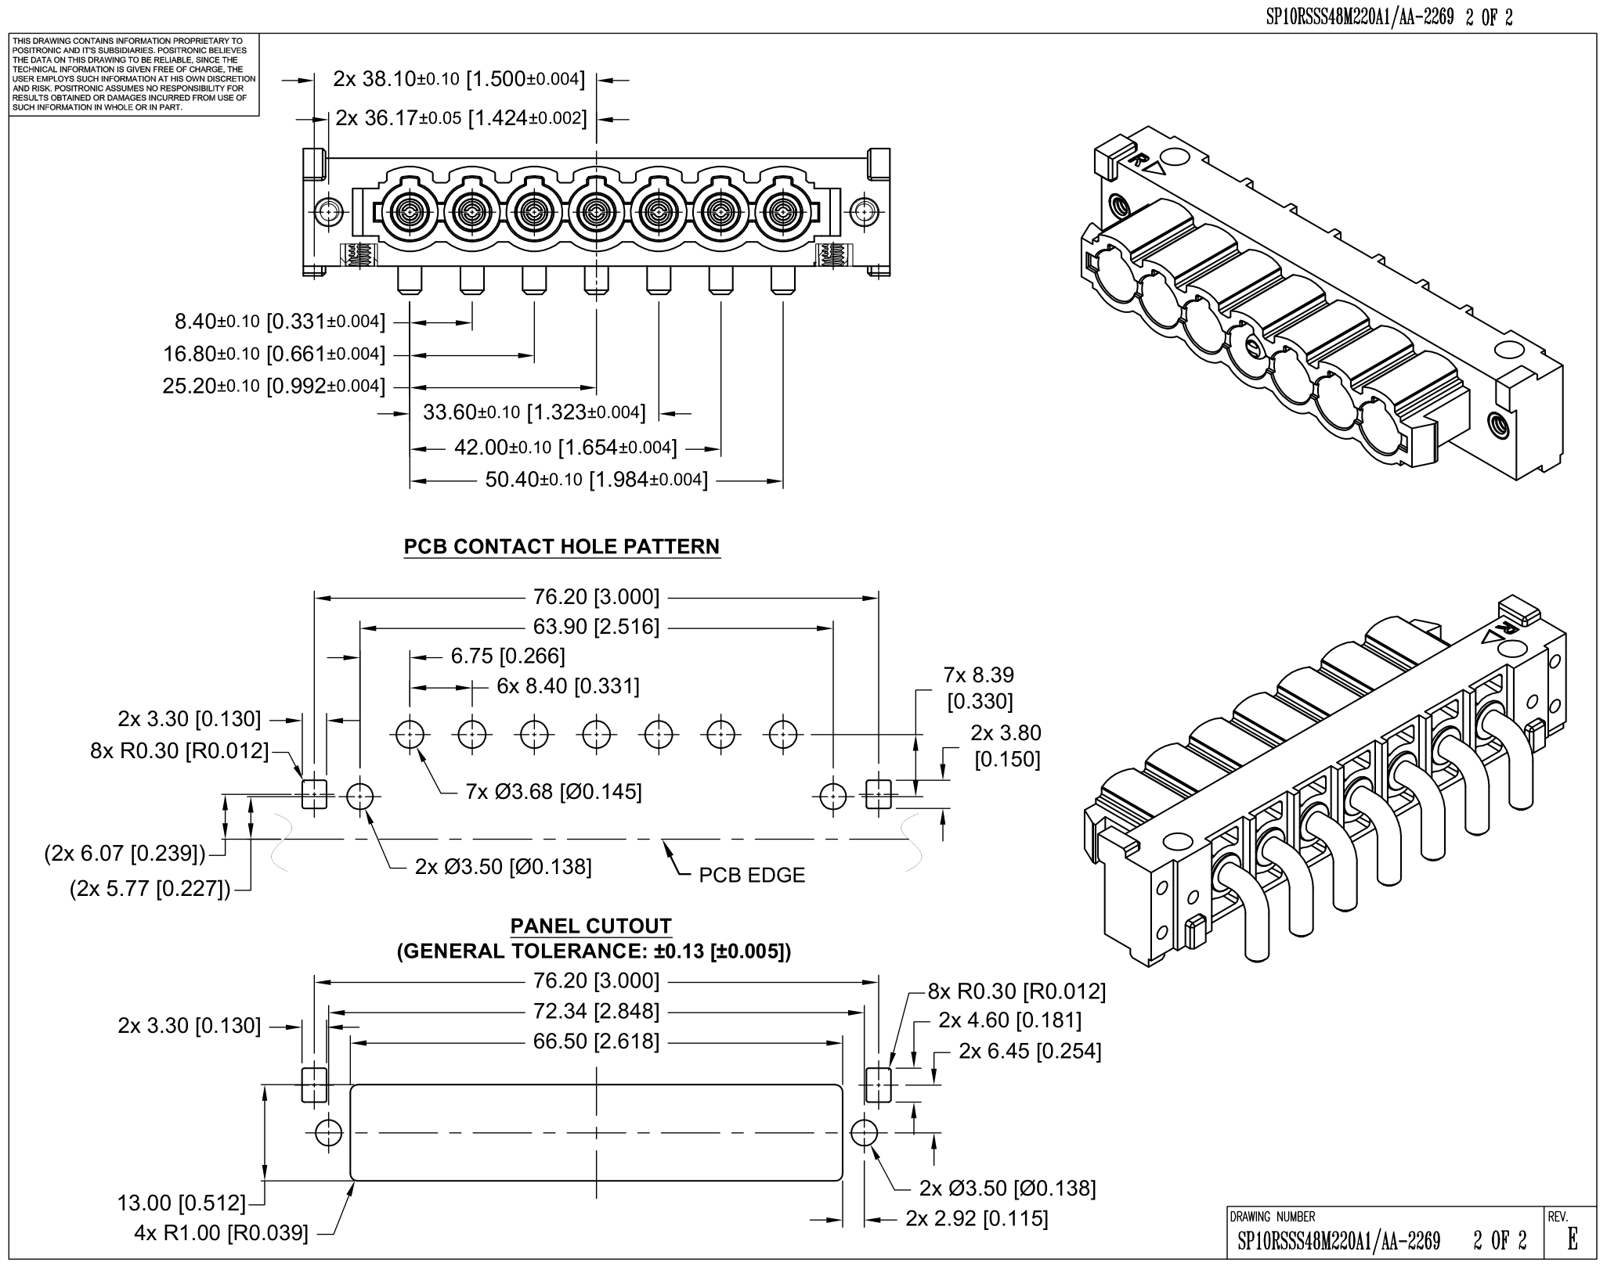
Figure 5.5 SP10RSSS48M220A1/AA-2269

Male right angle PCB contacts Connector with threaded insert mount – Left side (SP10RSSS48RM220A1/AA-2269)
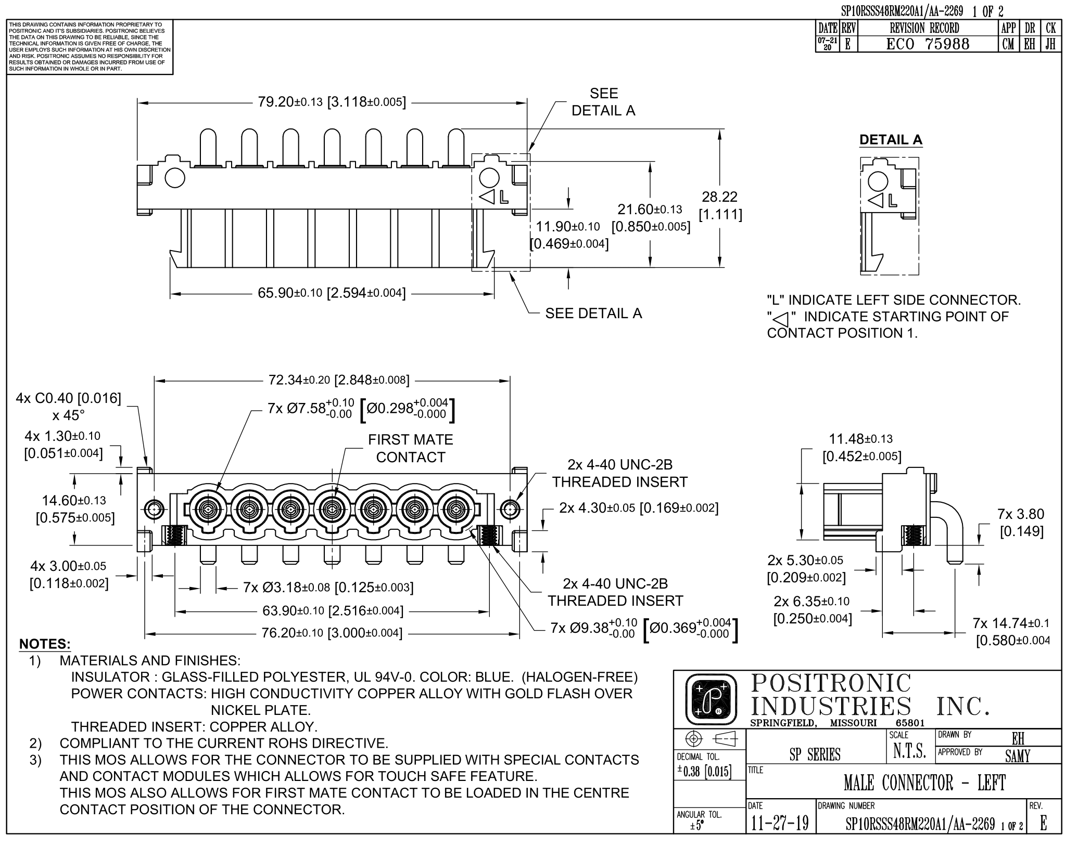
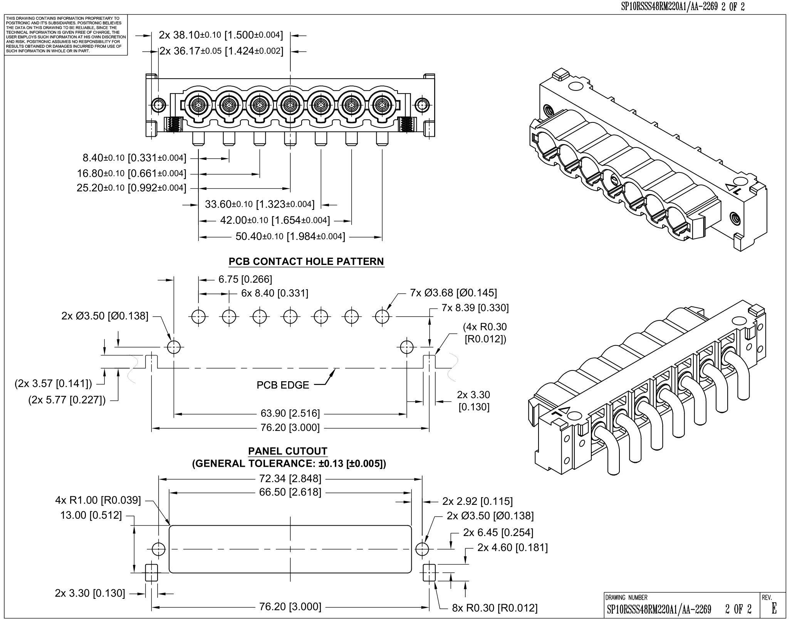
Figure 5.6 SP10RSSS48RM220A1/AA-2269
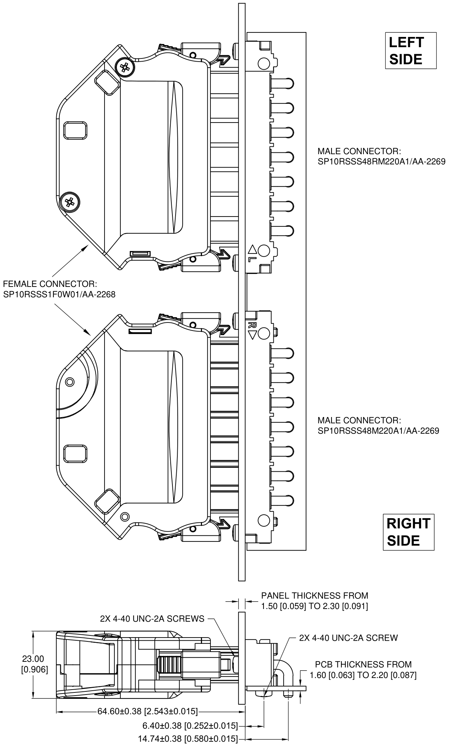
Figure 5.7
Mating Connector – Female cable to Male (Right side and Left side) Right Angle Connector

Contacts
Female Crimp Size 8 contact for 12 AWG wire
(FC4012DS/AA-2272)
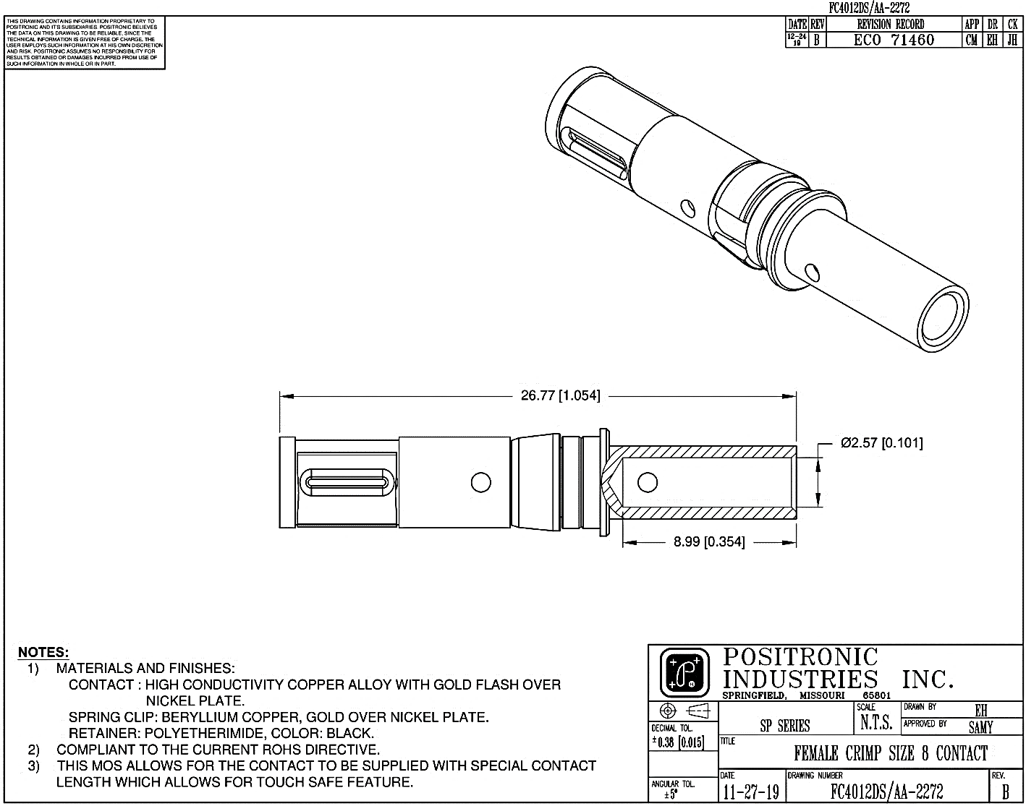
Figure 6.1 FC4012DS/AA-2272

The female crimp contacts ordering part numbers as follows:

CONTACT PART NUMBER | WIRE SIZE AWG [mm²] | ØA
FC4008DS/AA-2272 | 8 [10.0] | 4.60 [0.181]
FC4010DS/AA-2272 | 10 [5.3] | 3.10 [0.122]
FC4012DS/AA-2272 | 12 [4.0] | 2.57 [0.101]
Contact material to be High Conductivity Copper Alloy with Gold Flash over Nickel Plate.

Ordering Part number
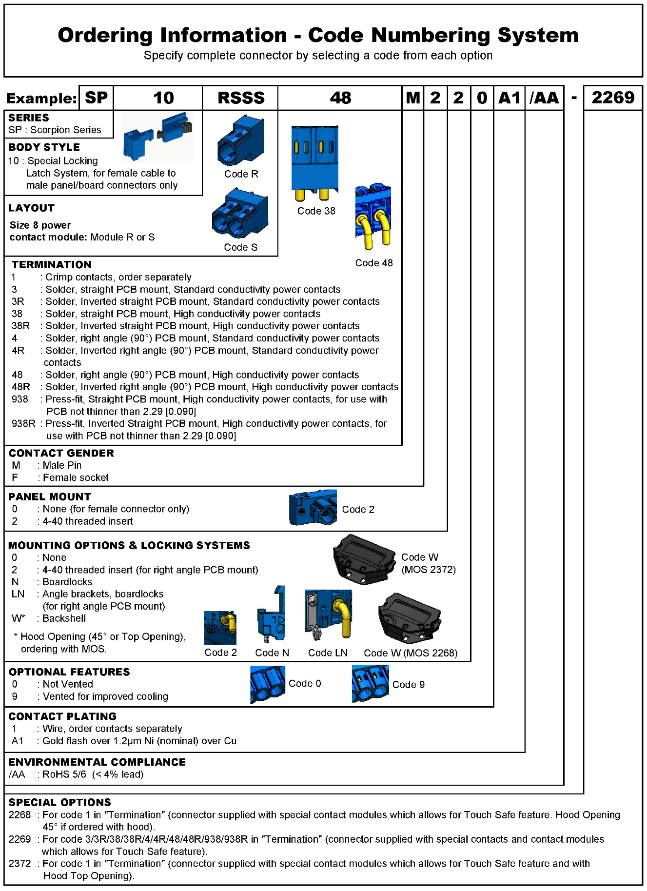

Positronic P/N | Amphenol P/N | Remarks
SP10RSSS1F0W01/AA-2268 | 10156980 | Female Cable Connector with Hood (45° Cable Opening)
SP10RSSS48M220A1/AA-2269 | 10156981 | Male Right Angle PCB Connector – Right Side
SP10RSSS48RM220A1/AA-2269 | 10156982 | Male Right Angle PCB Connector – Left Side
SP10RSSS48M2LN0A1/AA-2269 | 10156983 | Male Right Angle PCB Connector with Angle Brackets, Boardlocks – Right Side
SP10RSSS48RM2LN0A1/AA-2269 | 10156984 | Male Right Angle PCB Connector with Angle Brackets, Boardlocks – Left Side
SP10RSSS38M2N0A1/AA-2269 | 10156985 | Male Straight PCB Connector with Boardlocks  – Right Side
SP10RSSS38RM2N0A1/AA-2269 | 10156986 | Male Straight PCB Connector with Boardlocks  – Left Side
SP10RSSS38M200A1/AA-2269 | 10156987 | Male Straight PCB Connector with– Right Side
SP10RSSS38RM200A1/AA-2269 | 10156988 | Male Straight PCB Connector with– Left Side
SP10RSSS1M2001/AA-2268 | 10156989 | Male Cable Connector with Hood – Right Side
SP10RSSS1F0W01/AA-2373 | NA | Female Cable Connector with Hood  (Top Cable Opening)
SP10RSSS1F0001/AA-2268 | NA | Female Cable Connector without Hood
FC4012DS/AA-2272 | 10156991 | Female Crimp Contact – 12 AWG wire

The connector shall have a positive retention latch that can be unlatched with a finger release force less than 15 N.

The insertion force of the cable connector shall be less than 156 N.

Field replaceable terminals are not required.

Connector set shall be polarized.

Connector system shall provide for a ground pin that will make first mate/last break.

Provision for an optional protective cover for the connector when the cable is removed. Cover should provide a warning ISO 7010-W012 (shock warning).

The finger latches on the whip side connector need to be protected when the cable is extracted through the rack cable trough.

Environmental Requirements:
Connectors to be stored in their original shipping cartons in a humidity-controlled environment where the relative humidity remains below 75% and the ambient temperature is between 10°C and 27°C.
With the above conditions, the products will have a minimum shelf life of five (5) years from date of manufacture.

Quality
The following tests will be conducted with three samples each per Table 1.
Table 1
Test | Test Standard | Test Condition/ Method | Pass/Fail Criteria | Additional Data to Collect for Review
Durability | EIA-364-09 | 100 mating/un-mating cycles  30~60mm per second travel speed | contact resistance before and after  post test surface wear examination: no exposed nickel or copper | N/A
Contact Retention | EIA-364-29 | Method A  With minimum 15lbs axial load for minimum 6 seconds | no visible contact to housing displacement | N/A
Vibration | EIA-364-28  EIA-364-28F  Condition II | Test condition VII  Test condition letter E  15 minutes duration in each of the three mutually perpendicular direction | per standard  in addition: contact resistance before and after | post test contact wear optical examination,  SEM/EDX optional
Shock | EIA-364-27  EIA-364-27C  Condition H | half-sine pulse  test condition A  3 shocks * 3 perpendicular planes * 2 directions = 18 shocks | per standard  in addition: contact resistance before and after | post test contact wear optical examination,  SEM/EDX optional
Temperature Life | EIA-364-17 | Method C  Test condition 1: 125+/-2C  Test duration: 168hrs | per standard, section 4.4  in addition: contact resistance before and after | monitor contact voltage drop during test
Thermal Shock | EIA-364-32 | Method A  Test condition VII: -55C to 105C  Test duration: 10cycles | per standard, section 4.6 | N/A
Humidity | EIA-364-31 | Method IV | contact resistance before and after  dielectric withstand voltage before and after  insulation resistance before and after | N/A
Temperature rise | EIA-364-70 | Method I  Run at 32A through connector without exceeding 30°C above ambient temperature | Lower than 30C | N/A
Temperature rise | EIA-364-70 | Method 2 | Meet the required current | N/A
Contact Resistance Test | EIA-364-06 | @ Rated Current | Standard Conductivity Contacts material: 0.0006 ohms max.  High Conductivity Contact material: 0.0004 ohms max. | NA
Crimp Tensile Strength | EIA-364-08 | Per standard | 8 AWG: 489 N min.  10 AWG: 489 N min.  12 AWG: 489 N min.  16 AWG: 222 N min. | Values derived using silver-tin plated copper wires
Whip Connector Pull Out force | N/A | N/A | 111 N min. | Values derived with fully loaded connector
Threaded Insert Pull out force | N/A | N/A | 111 N min. | NA
Whip Side Connector drop test | UL 486A/B | Section 9.7 | No mechanical damage other than cosmetic damage allowed | N/A
Voltage Proof Test | EIA-364-20 | Per standard | 4000 V r.m.s. typical | N/A
Insertion and Withdrawal Force Test | EIA-364-13 | Per standard | Insertion force: 156 N max.  Withdrawal force: 9.73 N min. | Values derived with fully loaded connector
Insulation Resistance Test | EIA-364-21 | Per standard | 5G ohms minimum | N/A
Screw Torque Value | N/A | N/A | 2.5 inches pound to 3.5 inches pound for the following:  - Hood Assembly  - Panel Assembly  - PCB Assembly | N/A
Note: The above tests are conducted with the connector termination with code 1 (female connector) and code 48 and code 48R (male connector).

Compliance requirements for the connector
Connector shall be UL approved under UL1977, and it shall not cause any non-compliance issue with the latest amendment of the following Standards when it is integrated into the ORV3 rack.

- UL/IEC/EN 62368-1, Audio/video, information and communication technology equipment – Part 1: Safety requirements (applicable to meet anticipated effective date of December 20, 2020 for North America and Europe.)
- RoHS Directive (2011/65/EU, including proof by Declaration of Conformity and any other supporting documentation required for Deliverables, Components and Products, unless there are legal exemptions allowed); including aims to reduce the environmental impact of EEE by restricting the use of certain substances during manufacture.
- REACH Regulation (EC) No 1907/2006; registration with the European Chemicals Agency (ECHA), evaluation, authorization and restriction of chemicals.
- Halogen Free: IEC 61249-2-21, Definition of halogen free: 900ppm for Br or CI, or 1500ppm combined requires companies using tin, tantalum, tungsten, and gold (“3TG”) in their products to verify and disclose the mineral source.

Connector shall be designed to meet the following additional safety requirements
- A connector enclosure shall be constructed to reduce the risk of unintentional contact with any live parts. Live pins in the connector shall not be assessable when testing with the following pin as defined at UL standard.

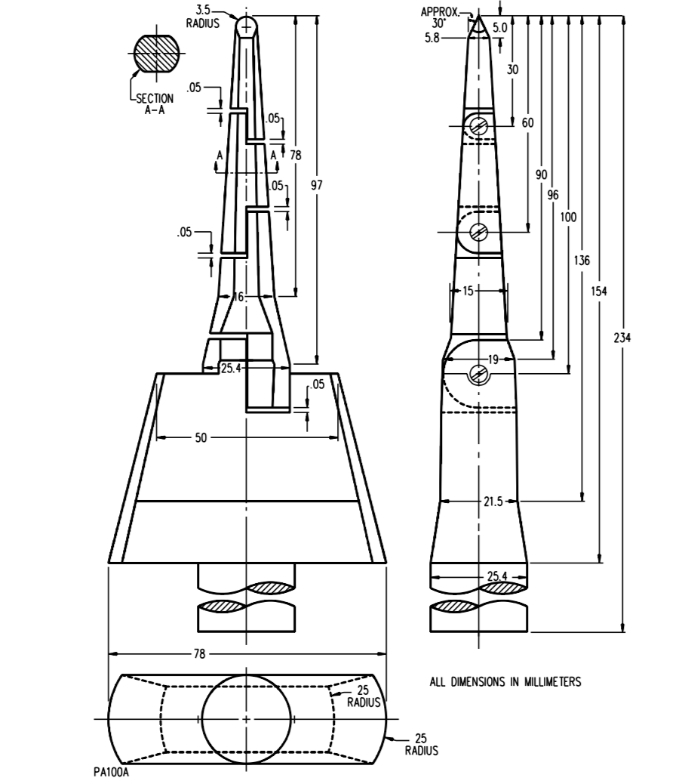

- If the above requirement cannot be met, the plastic cap must be provided for use with the unused connector, so that unintentional contact to pins cannot happen.
- A connector enclosure shall be constructed not to be easily accessible by user without using special tool. User has no access to the internal wiring for AC power configurations.
- Connector shall be keyed, in such a way that prevent from mating in wrong direction.
- Cord strain relief shall be provided, and it shall have a retention latch that shall not be damaged when minimum 100N force is applied in the most unfavorable direction.
- Connector shall be designed to have a minimum of 3.2mm air-spacing between an uninsulated live and any other metal part (if any) in the connector construction.
- Any exposed non-current carrying metal part of a device that are likely to become energized shall be conductively connected to the ground.
- The following caution label should be placed near the connector.

“CAUTION – Risk of Electric Shock. Do Not Disconnect Under Load”

- Connector must survive 50 cycles of insertion/removal at 150% of the maximum rated current and voltage. There shall not be any electrical and mechanical failure or burning of the contacts. In case any insulation material is used inside the connector and the insulator is exposed to the arcing, total 250 cycles shall be performed.
- Dielectric voltage-withstand tests (1000Volts + 2x rated voltage) must be performed after insertion/removal tests. There shall not be any indication of electrical or mechanical failure, electrical tracking, formation of a permanent carbon path, or ignition of material.
- Trise on the wiring terminals in the connector should not exceed 30°C when the device is carrying its maximum rated current.
- Connector plastic housing shall meet 94V0 flammability requirements.

Appendix 1 – Compliance requirements for the cable assembly for reference
- Parts used in the cable assembly shall be UL recognized or listed under the following standards.
Standard | Parts
UL 1682 | IEC 309 AC connector to the branch circuitry
UL498 | NEMA AC connector to the branch circuitry
UL1977 | Output connector that mates with connector in the power shelf
UL62 and UL817 | Flexible power cord that can be used for AC wiring
- Power cord shall meet UL/CSA SOOW and EU CENELEC <HAR> H07RN-F with +75C temperature rating. Halogen free cord (including internal wires) must be evaluate to the 150 degree C of Heat-shock test. And the following wire size (minimum) shall be used.
Ratings | Wire size
50Amps | 8AWG
32Amps | 10AWG
30Amps | 12AWG
20Amps | 16AWG

Revisions
Rev | Date | Author | Changes
0.1 | 5 JUL 19 | SM and HK | Initial Release
0.2 | 12 JUL 19 | Steve Mills | Extensive updates from the JDA group
0.3 | 1 AUG 19 | Ben Kim | Added detail to section 7 and created Appendix 1
0.4 | 22 SEP 20 | Natesh Kannan | Extensive updates including new modular connector design and drawings

