

OCP NIC 3.0 Design Specification

**Version 0.01**

Author: OCP Server Workgroup, OCP NIC subgroup

# Contents

1 Contents 2

2 Overview 5

2.1 License 5

2.2 Background 6

2.3 Acknowledgements 7

2.4 Overview 8

2.4.1 Mechanical Form factor overview 8

2.4.2 Electrical overview 10

2.5 References 10

3 Card form factor 12

3.1 Overview 12

3.2 Form factor options 12

3.3 I/O bracket 15

3.4 Line Side I/O Implementations 15

3.5 LED Implementation 16

3.6 Mechanical Keepout Zones 16

3.6.1 Baseboard Keep Out Zone 16

3.6.2 Add-in Card Keep Out Zone 16

3.7 Labeling Requirements 16

3.8 Insulation Requirements 16

3.9 NIC Implementation Examples 16

3.10 Non-NIC Use cases 16

3.10.1 PCIe Retimer card 16

3.10.2 Accelerator card 16

3.10.3 Storage HBA / RAID card 16

4 Card edge – Baseboard connector Interface 17

4.1 Gold Finger Requirement 17

4.2 Baseboard Connector Requirement 19

4.3 Pin definition 20

4.4 Signal Descriptions – Common 26

4.4.1 PCIe Interface Pins 26

4.4.2 PCIe Present and Bifurcation Control Pins 30

4.4.3 SMBus Interface Pins 32

4.4.4 Power Supply Pins 33

4.4.5 Miscellaneous Pins 34

4.5 Signal Descriptions – OCP Bay (Primary Connector Only) 35

4.5.1 PCIe Interface Pins – OCP Bay (Primary Connector Only) 35

4.5.2 NC-SI Over RBT Interface Pins – OCP Primary Connector only 36

4.5.3 Scan Chain Pins – OCP Primary Connector only 38

4.5.4 Connector A Miscellaneous Pins – OCP Connector A only 44

4.6 PCIe Bifurcation mechanism 45

4.6.1 PCIe Add-in Card to Baseboard Bifurcation Configuration (PRSNTA#, PRSNTB[3:0]#) 47

4.6.2 PCIe Baseboard to Add-in Card Bifurcation Configuration (BIF[2:0]#) 48

4.6.3 PCIe Bifurcation Decoder 49

4.6.4 Bifurcation Detection Flow 52

4.6.5 PCIe Bifurcation Examples 54

4.7 PCIe Clocking Topology 61

4.8 Power Capacity and Power Delivery 61

4.8.1 AC Power Off 62

4.8.2 Management Mode 62

4.8.3 Aux Power Mode (S5) 62

4.8.4 Main Power Mode (S0) 62

4.9 Power Sequence Timing Requirements 62

5 Management 63

5.1 SMBus Interface 63

5.2 NC-SI Sideband Interface 63

5.2.1 NC-SI addressing and Arb# 63

5.3 MAC Address Requirement 64

5.4 FRU EEPROM 64

5.4.1 Addressing(TBD) 64

5.5 FW Requirement (TBD) 64

5.6 Thermal Reporting Interface 64

6 Data Network Requirement 65

6.1 Network Booting (collect view from OEMs and hyperscale) 65

7 Routing Guidelines and Signal Integrity Considerations 66

7.1 NC-SI Over RBT 66

8 Thermal and Environmental 66

8.1 Environmental Requirements 66

8.1.1 Thermal Simulation Boundary Example 66

8.2 Shock & Vibration 66

8.3 Regulation 66

9 Revision History 67

# Overview

## License

As of April 7, 2011, the following persons or entities have made this Specification available under the Open Web Foundation Final Specification Agreement (OWFa 1.0), which is available at <http://www.openwebfoundation.org/legal/the-owf-1-0-agreements/owfa-1-0>:

Facebook, Inc.

You can review the signed copies of the Open Web Foundation Agreement Version 1.0 for this Specification at http://opencompute.org/licensing/, which may also include additional parties to those listed above.

Your use of this Specification may be subject to other third party rights. THIS SPECIFICATION IS PROVIDED "AS IS." The contributors expressly disclaim any warranties (express, implied, or otherwise), including implied warranties of merchantability, non-infringement, fitness for a particular purpose, or title, related to the Specification. The entire risk as to implementing or otherwise using the Specification is assumed by the Specification implementer and user. IN NO EVENT WILL ANY PARTY BE LIABLE TO ANY OTHER PARTY FOR LOST PROFITS OR ANY FORM OF INDIRECT, SPECIAL, INCIDENTAL, OR CONSEQUENTIAL DAMAGES OF ANY CHARACTER FROM ANY CAUSES OF ACTION OF ANY KIND WITH RESPECT TO THIS SPECIFICATION OR ITS GOVERNING AGREEMENT, WHETHER BASED ON BREACH OF CONTRACT, TORT (INCLUDING NEGLIGENCE), OR OTHERWISE, AND WHETHER OR NOT THE OTHER PARTY HAS BEEN ADVISED OF THE POSSIBILITY OF SUCH DAMAGE.

## Background

The OCP Mezzanine Card v0.5 and v2.0 specifications were created in 2012 and 2015 to standardize low profile PCIe NIC modules. These specifications are publically available and can be found at:

http://www.opencompute.org/wiki/Server/Mezz#Specifications_and_Designs

Compared to a NIC in in the standard PCIe CEM form factor, an OCP 2.0 Mezzanine is generally smaller in size with additional signals for NIC management, and support for multi-host use cases.

Figure 1: A Representative OCP 2.0 Mezzanine Card With Dual QSFP Ports

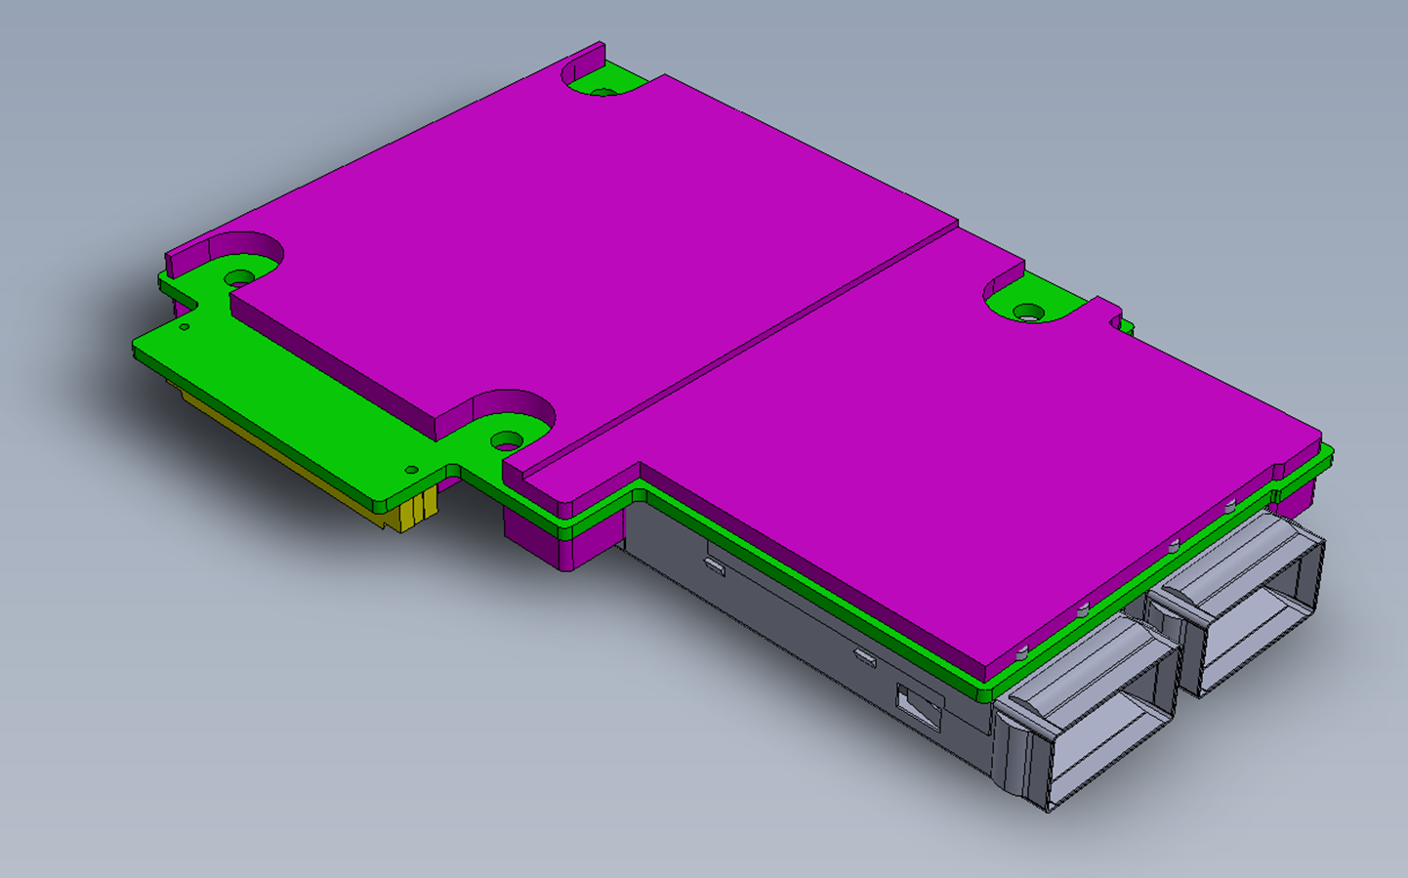

In the 2016 and 2017 OCP Summit, there was a healthy adoption of the OCP Mezzanine Card 2.0 form factor from both NIC and system suppliers. With this broader adoption, the OCP community raised the request to refresh the specification to support new and broader use cases, such as:

* Support NICs with Higher TDP
* Support for PCIe Gen4/5
* Support for more than x16 lanes of PCIe per card
* Support for Smart NIC implementations with on-board DRAM
* Support for greater board area for more complex add-in card designs
* Simplification of FRU installation and removal while reducing overall down time

The OCP NIC 3.0 specification aims to support these use cases. This specification was created under OCP Server workgroup - OCP NIC subgroup. A representative OCP 3.0 NIC mezzanine card is shown in Figure 2.

Figure 2: Representative Small OCP 3.0 NIC Mezzanine Card with Quad SFP Ports

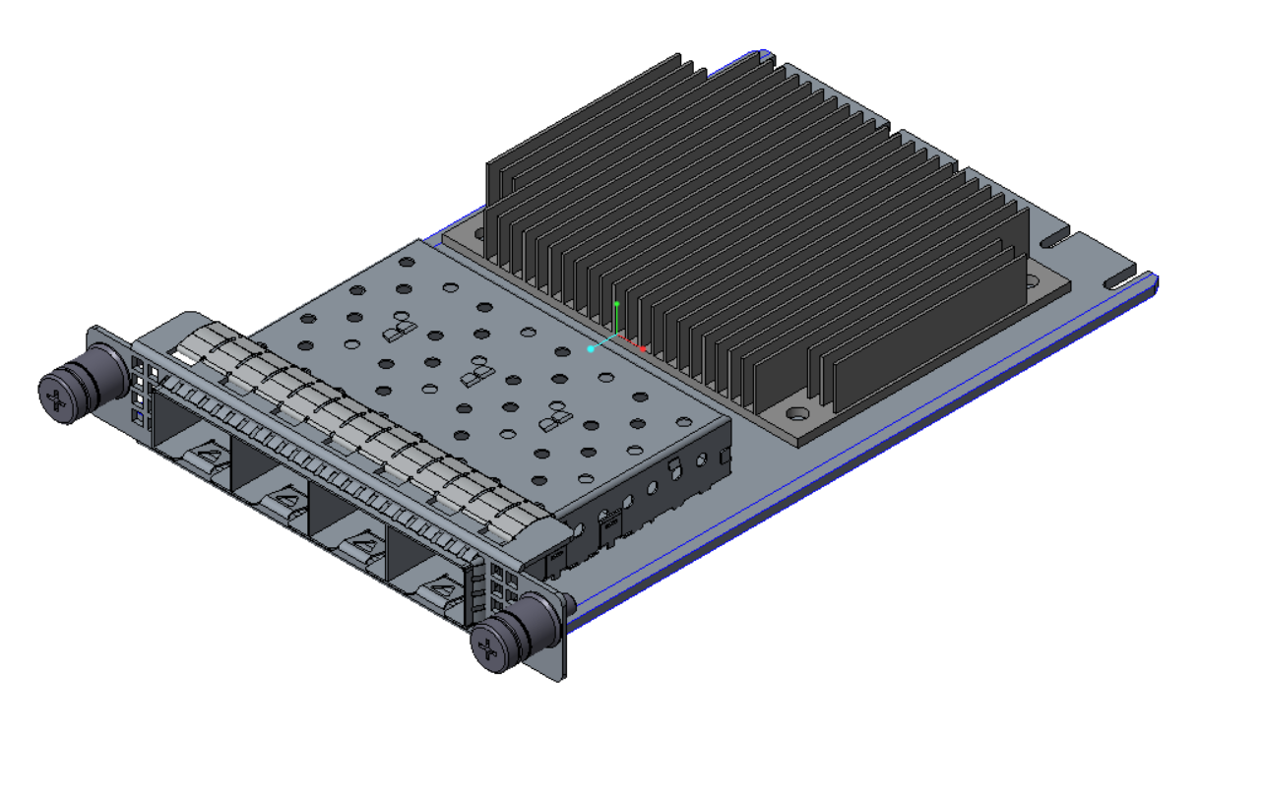

OCP 3.0 compliant cards are not backwards compatible to the 2.0 form-factor. Backward compatibility was considered during the specification process. However, after evaluating 14 major design concepts, the NIC and system suppliers converged on not supporting backward compatibility in order to achieve better features in this specification.

## Acknowledgements

Placeholder

## Overview

### Mechanical Form factor overview

The OCP NIC 3.0 specification defines a third generation mechanical form factor that allows for interoperability between specification compliant systems and cards.

OCP NIC 3.0 has two form factors – Small and Large. These cards are shown in Figure 3 below. The components shown in the figures are for illustrative purposes. The Small form factor card has one connector (Primary connector) on baseboard. The Large form factor card has two connectors (Primary Connector and Secondary Connector) on the baseboard. Both the Primary and Secondary connectors are defined in and compliant to SFF-TA-1002. [Editor’s note: plan to submit change back to SFF-TA-1002]. On the NIC side, the card edge is implemented with gold fingers. The gold finger design follows SFF-TA-1002 as well.

Figure 3: Small and Large Card Form-Factors (not to scale)

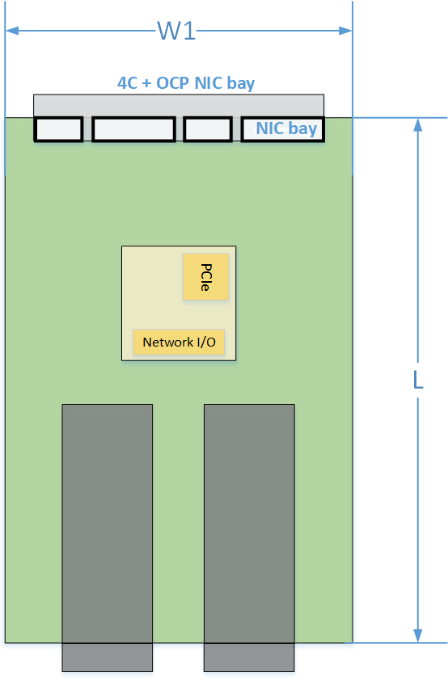 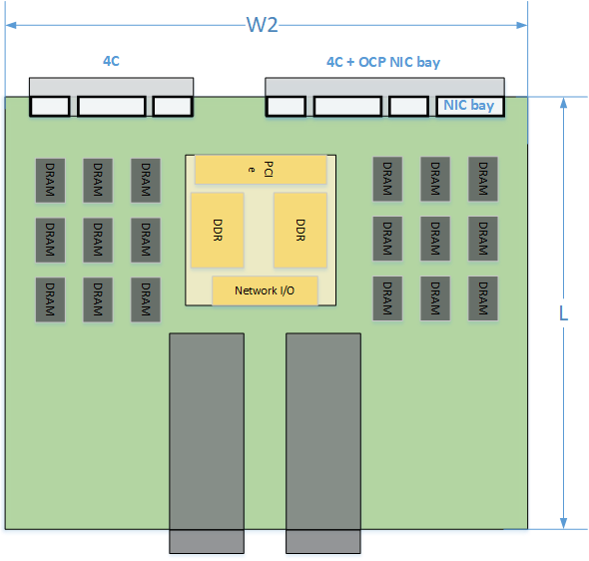

The two form factor dimensions are shown in Table 1.

Table 1: OCP 3.0 Form Factor Dimensions

|  |  |  |  |  |  |
| --- | --- | --- | --- | --- | --- |
| **Form Factor** | **Width** | **Depth** | **Primary Connector** | **Secondary Connector** | **Typical Use Case** |
| Small | W1=76 | 115mm | 4C+ OCP sideband | N/A | Low profile and general NIC in similar profile as OCP NIC 2.0; up to x16 PCIe lanes |
| Large | W2=139  [to be confirmed] | 115mm | 4C+ OCP sideband  168 pins | 4C | Largest PCB width to support feature rich NICs, and up to x32 PCIe lanes |

The design allows downward compatibility across the two sizes. Table 2 shows the compatibility between the baseboard and NIC combinations. A Large size baseboard slot may accept a small or large sized NIC. A small size baseboard slot may only accept a small sized NIC.

Table 2: Baseboard to OCP NIC Form factor Compatibility Chart

|  |  |  |
| --- | --- | --- |
| **Baseboard Slot Size** | **NIC Size / Supported PCIe Width** | |
| Small | Large |
| Small | Up to x16 | Not Supported |
| Large | Up to x16 | Up to x32 |

There are two baseboard connector options available for system designers: straddle mount and right angle (RA). The straddle mount connector option allows the OCP NIC and baseboard to exist in a co-planer position. To achieve this, a cutout exists on the baseboard and is defined in this specification. Alternatively, the right angle option allows the OCP NIC to be installed on top of the baseboard. A baseboard cutout is not required for the right angle connector. The right angle option allows the base board to use this area for additional baseboard routing. The straddle mount and right angle connectors are shown in Section 4.2.

For both the baseboard and OCP card, this specification defines the component and routing keep out areas. Refer to Section 3.6 for details.

Both the straddle mount and right angle implementations shall use the same OCP NIC and shall be supported in the baseboard chassis regardless of the baseboard connector selection (right angle or straddle mount) so long as the baseboard slot side and NIC size are a supported combination as shown in Table 2.

This specification defines form factor at NIC module level, including the front panel, latches and card guide features [TBD; pending on the Mechanical work across stakeholders].

More details about the card form-factor is shown in Section 3.

### Electrical overview

This specification defines electrical interface between baseboard/system and card/NIC module.

The electrical interface is implemented with a right angle or straddle mount connector on baseboard and gold finger on the add-in card. As previously noted in the mechanical overview, each card may implement a Primary Connector or Primary + Secondary Connector. Cards using only the Primary connector are suitable for both the Small and Large form-factors and may support up to x16 lanes of PCIe. The Secondary connector in conjunction with the Primary allows Large form-factor implementations and may support up to 32 lanes of PCIe.

#### Primary Connector

#### Secondary connector

## References

DMTF Standard. *DSP0222, Network Controller Sideband Interface (NC-SI) Specification.* Distributed Management Task Force, Inc, Rev 1.0.1, January 24th, 2013.

Open Compute Project. *OCP NIC Subgroup*. Online. <http://www.opencompute.org/wiki/Server/Mezz>

PCIe Base Specification. *PCI Express Base Specification, Revision 4.0 (draft)*.

PCIE CEM Specification. *PCI Express Card Electromechanical Specification, Revision 4.0 (draft)*.

SMBus specification

SNIA. *SFF-TA-1002, Specification for Protocol Agnostic Multi-Lane High Speed Connector*. SNIA SFF TWG Technology Affiliate, Rev 0.0.9.1, September 9th, 2017.

# Card form factor

## Overview

## Form factor options

OCP3.0 provides two fundamental form factor options: a small card (76mm x 115mm) and a large card (139mm x 115mm).

These form factors support a Primary Connector and optionally, a Secondary Connector. The Primary Connector is defined to be a SFF-TA-1002 compliant 4C connector plus a 28-pin bay extension for OCP 3.0 specific pins. The Secondary Connector is the 4C connector as defined in SFF-TA-1002. The 4C specification supports up to 32 differential pairs for a x16 PCIe connection per connector. For host platforms, the 28-pin OCP bay is required for the Primary connector. This is also mandatory for add-in cards.

The small card uses the 4C connector for up to a x16 PCIe interface. The small cards implement the 28 pin OCP bay for management functions and support for up to a four PCIe hosts. The small size card provides sufficient faceplate area to accommodate up to 2x QSFP modules, 4x SFP modules, or 4x RJ-45 for BASE-T operation. The small card form factor supports up to 79W of delivered power to the card edge.

Figure 4: Example Small Card Form Factor

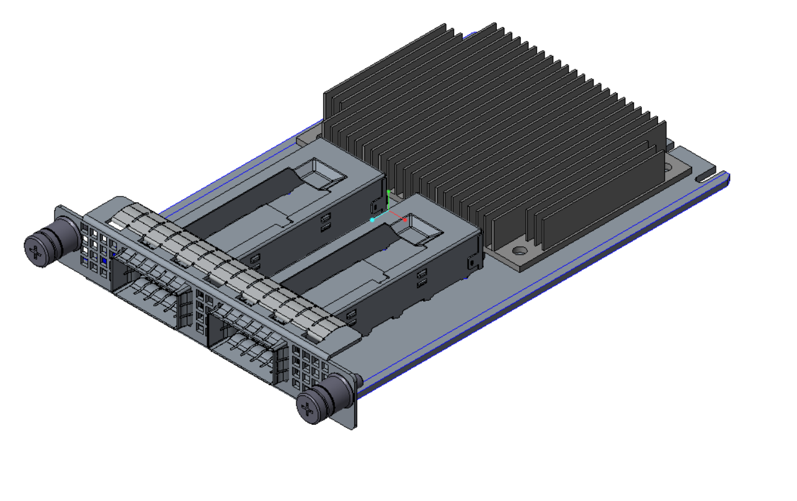

The large card uses provides the same functionality as the small card, but with support up to x32 PCIe interface. The large card utilizes both the Primary and Secondary connectors. The large size card supports higher power envelopes and provides additional board area for more complex designs. The small card form factor supports up to 158W of delivered power to the card edge at 79W per connector.

Figure 5: Example Large Card Form Factor

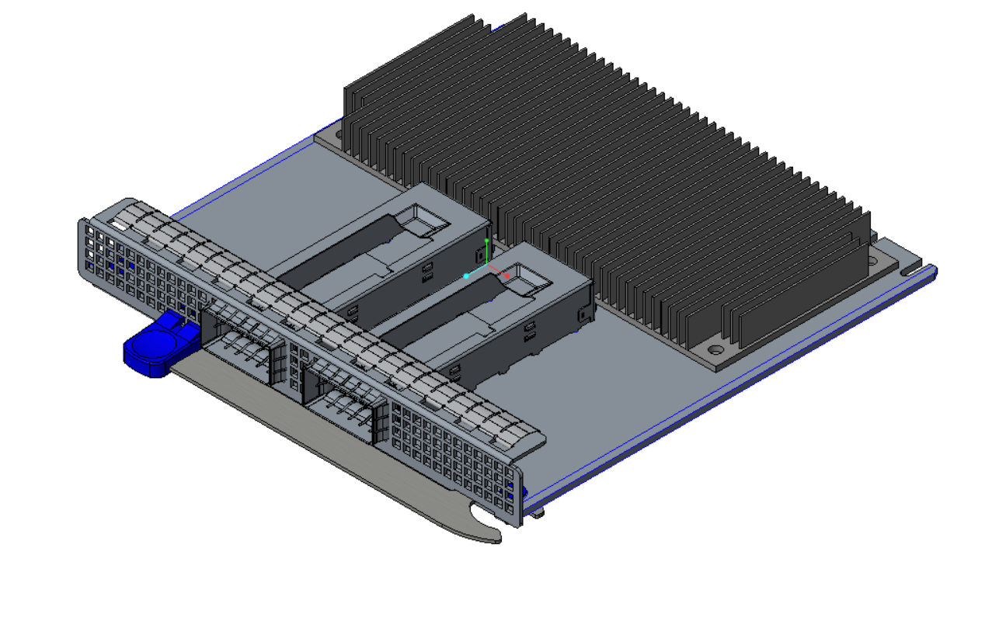

For both form-factors, an add-in card may optionally implement a subset of pins support a x8 PCIe connection. This is implemented using a 2C connector per SFF-TA-1002. The Primary Connector may support a 2C sized add in card along with the 28 pin OCP bay. The Secondary Connector cards may also support a 2C sized add in card. The following diagram from the SFF-TA-1002 specification illustrates the supported host Primary and Secondary Connectors and add in card configurations.

Figure 6: Primary Connector (4C + OCP Bay) with 4C and 2C Add in Cards

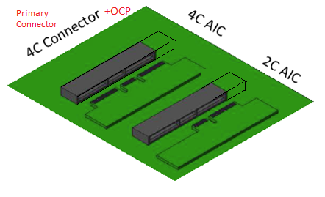

Figure 7: Secondary Connector (4C) with 4C and 2C Add in Cards

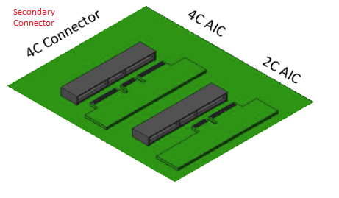

Table 3 summarizes the supported card form factors. Small form factors cards may support the Primary Connector, or the Secondary Connector and support up to 16 lanes of PCIe. Large form factor cards may support both the Primary and Secondary Connectors and support up to 32 lanes of PCIe.

Table 3: OCP 3.0 Card Definitions

|  |  |  |  |  |  |
| --- | --- | --- | --- | --- | --- |
| **Host Connectors:** | **Secondary** | | **Primary** | | |
|  | Max: 4C Connector, x16 PCIe  Min: 2C Connector, x8 PCIe | | Max: 4C Connector, x16 PCIe  Min: 2C Connector, x8 PCIe | | OCP Bay |
| **Add in Cards:** |  | |  | |  |
| Small (x8) – Primary |  |  |  | 2C | OCP Bay |
| Small (x16) – Primary |  |  | 4C | | OCP Bay |
| Small (x8) – Secondary |  | 2C |  | |  |
| Small (x16) – Secondary | 4C | |  | |  |
| Large 1 (x24) |  | 2C | 4C | | OCP Bay |
| Large 2 (x32) | 4C | | 4C | | OCP Bay |

## I/O bracket

## Line Side I/O Implementations

At the time of this writing, the Small and Large form-factor cards may support the following standard line side I/O implementations:

Table 4: OCP 3.0 Line Side I/O Implementations

|  |  |
| --- | --- |
| **Form Factor** | **Max Topology Connector Count** |
| Small | 2x QSFP28 |
| Small | 4x SFP28 |
| Small | 4x RJ-45 |
| Large | TBD |
| Large | TBD |
| Large | TBD |

Additional combinations are permissible as I/O technologies and thermal capabilities evolve.

## LED Implementation

An OCP 3.0 NIC in the small form-factor may not have sufficient space for LED indication. Thus, the line side link and activity LED indicators are implemented on the baseboard system. The LED states are transmitted over the Scan Chain as defined in Section 4.5.3 when implementing cards with at least the Primary connector.

At the time of this writing, the Scan Chain definition allows for up to one link and one activity LED per port. A total of up to 8 ports are supported in the Scan Chain. The bit stream defines the LEDs to be active low (ON).

## Mechanical Keepout Zones

### Baseboard Keep Out Zone

TBD – Need keepout drawings and envelopes for small / large size baseboard including primary/secondary/rail keepouts/cutout for straddle mount/keepout for right angle.

### Add-in Card Keep Out Zone

TBD – need keepout drawings and envelopes for small / large size NIC including primary/secondary/rail keepouts.

## Labeling Requirements

## Insulation Requirements

All cards must implement a secondary side insulator to prevent the bottom side card components from shorting out to the chassis. The mechanical insulator shall be 0.25mm thick and must reside within the following mechanical envelope:

## NIC Implementation Examples

TBD

## Non-NIC Use Cases

“PCIe interface with extra management sideband”

### PCIe Retimer card

### Accelerator card

### Storage HBA / RAID card

# Card edge – Baseboard connector Interface

## Gold Finger Requirement

**Editor’s note:** Connector vendors to provide input and all detailed views from the mechanical drawing. First stab at it is below. Diagrams are copied from SFF-TA-1002.

The OCP 3.0 mezzanine add-in cards are compliant to the SFF-TA-1002 specification with respect to the gold fingers and connectors.

Small Size cards may fit in the Primary Connector or the Secondary Connector. Primary Connector compliant cards are 76mm x 115mm and may implement the full 168-pins. Secondary Connector compliant cards are XXXmm x 115mm and may implement the 140-pin gold finger. Both the Primary and Secondary Connector cards may implement a subset of gold finger pins if there is a reduced PCIe width requirement (such as 1 x8). In this case, the card edge gold finger may implement a 2C design. The overall board thickness is 1.60mm. The gold finger dimensions for the Primary Connector and Secondary Connector compliant cards are shown below.

Large Size Cards support up to a x32 PCIe implementation and uses both the Primary and Secondary connectors.

For additional details, refer to the card and connector mechanical drawings located in XXX.

Note: The “B” pins on the connector are associated with the top side of the add-in card. The “A” pins on the connector are associated with the bottom side of the add-in card.

Figure 8: Small Size Primary Connector Gold Finger Mating Card Dimensions – x16 – Top Side

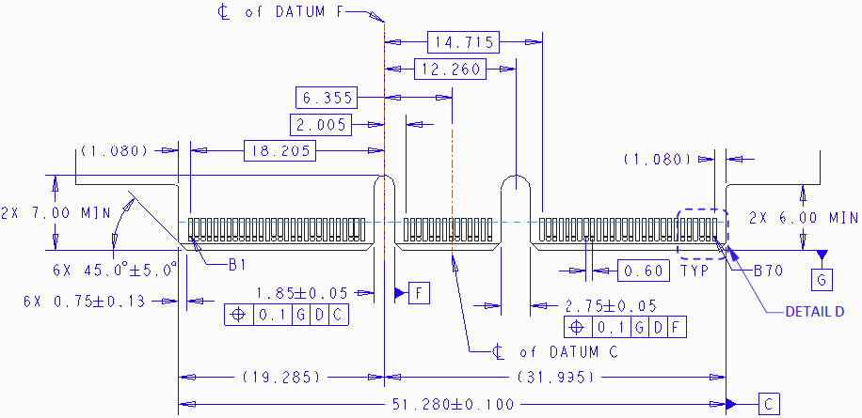

Figure 9: Small Size Primary Connector Gold Finger Mating Card Dimensions – x16 – Bottom Side

TBD

Figure 10: Small Size Secondary Connector Gold Finger Mating Card Dimensions – x16 – Top Side



Figure 11: Small Size Secondary Connector Gold Finger Mating Card Dimensions – x16 – Bottom Side

TBD

Figure 12: Large Size Card Gold Finger Mating Card Dimensions – x32 – Top Side

TBD

Figure 13: Large Size Card Gold Finger Mating Card Dimensions – x32 – Bottom Side

TBD

## Baseboard Connector Requirement

**Editor’s note:** Connector vendors to provide input.

The OCP3.0 connector is compliant to the “4C connector” as defined in the SFF-TA-1002 specification for a right angle or straddle mount form-factor. The 4C connector is 140-pins in width and includes support for up to 32 differential pairs to support a x16 PCIe connection. The connector also provides 6 pins of 12V for payload power. This implementation is common between both the Primary and Secondary Connector. In addition, the Primary Connector has a 28-pin OCP Bay to the right of pin 1. These pins are used for management and support for a 4 x4 multi-host configuration. The Primary and Secondary Connector drawings are shown in Figure 14 and Figure 15, below.

Figure 14: 168-pin Base Board Primary Connector – Right Angle

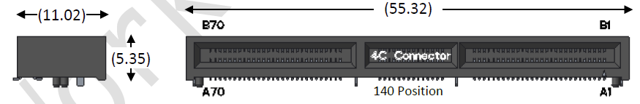

Figure 15: 140-pin Base Board Secondary Connector – Right Angle



Figure 16: 168-pin Base Board Primary Connector – Straddle Mount

TBD

Figure 17: 140-pin Base Board Secondary Connector – Straddle Mount

TBD

The Primary and Secondary Connector must be located per the mechanical drawing below for systems to support the Large Form-factor.

Figure 18: Primary and Secondary Conenctor Locations for Large Card Support

TBD

## Pin definition

**Editor’s note:** The pin map aligns with OCP 3.0 Pinout Proposal 20171121a_TN.xlsx.

The pin definition of a mezzanine card with up to a x32 PCIe interface are shown in Table 5 and Table 6. All signal directions are shown from the perspective of the baseboard.

A baseboard system may provide a combination of Primary Connectors, and Secondary Connectors. Both connectors have common functionality with power, SMBus, x16 PCIe Gen4 connections and bifurcation control. Baseboards that implement both the Primary Connector and Secondary Connector (located adjacent to each other) can support up to 32 PCIe lanes or can be mechanically implemented as two standalone x16 cards. Depending on the baseboard form-factor, multiple Primary Connector or Secondary Connector compliant cards may be designed into the system.

The Primary Connector has an additional OCP Bay (pins OCP_A[1:14], OCP_B[1:14]) with additional REFCLKs for supporting up to four PCIe hosts, NC-SI connectivity and a scan chain for information exchange between the host and card.

The pins common to the Primary and Secondary Connector are shown in Section 4.4. The OCP Bay for the Primary Connector only are shown in Section 4.5.

Cards or systems that do not require the use of a PCIe x16 connection may optionally implement a subset electrical connections as applicable to the design (for example, a x8 card using the first 8 PCIe lanes that is compliant with the Primary or Secondary Connector pinout). Please refer to Sections 4.1 and 4.2 for mechanical details. For these cases, the Primary and Secondary Connector matches the “2C” dimensions as defined in SFF-TA-1002.

In all cases, the host shall implement the Primary and Secondary Connector supporting x16 PCIe widths. Add-in cards may implement a x8 interface at the card edge.

Table 5: Primary Connector Mezzanine Card Pin Definition (x16) (4C + OCP Bay)

|  |  |  |  |  |  |
| --- | --- | --- | --- | --- | --- |
| **Side B** | | **Side A** | |  | |
| OCP_B1 | NIC_PWR_GOOD | WAKE_N | OCP_A1 | **Primary Connector (x16, 168-pin add-in card with OCP Bay)** | **Primary Connector (x8, 112-pin add-in card with OCP bay)** |
| OCP_B2 | PWRBRK# | PERST2# | OCP_A2 |
| OCP_B3 | LD# | PERST3# | OCP_A3 |
| OCP_B4 | DATA_IN | RBT_ARB_IN | OCP_A4 |
| OCP_B5 | DATA_OUT | RBT_ARB_OUT | OCP_A5 |
| OCP_B6 | CLK | GND | OCP_A6 |
| OCP_B7 | SLOT_ID0 | RBT_TX_EN | OCP_A7 |
| OCP_B8 | RBT_RXD1 | RBT_TXD1 | OCP_A8 |
| OCP_B9 | RBT_RXD0 | RBT_TXD0 | OCP_A9 |
| OCP_B10 | GND | GND | OCP_A10 |
| OCP_B11 | REFCLKn2 | REFCLKn3 | OCP_A11 |
| OCP_B12 | REFCLKp2 | REFCLKp3 | OCP_A12 |
| OCP_B13 | GND | GND | OCP_A13 |
| OCP_B14 | RBT_CRS_DV | RBT_CLK_IN | OCP_A14 |
| **Mechanical Key** | | | |
| B1 | +12V/+12V_AUX | GND | A1 |
| B2 | +12V/+12V_AUX | GND | A2 |
| B3 | +12V/+12V_AUX | GND | A3 |
| B4 | +12V/+12V_AUX | GND | A4 |
| B5 | +12V/+12V_AUX | GND | A5 |
| B6 | +12V/+12V_AUX | GND | A6 |
| B7 | BIF0# | SMCLK | A7 |
| B8 | BIF1# | SMDAT | A8 |
| B9 | BIF2# | SMRST# | A9 |
| B10 | PERST0# | PRSNTB2# | A10 |
| B11 | +3.3V/+3.3V_AUX | PERST1# | A11 |
| B12 | PWRDIS | PRSNTA# | A12 |
| B13 | GND | GND | A13 |
| B14 | REFCLKn0 | REFCLKn1 | A14 |
| B15 | REFCLKp0 | REFCLKp1 | A15 |
| B16 | GND | GND | A16 |
| B17 | PETn0 | PERn0 | A17 |
| B18 | PETp0 | PERp0 | A18 |
| B19 | GND | GND | A19 |
| B20 | PETn1 | PERn1 | A20 |
| B21 | PETp1 | PERp1 | A21 |
| B22 | GND | GND | A22 |
| B23 | PETn2 | PERn2 | A23 |
| B24 | PETp2 | PERp2 | A24 |
| B25 | GND | GND | A25 |
| B26 | PETn3 | PERn3 | A26 |
| B27 | PETp3 | PERp3 | A27 |
| B28 | GND | GND | A28 |
| **Mechanical Key** | | | |
| B29 | GND | GND | A29 |
| B30 | PETn4 | PERn4 | A30 |
| B31 | PETp4 | PERp4 | A31 |
| B32 | GND | GND | A32 |
| B33 | PETn5 | PERn5 | A33 |
| B34 | PETp5 | PERp5 | A34 |
| B35 | GND | GND | A35 |
| B36 | PETn6 | PERn6 | A36 |
| B37 | PETp6 | PERp6 | A37 |
| B38 | GND | GND | A38 |
| B39 | PETn7 | PERn7 | A39 |
| B40 | PETp7 | PERp7 | A40 |
| B41 | GND | GND | A41 |
| B42 | PRSNTB0# | PRSNTB1# | A42 |
| **Mechanical Key** | | | |  |
| B43 | GND | GND | A43 |  |
| B44 | PETn8 | PERn8 | A44 |  |
| B45 | PETp8 | PERp8 | A45 |  |
| B46 | GND | GND | A46 |  |
| B47 | PETn9 | PERn9 | A47 |  |
| B48 | PETp9 | PERp9 | A48 |  |
| B49 | GND | GND | A49 |  |
| B50 | PETn10 | PERn10 | A50 |  |
| B51 | PETp10 | PERp10 | A51 |  |
| B52 | GND | GND | A52 |  |
| B53 | PETn11 | PERn11 | A53 |  |
| B54 | PETp11 | PERp11 | A54 |  |
| B55 | GND | GND | A55 |  |
| B56 | PETn12 | PERn12 | A56 |  |
| B57 | PETp12 | PERp12 | A57 |  |
| B58 | GND | GND | A58 |  |
| B59 | PETn13 | PERn13 | A59 |  |
| B60 | PETp13 | PERp13 | A60 |  |
| B61 | GND | GND | A61 |  |
| B62 | PETn14 | PERn14 | A62 |  |
| B63 | PETp14 | PERp14 | A63 |  |
| B64 | GND | GND | A64 |  |
| B65 | PETn15 | PERn15 | A65 |  |
| B66 | PETp15 | PERp15 | A66 |  |
| B67 | GND | GND | A67 |  |
| B68 | RFU, N/C | RFU, N/C | A68 |  |
| B69 | RFU, N/C | RFU, N/C | A69 |  |
| B70 | PRSNTB3# | RFU, N/C | A70 |  |

Table 6: Secondary Connector Mezzanine Card Pin Definition (x16) (4C)

|  |  |  |  |  |  |
| --- | --- | --- | --- | --- | --- |
| **Side B** | | **Side A** | |  | |
| B1 | +12V/+12V_AUX | GND | A1 | **Secondary Connector (x16, 140-pin add-in card)** | **Secondary Connector (x8, 84-pin add-in card)** |
| B2 | +12V/+12V_AUX | GND | A2 |
| B3 | +12V/+12V_AUX | GND | A3 |
| B4 | +12V/+12V_AUX | GND | A4 |
| B5 | +12V/+12V_AUX | GND | A5 |
| B6 | +12V/+12V_AUX | GND | A6 |
| B7 | BIF0# | SMCLK | A7 |
| B8 | BIF1# | SMDAT | A8 |
| B9 | BIF2# | SMRST# | A9 |
| B10 | PERST0# | PRSNTB2# | A10 |
| B11 | +3.3V/+3.3V_AUX | PERST1# | A11 |
| B12 | PWRDIS | PRSNTA# | A12 |
| B13 | GND | GND | A13 |
| B14 | REFCLKn0 | REFCLKn1 | A14 |
| B15 | REFCLKp0 | REFCLKp1 | A15 |
| B16 | GND | GND | A16 |
| B17 | PETn0 | PERn0 | A17 |
| B18 | PETp0 | PERp0 | A18 |
| B19 | GND | GND | A19 |
| B20 | PETn1 | PERn1 | A20 |
| B21 | PETp1 | PERp1 | A21 |
| B22 | GND | GND | A22 |
| B23 | PETn2 | PERn2 | A23 |
| B24 | PETp2 | PERp2 | A24 |
| B25 | GND | GND | A25 |
| B26 | PETn3 | PERn3 | A26 |
| B27 | PETp3 | PERp3 | A27 |
| B28 | GND | GND | A28 |
| **Mechanical Key** | | | |
| B29 | GND | GND | A29 |
| B30 | PETn4 | PERn4 | A30 |
| B31 | PETp4 | PERp4 | A31 |
| B32 | GND | GND | A32 |
| B33 | PETn5 | PERn5 | A33 |
| B34 | PETp5 | PERp5 | A34 |
| B35 | GND | GND | A35 |
| B36 | PETn6 | PERn6 | A36 |
| B37 | PETp6 | PERp6 | A37 |
| B38 | GND | GND | A38 |
| B39 | PETn7 | PERn7 | A39 |
| B40 | PETp7 | PERp7 | A40 |
| B41 | GND | GND | A41 |
| B42 | PRSNTB0# | PRSNTB1# | A42 |
| **Mechanical Key** | | | |  |
| B43 | GND | GND | A43 |  |
| B44 | PETn8 | PERn8 | A44 |  |
| B45 | PETp8 | PERp8 | A45 |  |
| B46 | GND | GND | A46 |  |
| B47 | PETn9 | PERn9 | A47 |  |
| B48 | PETp9 | PERp9 | A48 |  |
| B49 | GND | GND | A49 |  |
| B50 | PETn10 | PERn10 | A50 |  |
| B51 | PETp10 | PERp10 | A51 |  |
| B52 | GND | GND | A52 |  |
| B53 | PETn11 | PERn11 | A53 |  |
| B54 | PETp11 | PERp11 | A54 |  |
| B55 | GND | GND | A55 |  |
| B56 | PETn12 | PERn12 | A56 |  |
| B57 | PETp12 | PERp12 | A57 |  |
| B58 | GND | GND | A58 |  |
| B59 | PETn13 | PERn13 | A59 |  |
| B60 | PETp13 | PERp13 | A60 |  |
| B61 | GND | GND | A61 |  |
| B62 | PETn14 | PERn14 | A62 |  |
| B63 | PETp14 | PERp14 | A63 |  |
| B64 | GND | GND | A64 |  |
| B65 | PETn15 | PERn15 | A65 |  |
| B66 | PETp15 | PERp15 | A66 |  |
| B67 | GND | GND | A67 |  |
| B68 | RFU, N/C | RFU, N/C | A68 |  |
| B69 | RFU, N/C | RFU, N/C | A69 |  |
| B70 | PRSNTB3# | RFU, N/C | A70 |  |

## Signal Descriptions – Common

The pins shown in this section are common to both the Primary and Secondary Connectors. All pin directions are from the perspective of the baseboard.

**Note:** Pins that are only used on Primary Connector 28-pin OCP bay are defined in Section 4.5.

### PCIe Interface Pins

This section provides the pin assignments for the PCIe interface signals. The AC/DC specifications are defined in Section XXX. Example connection diagrams for are shown in Figure 19 and Figure 20.

Table 7: Mezzanine Card Pin Descriptions – PCIe

|  |  |  |  |
| --- | --- | --- | --- |
| **Signal Name** | **Pin #** | **Baseboard Direction** | **Signal Description** |
| REFCLKn0  REFCLKp0 | B14  B15 | Output | PCIe compliant differential reference clock #0, and #1. 100MHz HCSL reference clocks are used for the add-in card PCIe core logic.  **Note:** For cards that only support 1 x16, REFCLK0 is used. For cards that support 2 x8, REFCLK0 is used for the first eight PCIe lanes, and REFCLK1 is used for the second eight PCIe lanes.  Refer to Section 2.1 in the PCIe CEM Specification, Rev 4.0 for electrical details. |
| REFCLKn1  REFCLKp1 | A14  A15 | Output |
| PETn0  PETp0 | B17  B18 | Output | Transmitter differential pair [0:15]. These pins are connected from the baseboard transmitter differential pairs to the receiver differential pairs on the add-in card.  The PCIe Transmit pins are AC coupled on the baseboard with capacitors and are placed next to the baseboard transmitters. The AC coupling capacitor must be between 176nF (min) and 265nF (max).  Refer to Section 6.1 in the PCIe CEM Specification, Rev 4.0 for details. |
| PETn1  PETp1 | B20  B21 | Output |
| PETn2  PETp2 | B23  B24 | Output |
| PETn3  PETp3 | B26  B27 | Output |
| PETn4  PETp4 | B30  B31 | Output |
| PETn5  PETp5 | B33  B34 | Output |
| PETn6  PETp6 | B36  B37 | Output |
| PETn7  PETp7 | B39  B40 | Output |
| PETn8  PETp8 | B44  B45 | Output |
| PETn9  PETp9 | B47  B48 | Output |
| PETn10  PETp10 | B50  B51 | Output |
| PETn11  PETp11 | B53  B54 | Output |
| PETn12  PETp12 | B56  B57 | Output |
| PETn13  PETp13 | B59  B60 | Output |
| PETn14  PETp14 | B62  B63 | Output |
| PETn15  PETp15 | B65  B66 | Output |
| PERn0  PERp0 | A17  A18 | Input | Receiver differential pair [0:15]. These pins are connected from the add-in card transmitter differential pairs to the receiver differential pairs on the baseboard.  The PCIe Receive pins are AC coupled on the add-in card with capacitors and are placed next to the add-in card transmitters. The AC coupling capacitor must be between 176nF (min) and 265nF (max).  Refer to Section 6.1 in the PCIe CEM Specification, Rev 4.0 for details. |
| PERn1  PERp1 | A20  A21 | Input |
| PERn2  PERp2 | A23  A24 | Input |
| PERn3  PERp3 | A26  A27 | Input |
| PERn4  PERp4 | A30  A31 | Input |
| PERn5  PERp5 | A33  A34 | Input |
| PERn6  PERp6 | A36  A37 | Input |
| PERn7  PERp7 | A39  A40 | Input |
| PERn8  PERp8 | A44  A45 | Input |
| PERn9  PERp9 | A47  A48 | Input |
| PERn10  PERp10 | A50  A51 | Input |
| PERn11  PERp11 | A53  A54 | Input |
| PERn12  PERp12 | A56  A57 | Input |
| PERn13  PERp13 | A59  A60 | Input |
| PERn14  PERp14 | A62  A63 | Input |
| PERn15  PERp15 | A65  A66 | Input |
| PERST0#  PERST1# | B10  A11 | Output | PCIe Reset #0, #1. Active low.  Indicates when the applied power is within tolerance and stable for the add-in card. PERST# goes high after 100ms per the PCI CEM Specification when the power rails are within operating limits. The PCIe REFCLKs also become stable within this period of time.  PERST is pulled high on the baseboard.  **Note:** For cards that only support 1 x16, PERST0# is used. For cards that support 2 x8, PERST0# is used for the first eight PCIe lanes, and PERST1# is used for the second eight PCIe lanes.  Refer to Section 2.2 in the PCIe CEM Specification, Rev 4.0 for details. |

### PCIe Present and Bifurcation Control Pins

This section provides the pin assignments for the PCIe present and bifurcation control pins. The AC/DC specifications are defined in Section XXX. An example connection diagram is shown in Figure 21.

The PRSNTA#/PRSNTB[0:3]#/BIF[0:2]# pins much be latched within TBD ms of the system AC power on. Changing the pin states after this timing window is not allowed. Refer to the AC timing diagram in Section XXX for details.

Table 8: Mezzanine Card Pin Descriptions – PCIe Present and Bifurcation Control Pins

|  |  |  |  |
| --- | --- | --- | --- |
| PRSNTA# | A12 | Output | Present A is used for card presence and add-in card PCIe capabilities detection. This pin is connected to GND on the baseboard. This pin is connected to the Present B pins on the add-in card. |
| PRSNTB0#  PRSNTB1#  PRSNTB2#  PRSNTB3# | B42  A42  A10  B70 | Input | Present B [0:3]# are used for card presence detection and PCIe capabilities detection.  For baseboards, these pins are connected to the I/O hub and are pulled up to +3.3V using 1kOhm resistors.  For add-in cards, these pins are strapped to PRSNTA#. The encoding definitions are described in Section 4.6.  PRSNTB3# is located at the bottom of the 4C connector and is only applicable for add-in cards with a PCIe width of x16 (or greater). Add-in cards that implement a 2C card edge do not use the PRSNTB3# pin for capabilities or present detection. |
| BIF0#  BIF1#  BIF2# | A7  A8  A9 | Output | Bifurcation [0:2]# are outputs driven from the baseboard I/O hub and allows the system to force configure the add-in card bifurcation.  The BIF[0:2]# encoding definitions are described in Section 4.6.  Note: the required combinatorial logic output for endpoint bifurcation is dependent on the specific silicon and is not defined in this specification. |

Figure 21: PCIe Present and Bifurcation Control Pins



### SMBus Interface Pins

This section provides the pin assignments for the SMBus interface signals. The AC/DC specifications are defined in Section XXX. An example connection diagram is shown in Figure XXX.

Table 9: Mezzanine Card Pin Descriptions – SMBus

|  |  |  |  |
| --- | --- | --- | --- |
| **Signal Name** | **Pin #** | **Baseboard Direction** | **Signal Description** |
| SMCLK | A7 | Output | SMBus clock. Open drain, pulled up to +3.3V on the baseboard. |
| SMDAT | A8 | Input / Output | SMBus Data. Open drain, pulled up to +3.3V on the baseboard. |
| SMRST# | A9 | Output | SMBus reset. Open drain, pulled up to +3.3V on the baseboard. Used to reset optional downstream SMBus devices (such as I/O expanders or thermal sensors). |

### Power Supply Pins

This section provides the pin assignments for the power supply interface signals. The AC/DC specifications are defined in Section XXX. An example connection diagram is shown in Figure XXX.

Table 10: Mezzanine Card Pin Descriptions – Power

|  |  |  |  |
| --- | --- | --- | --- |
| **Signal Name** | **Pin #** | **Baseboard Direction** | **Signal Description** |
| GND | Various | GND | Ground return; a total of 46 ground pins are on the main 140-pin connector area. |
| +12V/+12V_AUX | B1, B2, B3, B4, B5, B6 | Power | +12V main or 12V Aux power; total of 6 pins per connector. The 12V pins are rated to 1.1A per pin with a maximum derated power delivery of 79.2W.  The +12V power pins must be within the rail tolerances when the PWRDIS pin is driven low by the baseboard. |
| +3.3V/3.3V_AUX | B11 | Power | +3.3V main or +3.3V Aux power; total of 1 pin per connector. The 3.3V pin is rated to 1.1A for a maximum derated power delivery of 3.63W.  The +3.3V power pin must be within the rail tolerances when the PWRDIS pin is driven low by the baseboard. |
| PWRDIS | B12 | Output | Power disable. Active high.  This signal is driven by the baseboard.  When high, this signal notifies the add-in card to turn off all systems connected to +12V power.  When low, this signal notifies the add-in card to enable the on-card power supplies. |

### Miscellaneous Pins

This section provides the pin assignments for the miscellaneous interface signals. The AC/DC specifications are defined in Section XXX.

Table 11: Mezzanine Card Pin Descriptions – Miscellaneous

|  |  |  |  |
| --- | --- | --- | --- |
| **Signal Name** | **Pin #** | **Baseboard Direction** | **Signal Description** |
| RFU, N/C | B68, B69, A68, A69, A70 | Input / Output | Reserved future use pin. Leave these pins as no connect. |

## Signal Descriptions – OCP Bay (Primary Connector Only)

The following section describes the functions in the Primary Connector 28-pin OCP bay. This 28 pin bay is shown in Section 4.3 and have pin numbers designated as OCP_B[1:14], and OCP_A[1:14]. All pin directions on this OCP bay are from the perspective of the baseboard.

**Note:** The pins that are common to both the Primary and Secondary Connectors are defined in Section 4.4.

### PCIe Interface Pins – OCP Bay (Primary Connector Only)

This section provides the pin assignments for the PCIe interface signals on the Primary Connector OCP bay. The AC/DC specifications are defined in Section XXX. An example connection diagram that shows REFCLK2, REFCLK3, PERST2# and PERST3# is shown in Figure 20.

Table 12: Mezzanine Card Pin Descriptions – PCIe

|  |  |  |  |
| --- | --- | --- | --- |
| **Signal Name** | **Pin #** | **Baseboard Direction** | **Signal Description** |
| REFCLKn2  REFCLKp2 | OCP_B11  OCP_B12 | Output | PCIe compliant differential reference clock #2, and #3. 100MHz HCSL reference clocks are used for the add-in card PCIe core logic.  **Note:** REFCLK2 and REFCLK3 are not used for cards that only support a 1 x16 or 2 x8 connection.  Refer to Section 2.1 in the PCIe CEM Specification, Rev 4.0 for details. |
| REFCLKn3  REFCLKp3 | OCP_A11  OCP_A12 | Output |
| PERST2#  PERST3# | OCP_A2  OCP_A3 | Output | PCIe Reset #2, #3. Active low.  Indicates when the applied power is within tolerance and stable for the add-in card. PERST# goes high after 100ms per the PCI CEM Specification when the power rails are within operating limits. The PCIe REFCLKs also become stable within this period of time.  PERST is pulled high on the baseboard.  **Note:** PERST2# and PERST3# are not used for cards that only support a 1 x16 or 2 x8 connection.  Refer to Section 2.2 in the PCIe CEM Specification, Rev 4.0 for details. |
| WAKE# | OCP_A1 | Input | WAKE#. Active low. This signal is pulled up to +3.3V on the baseboard with a 10kOhm resistor.  This signal is driven by the add-in card to notify the baseboard restore the PCIe link. For add-in cards that support multiple WAKE# signals, their respective WAKE# pins may be tied together as the signal is open-drain to form a wired-OR.  Refer to Section 2.3 in the PCIe CEM Specification, Rev 4.0 for details. |

### NC-SI Over RBT Interface Pins – OCP Bay (Primary Connector Only)

This section provides the pin assignments for the NC-SI over RBT interface signals on the Primary Connector OCP bay. The AC/DC specifications are defined in Section XXX. An example connection diagram is shown in Figure 22.

Refer to the NC-SI Specification for implementation and timing details. For the purposes of this specification, the min and max length of the NC-SI signals shall be between 2 inches and 4 inches. The traces shall be implemented as impedance controlled 50 Ohm nets.

Table 13: Mezzanine Card Pin Descriptions – NC-SI Over RBT

|  |  |  |  |
| --- | --- | --- | --- |
| **Signal Name** | **Pin #** | **Baseboard Direction** | **Signal Description** |
| RBT_CLK_IN | OCP_A14 | Output | Reference clock input. Synchronous clock reference for receive, transmit and control interface. The clock has a nominal frequency of 50MHz ±100ppm. |
| RBT_CRS_DV | OCP_B14 | Input | Carrier sense/receive data valid. Signal is used to indicate to the baseboard that the carrier sense/receive data is valid. |
| RBT_RXD0  RBT_RXD1 | OCP_B9  OCP_B8 | Input | Receive data. Data signals from the network controller to the BMC. |
| RBT_TX_EN | OCP_A7 | Output | Transmit enable. |
| RBT_TXD0  RBT_TXD1 | OCP_A9  OCP_A8 | Output | Transmit data. Data signals from the BMC to the network controller. |
| RBT_ARB_OUT | OCP_A5 | Output | NC-SI hardware arbitration output. Used only if the end point silicon supports hardware arbitration. Connects to the ARB_IN signal of an adjacent device.  The ARB_IN pin is also routed to the card edge to allow multiple devices and OCP slots on the baseboard to share the NC-SI ring. |
| RBT_ARB_IN | OCP_A4 | Input | NC-SI hardware arbitration input. Used only if the end point silicon supports hardware arbitration. Connects to the ARB_OUT signal of an adjacent device.  The ARB_OUT pin is also routed to the card edge to allow multiple devices and OCP slots on the baseboard to share the NC-SI ring. |
| SLOT_ID0 | OCP_B7 | Output | NC-SI Address pin. Used only if the end point silicon supports package identification. N/C on NIC if not supported. |

Figure 22: NC-SI Over RBT Connection Example



### Scan Chain Pins – OCP Bay (Primary Connector Only)

This section provides the pin assignments for the Scan Bus interface signals on the Primary Connector OCP Bay. The AC/DC specifications are defined in Section XXX. An example connection diagram is shown in Figure 23.

Table 14: Mezzanine Card Pin Descriptions – Scan Bus

|  |  |  |  |
| --- | --- | --- | --- |
| **Signal Name** | **Pin #** | **Baseboard Direction** | **Signal Description** |
| CLK | OCP_B6 | Output | Scan clock. The SS_CLK is an output pin from the baseboard to the add-in card. |
| DATA_OUT | OCP_B5 | Output | Scan clock data output from the baseboard to the add-in card. This bit stream is used to shift in NIC configuration data. |
| DATA_IN | OCP_B4 | Input | Scan clock data input to the baseboard. This bit stream is used to shift out NIC status bits. |
| LD# | OCP_B3 | Output | Scan clock shift register load. Used to latch configuration data on the add-in card. |

The scan chain bit definition is defined in the two tables below. The scan chain data stream is 32-bits in length.

The DATA_OUT bus is an output from the host. The DATA_OUT bus provides initial configuration options to the add-in card. The default implementation is completed with a single 8-bit 74LV594 serial in to parallel out shift register for the first 8 bytes. The remaining 3 bytes are padded with 0’s in the data stream.

The DATA_IN bus is an input to the host. The DATA_IN bus provides NIC status indication to the host. The default implementation is completed with two 8-bit 74LV165 parallel in to serial out shift registers in a cascaded implementation. Up to four shift registers may be implemented to provide additional NIC status indication to the host platform.

Shift registers 0 & 1 are mandatory for all cards. Shift registers 2 & 3 are optional depending on the card type. Shift register 2 may be used for future revisions of the scan chain. Shift registers 2 & 3 are required for card implementations with 5-8 ports.

A 1kOhm pull up resistor shall be connected to the SER input of the last shift register in the DATA_IN scan chain to maintain a default bit value of 0b1 for unused bits.

Table 15: Mezzanine Card Pin Descriptions – Scan Bus DATA_OUT Bit Definition

|  |  |  |  |
| --- | --- | --- | --- |
| **Byte.bit** | **DATA_OUT Field Name** | **Default Value** | **Description** |
| 0.0 | SLOT_ID[0] | 0b0 | Used to set the two LSB of the RBT Device address  SLOT_ID[1:0] = 0b00 – RBT Address 0b00  SLOT_ID[1:0] = 0b01 – RBT Address 0b01  SLOT_ID[1:0] = 0b10 – RBT Address 0b10  SLOT_ID[1:0] = 0b11 – RBT Address 0b11 |
| 0.1 | SLOT_ID[1] | 0b0 |
| 0.[2..7] | RSVD | 0b000000 | Reserved. Bits 2..7 default to zero. |
| 1.[0..7] | RSVD | 0h00 | Reserved. Byte 1 value is 0h00. |
| 2.[0..7] | RSVD | 0h00 | Reserved. Byte 2 value is 0h00. |
| 3.[0..7] | RSVD | 0h00 | Reserved. Byte 3 value is 0h00. |

Table 16: Mezzanine Card Pin Descriptions – Scan Bus DATA_IN Bit Definition

|  |  |  |  |
| --- | --- | --- | --- |
| **Byte.bit** | **DATA_OUT Field Name** | **Default Value** | **Description** |
| 0.0 | PRSNTB[0]# | 0bX | PRSNTB[3:0]# value mirrored from the Primary Connector. |
| 0.1 | PRSNTB[1]# | 0bX |
| 0.2 | PRSNTB[2]# | 0bX |
| 0.3 | PRSNTB[3]# | 0bX |
| 0.4 | WAKE_N | 0bX | PCIe WAKE_N signal mirrored from the Primary Connector. |
| 0.5 | TEMP_WARN | 0b0 | Temperature monitoring pin from on-card thermal solution. Asserted high when temperature sensor exceeds the warning threshold. |
| 0.6 | TEMP_CRIT | 0b0 | Temperature monitoring pin from on-card thermal solution. Asserted high when temperature sensor exceeds the critical threshold. |
| 0.7 | FAN_ON_AUX | 0b0 | When high, FAN_ON_AUX requests the system fan to be enabled for extra cooling when the card is in the S5 state. |
| 1.0 | LINK0 | 0b1 | Port 0..3 link indication. Active low.  0b0 – Link LED is illuminated on the host platform.  0b1 – Link LED is not illuminated on the host platform.  Steady = link is detected on the port.  Off = no link is detected on the port. |
| 1.1 | LINK1 | 0b1 |
| 1.2 | LINK2 | 0b1 |
| 1.3 | LINK3 | 0b1 |
| 1.4 | ACT0 | 0b1 | Port 0..3 activity indication. Active low.  0b0 – Link LED is illuminated on the host platform.  0b1 – Link LED is not illuminated on the host platform.  Steady = no activity is detected on the port  Blink = activity is detected on the port.  Off = no link, see also LINK[3:0] LED bits.  The LED blink duty cycle is TBD. |
| 1.5 | ACT1 | 0b1 |
| 1.6 | ACT2 | 0b1 |
| 1.7 | ACT3 | 0b1 |
| 2.0 | ScanChainVer[0] | 0b1 | ScanChainVer[1:0] is used to indicate the scan chain bit definitions. The encoding is as follows:  0b11 – Scan chain bit definitions version 1 corresponding to OCP 3.0 spec version 1.0.  All other encodings are reserved. |
| 2.1 | ScanChainVer[1] | 0b1 |
| 2.2 | RSVD | 0b1 | Byte 2 bits [2:7] are reserved. These bits shall default to the value of 0b1. |
| 2.3 | RSVD | 0b1 |
| 2.4 | RSVD | 0b1 |
| 2.5 | RSVD | 0b1 |
| 2.6 | RSVD | 0b1 |
| 2.7 | RSVD | 0b1 |
| 3.0 | LINK4 | 0b1 | Port 4..7 link indication. Active low.  0b0 – Link LED is illuminated on the host platform.  0b1 – Link LED is not illuminated on the host platform.  Steady = link is detected on the port.  Off = no link is detected on the port. |
| 3.1 | LINK5 | 0b1 |
| 3.2 | LINK6 | 0b1 |
| 3.3 | LINK7 | 0b1 |
| 3.4 | ACT4 | 0b1 | Port 4..7 activity indication. Active low.  0b0 – Link LED is illuminated on the host platform.  0b1 – Link LED is not illuminated on the host platform.  Steady = no activity is detected on the port  Blink = activity is detected on the port.  Off = no link, see also LINK[3:0] LED bits. |
| 3.5 | ACT5 | 0b1 |
| 3.6 | ACT6 | 0b1 |
| 3.7 | ACT7 | 0b1 |

Figure 23: Scan Bus Connection Example



### Primary Connector Miscellaneous Pins – OCP Bay (Primary Connector Only)

This section provides the miscellaneous pin assignments for the pins on the Primary Connector OCP Bay. The AC/DC specifications are defined in Section XXX. An example connection diagram is shown in Figure XXX.

Table 17: Mezzanine Card Pin Descriptions – Miscellaneous

|  |  |  |  |
| --- | --- | --- | --- |
| **Signal Name** | **Pin #** | **Baseboard Direction** | **Signal Description** |
| PWRBRK# | OCP_B2 | Output | Power break. Active low, open drain.  This signal is pulled up to +3.3V on the add-in card with a minimum of 95kOhm and the baseboard with a stiffer resistance in-order to meet the timing specs as shown in CEM.  This signal is driven low by the baseboard and is used to notify that an Emergency Power Reduction State is requested. |
| NIC_PWR_GOOD | OCP_B1 | Input | NIC power good. Active high. This signal is driven by the add-in card.  When high, this signal indicates that all of the add-in card power rails are operating within nominal tolerances.  When low the add-in card power supplies are not yet ready or are in a fault condition.  Add-in cards may implemented a cascaded power good output or use a discrete power good monitor on the card. This signal is pulled down to ground with a 100kOhm resistor on the baseboard to prevent a false power good indication if no add-in card is present. |
| GND | OCP_A6  OCP_A10 OCP_A13 OCP B10  OCP_B13 | GND | Ground return; a total of 5 ground pins are on the OCP bay area. |

## PCIe Bifurcation mechanism

OCP3.0 cards support use cases with multiple root ports on a baseboard connected to a single add-in card; or a single root port with multiple end points on the same add-in card. To accomplish this, there are two PCIe bifurcation configuration mechanisms via I/O pins:

* Add-in card to baseboard configuration (PRSNTA#, PRSNTB[3:0]#). The PRSNTA# and PRSNTB# pins are hard strapped on the add-in card.
* Baseboard to add-in card configuration (BIF[3:0]#). The BIF# pin states are controlled by the baseboard.

The bifurcation mechanism is connected as follows on a system implemented both the Primary and Secondary Connectors.

Figure 24: PCIe Bifurcation Support



### PCIe Add-in Card to Baseboard Bifurcation Configuration (PRSNTA#, PRSNTB[3:0]#)

The add-in card to baseboard configuration mechanism consists of four dual use pins (PRSNTB[3:0]#). These pins provide card presence detection as well as mechanism to notify the baseboard of the pre-defined PCIe lane width capabilities. The PRSNTB[3:0]# pins are pulled up to +3.3V on the baseboard and are active low signals. A state of 0b1111 indicates that no card is present in the system. Depending on the capabilities of the add-in card, the PRSNTB[3:0]# signals may be strapped to the PRSNTA# signal. The encoding of the PRSTNB[3:0]# bits is in Table 18 for x16 PCIe cards and Table 19 for x8 PCIe cards.

### PCIe Baseboard to Add-in Card Bifurcation Configuration (BIF[2:0]#)

Three signals (BIF[2:0]#) are driven by the baseboard to notify requested bifurcation on the add-in card silicon. This allows the baseboard to set the lane configuration on the add-in card that supports multiple bifurcation options.

For example, a baseboard that has four separate hosts that support a 4 x4 connection, should appropriately drive the BIF[2:0]# pins per Table 18 and indicate to the add-in card silicon to setup a 4 x4 configuration.

### PCIe Bifurcation Decoder

The state combination of each of the PRSNTB[3:0]# and BIF[2:0]# pins deterministically sets the PCIe lane width for a given combination of baseboard and add-in cards.

For ease of reference, the negation of each binary encoding of the PRSNTB[3:0]# is designated with a Card Type value. The encoding 0b1111 is Card Type 0, encoding 0b1110 is Card Type 1, encoding 0b1101 is Card Type 2, etc.

[**Editor’s note:** Generate table directly in the specification once the encoding is locked down. Screen shot image quality may degrade due to publishing options. Card short names also need to be clarified.]

Table 18: PCIe Bifurcation Decoder for x16 Width Cards

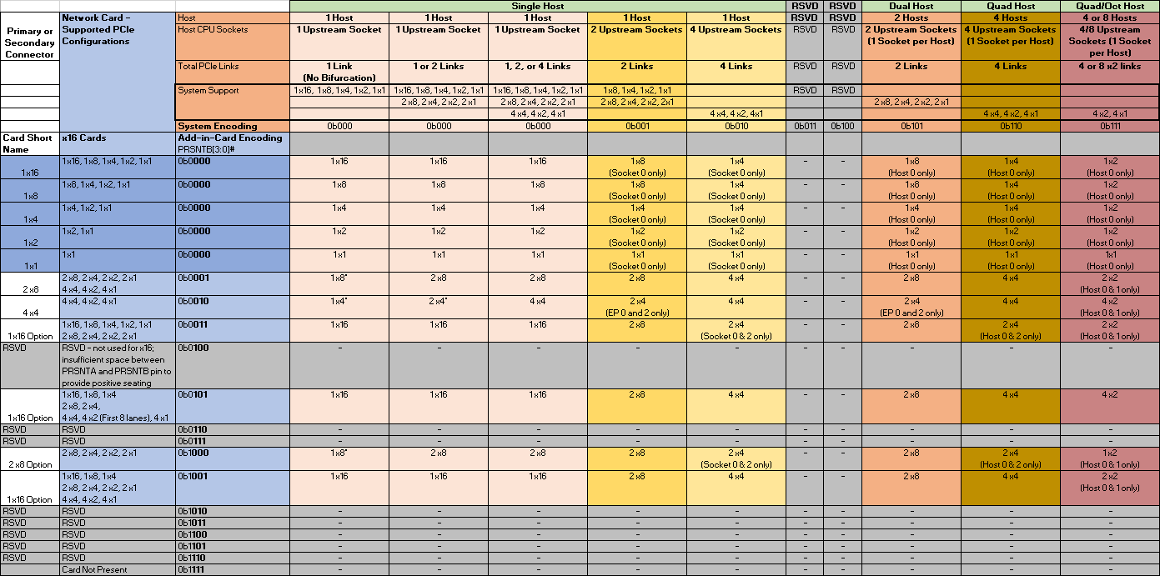

Table 19: PCIe Bifurcation Decoder for x8 Width Cards

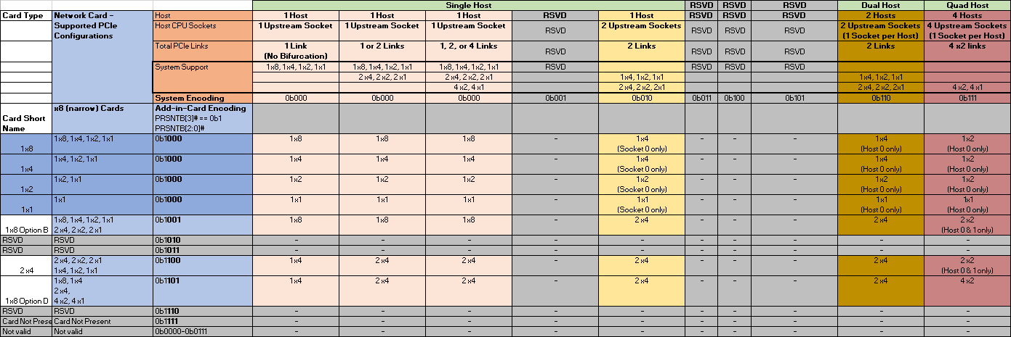

\***Note:** The baseboard must disable PCIe lanes during the initialization phase if the number of detected PCIe links are greater than what is supported to prevent a nondeterministic solution.

For example, if the baseboard only supports a 1 x16 connection, and the add-in card only supports a 2 x8 connection, the baseboard must disable PCIe lanes 8-15 to prevent any LTSSM issues.

### Bifurcation Detection Flow

**[Need input and clarification]**The following detection flow shall be followed to determine the resulting link width based on both the baseboard and add-in card configurations.

1. The baseboard reads the state of the PRSNTB[3:0]# pins. If the resulting value is not 0b1111, a card is present.
2. Firmware determines the add-in card PCIe lane width capabilities per Table 18 and Table 19.
3. The baseboard reconfigures the PCIe bifurcation on its ports to match the highest common lane width and lowest link count on the card.
4. For cases where the baseboard request a link count override (such as requesting a 4-host baseboard requesting 4 x4 operation on a supported card that would otherwise default to a 2 x8 case), the BIF[0:2]# pins would be asserted as appropriate.
5. PERST# is deasserted after the 100ms window as defined by the PCIe specification.

### PCIe Bifurcation Examples

For illustrative purposes, the following figures show several common bifurcation permutations.

Figure 25 illustrates a single host baseboard that supports x16 with a single controller add-in card that also supports x16 (Type 6). The PRSTNB[3:0]# state is 0b1001. The BIF[2:0]# state is 0b111 as there is no need to instruct the end-point network controller to a specific bifurcation. The PRSNTB encoding notifies the baseboard that this card is only capable of 1 x16. The single host baseboard determines that it is also capable of supporting 1 x16. The resulting link width is 1 x16.

Figure 25: Single Host (1 x16) and Type 6 Add-in Card (Single Controller, 1 x16 only)



Figure 26 illustrates a single host baseboard that supports 2 x8 with a single controller add-in card that also supports 2 x8 (Type 2). The PRSTNB[3:0]# state is 0b1101. The BIF[2:0]# state is 0b111 as there is no need to instruct the end-point network controllers to a specific bifurcation. The PRSNTB encoding notifies the baseboard that this card is only capable of 2 x8. The single host baseboard determines that it is also capable of supporting 2 x8. The resulting link width is 2 x8.

Figure 26: Single Host (2 x8) and Type 2 Add-in Card (Dual Controllers, 2 x8 only)



Figure 27 illustrates a four host baseboard that supports 4 x4 with a single controller add-in card that supports 1 x16, 2 x8 and 4 x4 (Type 4). The PRSTNB[3:0]# state is 0b1011. The BIF[2:0]# state is 0b101 as the end point network controller is forced to bifurcate to 4 x4. The PRSNTB encoding notifies the baseboard that this card is only capable of 1 x16, 2 x8 and 4 x4. The four host baseboard determines that it is also capable of supporting 4 x4. The resulting link width is 4 x4.

Figure 27: Four Hosts (4 x4) and Type 4 Add-in Card (Single Controller, 4 x4)



Figure 28 illustrates a four host baseboard that supports 4 x4 with a four controller add-in card that supports 4 x4 (Type 3). The PRSTNB[3:0]# state is 0b1100. The BIF[2:0]# state is 0b111 as there is no need to instruct the end-point network controllers to a specific bifurcation. The PRSNTB encoding notifies the baseboard that this card is only capable of 4 x4. The four host baseboard determines that it is also capable of supporting 4 x4. The resulting link width is 4 x4.

Figure 28: Four Hosts (4 x4) and Type 3 Add-in Card (Four Controllers, 4 x4)



Figure 29: Single Host with no Bifurcation (1 x16) and Type XXX Add-in Card (Two Controllers, 2 x8)

TBD

## PCIe Clocking Topology

The OCP NIC 3.0 specification allows for up to four PCIe REFCLKs. In general, the association of each REFCLK is based on the PCIe Link number in Table 20.

Table 20: PCIe Clock Associations

|  |  |  |
| --- | --- | --- |
| **REFCLK #** | **Description** | **Availability (Connector)** |
| REFCLK0 | REFCLK associated with Link 0. | Primary and Secondary Connectors. |
| REFCLK1 | REFCLK associated with Link 1. | Primary and Secondary Connectors. |
| REFCLK2 | REFCLK associated with Link 2. | Primary Connector only. |
| REFCLK3 | REFCLK associated with Link 3. | Primary Connector only. |

As noted in the Pin Definition (Section 4.3), cards that only implement the Primary Connector have up to four PCIe REFCLKS (0-3). Cards that implement only the Secondary Connector have up to two PCIe REFCLKS (0, 1). Cards that implement both the Primary and Secondary connectors have a total of up to 6 REFCLKs.

For each add-in card, the following REFCLK connection rules must be followed:

* For a 1 x16 capable add-in card, REFCLK0 is used for the PCIe end-point.
* For a 2 x8 capable add-in card, REFCLK0 is used for lanes [0:7] and REFCLK1 is used for lanes [8:15].
* For a 4 x4 capable add-in card, REFCLK0 is used for lanes [0:3], REFCLK1 is used for lanes [4:7], REFCLK2 is used for lanes [8:11] and REFCLK3 is used for lanes [12:15]. Pins for REFCLK2 and REFCLK3 are described in Section 4.5.1 and are located on the 28-pin OCP bay.

Figure 19: PCIe Interface Connections for 1 x16 and 2 x8 Add-in Cards



Figure 20: PCIe Interface Connections for a 4 x4 Add-in Card



## PCIe Link Bifurcation to REFCLK Mapping

<insert the x16 and x8 PCIe link to REFCLK tables here>

## Power Capacity and Power Delivery

There are four permissible power states: AC Power Off, Management (FRU Only Mode), Aux Power Mode (S5), and Main Power Mode (S0). The transition of these states is shown in Figure 30. The main/aux power domains are switched on the baseboard and uses the power pins defined in Table 10. For each of these states, the max power envelopes are defined as follows:

Table 21: Power Envelopes

|  |  |  |
| --- | --- | --- |
| **Power State** | **Max Power** | **Notes** |
| AC Power Off | 0W | AC power removed; board off |
| Management (FRU only mode) | TBD | Used only for board identification purposes. |
| Aux Power Mode (S5) | 35W |  |
| Main Power Mode (S0) | 79.2W | Add-in card may use up to the 79.2W limit per connector. |

Figure 30: Baseboard Power Sequencing



### AC Power Off

In AC power off mode, all power delivery has been turned off or disconnected from the baseboard.

### Management (FRU Only Mode)

In the Management (FRU Only Mode), only +3.3V Aux is available for powering up management only functions. FRU accesses are only allowed in this mode.

### Aux Power Mode (S5)

In Aux Power Mode provides both +3.3V Aux as well as +12V Aux is available. +12V Aux may be used to deliver power to the add-in card, but only up to the Aux budget of 35W.

### Main Power Mode (S0)

In Main Power Mode provides both +3.3V and +12V (Main) across the OCP connector. The add-in card operates in full capacity. Up to 79.2W may be delivered on +12V, and 3.63W on the +3.3V pins.

## Power Sequence Timing Requirements

The following figure shows the power sequence of 3.3V/3.3V_AUX, 12VMain/Aux relative to PWRDIS, PERSTn* and NIC_PWR_GOOD.

Figure 31: Baseboard Power Sequencing



Table 21: Power Sequencing Parameters

|  |  |  |  |
| --- | --- | --- | --- |
| **Parameter Name** | **Value** | **Units** | **Description** |
|  |  |  |  |

# Management

## SMBus Interface

The SMBus provides manageability of the add-in card.

## NC-SI Sideband Interface

### NC-SI addressing and Arb#

## MAC Address Requirement

## FRU EEPROM

### Addressing(TBD)

## FW Requirement (TBD)

## Thermal Reporting Interface

# Data Network Requirement

## Network Booting (collect view from OEMs and hyperscale)

Mezzanine NIC shall support network booting in uEFI system environment. Mezzanine NIC shall support both IPv4 and IPv6 network booting.

# Routing Guidelines and Signal Integrity Considerations

## NC-SI Over RBT

Min Length: 2”

Max length: 4”

Impedance: 50 Ohm single ended

# Thermal and Environmental

## Environmental Requirements

The specific environment requirement is removed to allow the adoption of OCP Mezzanine NIC in systems with very different thermal requirement and boundary condition.

This Mezzanine card shall meet the same environmental requirements specified in the OCP systems that the Mezzanine card is in. The OCP system that uses OCP Mezzanine card shall define air flow direction, inlet air temperature, air flow (or speed) to the local area where Mezzanine card is at, and simulation boundary.

### Thermal Simulation Boundary Example

**Placeholder for Thermal Simulation Method. Using Facebook Intel® Motherboard V3.0 as example. Not covered by this update.**

## Shock & Vibration

This Mezzanine card shall meet the same shock & vibration requirements specified in updated Facebook OCP Intel® Motherboard V2.0 and V3.0 Design Specification.

## Regulation

This Mezzanine card shall meet CE, CB, FCC Class A, WEEE, ROHS requirements.

# Revision History

|  |  |  |  |
| --- | --- | --- | --- |
| Author | Description | Revision | Date |
|  |  |  |  |
|  |  |  |  |
|  |  |  |  |
|  |  |  |  |
|  |  |  |  |
|  |  |  |  |
|  |  |  |  |
|  |  |  |  |
|  |  |  |  |
|  |  |  |  |
|  |  |  |  |
|  |  |  |  |
|  |  |  |  |
|  |  |  |  |
|  |  |  |  |
|  |  |  |  |