

OCP NIC 3.0 Design Specification

**Version 0.01**

Author: OCP Server Workgroup, OCP NIC subgroup

Table of Contents

1 Overview 7

1.1 License 7

1.2 Background 8

1.3 Acknowledgements 9

1.4 Overview 9

1.4.1 Mechanical Form factor overview 9

1.4.2 Electrical overview 12

1.5 References 12

2 Card Form Factor 14

2.1 Overview 14

2.2 Form Factor Options 14

2.3 I/O bracket 16

2.4 Line Side I/O Implementations 16

2.5 LED Implementations 17

2.5.1 Baseboard LEDs Configuration Over the Scan Chain 17

2.5.2 Add-in Card LED Configuration 19

2.5.3 LED Ordering 20

2.6 Mechanical Keepout Zones 21

2.6.1 Baseboard Keep Out Zones 21

2.6.2 Add-in Card Keep Out Zones 21

2.7 Labeling Requirements 21

2.8 Insulation Requirements 21

2.9 NIC Implementation Examples 21

2.10 Non-NIC Use Cases 21

2.10.1 PCIe Retimer card 21

2.10.2 Accelerator card 21

2.10.3 Storage HBA / RAID card 21

3 Card Edge and Baseboard Connector Interface 22

3.1 Gold Finger Requirement 22

3.1.1 Gold Finger Mating Sequence 23

3.2 Baseboard Connector Requirement 26

3.3 Pin definition 27

3.4 Signal Descriptions – Common 33

3.4.1 PCIe Interface Pins 33

3.4.2 PCIe Present and Bifurcation Control Pins 37

3.4.3 SMBus Interface Pins 39

3.4.4 Power Supply Pins 40

3.4.5 Miscellaneous Pins 42

3.5 Signal Descriptions – OCP Bay (Primary Connector) 42

3.5.1 PCIe Interface Pins – OCP Bay (Primary Connector) 43

3.5.2 NC-SI Over RBT Interface Pins – OCP Bay (Primary Connector) 45

3.5.3 Scan Chain Pins – OCP Bay (Primary Connector) 51

3.5.4 Primary Connector Miscellaneous Pins – OCP Bay (Primary Connector) 61

3.6 PCIe Bifurcation Mechanism 62

3.6.1 PCIe Add-in Card to Baseboard Bifurcation Configuration (PRSNTA#, PRSNTB[3:0]#) 63

3.6.2 PCIe Baseboard to Add-in Card Bifurcation Configuration (BIF[2:0]#) 63

3.6.3 PCIe Bifurcation Decoder 64

3.6.4 Bifurcation Detection Flow 66

3.6.5 PCIe Bifurcation Examples 67

3.7 PCIe Clocking Topology 73

3.8 PCIe Bifurcation Results and REFCLK Mapping 75

3.9 Power Capacity and Power Delivery 84

3.9.1 AC Power Off 85

3.9.2 ID Mode 85

3.9.3 Aux Power Mode (S5) 85

3.9.4 Main Power Mode (S0) 85

3.10 Power Supply Rail Requirements 85

3.11 Hot Swap Considerations for 12V and 3.3V Rails 86

3.12 Power Sequence Timing Requirements 87

4 Management 89

4.1 SMBus Interface 89

4.2 NC-SI Sideband Interface 89

4.2.1 NC-SI addressing and Arb# 89

4.3 MAC Address Requirement 89

4.4 FRU EEPROM 89

4.4.1 Minimum EEPROM Size 89

4.4.2 EEPROM Map Definition 89

4.4.3 EEPROM Address 90

4.5 FW Requirement (TBD) 90

4.6 Thermal Reporting Interface 90

5 Data Network Requirement 91

5.1 Network Booting (collect view from OEMs and hyperscale) 91

6 Routing Guidelines and Signal Integrity Considerations 92

6.1 NC-SI Over RBT 92

7 Thermal and Environmental 92

7.1 Environmental Requirements 92

7.1.1 Thermal Simulation Boundary Example 92

7.2 Shock & Vibration 92

7.3 Regulation 92

8 Revision History 93

List of Figures

Figure 1: Representative Small OCP NIC 3.0 Card with Quad SFP Ports 8

Figure 2: Representative Large OCP NIC 3.0 Card with Dual QSFP Ports and on-board DRAM 9

Figure 3: Small and Large Card Form-Factors (not to scale) 10

Figure 4: Example Small Card Form Factor 14

Figure 5: Example Large Card Form Factor 15

Figure 6: Primary Connector (4C + OCP Bay) with 4C and 2C Add-in Cards 16

Figure 7: LED Ordering – Example Small Card Link/Activity and Speed LED Placement 20

Figure 8: Small Size Primary Connector Gold Finger Mating Card Dimensions – x16 – Top Side 22

Figure 9: Small Size Primary Connector Gold Finger Mating Card Dimensions – x16 – Bottom Side 23

Figure 10: Large Size Card Gold Finger Mating Card Dimensions – x32 – Top Side 23

Figure 11: Large Size Card Gold Finger Mating Card Dimensions – x32 – Bottom Side 23

Figure 12: 168-pin Base Board Primary Connector – Right Angle 26

Figure 13: 140-pin Base Board Secondary Connector – Right Angle 26

Figure 14: 168-pin Base Board Primary Connector – Straddle Mount 26

Figure 15: 140-pin Base Board Secondary Connector – Straddle Mount 26

Figure 16: Primary and Secondary Connector Locations for Large Card Support 26

Figure 17: PCIe Present and Bifurcation Control Pins 38

Figure 18: Example Power Supply Topology 41

Figure 19: NC-SI Over RBT Connection Example 50

Figure 20: Scan Bus Connection Example 58

Figure 21: PCIe Bifurcation Pin Connections Support 63

Figure 22: Single Host (1 x16) and 1 x16 Add-in Card (Single Controller) 67

Figure 23: Single Host (2 x8) and 2 x8 Add-in Card (Dual Controllers) 68

Figure 24: Four Hosts (4 x4) and 4 x4 Add-in Card (Single Controller) 69

Figure 25: Four Hosts (4 x4) and 4 x4 Add-in Card (Four Controllers) 70

Figure 26: Single Host with no Bifurcation (1 x16) and 2 x8 Add-in Card (Two Controllers) 72

Figure 27: PCIe Interface Connections for 1 x16 and 2 x8 Add-in Cards 73

Figure 28: PCIe Interface Connections for a 4 x4 Add-in Card 74

Figure 29: Baseboard Power States 84

Figure 30: Power Sequencing 87

List of Tables

Table 1: OCP 3.0 Form Factor Dimensions 10

Table 2: Baseboard to OCP NIC Form factor Compatibility Chart 11

Table 3: OCP NIC 3.0 Card Definitions 16

Table 4: OCP 3.0 Line Side I/O Implementations 17

Table 5: Baseboard LED Configurations with Two Physical LEDs per Port 18

Table 6: Add-in Card LED Configuration with Two Physical LEDs per Port 19

Table 7: Contact Mating Positions for the Primary and Secondary Connectors 24

Table 8: Primary Connector Pin Definition (x16) (4C + OCP Bay) 27

Table 9: Secondary Connector Pin Definition (x16) (4C) 31

Table 10: Pin Descriptions – PCIe 1 33

Table 11: Pin Descriptions – PCIe Present and Bifurcation Control Pins 37

Table 12: Pin Descriptions – SMBus 39

Table 13: Pin Descriptions – Power 40

Table 14: Pin Descriptions – Miscellaneous 1 42

Table 15: Pin Descriptions – PCIe 2 43

Table 16: Pin Descriptions – NC-SI Over RBT 45

Table 17: Pin Descriptions – Scan Chain 51

Table 18: Pin Descriptions – Scan Chain DATA_OUT Bit Definition 54

Table 19: Pin Descriptions – Scan Bus DATA_IN Bit Definition 54

Table 20: Pin Descriptions – Miscellaneous 2 61

Table 21: PCIe Bifurcation Decoder for x16 and x8 Card Widths 65

Table 22: PCIe Clock Associations 73

Table 23: Bifurcation for Single Host, Single Socket and Single Upstream Link (BIF[2:0]#=0b000) 76

Table 24: Bifurcation for Single Host, Single Socket and Single/Dual Upstream Links (BIF[2:0]#=0b000) 77

Table 25: Bifurcation for Single Host, Single Socket and Single/Dual/Quad Upstream Links (BIF[2:0]#=0b000) 78

Table 26: Bifurcation for Single Host, Dual Sockets and Dual Upstream Links (BIF[2:0]#=0b001) 79

Table 27: Bifurcation for Single Host, Four Sockets and Dual Upstream Links (BIF[2:0]#=0b010) 80

Table 28: Bifurcation for Dual Host, Dual Sockets and Dual Upstream Links (BIF[2:0]#=0b101) 81

Table 29: Bifurcation for Quad Host, Quad Sockets and Quad Upstream Links (BIF[2:0]#=0b110) 82

Table 30: Bifurcation for Quad Host, Quad Sockets and Quad Upstream Links (BIF[2:0]#=0b110) 83

Table 31: Power States 84

Table 32: Baseboard Power Supply Rail Requirements 85

Table 33: Power Sequencing Parameters 88

# Overview

## License

As of April 7, 2011, the following persons or entities have made this Specification available under the Open Web Foundation Final Specification Agreement (OWFa 1.0), which is available at <http://www.openwebfoundation.org/legal/the-owf-1-0-agreements/owfa-1-0>:

Facebook, Inc.

You can review the signed copies of the Open Web Foundation Agreement Version 1.0 for this Specification at http://opencompute.org/licensing/, which may also include additional parties to those listed above.

Your use of this Specification may be subject to other third party rights. THIS SPECIFICATION IS PROVIDED "AS IS." The contributors expressly disclaim any warranties (express, implied, or otherwise), including implied warranties of merchantability, non-infringement, fitness for a particular purpose, or title, related to the Specification. The entire risk as to implementing or otherwise using the Specification is assumed by the Specification implementer and user. IN NO EVENT WILL ANY PARTY BE LIABLE TO ANY OTHER PARTY FOR LOST PROFITS OR ANY FORM OF INDIRECT, SPECIAL, INCIDENTAL, OR CONSEQUENTIAL DAMAGES OF ANY CHARACTER FROM ANY CAUSES OF ACTION OF ANY KIND WITH RESPECT TO THIS SPECIFICATION OR ITS GOVERNING AGREEMENT, WHETHER BASED ON BREACH OF CONTRACT, TORT (INCLUDING NEGLIGENCE), OR OTHERWISE, AND WHETHER OR NOT THE OTHER PARTY HAS BEEN ADVISED OF THE POSSIBILITY OF SUCH DAMAGE.

## Background

The OCP NIC 3.0 specification is a follow-on to the OCP 2.0 form-factor for PCIe add-in cards. The OCP NIC 3.0 specification supports two basic card sizes: Small Card, and Large Card. The Small Card allows for up to 16 PCIe lanes on the card edge while a Large Card supports up to 32 PCIe. Compared to the OCP NIC 2.0 release, the updated specification provides a broader solution space for NIC and system vendors to support the following use case scenarios:

* NICs with a higher TDP
* Support up to 79W of power delivery to a single connector (Small) card; and 158W to a dual connector (Large) card
* PCIe Gen4 and Gen5 on the system and add-in card
* Support for upto 32 lanes of PCIe per add-in card
* Support for single host and multi-host environments
* Support a greater board area for more complex add-in card designs
* Support for Smart NIC implementations with on-board DRAM
* Simplification of FRU installation and removal while reducing overall down time

A representative Small Card OCP 3.0 NIC mezzanine card is shown in Figure 1 and a representative Large Card is shown in Figure 2.

Figure 1: Representative Small OCP NIC 3.0 Card with Quad SFP Ports

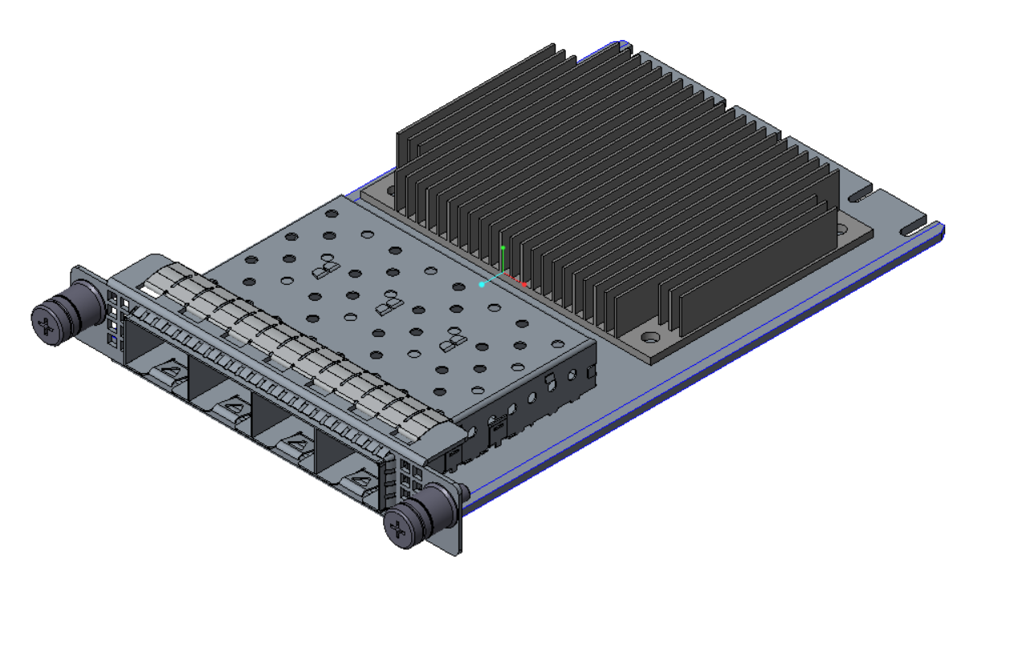

Figure 2: Representative Large OCP NIC 3.0 Card with Dual QSFP Ports and on-board DRAM

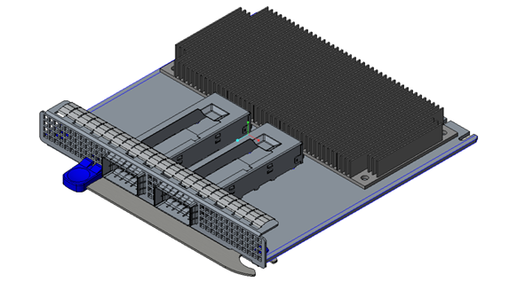

In order to achieve the features outlined in this specification, OCP 3.0 compliant cards are not backwards compatible to the 2.0 cards.

This specification is created under OCP Server workgroup – OCP NIC subgroup. An electronic copy of this specification can be found on the Open Compute Project website:

<http://www.opencompute.org/wiki/Server/Mezz#Specifications_and_Designs>

## Acknowledgements

Placeholder

## Overview

### Mechanical Form factor overview

The OCP NIC 3.0 specification defines a third generation mechanical form factor that allows for interoperability between compliant baseboards and add-in cards.

OCP NIC 3.0 cards have two form factors – Small and Large. These cards are shown in Figure 3 below. The components shown in the figures are for illustrative purposes. The Small form factor card has one connector (Primary connector) on baseboard. The Large form factor card has two connectors (Primary Connector and Secondary Connector) on the baseboard. Both the Primary and Secondary connectors are defined in and compliant to SFF-TA-1002. [Editor’s note: plan to submit change back to SFF-TA-1002]. On the NIC side, the card edge is implemented with gold fingers. The gold finger design follows SFF-TA-1002 as well.

Figure 3: Small and Large Card Form-Factors (not to scale)



The two form factor dimensions are shown in Table 1.

Table 1: OCP 3.0 Form Factor Dimensions

|  |  |  |  |  |  |
| --- | --- | --- | --- | --- | --- |
| **Form Factor** | **Width** | **Depth** | **Primary Connector** | **Secondary Connector** | **Typical Use Case** |
| Small | W1 = 76 mm | L = 115 mm | 4C + OCP sideband 168 pins | N/A | Low profile and general NIC with a similar profile as an OCP NIC 2.0 add-in card; up to x16 PCIe. |
| Large | W2 = 139 mm | L = 115 mm | 4C + OCP sideband  168 pins | 4C  140 pins | Larger PCB width to support feature rich NICs; up to x32 PCIe. |

The OCP NIC 3.0 design allows downward compatibility between the two card sizes. Table 2 shows the compatibility between the baseboard and NIC combinations. A small size baseboard slot may only accept a small sized NIC. A Large size baseboard slot may accept a small or large sized NIC.

Table 2: Baseboard to OCP NIC Form factor Compatibility Chart

|  |  |  |
| --- | --- | --- |
| **Baseboard Slot Size** | **NIC Size / Supported PCIe Width** | |
| Small | Large |
| Small | Up to x16 | Not Supported |
| Large | Up to x16 | Up to x32 |

There are two baseboard connector options available for system designers: straddle mount and right angle (RA). The straddle mount connector option allows the OCP NIC and baseboard to exist in a co-planer position. To achieve this, a cutout exists on the baseboard and is defined in this specification. Alternatively, the right angle option allows the OCP NIC to be installed on top of the baseboard. A baseboard cutout is not required for the right angle connector. The right angle option allows the baseboard to use this area for additional routing or backside component placement. The straddle mount and right angle connectors are shown in Section 3.2.

For both the baseboard and OCP card, this specification defines the component and routing keep out areas. Refer to Section 2.6 for details.

Both the straddle mount and right angle implementations shall accept the same OCP add-in card and shall be supported in the baseboard chassis regardless of the baseboard connector selection (right angle or straddle mount) so long as the baseboard slot side and add-in card sizes are a supported combination as shown in Table 2.

This specification defines the form factor at the add-in card level, including the front panel, latching mechanism and card guide features [TBD; pending on the Mechanical work across stakeholders].

More details about the card form-factor is shown in Section 2.

### Electrical overview

This specification defines the electrical interface between baseboard and the add-in card.

The electrical interface is implemented with a right angle or straddle mount connector on baseboard and gold finger on the add-in card. As previously noted in the mechanical overview, each card may implement a Primary Connector or Primary + Secondary Connector. Cards using only the Primary connector are suitable for both the Small and Large form-factors and may support up to x16 lanes of PCIe. The Secondary connector, when used in conjunction with the Primary connector, allows Large form-factor implementations and may support up to 32 lanes of PCIe.

#### Primary Connector

#### Secondary connector

## References

* DMTF Standard. *DSP0222, Network Controller Sideband Interface (NC-SI) Specification.* Distributed Management Task Force, Inc, Rev 1.0.1, January 24th, 2013.
* EDSFF. *Enterprise and Datacenter SSD Form Factor Connector Specification*. Enterprise and Datacenter SSD Form Factor Working Group, Rev 0.9 (draft), August 2nd 2017.
* NXP Semiconductors. *I2C-bus specification and user manual.* NXP Semiconductors, Rev 6, April 4th, 2014.
* Open Compute Project. *OCP NIC Subgroup*. Online. <http://www.opencompute.org/wiki/Server/Mezz>
* PCIe Base Specification. *PCI Express Base Specification, Revision 4.0 (draft)*.
* PCIe CEM Specification. *PCI Express Card Electromechanical Specification, Revision 4.0 (draft)*.
* SMBus Management Interface Forum. *System Management Bus (SMBus) Specification*. System Management Interface Forum, Inc, Version 3.0, December 20th, 2014.
* SNIA. *SFF-TA-1002, Specification for Protocol Agnostic Multi-Lane High Speed Connector*. SNIA SFF TWG Technology Affiliate, Rev 0.0.9.1, September 9th, 2017.

# Card Form Factor

## Overview

## Form Factor Options

OCP3.0 provides two fundamental form factor options: a small card (76mm x 115mm) and a large card (139mm x 115mm).

These form factors support a Primary Connector and optionally, a Secondary Connector. The Primary Connector is defined to be a SFF-TA-1002 compliant 4C connector plus a 28-pin bay for OCP 3.0 specific pins. The Secondary Connector is the 4C connector as defined in SFF-TA-1002. The 4C specification supports up to 32 differential pairs for a x16 PCIe connection per connector. For host platforms, the 28-pin OCP bay is required for the Primary connector. This is also mandatory for add-in cards.

The small card uses the 4C connector for up to a x16 PCIe interface. The small cards implement and additional 28-pin OCP bay for management functions and support for up to a four PCIe hosts. The small size card provides sufficient faceplate area to accommodate up to 2x QSFP modules, 4x SFP modules, or 4x RJ-45 for BASE-T operation. The small card form factor supports up to 79W of delivered power to the card edge.

Figure 4: Example Small Card Form Factor

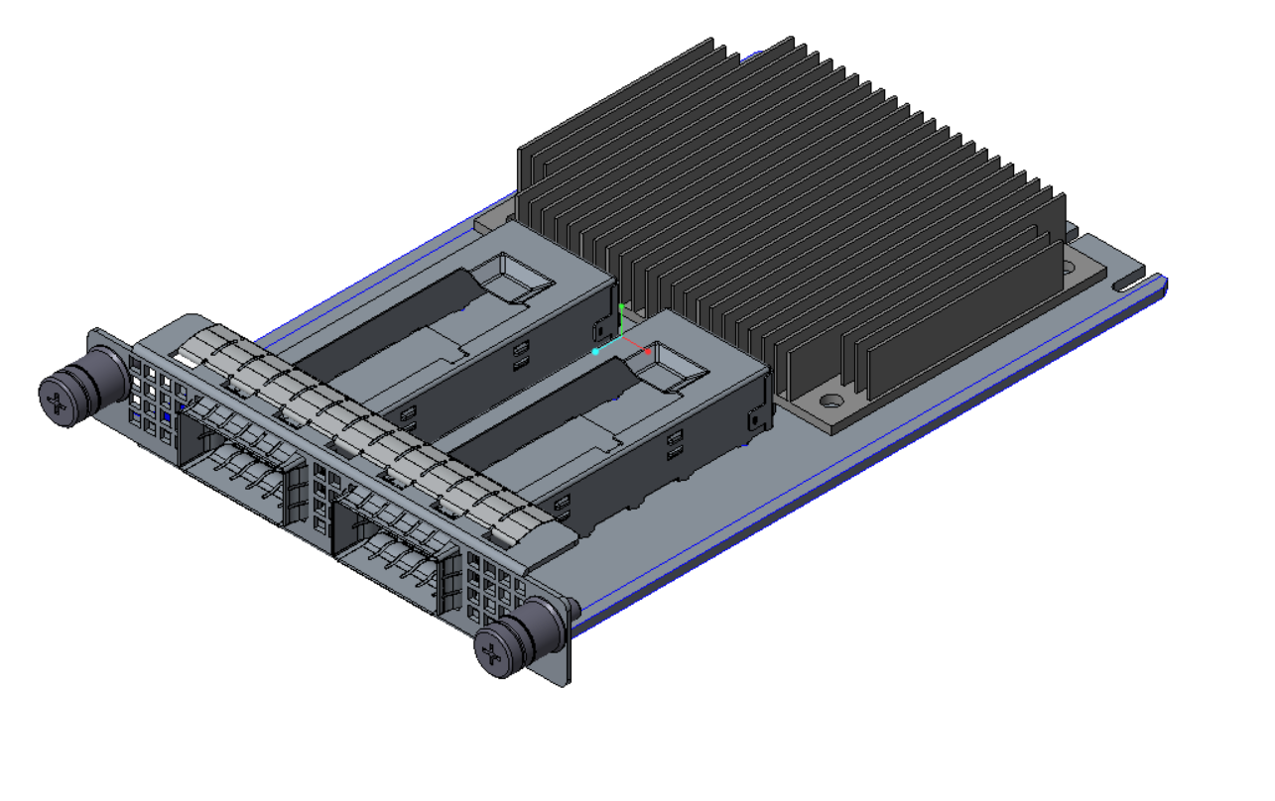

The large card uses provides the same functionality as the small card, but with support up to a x32 PCIe interface. The large card utilizes both the Primary and Secondary connectors. The large size card supports higher power envelopes and provides additional board area for more complex designs. The small card form factor supports up to 158W of delivered power to the card edge at 79W per connector.

Figure 5: Example Large Card Form Factor

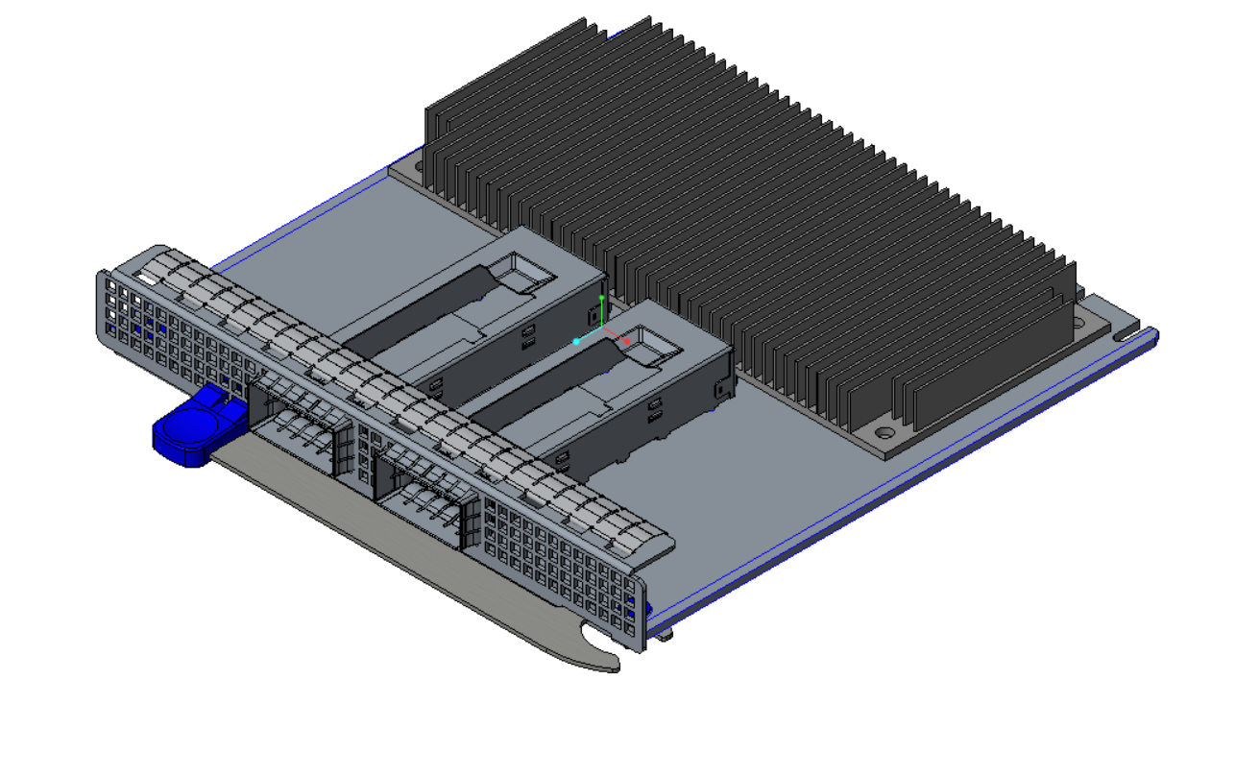

For both form-factors, an add-in card may optionally implement a subset of pins to support a x8 PCIe connection. This is implemented using a 2C card edge per SFF-TA-1002. The Primary Connector may support a 2C sized add-in card along with the 28 pin OCP bay. The following diagram from the SFF-TA-1002 specification illustrates the supported host Primary and Secondary Connectors and add-in card configurations.

Figure 6: Primary Connector (4C + OCP Bay) with 4C and 2C Add-in Cards

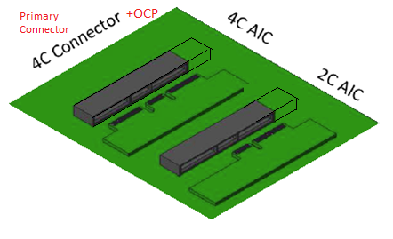

Table 3 summarizes the supported card form factors. Small form factors cards support the Primary Connector and up to 16 PCIe lanes. Large form factor cards support both the Primary and Secondary Connectors and up to 32 PCIe lanes.

Table 3: OCP NIC 3.0 Card Definitions

|  |  |  |  |  |  |
| --- | --- | --- | --- | --- | --- |
| **Add in Card Size and max PCIe Lane Count** | **Secondary Connector** | | **Primary Connector** | | |
| 4C Connector, x16 PCIe | | 4C Connector, x16 PCIe | | OCP Bay |
| Small (x8) |  |  |  | 2C | OCP Bay |
| Small (x16) |  |  | 4C | | OCP Bay |
| Large (x24) |  | 2C | 4C | | OCP Bay |
| Large (x32) | 4C | | 4C | | OCP Bay |

## I/O bracket

TBD <need input from OCP mechanical groups>

## Line Side I/O Implementations

At the time of this writing, the Small and Large form-factor cards may support the following standard line side I/O implementations:

Table 4: OCP 3.0 Line Side I/O Implementations

|  |  |
| --- | --- |
| **Form Factor** | **Max Topology Connector Count** |
| Small | 2x QSFP28 |
| Small | 4x SFP28 |
| Small | 4x RJ-45 |
| Large | TBD |
| Large | TBD |
| Large | TBD |

Additional combinations are permissible as I/O form-factor technologies and thermal capabilities evolve.

## LED Implementations

LEDs must be implemented on the card Scan Chain (as defined in Section 3.5.3) for remote link/activity indication on the baseboard and may optionally be implemented on the OCP NIC 3.0 I/O bracket if there is sufficient space for local indication. These two cases are described below. In both cases, the actual link rate may be directly queried through the management interface.

### Baseboard LEDs Configuration Over the Scan Chain

A small form-factor OCP NIC 3.0 with a fully populated I/O bracket (2x QSFP28, 4x SFP28, or 4x RJ-45) has insufficient space for discrete on-board (faceplate) LED indicators. In this case, the line side link and activity LED indicators are implemented on the baseboard system via the Scan Chain. The Scan Chain bit stream is defined in Section 3.5.3. This LED implementation is required for all add-in cards. The baseboard LED implementation uses two discrete LEDs (Link/Activity and Speed indication). Table 5 describes the baseboard LED configuration for baseboard implementations.

Table 5: Baseboard LED Configurations with Two Physical LEDs per Port

|  |  |  |
| --- | --- | --- |
| **LED Pin** | **LED Color** | **Description** |
| Link / Activity | Green | Active low. Multifunction LED.  When lit and solid, this LED is used to indicate the link is up at the MAC level. Local and Remote Faults are clear and the link is ready for data transmission.  When the LED is off, the physical link is down or disabled.  The LED should blink low for 50-500 ms during Packet Activity.  The Link/Activity LED shall be located on the left hand side for each port. |
|  |
| Speed | Green | Active low. Multifunction LED.  The LED is Green when the port is linked at its maximum speed.  The LED is off when the device is linked at a speed lower than the highest capable speed, or no link is present.  The bicolor speed LED shall be located on the right hand side for each port. |
| Off |
|  |

At the time of this writing, the Scan Chain definition allows for up to one link/activity and one speed LED per port. A total of up to 8 ports are supported in the Scan Chain. The bit stream defines the LEDs to be active low (ON). The Scan Chain LED implementation allows the NIC LED indicators to be remotely located on the OCP 3.0 compliant chassis (e.g. front LED indicators with rear I/O cards).

### Add-in Card LED Configuration

For low I/O count small form-factor cards without built in light pipes (such as 1x QSFP28, 2x SFP28), or a large form-factor OCP 3.0 NIC, where additional I/O bracket area is available, the card may optionally implement on-board link/activity indications in addition to the Scan Chain LED stream. The recommended local (on-card) LED implementation uses two physical LEDs (a discrete Link/Activity LED and a bi-colored Speed A/Speed B LED). Table 6 describes the add-in card LED implementations.

Table 6: Add-in Card LED Configuration with Two Physical LEDs per Port

|  |  |  |
| --- | --- | --- |
| **LED Pin** | **LED Color** | **Description** |
| Link / Activity | Green | Active low. Multifunction LED.  When lit and solid, this LED is used to indicate the link is up at the MAC level. Local and Remote Faults are clear and the link is ready for data transmission.  When the LED is off, the physical link is down or disabled.  The LED should blink low for 50-500 ms during Packet Activity.  The Link/Activity LED shall be located on the left hand side for each port. |
|  |
| Speed | Green | Active low. Bicolor multifunction LED.  The LED is Green when the port is linked at its maximum speed.  The LED is Amber when the port is linked at it second highest speed.  The LED is off when the device is linked at a speed lower than the second highest capable speed, or no link is present.  The Amber Speed LED indicator may be used for port identification through vendor specific link diagnostic software.  The bicolor speed LED shall be located on the right hand side for each port. |
| Amber |
| Off |
|  |

### LED Ordering

For all LED use cases, the green Link/Activity LED shall be located on the left side for each port. The bicolor green/amber speed A/B LED shall be located on the right side for each port. (Note Speed B is only available for local (on-card) LEDs. The placement of the LEDs may be to the side of the physical port for the case with add-in cards. The LED port association shall be clearly labeled on the add-in card and on the baseboard.

Figure 7: LED Ordering – Example Small Card Link/Activity and Speed LED Placement



## Mechanical Keepout Zones

### Baseboard Keep Out Zones

TBD – Need keepout drawings and envelopes for small / large size baseboard including primary/secondary/rail keepouts/cutout for straddle mount/keepout for right angle.

### Add-in Card Keep Out Zones

TBD – need keepout drawings and envelopes for small / large size NIC including primary/secondary/rail keepouts.

## Labeling Requirements

TBD

## Insulation Requirements

All cards must implement a secondary side insulator to prevent the bottom side card components from shorting out to the chassis. The recommended insulator thickness is 0.25mm and must reside within the following mechanical envelope for the Small and Large size cards:

TBD <need 2D drawings>

## NIC Implementation Examples

TBD

## Non-NIC Use Cases

“PCIe interface with extra management sideband”

### PCIe Retimer card

### Accelerator card

### Storage HBA / RAID card

# Card Edge and Baseboard Connector Interface

## Gold Finger Requirement

The OCP NIC 3.0 add-in cards are compliant to the SFF-TA-1002 specification with respect to the gold fingers and connectors.

Small Size cards fit in the Primary Connector. Primary Connector compliant cards are 76mm x 115mm and may implement the full 168-pins. The Primary Connector cards may optionally implement a subset of gold finger pins if there is a reduced PCIe width requirement (such as 1 x8 and below). In this case, the card edge gold finger may implement a 2C design. The overall board thickness is 1.60mm. The gold finger dimensions for the Primary Connector compliant cards are shown below.

Large Size Cards support up to a x32 PCIe implementation and uses both the Primary and Secondary connectors.

For additional details, refer to the card and connector mechanical drawings located in XXX.

Note: The “B” pins on the connector are associated with the top side of the add-in card. The “A” pins on the connector are associated with the bottom side of the add-in card.

Figure 8: Small Size Primary Connector Gold Finger Mating Card Dimensions – x16 – Top Side

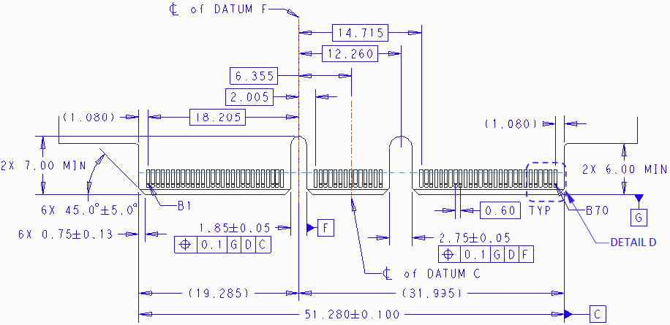

Figure 9: Small Size Primary Connector Gold Finger Mating Card Dimensions – x16 – Bottom Side

TBD

Figure 10: Large Size Card Gold Finger Mating Card Dimensions – x32 – Top Side

TBD

Figure 11: Large Size Card Gold Finger Mating Card Dimensions – x32 – Bottom Side

TBD

### Gold Finger Mating Sequence

Per the SFF-TA-1002 specification, the Primary and Secondary connectors are protocol agnostic and are optimized for high speed differential pairs. For use in the OCP NIC 3.0 application, some pin locations are used for single ended control nets or power and would benefit from a shorter pin length for staggering. As such, the recommended add-in card gold finger staging is shown in Table 7 for a two stage, first-mate, last-break functionality. The host connectors have a single stage mating and do not implement different pin lengths.

The AIC Plug (Free) side refers to the add-in card gold fingers; the receptacle (Fixed) side refers to the physical connector on the host platform. This table is based on the SFF-TA-1002 Table A-1 with modifications for OCP NIC 3.0. Refer to the mechanical drawings for pin the first-mate and second-mate lengths.

Table 7: Contact Mating Positions for the Primary and Secondary Connectors

|  |  |  |  |  |  |  |  |  |  |  |  |  |
| --- | --- | --- | --- | --- | --- | --- | --- | --- | --- | --- | --- | --- |
| **Side B** | | | | | |  | **Side A** | | | | | |
|  | **AIC Plug (Free)** | |  | **Receptacle (Fixed)** | |  |  | **AIC Plug (Free)** | |  | **Receptacle (Fixed)** | |
|  | 2nd Mate | 1st Mate |  |  |  |  |  | 2nd Mate | 1st Mate |  |  |  |
| OCP B1 |  |  |  |  | |  | OCP A1 |  |  |  |  | |
| OCP B2 |  |  |  |  | OCP A2 |  |  |  |
| OCP B3 |  |  |  |  | OCP A3 |  |  |  |
| OCP B4 |  |  |  |  | OCP A4 |  |  |  |
| OCP B5 |  |  |  |  | OCP A5 |  |  |  |
| OCP B6 |  |  |  |  | OCP A6 |  |  |  |
| OCP B7 |  |  |  |  | OCP A7 |  |  |  |
| OCP B8 |  |  |  |  | OCP A8 |  |  |  |
| OCP B9 |  |  |  |  | OCP A9 |  |  |  |
| OCP B10 |  |  |  |  | OCP A10 |  |  |  |
| OCP B11 |  |  |  |  | OCP A11 |  |  |  |
| OCP B12 |  |  |  |  | OCP A12 |  |  |  |
| OCP B13 |  |  |  |  | OCP A13 |  |  |  |
| OCP B14 |  |  |  |  | OCP A14 |  |  |  |
| **Mechanical Key** | | | | | | | | | | | | |
| B1 |  |  |  |  | |  | A1 |  |  |  |  | |
| B2 |  |  |  |  | A2 |  |  |  |
| B3 |  |  |  |  | A3 |  |  |  |
| B4 |  |  |  |  | A4 |  |  |  |
| B5 |  |  |  |  | A5 |  |  |  |
| B6 |  |  |  |  | A6 |  |  |  |
| B7 |  |  |  |  | A7 |  |  |  |
| B8 |  |  |  |  | A8 |  |  |  |
| B9 |  |  |  |  | A9 |  |  |  |
| B10 |  |  |  |  | A10 |  |  |  |
| B11 |  |  |  |  | A11 |  |  |  |
| B12 |  |  |  |  | A12 |  |  |  |
| B13 |  |  |  |  | A13 |  |  |  |
| B14 |  |  |  |  | A14 |  |  |  |
| B15 |  |  |  |  | A15 |  |  |  |
| B16 |  |  |  |  | A16 |  |  |  |
| B17 |  |  |  |  | A17 |  |  |  |
| B18 |  |  |  |  | A18 |  |  |  |
| B19 |  |  |  |  | A19 |  |  |  |
| B20 |  |  |  |  | A20 |  |  |  |
| B21 |  |  |  |  | A21 |  |  |  |
| B22 |  |  |  |  | A22 |  |  |  |
| B23 |  |  |  |  | A23 |  |  |  |
| B24 |  |  |  |  | A24 |  |  |  |
| B25 |  |  |  |  | A25 |  |  |  |
| B26 |  |  |  |  | A26 |  |  |  |
| B27 |  |  |  |  | A27 |  |  |  |
| B28 |  |  |  |  | A28 |  |  |  |
| **Mechanical Key** | | | | | | | | | | | | |
| B29 |  |  |  |  | |  | A29 |  |  |  |  | |
| B30 |  |  |  |  | A30 |  |  |  |
| B31 |  |  |  |  | A31 |  |  |  |
| B32 |  |  |  |  | A32 |  |  |  |
| B33 |  |  |  |  | A33 |  |  |  |
| B34 |  |  |  |  | A34 |  |  |  |
| B35 |  |  |  |  | A35 |  |  |  |
| B36 |  |  |  |  | A36 |  |  |  |
| B37 |  |  |  |  | A37 |  |  |  |
| B38 |  |  |  |  | A38 |  |  |  |
| B39 |  |  |  |  | A39 |  |  |  |
| B40 |  |  |  |  | A40 |  |  |  |
| B41 |  |  |  |  | A41 |  |  |  |
| B42 |  |  |  |  | A42 |  |  |  |
| **Mechanical Key** | | | | | | | | | | | | |
| B43 |  |  |  |  | |  | A43 |  |  |  |  | |
| B44 |  |  |  |  | A44 |  |  |  |
| B45 |  |  |  |  | A45 |  |  |  |
| B46 |  |  |  |  | A46 |  |  |  |
| B47 |  |  |  |  | A47 |  |  |  |
| B48 |  |  |  |  | A48 |  |  |  |
| B49 |  |  |  |  | A49 |  |  |  |
| B50 |  |  |  |  | A50 |  |  |  |
| B51 |  |  |  |  | A51 |  |  |  |
| B52 |  |  |  |  | A52 |  |  |  |
| B53 |  |  |  |  | A53 |  |  |  |
| B54 |  |  |  |  | A54 |  |  |  |
| B55 |  |  |  |  | A55 |  |  |  |
| B56 |  |  |  |  | A56 |  |  |  |
| B57 |  |  |  |  | A57 |  |  |  |
| B58 |  |  |  |  | A58 |  |  |  |
| B59 |  |  |  |  | A59 |  |  |  |
| B60 |  |  |  |  | A60 |  |  |  |
| B61 |  |  |  |  | A61 |  |  |  |
| B62 |  |  |  |  | A62 |  |  |  |
| B63 |  |  |  |  | A63 |  |  |  |
| B64 |  |  |  |  | A64 |  |  |  |
| B65 |  |  |  |  | A65 |  |  |  |
| B66 |  |  |  |  | A66 |  |  |  |
| B67 |  |  |  |  | A67 |  |  |  |
| B68 |  |  |  |  | A68 |  |  |  |
| B69 |  |  |  |  | A69 |  |  |  |
| B70 |  |  |  |  | A70 |  |  |  |

## Baseboard Connector Requirement

The OCP NIC 3.0 connectors are compliant to the “4C connector” as defined in the SFF-TA-1002 specification for a right angle or straddle mount form-factor. The 4C connector is 140-pins in width and includes support for up to 32 differential pairs to support a x16 PCIe connection. The connector also provides 6 pins of 12V for payload power. This implementation is common between both the Primary and Secondary Connectors. In addition, the Primary Connector has a 28-pin OCP Bay to the right of pin 1. These pins are used for management and support for up to a 4 x4 multi-host configuration on the Primary Connector. The Primary and Secondary Connector drawings are shown in Figure 12, Figure 13, Figure 14 and Figure 15 below.

Figure 12: 168-pin Base Board Primary Connector – Right Angle

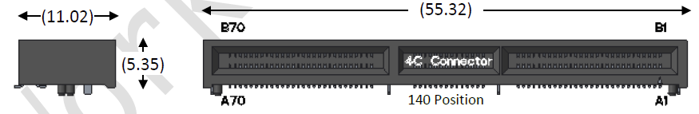

Figure 13: 140-pin Base Board Secondary Connector – Right Angle



Figure 14: 168-pin Base Board Primary Connector – Straddle Mount

TBD

Figure 15: 140-pin Base Board Secondary Connector – Straddle Mount

TBD

In order to the support the large form factor, systems must locate the Primary and Secondary Connectors per the mechanical drawing shown in Figure 16.

Figure 16: Primary and Secondary Connector Locations for Large Card Support

TBD

## Pin definition

The pin definitions of an OCP NIC 3.0 card with up to a x32 PCIe interface are shown in Table 8 and Table 9. All signal directions are shown from the perspective of the baseboard.

A baseboard system may provide a combination of Primary Connectors only, or Primary and Secondary Connectors to support multiple sizes of add-in cards. Both connectors share common functionality with power, SMBus, x16 PCIe Gen4 and bifurcation control. The Primary Connector has an additional OCP Bay (pins OCP_A[1:14], OCP_B[1:14]) with additional REFCLKs for supporting up to four PCIe hosts, NC-SI connectivity and a Scan Chain for information exchange between the host and card. The NIC is required to implement the Scan Chain, while the baseboard may choose to optionally implement it. Depending on the baseboard form-factor, multiple OCP NIC 3.0 compliant cards may be designed into the system.

The pins common to the Primary and Secondary Connectors are shown in Section 3.4. The OCP Bay pins on the Primary Connector only are shown in Section 3.5.

Cards or systems that do not require the use of a PCIe x16 connection may optionally implement a subset electrical connections as applicable to the design. For example, a x8 (or smaller) card using the first 8 PCIe lanes that is compliant with the Primary Connector pinout. Refer to Sections 3.1 and 3.2 for mechanical details. For these cases, the Primary Connector matches the 2C dimensions as defined in SFF-TA-1002.

In all cases, the physical baseboard connectors shall support x16 PCIe widths and must be implemented with the Primary (4C + OCP Bay) and Secondary (4C) connectors.

Table 8: Primary Connector Pin Definition (x16) (4C + OCP Bay)

|  |  |  |  |  |  |
| --- | --- | --- | --- | --- | --- |
| **Side B** | | **Side A** | |  | |
| OCP_B1 | NIC_PWR_GOOD | WAKE_N | OCP_A1 | **Primary Connector (x16, 168-pin add-in card with OCP Bay)** | **Primary Connector (x8, 112-pin add-in card with OCP bay)** |
| OCP_B2 | PWRBRK# | PERST2# | OCP_A2 |
| OCP_B3 | LD# | PERST3# | OCP_A3 |
| OCP_B4 | DATA_IN | RBT_ARB_IN | OCP_A4 |
| OCP_B5 | DATA_OUT | RBT_ARB_OUT | OCP_A5 |
| OCP_B6 | CLK | GND | OCP_A6 |
| OCP_B7 | SLOT_ID0 | RBT_TX_EN | OCP_A7 |
| OCP_B8 | RBT_RXD1 | RBT_TXD1 | OCP_A8 |
| OCP_B9 | RBT_RXD0 | RBT_TXD0 | OCP_A9 |
| OCP_B10 | GND | GND | OCP_A10 |
| OCP_B11 | REFCLKn2 | REFCLKn3 | OCP_A11 |
| OCP_B12 | REFCLKp2 | REFCLKp3 | OCP_A12 |
| OCP_B13 | GND | GND | OCP_A13 |
| OCP_B14 | RBT_CRS_DV | RBT_CLK_IN | OCP_A14 |
| **Mechanical Key** | | | |
| B1 | +12V/+12V_AUX | GND | A1 |
| B2 | +12V/+12V_AUX | GND | A2 |
| B3 | +12V/+12V_AUX | GND | A3 |
| B4 | +12V/+12V_AUX | GND | A4 |
| B5 | +12V/+12V_AUX | GND | A5 |
| B6 | +12V/+12V_AUX | GND | A6 |
| B7 | BIF0# | SMCLK | A7 |
| B8 | BIF1# | SMDAT | A8 |
| B9 | BIF2# | SMRST# | A9 |
| B10 | PERST0# | PRSNTA# | A10 |
| B11 | +3.3V/+3.3V_AUX | PERST1# | A11 |
| B12 | PWRDIS | PRSNTB2# | A12 |
| B13 | GND | GND | A13 |
| B14 | REFCLKn0 | REFCLKn1 | A14 |
| B15 | REFCLKp0 | REFCLKp1 | A15 |
| B16 | GND | GND | A16 |
| B17 | PETn0 | PERn0 | A17 |
| B18 | PETp0 | PERp0 | A18 |
| B19 | GND | GND | A19 |
| B20 | PETn1 | PERn1 | A20 |
| B21 | PETp1 | PERp1 | A21 |
| B22 | GND | GND | A22 |
| B23 | PETn2 | PERn2 | A23 |
| B24 | PETp2 | PERp2 | A24 |
| B25 | GND | GND | A25 |
| B26 | PETn3 | PERn3 | A26 |
| B27 | PETp3 | PERp3 | A27 |
| B28 | GND | GND | A28 |
| **Mechanical Key** | | | |
| B29 | GND | GND | A29 |
| B30 | PETn4 | PERn4 | A30 |
| B31 | PETp4 | PERp4 | A31 |
| B32 | GND | GND | A32 |
| B33 | PETn5 | PERn5 | A33 |
| B34 | PETp5 | PERp5 | A34 |
| B35 | GND | GND | A35 |
| B36 | PETn6 | PERn6 | A36 |
| B37 | PETp6 | PERp6 | A37 |
| B38 | GND | GND | A38 |
| B39 | PETn7 | PERn7 | A39 |
| B40 | PETp7 | PERp7 | A40 |
| B41 | GND | GND | A41 |
| B42 | PRSNTB0# | PRSNTB1# | A42 |
| **Mechanical Key** | | | |  |
| B43 | GND | GND | A43 |  |
| B44 | PETn8 | PERn8 | A44 |  |
| B45 | PETp8 | PERp8 | A45 |  |
| B46 | GND | GND | A46 |  |
| B47 | PETn9 | PERn9 | A47 |  |
| B48 | PETp9 | PERp9 | A48 |  |
| B49 | GND | GND | A49 |  |
| B50 | PETn10 | PERn10 | A50 |  |
| B51 | PETp10 | PERp10 | A51 |  |
| B52 | GND | GND | A52 |  |
| B53 | PETn11 | PERn11 | A53 |  |
| B54 | PETp11 | PERp11 | A54 |  |
| B55 | GND | GND | A55 |  |
| B56 | PETn12 | PERn12 | A56 |  |
| B57 | PETp12 | PERp12 | A57 |  |
| B58 | GND | GND | A58 |  |
| B59 | PETn13 | PERn13 | A59 |  |
| B60 | PETp13 | PERp13 | A60 |  |
| B61 | GND | GND | A61 |  |
| B62 | PETn14 | PERn14 | A62 |  |
| B63 | PETp14 | PERp14 | A63 |  |
| B64 | GND | GND | A64 |  |
| B65 | PETn15 | PERn15 | A65 |  |
| B66 | PETp15 | PERp15 | A66 |  |
| B67 | GND | GND | A67 |  |
| B68 | RFU, N/C | RFU, N/C | A68 |  |
| B69 | RFU, N/C | RFU, N/C | A69 |  |
| B70 | PRSNTB3# | RFU, N/C | A70 |  |

Table 9: Secondary Connector Pin Definition (x16) (4C)

|  |  |  |  |  |  |
| --- | --- | --- | --- | --- | --- |
| **Side B** | | **Side A** | |  | |
| B1 | +12V/+12V_AUX | GND | A1 | **Secondary Connector (x16, 140-pin add-in card)** | **Secondary Connector (x8, 84-pin add-in card)** |
| B2 | +12V/+12V_AUX | GND | A2 |
| B3 | +12V/+12V_AUX | GND | A3 |
| B4 | +12V/+12V_AUX | GND | A4 |
| B5 | +12V/+12V_AUX | GND | A5 |
| B6 | +12V/+12V_AUX | GND | A6 |
| B7 | BIF0# | SMCLK | A7 |
| B8 | BIF1# | SMDAT | A8 |
| B9 | BIF2# | SMRST# | A9 |
| B10 | PERST0# | PRSNTA# | A10 |
| B11 | +3.3V/+3.3V_AUX | PERST1# | A11 |
| B12 | PWRDIS | PRSNTB2# | A12 |
| B13 | GND | GND | A13 |
| B14 | REFCLKn0 | REFCLKn1 | A14 |
| B15 | REFCLKp0 | REFCLKp1 | A15 |
| B16 | GND | GND | A16 |
| B17 | PETn0 | PERn0 | A17 |
| B18 | PETp0 | PERp0 | A18 |
| B19 | GND | GND | A19 |
| B20 | PETn1 | PERn1 | A20 |
| B21 | PETp1 | PERp1 | A21 |
| B22 | GND | GND | A22 |
| B23 | PETn2 | PERn2 | A23 |
| B24 | PETp2 | PERp2 | A24 |
| B25 | GND | GND | A25 |
| B26 | PETn3 | PERn3 | A26 |
| B27 | PETp3 | PERp3 | A27 |
| B28 | GND | GND | A28 |
| **Mechanical Key** | | | |
| B29 | GND | GND | A29 |
| B30 | PETn4 | PERn4 | A30 |
| B31 | PETp4 | PERp4 | A31 |
| B32 | GND | GND | A32 |
| B33 | PETn5 | PERn5 | A33 |
| B34 | PETp5 | PERp5 | A34 |
| B35 | GND | GND | A35 |
| B36 | PETn6 | PERn6 | A36 |
| B37 | PETp6 | PERp6 | A37 |
| B38 | GND | GND | A38 |
| B39 | PETn7 | PERn7 | A39 |
| B40 | PETp7 | PERp7 | A40 |
| B41 | GND | GND | A41 |
| B42 | PRSNTB0# | PRSNTB1# | A42 |
| **Mechanical Key** | | | |  |
| B43 | GND | GND | A43 |  |
| B44 | PETn8 | PERn8 | A44 |  |
| B45 | PETp8 | PERp8 | A45 |  |
| B46 | GND | GND | A46 |  |
| B47 | PETn9 | PERn9 | A47 |  |
| B48 | PETp9 | PERp9 | A48 |  |
| B49 | GND | GND | A49 |  |
| B50 | PETn10 | PERn10 | A50 |  |
| B51 | PETp10 | PERp10 | A51 |  |
| B52 | GND | GND | A52 |  |
| B53 | PETn11 | PERn11 | A53 |  |
| B54 | PETp11 | PERp11 | A54 |  |
| B55 | GND | GND | A55 |  |
| B56 | PETn12 | PERn12 | A56 |  |
| B57 | PETp12 | PERp12 | A57 |  |
| B58 | GND | GND | A58 |  |
| B59 | PETn13 | PERn13 | A59 |  |
| B60 | PETp13 | PERp13 | A60 |  |
| B61 | GND | GND | A61 |  |
| B62 | PETn14 | PERn14 | A62 |  |
| B63 | PETp14 | PERp14 | A63 |  |
| B64 | GND | GND | A64 |  |
| B65 | PETn15 | PERn15 | A65 |  |
| B66 | PETp15 | PERp15 | A66 |  |
| B67 | GND | GND | A67 |  |
| B68 | RFU, N/C | RFU, N/C | A68 |  |
| B69 | RFU, N/C | RFU, N/C | A69 |  |
| B70 | PRSNTB3# | RFU, N/C | A70 |  |

## Signal Descriptions – Common

The pins shown in this section are common to both the Primary and Secondary Connectors. All pin directions are from the perspective of the baseboard.

The add-in card shall implement protection methods to prevent leakage paths between the Vaux and Vmain power domains in the event that a NIC is powered down in a powered up baseboard.

**Note:** Pins that are only used on Primary Connector 28-pin OCP bay are defined in Section 3.5.

### PCIe Interface Pins

This section provides the pin assignments for the PCIe interface signals. The AC/DC specifications are defined in the PCIe CEM Specification, Rev 4.0. Example connection diagrams for are shown in Figure 28.

Table 10: Pin Descriptions – PCIe 1

|  |  |  |  |
| --- | --- | --- | --- |
| **Signal Name** | **Pin #** | **Baseboard Direction** | **Signal Description** |
| REFCLKn0  REFCLKp0 | B14  B15 | Output | PCIe compliant differential reference clock #0, and #1. 100MHz reference clocks are used for the add-in card PCIe core logic.  For baseboards, the REFCLK0 and REFCLK1 signals are required at the connector.  For add-in cards, the required REFCLKs shall be connected per the endpoint datasheet.  **Note:** For cards that only support 1 x16, REFCLK0 is used. For cards that support 2 x8, REFCLK0 is used for the first eight PCIe lanes, and REFCLK1 is used for the second eight PCIe lanes.  Refer to Section 2.1 in the PCIe CEM Specification, Rev 4.0 for electrical details. |
| REFCLKn1  REFCLKp1 | A14  A15 | Output |
| PETn0  PETp0 | B17  B18 | Output | Transmitter differential pairs [0:15]. These pins are connected from the baseboard transmitter differential pairs to the receiver differential pairs on the add-in card.  The PCIe transmit pins are AC coupled on the baseboard with capacitors and are placed next to the baseboard transmitters. The AC coupling capacitor must be between 176nF (min) and 265nF (max).  For baseboards, the PET[0:15] signals are required at the connector.  For add-in cards, the required PET[0:15] signals shall be connected to the endpoint silicon. For silicon that uses less than a x16 connection, the appropriate PET[0:15] signals shall be connected per the endpoint datasheet.  Refer to Section 6.1 in the PCIe CEM Specification, Rev 4.0 for details. |
| PETn1  PETp1 | B20  B21 | Output |
| PETn2  PETp2 | B23  B24 | Output |
| PETn3  PETp3 | B26  B27 | Output |
| PETn4  PETp4 | B30  B31 | Output |
| PETn5  PETp5 | B33  B34 | Output |
| PETn6  PETp6 | B36  B37 | Output |
| PETn7  PETp7 | B39  B40 | Output |
| PETn8  PETp8 | B44  B45 | Output |
| PETn9  PETp9 | B47  B48 | Output |
| PETn10  PETp10 | B50  B51 | Output |
| PETn11  PETp11 | B53  B54 | Output |
| PETn12  PETp12 | B56  B57 | Output |
| PETn13  PETp13 | B59  B60 | Output |
| PETn14  PETp14 | B62  B63 | Output |
| PETn15  PETp15 | B65  B66 | Output |
| PERn0  PERp0 | A17  A18 | Input | Receiver differential pairs [0:15]. These pins are connected from the add-in card transmitter differential pairs to the receiver differential pairs on the baseboard.  The PCIe receive pins are AC coupled on the add-in card with capacitors and are placed next to the add-in card transmitters. The AC coupling capacitor must be between 176nF (min) and 265nF (max).  For baseboards, the PER[0:15] signals are required at the connector.  For add-in cards, the required PER[0:15] signals shall be connected to the endpoint silicon. For silicon that uses less than a x16 connection, the appropriate PER[0:15] signals shall be connected per the endpoint datasheet.  Refer to Section 6.1 in the PCIe CEM Specification, Rev 4.0 for details. |
| PERn1  PERp1 | A20  A21 | Input |
| PERn2  PERp2 | A23  A24 | Input |
| PERn3  PERp3 | A26  A27 | Input |
| PERn4  PERp4 | A30  A31 | Input |
| PERn5  PERp5 | A33  A34 | Input |
| PERn6  PERp6 | A36  A37 | Input |
| PERn7  PERp7 | A39  A40 | Input |
| PERn8  PERp8 | A44  A45 | Input |
| PERn9  PERp9 | A47  A48 | Input |
| PERn10  PERp10 | A50  A51 | Input |
| PERn11  PERp11 | A53  A54 | Input |
| PERn12  PERp12 | A56  A57 | Input |
| PERn13  PERp13 | A59  A60 | Input |
| PERn14  PERp14 | A62  A63 | Input |
| PERn15  PERp15 | A65  A66 | Input |
| PERST0#  PERST1# | B10  A11 | Output | PCIe Reset #0, #1. Active low.  Indicates when the applied power is within tolerance and stable for the add-in card. PERST# goes high at least 100ms after the power rails are within operating limits per the PCIe CEM Specification. The PCIe REFCLKs also become stable within this period of time.  PERST is pulled high on the baseboard.  For OCP NIC 3.0, PERST deassertion also indicates the full card power envelope is available to the add-in card.  For baseboards, the PERST[0:1]# signals are required at the connector.  For add-in cards, the required PERST[0:1]# signals shall be connected to the endpoint silicon.  **Note:** For cards that only support 1 x16, PERST0# is used. For cards that support 2 x8, PERST0# is used for the first eight PCIe lanes, and PERST1# is used for the second eight PCIe lanes.  Refer to Section 2.2 in the PCIe CEM Specification, Rev 4.0 for details. |

### PCIe Present and Bifurcation Control Pins

This section provides the pin assignments for the PCIe present and bifurcation control signals. The AC/DC specifications are defined in Section XXX. An example connection diagram is shown in Figure 17.

The PRSNTA#/PRSNTB[0:3]# state may be used to determine if a card has been physically plugged in. The BIF[0:2]# pins much be latched at least 1 ms before PWRDIS deassertion to ensure the correct values are detected by the system. Changing the pin states after this timing window is not allowed. Refer to the AC timing diagram in Section XXX for details.

Table 11: Pin Descriptions – PCIe Present and Bifurcation Control Pins

|  |  |  |  |
| --- | --- | --- | --- |
| **Signal Name** | **Pin #** | **Baseboard Direction** | **Signal Description** |
| PRSNTA# | A12 | Output | Present A is used for add-in card presence and PCIe capabilities detection.  For baseboards, this pin is directly connected to GND.  For add-in cards, this pin is connected to the PRSNTB[3:0]# pins. |
| PRSNTB0#  PRSNTB1#  PRSNTB2#  PRSNTB3# | B42  A42  A10  B70 | Input | Present B [0:3]# are used for add-in card presence and PCIe capabilities detection.  For baseboards, these pins are connected to the I/O hub and are pulled up to +3.3Vaux using 1kOhm resistors.  For add-in cards, these pins are strapped to PRSNTA#. The encoding definitions are described in Section 3.6.  PRSNTB3# is located at the bottom of the 4C connector and is only applicable for add-in cards with a PCIe width of x16 (or greater). Add-in cards that implement a 2C card edge do not use the PRSNTB3# pin for capabilities or present detection. |
| BIF0#  BIF1#  BIF2# | A7  A8  A9 | Output | Bifurcation [0:2]# pins allow the baseboard to force configure the add-in card bifurcation.  For baseboards, these pins are outputs driven from the baseboard I/O hub and allows the system to force configure the add-in card bifurcation. The baseboard may optionally tie the BIF[0:2]# signals to 3.3Vaux or to ground if no dynamic bifurcation configuration is required.  For add-in cards, these signals connect to the endpoint bifurcation pins if it is supported.  The BIF[0:2]# encoding definitions are described in Section 3.6.  Note: the required combinatorial logic output for endpoint bifurcation is dependent on the specific silicon and is not defined in this specification. |

Figure 17: PCIe Present and Bifurcation Control Pins



### SMBus Interface Pins

This section provides the pin assignments for the SMBus interface signals. The AC/DC specifications are defined in the SMBus and I2C bus specifications. An example connection diagram is shown in Figure XXX.

Table 12: Pin Descriptions – SMBus

|  |  |  |  |
| --- | --- | --- | --- |
| **Signal Name** | **Pin #** | **Baseboard Direction** | **Signal Description** |
| SMCLK | A7 | Output, OD | SMBus clock. Open drain, pulled up to 3.3Vaux on the baseboard.  For baseboards, connect the SMCLK from the platform SMBus master to the connector.  For add-in cards, connect the SMCLK from the endpoint silicon to the card edge gold fingers. |
| SMDAT | A8 | Input / Output, OD | SMBus Data. Open drain, pulled up to 3.3Vaux on the baseboard.  For baseboards, connect the SMDAT from the platform SMBus master to the connector.  For add-in cards, connect the SMDAT from the endpoint silicon to the card edge gold fingers. |
| SMRST# | A9 | Output, OD | SMBus reset. Open drain.  For baseboards, this pin is pulled up to 3.3Vauxand is used to reset optional downstream SMBus devices (such as temperature sensors). SMRST# is a mandatory signal for baseboard implementations.  For add-in cards, SMRST# is optional. |

### Power Supply Pins

This section provides the pin assignments for the power supply interface signals. The AC/DC specifications are defined in the PCIe CEM Specification, Rev 4.0 and amended in Section 3.10. An example connection diagram is shown in Figure 18.

Table 13: Pin Descriptions – Power

|  |  |  |  |
| --- | --- | --- | --- |
| **Signal Name** | **Pin #** | **Baseboard Direction** | **Signal Description** |
| GND | Various | GND | Ground return; a total of 46 ground pins are on the main 140-pin connector area. |
| +12V/+12V_AUX | B1, B2, B3, B4, B5, B6 | Power | 12V main or 12V Aux power; total of 6 pins per connector. The 12V pins are rated to 1.1A per pin with a maximum derated power delivery of 79.2W.  The +12V power pins must be within the rail tolerances (TBD tolerance for Aux) when the PWRDIS pin is driven low by the baseboard. |
| +3.3V/3.3V_AUX | B11 | Power | 3.3V main or 3.3V Aux power; total of 1 pin per connector. The 3.3V pin is rated to 1.1A for a maximum derated power delivery of 3.63W.  The 3.3Vaux/main power pin must be within the rail tolerances when the PWRDIS pin is driven low by the baseboard. |
| PWRDIS | B12 | Output, O/D | Power disable. Active high. Open-drain  This signal is pulled up to 3.3V through a 10kOhm resistor on the baseboard.  When high, all add-in card supplies are disabled.  When low, add-in card supplies are enabled. |

Figure 18: Example Power Supply Topology



### Miscellaneous Pins

This section provides the pin assignments for the miscellaneous interface signals.

Table 14: Pin Descriptions – Miscellaneous 1

|  |  |  |  |
| --- | --- | --- | --- |
| **Signal Name** | **Pin #** | **Baseboard Direction** | **Signal Description** |
| RFU, N/C | B68, B69, A68, A69, A70 | Input / Output | Reserved future use pins. Leave these pins as no connect. |

## Signal Descriptions – OCP Bay (Primary Connector)

The following section describes the functions in the Primary Connector 28-pin OCP bay. This 28-pin bay is shown in Section 3.3 and have pin numbers designated as OCP_B[1:14], and OCP_A[1:14]. All pin directions on this OCP bay are from the perspective of the baseboard.

The add-in card shall implement protection methods to prevent leakage paths between the Vaux and Vmain power domains in the event that a NIC is powered down in a powered up baseboard.

**Note:** The pins that are common to both the Primary and Secondary Connectors are defined in Section 3.4.

### PCIe Interface Pins – OCP Bay (Primary Connector)

This section provides the pin assignments for the PCIe interface signals on the Primary Connector OCP bay. The AC/DC specifications are defined in Section XXX. An example connection diagram that shows REFCLK2, REFCLK3, PERST2# and PERST3# is shown in Section 3.7.

Table 15: Pin Descriptions – PCIe 2

|  |  |  |  |
| --- | --- | --- | --- |
| **Signal Name** | **Pin #** | **Baseboard Direction** | **Signal Description** |
| REFCLKn2  REFCLKp2 | OCP_B11  OCP_B12 | Output | PCIe compliant differential reference clock #2, and #3. 100MHz reference clocks are used for the add-in card PCIe core logic.  For baseboards, the REFCLK2 and REFCLK3 signals are required at the Primary connector.  For add-in cards, the required REFCLKs shall be connected per the endpoint datasheet.  **Note:** REFCLK2 and REFCLK3 are not used for cards that only support a 1 x16 or 2 x8 connection.  Refer to Section 2.1 in the PCIe CEM Specification, Rev 4.0 for details. |
| REFCLKn3  REFCLKp3 | OCP_A11  OCP_A12 | Output |
| PERST2#  PERST3# | OCP_A2  OCP_A3 | Output | PCIe Reset #2, #3. Active low.  Indicates when the applied power is within tolerance and stable for the add-in card. PERST# goes high at least 100ms after the power rails are within operating limits per the PCIe CEM Specification. The PCIe REFCLKs also become stable within this period of time.  PERST is pulled high on the baseboard.  For OCP NIC 3.0, PERST deassertion also indicates the full card power envelope is available to the add-in card.  For baseboards, the PERST[0:1]# signals are required at the connector.  For add-in cards, the required PERST[0:1]# signals shall be connected to the endpoint silicon.  **Note:** PERST2# and PERST3# are not used for cards that only support a 1 x16 or 2 x8 connection.  Refer to Section 2.2 in the PCIe CEM Specification, Rev 4.0 for details. |
| WAKE# | OCP_A1 | Input, OD | WAKE#. Open drain. Active low.  This signal is driven by the add-in card to notify the baseboard restore the PCIe link. For add-in cards that support multiple WAKE# signals, their respective WAKE# pins may be tied together as the signal is open-drain to form a wired-OR.  For baseboards, this signal is pulled up to +3.3V on the baseboard with a 10kOhm resistor and is connected to the system WAKE# signal.  For add-in cards, this signal is connected directly to the endpoint silicon WAKE# pin(s).  Refer to Section 2.3 in the PCIe CEM Specification, Rev 4.0 for details. |

### NC-SI Over RBT Interface Pins – OCP Bay (Primary Connector)

This section provides the pin assignments for the NC-SI over RBT interface signals on the Primary Connector OCP bay. The AC/DC specifications are defined in the NC-SI specification. An example connection diagram is shown in Figure 19.

For the purposes of this specification, the min and max electrical trace length of the NC-SI signals shall be between 2 inches and 4 inches. The traces shall be implemented as 50 Ohm impedance controlled nets.

Table 16: Pin Descriptions – NC-SI Over RBT

|  |  |  |  |
| --- | --- | --- | --- |
| **Signal Name** | **Pin #** | **Baseboard Direction** | **Signal Description** |
| RBT_CLK_IN | OCP_A14 | Output | Reference clock input. Synchronous clock reference for receive, transmit and control interface. The clock has a nominal frequency of 50MHz ±100ppm.  For baseboards, connect this pin between the baseboard NC-SI over RBT PHY and the connector. This signal requires a 100kOhm pull down resistor on the baseboard. If the baseboard does not support NC-SI over RBT, then terminate this signal to ground through a 100kOhm pull down resistor.  For add-in cards, connect this pin from the gold finger to the endpoint silicon. Leave this pin as a no connect if NC-SI is not supported. |
| RBT_CRS_DV | OCP_B14 | Input | Carrier sense/receive data valid. This signal is used to indicate to the baseboard that the carrier sense/receive data is valid.  For baseboards, connect this pin between the baseboard NC-SI over RBT PHY and the connector. This signal requires a 100kOhm pull down resistor on the baseboard. If the baseboard does not support NC-SI over RBT, then terminate this signal to ground through a 100kOhm pull down resistor.  For add-in cards, connect this pin from the gold finger to the endpoint silicon. Leave this pin as a no connect if NC-SI is not supported. |
| RBT_RXD0  RBT_RXD1 | OCP_B9  OCP_B8 | Input | Receive data. Data signals from the network controller to the BMC.  For baseboards, connect this pin between the baseboard NC-SI over RBT PHY and the connector. This signal requires a 100kOhm pull-up resistor to 3.3Vaux on the baseboard. If the baseboard does not support NC-SI over RBT, then terminate this signal to 3.3Vaux through a 100kOhm pull-up.  For add-in cards, connect this pin from the gold finger to the endpoint silicon. Leave this pin as a no connect if NC-SI is not supported. |
| RBT_TX_EN | OCP_A7 | Output | Transmit enable.  For baseboards, connect this pin between the baseboard NC-SI over RBT PHY and the connector. This signal requires a 100kOhm pull down resistor to ground on the baseboard. If the baseboard does not support NC-SI over RBT, then terminate this signal to ground through a 100kOhm pull down.  For add-in cards, connect this pin from the gold finger to the endpoint silicon. Leave this pin as a no connect if NC-SI is not supported. |
| RBT_TXD0  RBT_TXD1 | OCP_A9  OCP_A8 | Output | Transmit data. Data signals from the BMC to the network controller.  For baseboards, connect this pin between the baseboard NC-SI over RBT PHY and the connector. This signal requires a 100kOhm pull-up resistor to 3.3Vaux on the baseboard. If the baseboard does not support NC-SI over RBT, then terminate this signal to 3.3Vaux through a 100kOhm pull-up.  For add-in cards, connect this pin from the gold finger to the endpoint silicon. Leave this pin as a no connect if NC-SI is not supported. |
| RBT_ARB_OUT | OCP_A5 | Output | NC-SI hardware arbitration output. Used only if the end point silicon supports hardware arbitration. Connects to the ARB_IN signal of an adjacent device.  The ARB_IN pin is also routed to the card edge to allow multiple devices and OCP slots on the baseboard to share the NC-SI ring. The baseboard shall implement a multiplexing implementation that directs the RBT_ARB_OUT to the RBT_ARB_IN pin of the next NC-SI capable device in the ring, or back to the RBT_ARB_IN pin of the source device if there is a single device on the ring.  For baseboards, connect this pin between the baseboard OCP connector(s) to complete the hardware arbitration ring. If the baseboard does not support NC-SI over RBT, connect this signal directly to the RBT_ARB_IN pin.  For add-in cards, connect this pin from the gold finger to the endpoint silicon. Leave this pin as a no connect if NC-SI is not supported. |
| RBT_ARB_IN | OCP_A4 | Input | NC-SI hardware arbitration input. Used only if the end point silicon supports hardware arbitration. Connects to the ARB_OUT signal of an adjacent device.  The ARB_OUT pin is also routed to the card edge to allow multiple devices and OCP slots on the baseboard to share the NC-SI ring. The baseboard shall implement a multiplexing implementation that directs the RBT_ARB_IN to the RBT_ARB_OUT pin of the next NC-SI capable device in the ring, or back to the RBT_ARB_OUT pin of the source device if there is a single device on the ring.  For baseboards, connect this pin between the baseboard OCP connector(s) to complete the hardware arbitration ring. If the baseboard does not support NC-SI over RBT, connect this signal directly to the RBT_ARB_OUT pin.  For add-in cards, connect this pin from the gold finger to the endpoint silicon. Leave this pin as a no connect if NC-SI is not supported. |
| SLOT_ID | OCP_B7 | Output | NC-SI Address pin. Used only if the end point silicon supports package identification.  For baseboards, this pin is used to identify the slot ID value. Connect this pin directly to GND for SlotID = 0; or pull this pin up to 3.3Vaux for SlotID = 1.  For add-in cards, connect this pin to the endpoint Package ID[1] field. Refer to the endpoint device datasheet for details.  The Package ID[2:0] is a 3-bit field and is encoded in the NC-SI Channel ID as bits [7:5].  Package ID[2] is defaults to 0b0 in the NC-SI specification, but is optionally configurable if the target silicon supports configuring this bit.  Package ID[1] is connected to the SLOT_ID pin.  Package ID[0] is set to 0b0 for Network Silicon #0. Package ID[1] is set to 0b1 for Network Silicon #1 in the case of an OCP NIC 3.0 card with two discrete silicon instances.  As written in the NC-SI specification, up to four silicon devices are supported on the bus if only Package ID[1:0] is configurable (e.g. Package ID[2] is statically set to 0b0). Up to eight silicon devices are supported on the NC-SI bus if Package ID[2:0] are all configurable.  For add-in cards with multiple endpoint devices, the SLOT_ID pin may be used to configure a different Package ID value so long as the resulting combination does not cause addressing interferences.  For endpoint devices without NC-SI support, leave this pin as a no connect on the add-in card. |

Figure 19: NC-SI Over RBT Connection Example



**Note 1:** For baseboard designs with a single Primary Connector, connect ARB_IN to ARB_OUT to complete the NC-SI hardware arbitration ring. For designs with multiple Primary Connectors, connect ARB_IN and ARB_OUT to an analog mux to complete the NC-SI arbitration ring based on the number of cards installed in the system.

**Note 2:** For add-in cards with two discrete endpoint silicon, the Package ID[0] bit shall be statically set based on its silicon instance. For example, the figure above shows Network Silicon #0 and Network Silicon #1. Network Silicon #0 has Package ID[0] = 0b0, Network Silicon #1 has Package ID[0] = 0b1.

### Scan Chain Pins – OCP Bay (Primary Connector)

This section provides the pin assignments for the Scan Bus interface signals on the Primary Connector OCP Bay. The AC/DC specifications are defined in Section XXX. An example connection diagram is shown in Figure 20.

Table 17: Pin Descriptions – Scan Chain

|  |  |  |  |
| --- | --- | --- | --- |
| **Signal Name** | **Pin #** | **Baseboard Direction** | **Signal Description** |
| CLK | OCP_B6 | Output | Scan clock. The CLK is an output pin from the baseboard to the add-in card. The CLK may run up to 12.5MHz.  For baseboard implementations, connect the CLK pin to the Primary Connector. Tie the CLK pin directly to GND if the scan chain is not used.  For NIC implementations, the CLK pin must be connected to Shift Registers 0 & 1, and optionally to Shift Registers 2 & 3 (if implemented) as defined in the text and Figure 20, below. Pull the CLK pin up to 3.3Vaux through a 1kOhm resistor. |
| DATA_OUT | OCP_B5 | Output | Scan clock data output from the baseboard to the add-in card. This bit stream is used to shift in NIC configuration data.  For baseboard implementations, connect the DATA_OUT pin to the Primary Connector. Tie the DATA_OUT pin directly to GND if the scan chain is not used.  For NIC implementations, the DATA_OUT pin may be left floating if it is not used for add-in card configuration. Pull the DATA_OUT pin up to 3.3Vaux through a 1kOhm resistor. |
| DATA_IN | OCP_B4 | Input | Scan clock data input to the baseboard. This bit stream is used to shift out NIC status bits.  For baseboard implementations, the DATA_IN pin shall be pulled up to 3.3Vaux through a 10kOhm resistor to prevent the input signal from floating if a card is not installed. This pin may be left as a no connect if the scan chain is not used.  For NIC implementations, the DATA_IN scan chain is required. The DATA_IN connection to Shift Registers 0 & 1, as defined in the text and Figure 20, are required. |
| LD# | OCP_B3 | Output | Scan clock shift register load. Used to latch configuration data on the add-in card.  For baseboard implementations, the LD# pin shall be pulled up to 3.3Vaux through a 1kOhm resistor if the scan chain is not used to prevent the add-in card from erroneous data latching.  For NIC implementations, the LD# pin implementation is required. The LD# pin must be connected to Shift Registers 0 & 1 as defined in the text and Figure 20. Pull the LD# pin up to 3.3Vaux through a 1kOhm resistor. |

The scan chain provides side band status indication between the add-in card and the baseboard. The scan chain bit definition is defined in the two tables below. The scan chain data stream is 32-bits in length for both the DATA_OUT and the DATA_IN streams. The scan chain implementation is optional on the host, but is mandatory on all OCP NIC 3.0 cards. The scan chain components operates on the 3.3Vaux power domain.

The DATA_OUT bus is an output from the host. The DATA_OUT bus provides initial configuration options to the add-in card. At the time of this writing, the default implementation does not use the DATA_OUT stream and is not implemented on the NIC. However, all baseboard systems that implement the Scan Chain shall connect DATA_OUT between the platform and the Primary Connector for future-proofing NIC implementations and subsequent revisions of this specification.

Table 18: Pin Descriptions – Scan Chain DATA_OUT Bit Definition

|  |  |  |  |
| --- | --- | --- | --- |
| **Byte.bit** | **DATA_OUT Field Name** | **Default Value** | **Description** |
| 0.[0..7] | RSVD | 0b000000 | Reserved. Byte 0 value is 0h00. |
| 1.[0..7] | RSVD | 0h00 | Reserved. Byte 1 value is 0h00. |
| 2.[0..7] | RSVD | 0h00 | Reserved. Byte 2 value is 0h00. |
| 3.[0..7] | RSVD | 0h00 | Reserved. Byte 3 value is 0h00. |

The DATA_IN bus is an input to the host and provides NIC status indication. The default implementation is completed with two 8-bit 74LV165 parallel in to serial out shift registers in a cascaded implementation. Up to four shift registers may be implemented to provide additional NIC status indication to the host platform.

DATA_IN shift registers 0 & 1 are mandatory for all cards. DATA_IN shift registers 2 & 3 are optional depending on the card type and fields being reported to the host. DATA_IN shift register 2 may be used to indicate future definitions of the scan chain bit stream. DATA_IN shift registers 3 (in conjunction with shift register 2) are required for reporting link/activity indication on card implementations with 5-8 ports.

The host should read the DATA_IN bus multiple (TBD) times to qualify the incoming data stream.

A 1kOhm pull up resistor shall be implemented on the NIC to the SER input of the last shift register on the DATA_IN scan chain to maintain a default bit value of 0b1 for unused bits for implementations using less than four shift registers.

Table 19: Pin Descriptions – Scan Bus DATA_IN Bit Definition

|  |  |  |  |
| --- | --- | --- | --- |
| **Byte.bit** | **DATA_OUT Field Name** | **Default Value** | **Description** |
| 0.0 | PRSNTB[0]# | 0bX | PRSNTB[3:0]# value is mirrored from the Primary Connector. |
| 0.1 | PRSNTB[1]# | 0bX |
| 0.2 | PRSNTB[2]# | 0bX |
| 0.3 | PRSNTB[3]# | 0bX |
| 0.4 | WAKE_N | 0bX | PCIe WAKE_N signal is mirrored from the Primary Connector. |
| 0.5 | TEMP_WARN | 0b0 | Temperature monitoring pin from the on-card thermal solution. This pin is asserted high when temperature sensor exceeds the temperature warning threshold. |
| 0.6 | TEMP_CRIT | 0b0 | Temperature monitoring pin from the on-card thermal solution. This pin is asserted high when temperature sensor exceeds the temperature critical threshold. |
| 0.7 | FAN_ON_AUX | 0b0 | When high, FAN_ON_AUX requests the system fan to be enabled for extra cooling in the S5 state. |
| 1.0 | LINK_ACT0 | 0b1 | Port 0..3 link/activity indication. Active low.  0b0 – Link LED is illuminated on the host platform.  0b1 – Link LED is not illuminated on the host platform.  **Steady** = link is detected on the port.  **Blinking** = activity is detected on the port. The blink rate should blink low for 50-500ms during activity periods.  **Off** = the physical link is down or disabled |
| 1.1 | LINK_ACT1 | 0b1 |
| 1.2 | LINK_ACT2 | 0b1 |
| 1.3 | LINK_ACT3 | 0b1 |
| 1.4 | SPEED0 | 0b1 | Port 0..3 speed indication. Active low.  0b0 – Port is linked at maximum speed.  0b1 – Port is not linked at the maximum speed or no link is present. |
| 1.5 | SPEED1 | 0b1 |
| 1.6 | SPEED2 | 0b1 |
| 1.7 | SPEED3 | 0b1 |
| 2.0 | ScanChainVer[0] | 0b1 | ScanChainVer[1:0] is used to indicate the scan chain bit definitions. The encoding is as follows:  0b11 – Scan chain bit definitions version 1 corresponding to OCP 3.0 spec version 1.0.  All other encodings are reserved. |
| 2.1 | ScanChainVer[1] | 0b1 |
| 2.2 | RSVD | 0b1 | Byte 2 bits [2:7] are reserved. These bits shall default to the value of 0b1. These bits may be used in future versions of the scan chain. |
| 2.3 | RSVD | 0b1 |
| 2.4 | RSVD | 0b1 |
| 2.5 | RSVD | 0b1 |
| 2.6 | RSVD | 0b1 |
| 2.7 | RSVD | 0b1 |
| 3.0 | LINK_ACT4 | 0b1 | Port 4..7 link/activity indication. Active low.  0b0 – Link LED is illuminated on the host platform.  0b1 – Link LED is not illuminated on the host platform.  **Steady** = link is detected on the port.  **Blinking** = activity is detected on the port. The blink rate should blink low for 50-500ms during activity periods.  **Off** = the physical link is down or disabled |
| 3.1 | LINK_ACT 5 | 0b1 |
| 3.2 | LINK_ACT 6 | 0b1 |
| 3.3 | LINK_ACT 7 | 0b1 |
| 3.4 | SPEED4 | 0b1 | Port 4..7 speed indication. Active low.  0b0 – Port is linked at maximum speed.  0b1 – Port is not linked at the maximum speed or no link is present. |
| 3.5 | SPEED5 | 0b1 |
| 3.6 | SPEED6 | 0b1 |
| 3.7 | SPEED7 | 0b1 |

Figure 20: Scan Bus Connection Example



### Primary Connector Miscellaneous Pins – OCP Bay (Primary Connector)

This section provides the miscellaneous pin assignments for the pins on the Primary Connector OCP Bay. The AC/DC specifications are defined in the PCIe CEM Specification, Rev 4.0 and Section 3.12. An example connection diagram is shown in Figure XXX.

Table 20: Pin Descriptions – Miscellaneous 2

|  |  |  |  |
| --- | --- | --- | --- |
| **Signal Name** | **Pin #** | **Baseboard Direction** | **Signal Description** |
| PWRBRK# | OCP_B2 | Output, OD | Power break. Active low, open drain.  This signal is pulled up to 3.3Vaux on the add-in card with a minimum of 95kOhm and the baseboard with a stiffer resistance in-order to meet the timing specs as shown in the PCIe CEM Specification.  This signal is driven low by the baseboard and is used to notify that an Emergency Power Reduction State is requested. The add-in card shall move to a lower power consumption state. |
| NIC_PWR_GOOD | OCP_B1 | Input | NIC Power Good. Active high. This signal is driven by the add-in card.  When high, this signal indicates that all of the add-in card power rails are operating within nominal tolerances.  When low the add-in card power supplies are not yet ready or are in a fault condition.  For baseboards, this pin may be connected to the platform I/O hub as a NIC power health status indication. This signal is pulled down to ground with a 100kOhm resistor on the baseboard to prevent a false power good indication if no add-in card is present.  For add-in cards this signal may be implemented by a cascaded power good or a discrete power good monitor output. |
| GND | OCP_A6  OCP_A10 OCP_A13 OCP B10  OCP_B13 | GND | Ground return; a total of 5 ground pins are on the OCP bay area. |

## PCIe Bifurcation Mechanism

OCP3.0 baseboards and add-in cards support multiple bifurcation combinations. Single socket baseboards with a single or multiple root ports, as well as a multi-socket baseboards with a single or multiple root ports are supported. The bifurcation mechanism also supports add-in cards with a single or multiple end points. These features are accomplished via I/O pins on the Primary and Secondary connector:

* PRSNTA#, PRSNTB[3:0]#. The PRSNTA# pin connects to the PRSNTB# pins as a hard coded value on the add-in card. The encoding of the PRSNTB[3:0]# pins allows the baseboard to determine the PCIe Links available on the add-in card.
* BIF[3:0]#. The BIF# pin states are controlled by the baseboard and allows the baseboard to override the default end point bifurcation for silicon that support bifurcation. Additional combinatorial logic is required and is specific to the card silicon. The combinatorial logic is not covered in this specification.

The high level bifurcation connections are shown in Figure 21.

Figure 21: PCIe Bifurcation Pin Connections Support



### PCIe Add-in Card to Baseboard Bifurcation Configuration (PRSNTA#, PRSNTB[3:0]#)

The add-in card to baseboard configuration mechanism consists of four dual use pins (PRSNTB[3:0]#) on the add-in card and a grounded PRSNTA# pin on the baseboard. These pins provide card presence detection as well as mechanism to notify the baseboard of the pre-defined PCIe lane width capabilities. The PRSNTB[3:0]# pins are pulled up to 3.3Vaux on the baseboard and are active low signals. A state of 0b1111 indicates that no card is present in the system. Depending on the capabilities of the add-in card, a selection of PRSNTB[3:0]# signals may be strapped to the PRSNTA# signal and is pulled low by the baseboard. The encoding of the PRSTNB[3:0]# bits is shown in Table 21 for x16 and x8 PCIe cards.

### PCIe Baseboard to Add-in Card Bifurcation Configuration (BIF[2:0]#)

Three signals (BIF[2:0]#) are driven by the baseboard to notify requested bifurcation on the add-in card silicon. This allows the baseboard to set the lane configuration on the add-in card that supports multiple bifurcation options.

For example, a baseboard that has four separate hosts that support a 4 x4 connection, should appropriately drive the BIF[2:0]# pins per Table 21 and indicate to the add-in card silicon to setup a 4 x4 configuration.

As previously noted, the BIF[2:0]# signals require additional combinatorial logic to decode the BIF[2:0]# value and appropriately apply it to the end-point silicon. The combinatorial logic is not covered in the specification as its implementation is specific to the vendor silicon used.

### PCIe Bifurcation Decoder

The combination of the PRSNTB[3:0]# and BIF[2:0]# pins deterministically sets the PCIe lane width for a given combination of baseboard and add-in cards. Table 21 shows the resulting number of PCIe links and its width for known combinations of baseboards and add-in cards.

\***Note:** The baseboard must disable PCIe lanes during the initialization phase if the number of detected PCIe links are greater than what is supported on the baseboard to prevent a nondeterministic solution. For example, if the baseboard only supports a 1 x16 connection, and the add-in card only supports a 2 x8 connection, the baseboard must disable PCIe lanes 8-15 to prevent any potential LTSSM issues during the discovery phase.

Table 21: PCIe Bifurcation Decoder for x16 and x8 Card Widths

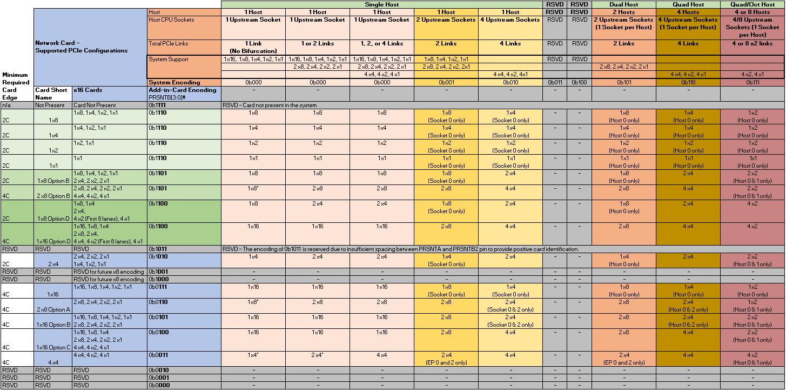

### Bifurcation Detection Flow

**[Need input and clarification from system vendors]**The following detection flow shall be used to determine the resulting link count and lane width based on the baseboard and add-in card configurations.

1. The baseboard reads the state of the PRSNTB[3:0]# pins. If the resulting value is not 0b1111, an add-in card is present.
2. Firmware determines the add-in card PCIe lane width capabilities per Table 21 by reading the PRSNTB[3:0]# pins.
3. The baseboard reconfigures the PCIe bifurcation on its ports to match the highest common lane width and lowest common link count on the card.
4. For cases where the baseboard request a link count override (such as requesting a 4-host baseboard requesting 4 x4 operation on a supported card that would otherwise default to a 2 x8 case), the BIF[0:2]# pins would be asserted as appropriate. Doing so assumes the add-in card supports the requested link override.
5. PERST# is deasserted after the >100ms window as defined by the PCIe specification. Refer to Section 3.12 for timing details.

### PCIe Bifurcation Examples

For illustrative purposes, the following figures show several common bifurcation permutations.

Figure 22 illustrates a single host baseboard that supports x16 with a single controller add-in card that also supports x16. The PRSTNB[3:0]# state is 0b0111. The BIF[2:0]# state is 0b000 as there is no need to instruct the end-point network controller to a specific bifurcation. The PRSNTB encoding notifies the baseboard that this card is only capable of 1 x16. The single host baseboard determines that it is also capable of supporting 1 x16. The resulting link width is 1 x16.

Figure 22: Single Host (1 x16) and 1 x16 Add-in Card (Single Controller)



Figure 23 illustrates a single host baseboard that supports 2 x8 with a single controller add-in card that also supports 2 x8. The PRSTNB[3:0]# state is 0b0110. The BIF[2:0]# state is 0b111 as there is no need to instruct the end-point network controllers to a specific bifurcation. The PRSNTB encoding notifies the baseboard that this card is only capable of 2 x8. The single host baseboard determines that it is also capable of supporting 2 x8. The resulting link width is 2 x8.

Figure 23: Single Host (2 x8) and 2 x8 Add-in Card (Dual Controllers)



Figure 24 illustrates a four host baseboard that supports 4 x4 with a single controller add-in card that supports 1 x16, 2 x8 and 4 x4. The PRSTNB[3:0]# state is 0b0011. The BIF[2:0]# state is 0b101 as the end point network controller is forced to bifurcate to 4 x4. The PRSNTB encoding notifies the baseboard that this card is only capable of 1 x16, 2 x8 and 4 x4. The four host baseboard determines that it is also capable of supporting 4 x4. The resulting link width is 4 x4.

Figure 24: Four Hosts (4 x4) and 4 x4 Add-in Card (Single Controller)



Figure 25 illustrates a four host baseboard that supports 4 x4 with a four controller add-in card that supports 4 x4. The PRSTNB[3:0]# state is 0b0011. The BIF[2:0]# state is 0b111 as there is no need to instruct the end-point network controllers to a specific bifurcation. The PRSNTB encoding notifies the baseboard that this card is only capable of 4 x4. The four host baseboard determines that it is also capable of supporting 4 x4. The resulting link width is 4 x4.

Figure 25: Four Hosts (4 x4) and 4 x4 Add-in Card (Four Controllers)



Figure 26 illustrates a single host baseboard that supports 1 x16 with a dual controller add-in card that supports 2 x8. The PRSTNB[3:0]# state is 0b0110. The BIF[2:0]# state is 0b111 as there is no need to instruct the end-point network controllers to a specific bifurcation. The PRSNTB encoding notifies the baseboard that this card is only capable of 2 x8. The four host baseboard determines that it is capable of 1x 16, but down shifts to 1 x8. The resulting link width is 1 x8 and only on endpoint 0.

Figure 26: Single Host with no Bifurcation (1 x16) and 2 x8 Add-in Card (Two Controllers)



## PCIe Clocking Topology

The OCP NIC 3.0 specification allows for up to four PCIe REFCLKs on the Primary Connector and up to two PCIe REFCLKs on the Secondary Connector. In general, the association of each REFCLK is based on the PCIe Link number on a per connector basis and is shown in Table 22. Cards that implement both the Primary and Secondary connectors have a total of up to 6 REFCLKs.

Table 22: PCIe Clock Associations

|  |  |  |
| --- | --- | --- |
| **REFCLK #** | **Description** | **Availability (Connector)** |
| REFCLK0 | REFCLK associated with Link 0. | Primary and Secondary Connectors. |
| REFCLK1 | REFCLK associated with Link 1. | Primary and Secondary Connectors. |
| REFCLK2 | REFCLK associated with Link 2. | Primary Connector only. |
| REFCLK3 | REFCLK associated with Link 3. | Primary Connector only. |

For each add-in card, the following REFCLK connection rules must be followed:

* For a 1 x16 capable add-in card, REFCLK0 is used for lanes [0:15].
* For a 2 x8 capable add-in card, REFCLK0 is used for lanes [0:7] and REFCLK1 is used for lanes [8:15].
* For a 4 x4 capable add-in card, REFCLK0 is used for lanes [0:3], REFCLK1 is used for lanes [4:7], REFCLK2 is used for lanes [8:11] and REFCLK3 is used for lanes [12:15]. Pins for REFCLK2 and REFCLK3 are described in Section 3.5.1 and are located on the 28-pin OCP bay.

Figure 27: PCIe Interface Connections for 1 x16 and 2 x8 Add-in Cards



Figure 28: PCIe Interface Connections for a 4 x4 Add-in Card



## PCIe Bifurcation Results and REFCLK Mapping

For the cases where the baseboard and add-in card bifurcation are permissible, this section enumerates all of the supported PCIe link, lane and REFCLK mappings for each supported configuration. The bifurcation decoder is shown in Section 3.6.3.

Table 23: Bifurcation for Single Host, Single Socket and Single Upstream Link (BIF[2:0]#=0b000)

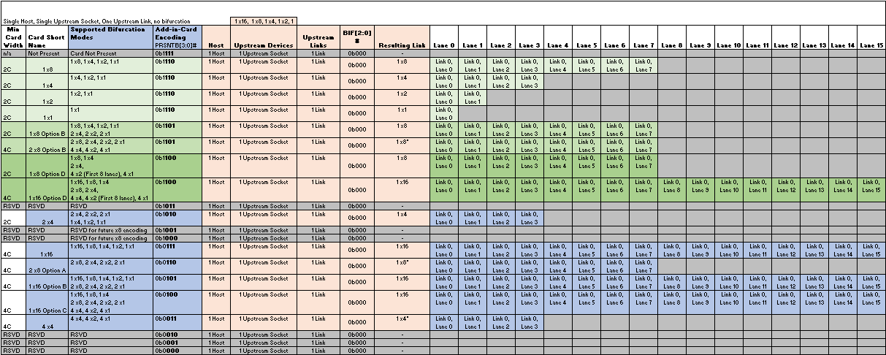

Table 24: Bifurcation for Single Host, Single Socket and Single/Dual Upstream Links (BIF[2:0]#=0b000)

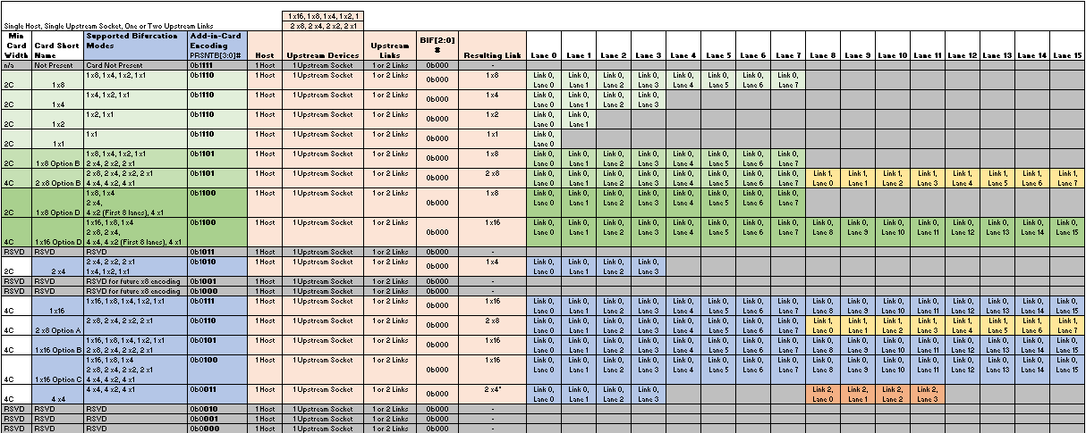

Table 25: Bifurcation for Single Host, Single Socket and Single/Dual/Quad Upstream Links (BIF[2:0]#=0b000)

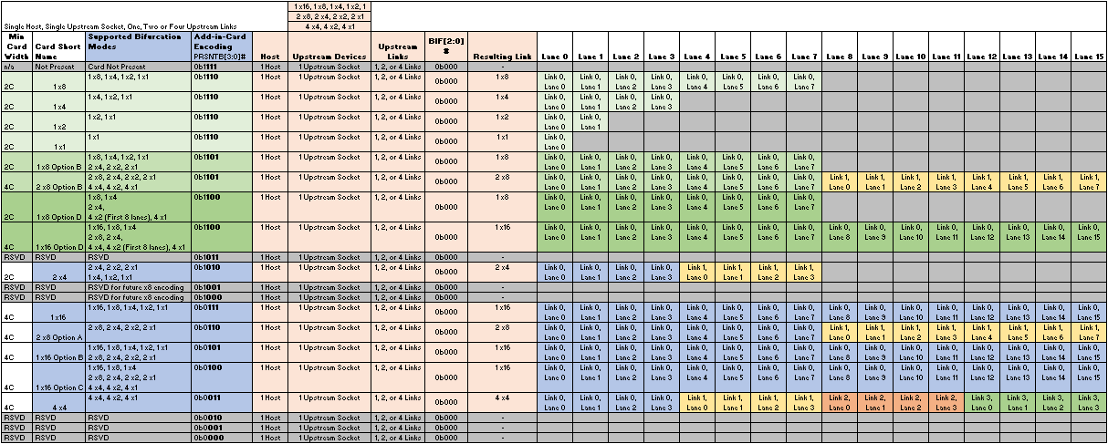

Table 26: Bifurcation for Single Host, Dual Sockets and Dual Upstream Links (BIF[2:0]#=0b001)

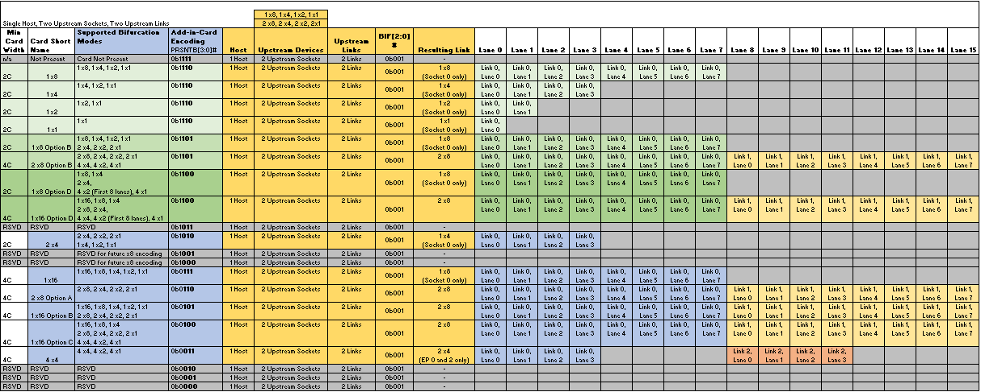

Table 27: Bifurcation for Single Host, Four Sockets and Dual Upstream Links (BIF[2:0]#=0b010)

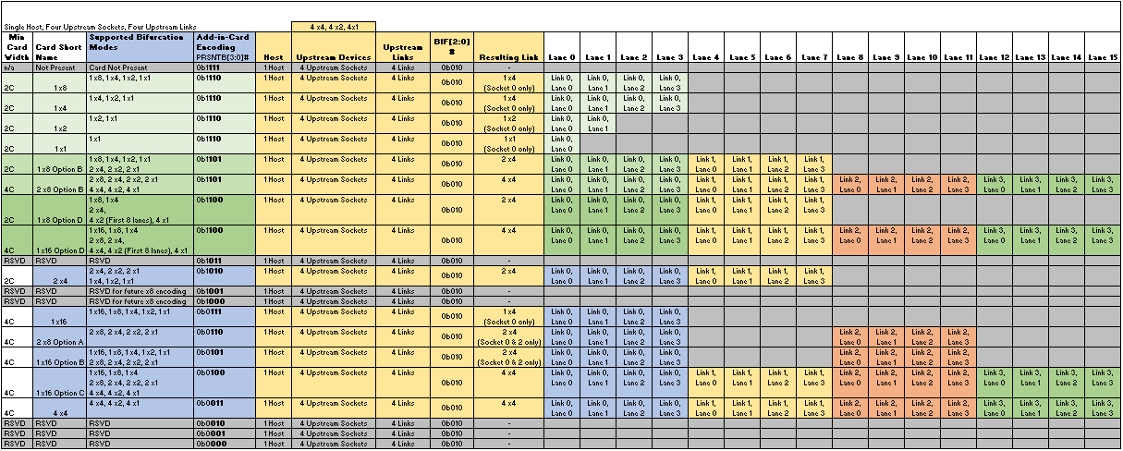

Table 28: Bifurcation for Dual Host, Dual Sockets and Dual Upstream Links (BIF[2:0]#=0b101)

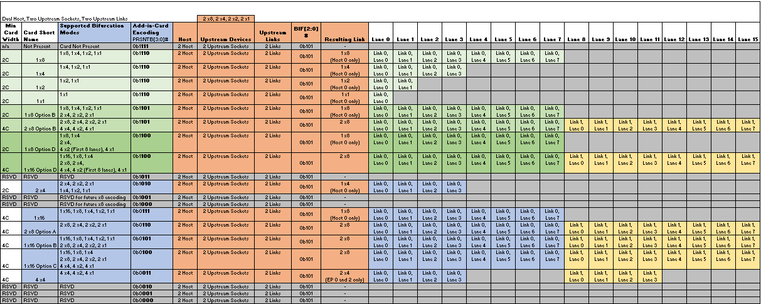

Table 29: Bifurcation for Quad Host, Quad Sockets and Quad Upstream Links (BIF[2:0]#=0b110)

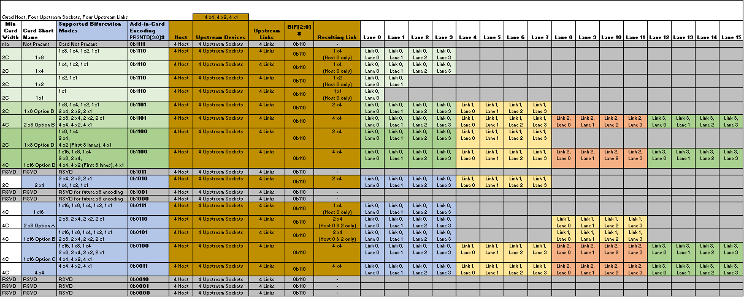

Table 30: Bifurcation for Quad Host, Quad Sockets and Quad Upstream Links (BIF[2:0]#=0b110)

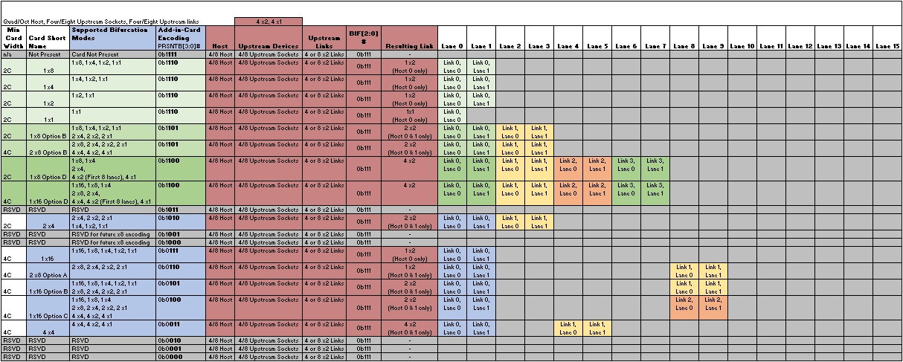

## Power Capacity and Power Delivery

There are four permissible power states: AC Power Off, ID Mode, Aux Power Mode (S5), and Main Power Mode (S0). The transition of these states is shown in Figure 29. The max available power envelopes for each of these states are defined in Table 31.

Figure 29: Baseboard Power States



Table 31: Power States

|  |  |  |  |  |  |  |  |
| --- | --- | --- | --- | --- | --- | --- | --- |
| **Power State** | **PWRDIS** | **PERSTn** | **FRU** | **Scan Chain** | **RBT Link** | **3.3V** | **12V** |
| AC Power Off | Low | Low |  |  |  |  |  |
| ID Mode | High | Low | X | X |  | X | X |
| Aux Power Mode (S5) | Low | Low | X | X | X | X | X |
| Main Power Mode (S0) | Low | High | X | X | X | X | X |

### AC Power Off

In AC power off mode, all power delivery has been turned off or disconnected from the baseboard.

### ID Mode

In the ID Mode, only 3.3V Aux is available for powering up management only functions. FRU accesses are only allowed in this mode.

### Aux Power Mode (S5)

In Aux Power Mode provides both 3.3V Aux as well as 12V Aux is available. 12V Aux may be used to deliver power to the add-in card, but only up to the Aux budget of 35W.

### Main Power Mode (S0)

In Main Power Mode provides both 3.3V and 12V (Main) across the OCP connector. The add-in card operates in full capacity. Up to 79.2W may be delivered on 12V, and 3.63W on the 3.3V pins.

## Power Supply Rail Requirements

The baseboard provides 3.3Vaux and 12Vaux/main to both the Primary and Secondary connectors. The rail requirements are leveraged from the PCIe CEM 4.0 specification. For OCP NIC 3.0 cards, the requirements are as follows:

Table 32: Baseboard Power Supply Rail Requirements

|  |  |  |  |
| --- | --- | --- | --- |
| **Power Rail** | **30W Slot  Small Card Hot Aisle** | **80W Slot  Small Card Cold Aisle** | **150W  Large Card Cold Aisle** |
| **3.3V**  Voltage Tolerance  Supply Current  ID Mode  Aux Mode  Main Mode  Capacitive Load | ±9% (max)  375mA (max)  1.1A (max)  1.1A (max)  150μF (max) | ±9% (max)  375mA (max)  1.1A (max)  1.1A (max)  150μF (max) | ±9% (max)  375mA (max)  2.2A (max)  2.2A (max)  300μF (max) |
| **12V**  Voltage Tolerance  Supply Current  ID Mode  Aux Mode  Main Mode  Capacitive Load | ±8% (max)  100mA (max)  1.3A (max)  2.5A (max)  1000μF (max) | ±8% (max)  100mA (max)  3.3A (max)  6.6A (max)  2000μF (max) | ±8% (max)  100mA (max)  6.3A (max)  12.5A (max)  4000μF (max) |

## Hot Swap Considerations for 12V and 3.3V Rails

For baseboards that support system hot (powered on) add-in card insertions and extractions, the system implementer shall consider the use of hotswap controllers on both the 12Vmain/aux and 3.3Vaux pins to prevent damage to the baseboard or the add-in card. Hotswap controllers help with in-rush current limiting while also providing overcurrent protection, undervoltage and overvoltage protection capabilities.

The hotswap controller may gate the 12Vmain/aux and 3.3Vmain/aux based on the PRSNTB[3:0]# value. Per Section 3.6.3, a card is present in the system when the encoded value is not 0b1111. The PRSNTB[3:0]# can be AND’ed together and connected to the hotswap controller to accomplish this result. Per the OCP NIC 3.0 mechanical definition (Section XXX), the present pins are short pins and engage only when the card is positively seated.

Baseboards that do not support hot insertion, or hot extractions may opt to not implement these features.

## Power Sequence Timing Requirements

The following figure shows the power sequence of PRSNTB[3:0]#, 3.3Vaux, 12Vaux/12Vmain relative to PWRDIS, BIF[2:0]#, PERSTn*, the add-in card power ramp and NIC_PWR_GOOD.

Figure 30: Power Sequencing



Table 33: Power Sequencing Parameters

|  |  |  |  |
| --- | --- | --- | --- |
| **Parameter** | **Value** | **Units** | **Description** |
| Tss | 20 | ms | Max time between system 3.3Vaux and 12Vaux/main ramp to power stable. |
| TAUXVALID | >1 | ms | Min time between 3.3Vaux valid to PWRDIS assertion. |
| TBIFVALID | >1 | ms | Min time between BIF[2:0]# valid to PWRDIS assertion. The BIF[2:0]# value sets the add-in card bifurcation mode (if applicable) |
| TPL | <? | ms | Max time between the NIC payload power ramp to NIC_PWR_GOOD assertion |
| TPVPERL | >100 | ms | Max time between PWRDIS deassertion and PERST# deassertion. This value is from the PCIe CEM Specification, Rev 4.0. |

# Management

## SMBus Interface

The SMBus provides manageability of the add-in card.

## NC-SI Sideband Interface

### NC-SI addressing and Arb#

## MAC Address Requirement

Placeholder; needs other editors’ help

## FRU EEPROM

### FRU EEPROM Address, Size, and Availability

EEPROM on OCP NIC 3.0 is for baseboard to identify different types of OCP NIC. OCP NIC FRU EEPROM is connected to SMBCLK/SMBDAT (pin A7/A8) and address is 0xA2 (8bit format). The size of EEPROM is 1Kbits. NIC vendors may use larger size EEPROM if needed.

Only one EEPROM is required for one NIC, and it shall be connected to the SMBus on Primary connector.

FRU EEPROM shall be accessible in ID mode, AUX(S5) mode, and MAIN(S0) mode.

### EEPROM Content Requirement

Editor’s note [TN, 20171208]: the EEPROM map definition should include the card power class (e.g. be able to identify the max power required for 12V to the baseboard). This allows the baseboard to intelligently enable/disable the card based on the available baseboard power budget.

Follow IPMI Platform Management FRU Information Storage Definition v1.0 for data format. Use OEM record 0xC0, offset 1 to TBD to store OCP NIC specific records.

Table 15: OCP NIC Specific EEPROM Recoards

|  |  |
| --- | --- |
| Offset 1 | Primary Connector PRSNTB [3:0]# |
| 0b1110 (ox0E) | Follows Pinout; to be filled after the pinout table is fixed |
| 0b1101 (ox0D) |  |
| 0b1100 (0x0C) |  |
| 0b1010 (0x0A) |  |
| 0b0111 (0x07) |  |
| 0b0110 (0x06) |  |
| 0b0101 (0x05) |  |
| 0b0100 (0x04) |  |
| 0b0011 (0x03) |  |
| 0b1011 (0x0B) | Not a valid reading – Wrong EEPROM programming |
| 0b1111 (0x0F) | Not a valid reading – Wrong EEPROM programming |
| All others | RFU |
| No FRU device detected | No NIC connected / bad connection |
|  |  |
| Offset 2 | Secondary Connector PRSNTB [3:0]# |
| 0b1110 (ox0E) | Follows Pinout; to be filled after the pinout table is fixed |
| 0b1101 (ox0D) |  |
| 0b1100 (0x0C) |  |
| 0b1010 (0x0A) |  |
| 0b0111 (0x07) |  |
| 0b0110 (0x06) |  |
| 0b0101 (0x05) |  |
| 0b0100 (0x04) |  |
| 0b0011 (0x03) |  |
| 0b1011 (0x0B) | Not a valid reading – Wrong EEPROM programming |
| 0b1111 (0x0F) | Not a valid reading – Wrong EEPROM programming |
| All others | RFU |
| No FRU device detected | No NIC connected / bad connection |
|  |  |
| Offset 3 | Card max power in Aux(S5) |
| 0x01 ~ 0xFE | Hex format in Watts when NIC is in AUX(S5) mode; LSB = 1x Watt; round up for fraction. |
| 0xFF | Invalid entry |
| 0x00 | Invalid entry |
| Offset 4 | Card max power in Main(S0) |
| 0x01 ~ 0xFE | Hex format in Watts when NIC is in Main (S0) mode; LSB = 1x Watt; round up for fraction. |
| 0xFF | Invalid entry |
| 0x00 | Invalid entry |
| Offset 5 | Thermal Reporting Interface |
| 0x01 | Emulated thermal reporting on SMBus |
| 0x02 | Remote on-die sensor with TMP421 on SMBus |
| 0x04 | PLDM method on NC-SI over RBT |
|  |  |
|  |  |
|  |  |
|  |  |
|  |  |

## FW Requirement

(tentative list; collecting feedback)

OCP NIC 3.0 shall support device firmware upgrade from BMC controller

OCP NIC 3.0 shall support secured firmware; when secured firmware feature is enabled, the device shall allow update signed firmware only, and execute signed firmware only

OCP NIC 3.0 shall allow queries for FW versions and device model/ID from both in-band and out-of-band interfaces, without impacting NIC function and performance of in-band and out-of-band paths.

Multi-host NIC shall gracefully handle concurrent in-band accesses from multiple hosts and out-of-band access from BMC for query management status and firmware / device model/ID info.

Multi-host NIC shall allow only one entity to perform write access to NIC firmware at a time, without creating contention and/or crashing when more than one entities attempt to perform write action to NIC firmware.

## Thermal Reporting Interface

OCP NIC 3.0 Thermal reporting interface is defined on SMCLK/ SMDAT (A7/A8) or NC-SI over RBT depending on implementation methods described in this section.

The implementation of this requirement will improve the thermal management of system and allow baseboard management device to access key component temperature on OCP NIC.

There are 3x methods to implement thermal reporting described in this section:

Emulated method and remote on-die sensing method are the 2x methods defined in OCP NIC 2.0. Both methods will be treated by baseboard management controller as a TI/TMP421 thermal sensor with slave address 0x3E in 8 bit format. SMBus is the thermal reporting interface for these 2x methods.

PLDM method is the recommend implementation method of OCP NIC 3.0. NC-SI over RBT is the thermal reporting interface for this method.

For OCP NIC with Thermal Design Power > 10 Watts, this implementation of this interface is required.

Thermal reporting interface shall be accessible in AUX(S5) mode, and MAIN(S0) mode.

### Emulated Thermal Reporting (may remove if PLDM is a good replacement for all coming NICs)

In this method, OCP NIC should emulate its key temperatures to be accessed from SMBus (A7/A8). The emulation should follow TMP421 register mapping[1]. Baseboard treats the OCP NIC thermal sensor as TMP421. Baseboard BMC controller should use 2x separate reads to obtain the MSB and LSB of temperature data. Data obtained is used for system thermal monitoring and fan speed control.

There are two temperatures for TMP421 register mapping, local and remote channel 1. Remote channel 1 is typically used to represent key controller temperature of the card. Local channel is typically used to represent highest of other key components temperature on the card, such as highest temperature of active cable module.

Address of the emulated TMP421 device is fixed at 0x3E in 8bit format.

An implementation block diagram is shown in Figure 29.



Figure 29: Block Diagram for Emulated Thermal Reporting

With firmware change of the controller on baseboard managing thermal data and control, a register mapping of TMP422/TMP423 can be used to support one/two more temperatures without hardware change. The slave address of emulated device is always 0x3E, even it emulates TMP422/TMP423.

Vendor ID and device ID is mapped to offset 0xFE and 0xFF for board management controller to detect card types.

Power reporting and power capping is mapped to offset 0xF2 and 0xF3 as an optional feature to achieve device power monitoring and power capping level setting.

Table 17: describes the register implementation requirement for emulated method.

Table 17: Implementation Requirement for TMP421 Registers

|  |  |  |  |
| --- | --- | --- | --- |
| Offset | Description | Original TMP offset | Implementation requirement for emulated method |
| 0x0 | Local Temperature (High Byte) | Y | Represents highest temperature of all other key components  Required if any of the other key components or modules are critical for thermal design  Otherwise it is an optional offset and return 0x00 if not used |
| 0x1 | Remote Temperature 1 (High Byte) | Y | Required; represent temperature of main controller |
| 0x2 | Remote Temperature 2 (High Byte) | Y | Optional; represent temperature of key component 1; return 0x00 if not used |
| 0x3 | Remote Temperature 3 (High Byte) | Y | Optional; represent temperature of key component 2; return 0x00 if not used |
| 0x8 | Status Register | Y | Not required |
| 0x9 | Configuration Register 1 | Y | Not required; Emulated behavior follows SD=0, Temperature Range=0 |
| 0x0A | Configuration Register 2 | Y | Required; follow TMP423 datasheet to declare the channel supported; RC=1 |
| 0x0B | Conversion Rate Register | Y | Not required; Equivalent emulated conversion rate should be >2 sample/s |
| 0x0F | One-Shot Start | Y | Not required |
| 0x10 | Local Temperature (Low Byte) | Y | Optional; return 0x00 if not used |
| 0x11 | Remote Temperature 1 (Low Byte) | Y | Optional; return 0x00 if not used |
| 0x12 | Remote Temperature 2 (Low Byte) | Y | Optional; return 0x00 if not used |
| 0x13 | Remote Temperature 3 (Low Byte) | Y | Optional; return 0x00 if not used |
| 0x21 | N Correction 1 | Y | Not required |
| 0x22 | N Correction 2 | Y | Not required |
| 0x23 | N Correction 3 | Y | Not required |
| 0xF0 | Manufacturer ID(High Byte) | N | High byte of PCIe vendor ID, if using emulated temperature sensor method |
| 0xF1 | Device ID(High Byte) | N | High byte of PCIe device ID, if using emulated temperature sensor method |
| 0xF2 | Power reporting | N | Optional; card power reporting; 1LSB=1W; Read only |
| 0xF3 | Power capping | N | Optional; card power capping; 1LSB=1W; Read/Write |
| 0xFC | Software Reset | Y | Not required |
| 0xFE | Manufacturer ID | Y(redefined) | Low byte of PCIe vendor ID, if using emulated temperature sensor method |
| 0xFF | Device ID | Y(redefined) | Low byte of PCIe device ID, if using emulated temperature sensor method |

### Remote on-die sensing

Alternatively, one TMP421 sensor can be used to do on die temperature sensing for IC with thermal diode interface with TMP421 remote sensing channel; Connection diagram is shown in Figure 30.

For NIC needs more than one remote on-die sensing, TMP422/TMP423 can be used and slave address is 0x98(8bit) for this case.

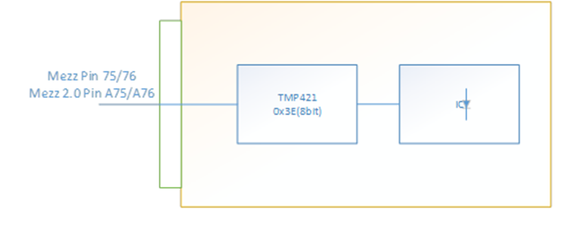

Figure 30: Block Diagram for Remote on-die Sensing

### PLDM Method

Placeholder; needs other editors’ help.

### Thermal reporting accuracy

The recommended accuracy for temperature sensors on the card is ±3°C

# Data Network Requirement

## Network Booting

OCP NIC 3.0 shall support network booting in uEFI system environment with both IPv4 and IPv6 network booting.

For UEFI booting, below features are required (tentative list; collecting feedback)

* EFI_DRIVER_BINDING_PROTOCOL (for starting and stopping the driver)
* EFI_DEVICE_PATH_PROTOCOL (provides location of the device)
* EFI_MANAGED_NETWORK_SERVICE_BINDING_PROTOCOL (asynchronous network packet I/O services)
* EFI_DRIVER_DIAGNOSTICS2_PROTOCOL & EFI_DRIVER_DIAGNOSTICS_PROTOCOL (driver will allow the UEFI shell command *drvdiag* to perform a cursory check of the connections managed by the driver)
* Human Interface Infrastructure (HII) protocols
* EFI_DRIVER_HEALTH_PROTOCOL
* EFI_FIRMWARE_UPDATE_PROTOCOL

# Routing Guidelines and Signal Integrity Considerations

## NC-SI Over RBT

Min Length: 2”

Max length: 4”

Impedance: 50 Ohm single ended

## PCIe

PCIe Gen3

Min Length (or Loss?): TBD

Max Length (or Loss?): TBD

Impedance: 85 Ohm +/- 10%

PCIe Gen4

Min Length (or Loss?): TBD

Max Length (or Loss?): TBD

Impedance: 85 Ohm +/- 10%

# Thermal and Environmental

## Environmental Requirements

Specifics are not included to permit adoption of OCP 3.0 NIC in systems with varying thermal requirements and boundary conditions. The system adopting OCP NIC should define air flow direction, local approach air temperature and speed to the NIC, operational altitude and relative humidity.

For example, a system configured with I/O facing the cold aisle, can specify approach air temperature and speed of 35°C and 200 LFM respectively, with airflow impinging on the I/O modules first and an operational altitude of 6000 feet.

### Thermal Reporting interface

[Link to 4.6; this session can be incorporated into Chapter 4.6] The NIC should support temperature reporting for key components on the card (including readings from active I/O modules). To improve thermal efficiency, the recommended accuracy for temperature sensors on the card is ±3°C. A power reporting interface is optional for low-power NICs (less than 10W), but strongly recommended for higher-powered NICs.

### Thermal Simulation Boundary Example

**Placeholder for the link to upcoming test fixture documentation (under development).**

## Shock & Vibration

Seek ME for input for common shock and Vib spec.

Plan to remove if there is no common spec.

## Regulation

This OCP NIC 3.-0 shall meet CE, CB, FCC Class A, WEEE, ROHS requirements.

# Revision History

|  |  |  |  |
| --- | --- | --- | --- |
| Author | Description | Revision | Date |
| Thomas Ng | Initial draft | 0.1 | 12/xx/2017 |
|  |  |  |  |
|  |  |  |  |
|  |  |  |  |
|  |  |  |  |
|  |  |  |  |
|  |  |  |  |
|  |  |  |  |
|  |  |  |  |
|  |  |  |  |
|  |  |  |  |
|  |  |  |  |
|  |  |  |  |
|  |  |  |  |
|  |  |  |  |
|  |  |  |  |

1. TMP421 specification: http://www.ti.com/lit/ds/sbos398c/sbos398c.pdf