Mono Lake User Manual

1. Mono Lake Block Diagram

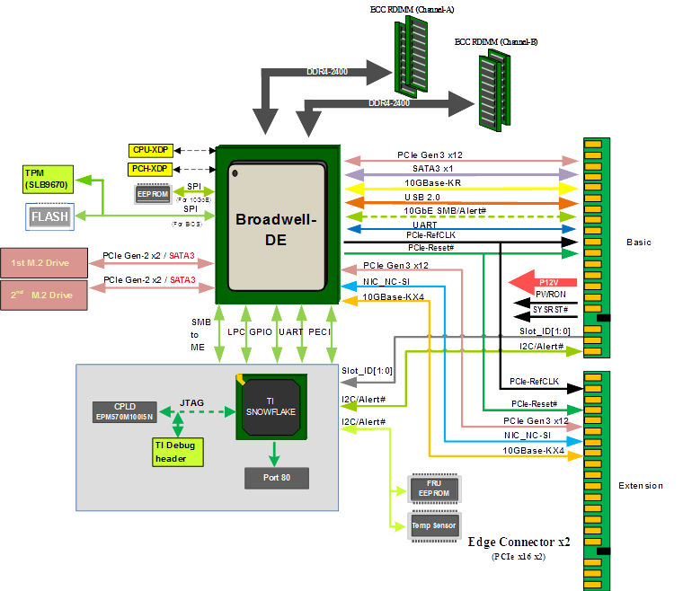

1. Major components location

Top side:

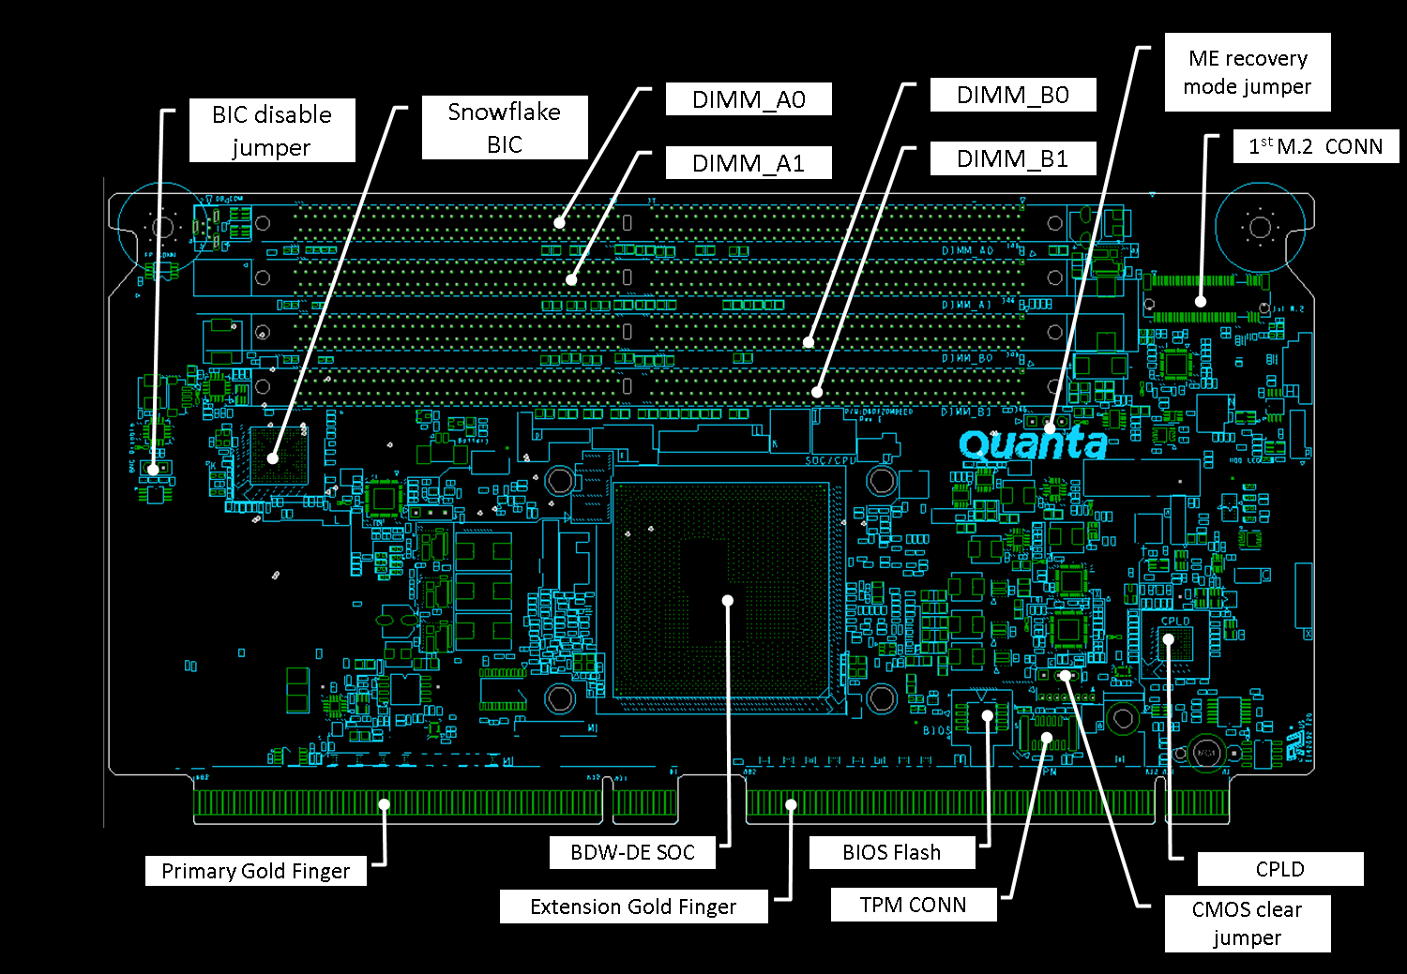

Bottom side:

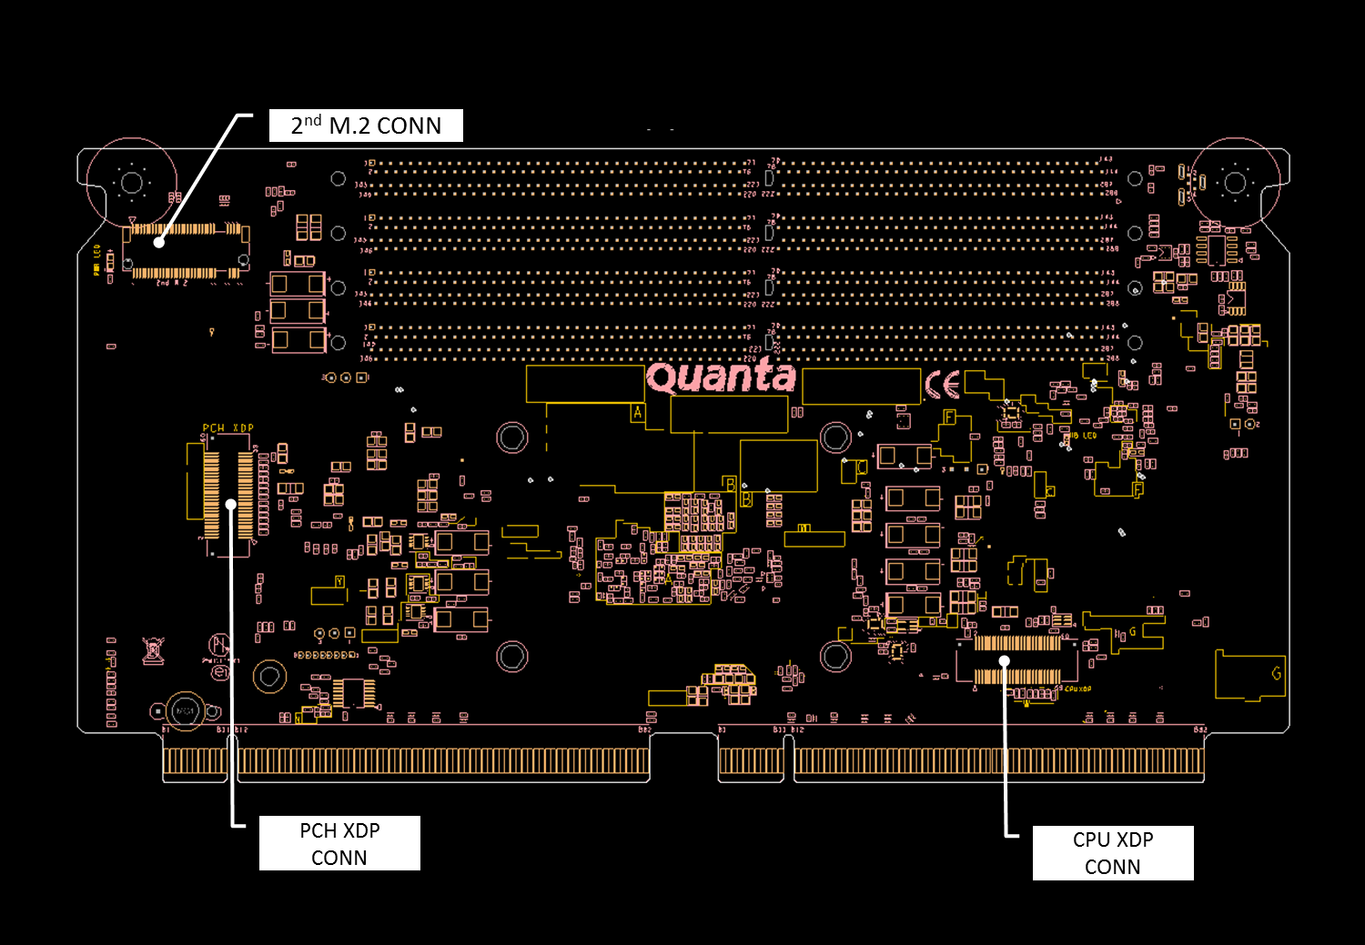

1. Recommended DIMMs and M.2 SSDs

Recommended DDR4 DIMMs:



Recommended M.2 SSD:

