

AT&T Open XGS-PON

NFV 1RU OLT Specification

Revision 1.1

Author: Thomas Anschutz

# Revision History

|  |  |  |  |
| --- | --- | --- | --- |
| Revision | Date | Author | Description |
| 1.0 | 3/3/2016 | Robert Mapes | Initial Release |
| 1.1 | 10/11/2016 | Tom Anschutz | Updates from feedback |
|  |  |  |  |
|  |  |  |  |
|  |  |  |  |

# **Contents**

Revision History 1

Licenses 4

Scope 4

Overview 4

Virtual OLT 5

XGS-PON Network 8

Physical Overview 10

Maximum Dimensions 10

Top View 10

Front View 12

Panel LED Definitions 12

XFP Interface Module support 13

QSFP+ Interface Module Support 13

Rear View 13

Field Replaceable Units 14

Power Supply Modules 14

Fan Modules 15

System Overview 17

Main Block Diagram 17

Channels Connectivity 18

Board placement 20

Front Panel 21

Rear Panel 22

XFP Modules placement on the front panel 23

PCB Board Set 23

Functional Hardware Blocks 24

xPON SoC – Broadcom BCM68620 24

Host CPU 24

Control FPGA 24

Broadcom BCM88470 QAX - Switching & TM device 24

Optical modules 25

Uplink 25

Timing 25

Software Support 26

BMC support 26

U-Boot (Optional CPU Module) 26

ONIE (Optional CPU Module) 26

Open Network Linux (Optional CPU Module) 26

Overall System Software 26

General Specifications 27

Power Consumption 27

Specification Requirements 28

Power Consumption 28

Environmental 28

Safety 28

Electromagnetic Compatibility 29

ROHS 29

# Licenses

All devices that may be referred to in this specification, or required to manufacture products described in this specification, will be considered referenced only, and no intellectual property rights embodied in or covering such devices shall be licensed as a result of this specification or such references. Notwithstanding anything to the contrary in the Open Compute Project Contributor License Agreement or the Open Web Foundation Final Specification Agreement (OWFa 1.0), the licenses set forth therein do not apply to the intellectual property rights included in or related to the devices identified in this specification. For clarity, no patent claim that reads on such semiconductor devices will be considered a “Granted Claim” under the applicable Open Web Foundation Final Specification Agreement (OWFa 1.0) for this specification.

To the extent of AT&T’s authorship in this specification, AT&T submits this specification to the Open Compute Project Foundation as a Contribution under the Open Compute Project Contributor License Agreement (July 13, 2014 version, available at the time of this writing, March 4, 2016, at <https://rightsignature.com/forms/OMMUS-72474399-v1-db5554/token/27cfcf4a00d>. AT&T agrees to make such specification available under the Open Web Foundation Final Specification Agreement (OWFa 1.0), which is available at <http://www.openwebfoundation.org/legal/the-owf-1-0-agreements/owfa-1-0>.

Your use of this specification may be subject to other third party rights. THIS SPECIFICATION IS PROVIDED "AS IS." No support of any kind will be provided by the contributors. The contributors expressly disclaim any warranties (express, implied, or otherwise), including implied warranties of merchantability, non-infringement, fitness for a particular purpose, completeness or title, related to the specification. The entire risk as to implementing or otherwise using the specification is assumed by the specification implementer and user. IN NO EVENT WILL ANY PARTY BE LIABLE TO ANY OTHER PARTY FOR LOST PROFITS OR ANY FORM OF INDIRECT, SPECIAL, INCIDENTAL, OR CONSEQUENTIAL DAMAGES OF ANY C H A R A C T E R FROM ANY CAUSES OF ACTION OF ANY KIND WITH RESPECT TO THIS SPECIFICATION OR ITS GOVERNING AGREEMENT, WHETHER BASED ON BREACH OF CONTRACT, TORT (INCLUDING NEGLIGENCE), OR OTHERWISE, AND WHETHER OR NOT THE OTHER PARTY HAS BEEN ADVISED OF THE POSSIBILITY OF SUCH DAMAGE.

# Scope

This document defines the technical specifications for the AT&T Open XGS-PON 1RU OLT submitted to the Open Compute Project. This is a derivative work from the AT&T Open GPON NFV OLT Line Card Specification and re-uses much of that design.

# Overview

This document describes the technical specifications of the AT&T Open XGS-PON 1RU OLT. The system is a physical 1RU that is self‐ contained, and not part of a physical chassis system. However, like the GPON system, this physical box is attached to a fabric (e.g. leaf and spine) that interconnects many to create large scale‐out virtual network elements[1]. The Open XGS-PON 1RU OLT is a high-performance access design focused on NFV Infrastructure deployments which support symmetric 10Gbps XGSPON access connectivity and provide up to 100Gbps uplinks to the ToR (Top of Rack) or Spine layer of the network.

The switch supports 16x XFP XGS-PON ports that each operate at 10Gb downstream (egress) and 10Gb upstream (ingress), four QSFP28 ports that operate as up to four 28Gb ports each. These 4 physical ports are arranged in a 1‐1 active‐standby arrangement, where each lane in a primary port has a corresponding backup in a failover port. Other applications are also envisioned and described below.

The Open XGS-PON 1RU OLT is a PHY‐Less design with the XFP connections directly attaching to the XFI and SERDES interfaces of the Broadcom BCM68620 xPON SoC for OLT. The Open XGS-PON 1RU OLT supports traditional features found in Top of Rack switches such as:

* Redundant field replaceable power supply and fan units
* A variety of supported power supply voltages
* Support for “Front to Back” or “Back to Front” air flow direction
* A 1RU design that supports standard 19” rack deployments as well as standard 21” Open Rack and also 23” telco rack deployments.

Applications of this design include some specific variations and considerations in order to address a broader market and set of collaborators for this project. Specifically, the set of variations considered include:

1. The line card application for a virtualized scale‐out OLT.
2. A small, simplified, self‐contained traditional OLT device that can be used in non‐NFVI environments.
3. The ability to manage and control the device using a separate out‐of‐band port.
4. The ability to synchronize and distribute timing from upstream toward ONUs.

The four variations are not mutually exclusive, and are now described in more detail.

# Virtual OLT

The first application embodies the virtual OLT. In this application the device is envisioned to be part of a NFVI deployment, where compute, storage, and other cloud infrastructure are part of the environment. In this environment, the Open XGS-PON 1RU OLT connects to leaf or spine devices that aggregate traffic and also provide transport for management and control.

The low‐level management processes that might be typically performed by an embedded processor on a XGS-PON 1RU OLT are performed outside the box, in a separate commodity server. This allows managing many OLT devices from a small number of commodity servers, and conserves compute and storage in the same way that performing aggregation in the ToR switch conserves aggregation typically performed on line cards to interface several XGS-PON PHY chips to a backplane or fabric. The arrangement also allows for an overall system design where there is no single point of failure that affects the entire Open XGS-PON 1RU OLT and allows application of cloud application architecture to software that was previously hosted on embedded processors.

This system is described as a disaggregated or virtual OLT because the various software and hardware components that were once integrated into a single physical device have been separated and supported in a distributed way across NFV infrastructure. By doing this it becomes more likely to re‐use components among disparate networking functions and to independently scale resources and investments according the specific application of the technology.

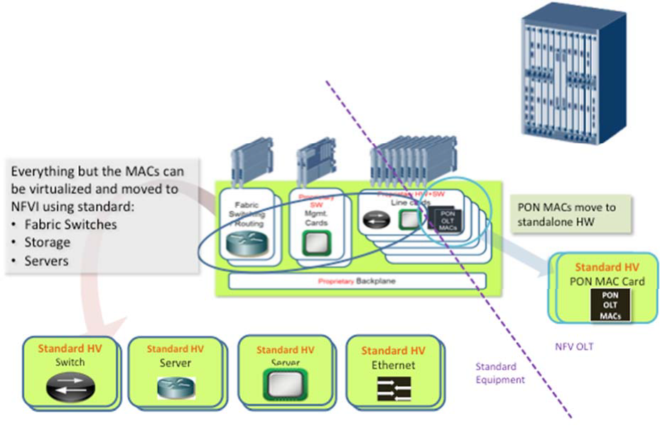

Figure - Virtual OLT

Figure 1 shows the disaggregation of a typical OLT and the mapping of its functions to NFV infrastructure. The backplane or fabric of the OLT is mapped to the fabric of NFVI (ToR and EoR / leaf & spine switches). The interfaces to the fabric (what were card edge connectors) become simple Ethernet interfaces. The control and management functions are embodied in SDN control and Orchestration with a software stack that will be described shortly. Processing and configuration are mapped to compute and storage in NFVI. The figure shows that almost all the components in an OLT, those to the left of the dashed line, can be mapped to standard high‐volume (HV) components found in NFVI. The exception is in the XGS-PON PHY and MAC. Those are not typically found in NFVI and this specification describes a standard HV device that supports them.

In the Virtual OLT, the application of the AT&T Open XGS-PON 1RU OLT is to facilitate attaching XGS-PON silicon to the fabric of NFVI – as shown in Figure 2.

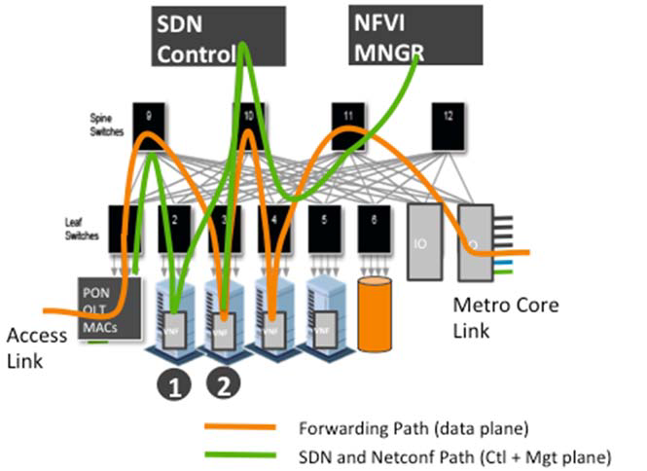

Figure - Typical application of XGS-PON 1RU OLT

Figure 2 shows the Open XGS-PON 1RU vOLT attached to typical ToR (Leaf) switches in the lower left corner. Shown prominently at the top are processes that are run inside the compute VNFs at point 1 and 2. These processes provide the management and control plane functions that manage and control the overall system including the XGS-PON silicon within the Open XGS-PON 1RU OLT.

The software used to support this system is partly shown in Figure 3. At the lowest level of the figure we find firmware and hardware drivers that are part of the software loaded and run on the BCM68620 SoC chip. That software is loaded on the chip and then subsequently configured and managed through a matching low‐level API along with an OMCI stack which is run on a commodity data center (DC) server. These elements are colored blue because they are proprietary and specific to the BCM68620, and would need to be replaced to support other chips and PHY technologies.

The next layer up is shown in purple and represents open source software. The lowest layer of this software consumes OLT API calls and OMCI signaling and creates a homogenized abstraction of an OpenFlow controlled OLT – largely patterned after an Ethernet switch. This abstraction is then plugged into the southbound side of an OpenFlow agent and configuration management block, and that software comprises all the code to generically manage and control the Open XGS-PON 1RU OLT.

The next layer in the software stack is an OpenFlow Controller and configuration. These might be combined or separate software. Finally, in green, we see the applications that embody the control plane and management applications for a number of access technologies and instances of each.

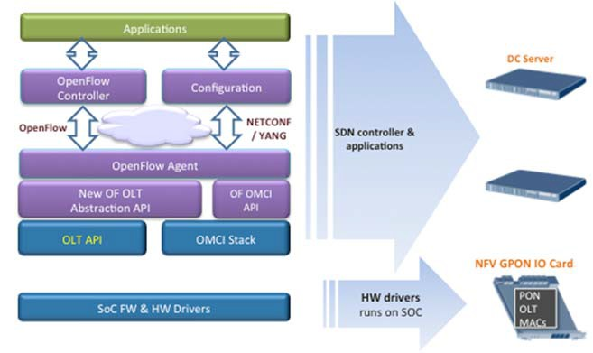

Figure 2 - Software stack for Open VOLT XGS-PON 1RU OLT

To support this application, the Open XGS-PON 1RU OLT minimizes the number of components populated on the system board and leverages external, scalable, available and re‐usable components instead.

This is the most basic and economic instantiation of this design. Management is performed through external processes and is communicated through a virtual LAN that isolates that traffic from customer traffic. Specifically, there is a need to support OOB (out of band management) LAN. The design does still support a variety of power supply options, airflow options, and a baseboard management controller (BMC) to manage these resources.

# Mini OLT

The next application of this technology moves to the opposite extreme. In this case the Open XGS-PON 1RU OLT is extended with Processing, Storage, and an internal PCIe communications to facilitate the device becoming a stand-alone OLT system. From a hardware perspective, the board is populated in addition to the components of the virtual OLT with a CPU and RAM, and Flash storage. This application is useful in one-off applications, in lab and development environments, and in places where NFVI isn’t available or desired. The software stack for this device can be identical to that used in the virtual OLT: where either part or even all the software shown in Figure 3 is hosted on the onboard CPU. However, it is also possible to optimize. For example, control and management applications could be written directly to the merchant silicon APIs. Obviously, hybrid approaches are also possible by making other software placement choices, and other software not shown above could also be run on the CPU. Note however, that this design has several single points of failure, and is not as robust from the perspective of availability as the virtual OLT.

# Timing

The next application covers a case for timing distribution. This application is largely independent of the previous ones. That is, regardless of whether there is an onboard software, processor and storage, there are situations when distributing timing is desired. The typical case for including timing distribution is where XGS-PON is used to provide backhaul for cell sites, but this is not a universal requirement for using GPON for cell site backhaul. In this application a Synchronization Management Unit is added to the system to facilitate SyncE and IEEE 1588 timing paths.

This overall design supports all the aforementioned use cases, and allows the omission or depopulation of various components as manufacturing options to source the device for the various use cases.

# XGS-PON Network

A 10 Gigabit Services PON (XGS-PON) network supports symmetrical 10G/10G communications to enable a variety of applications. Some key features include:

* Data rates of : ~10Gbps (9953Mbps) DS/~10Gbps (9953Mbps) US
* At least 128 ONTs (downstream PON endpoints) per PON Link
* ToD synchronization
* ONT power saving operation
* Optional downstream AES encryption for each port
* IPv6
* Dual-stack IPv4 and IPv6
* Symmetric bandwidth allocation

Figure 4 shows a typical XGS-PON Network.

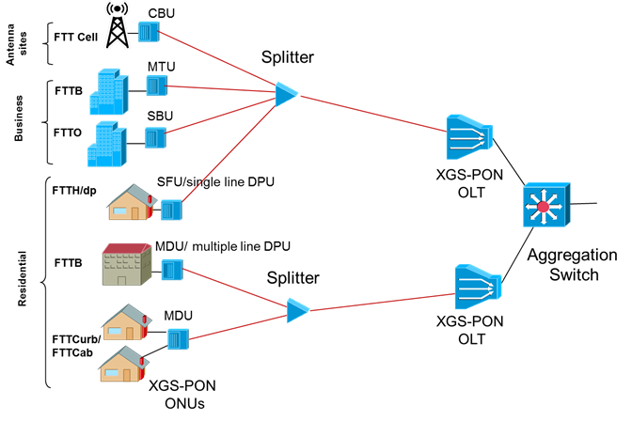

Figure 3 - XGS-PON Network

# System Overview

An overview of the system in terms of functional blocks is seen in .

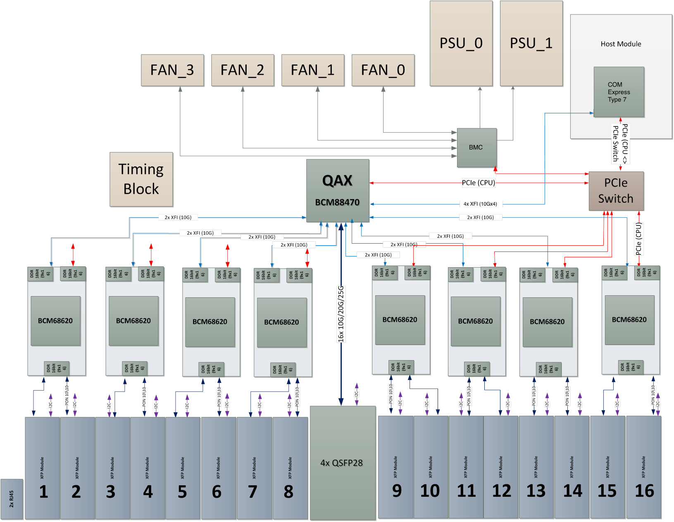

Figure 8 - Main system Block diagram

The block diagram in Figure 8 shows 8x BCM68620 devices connected to the QAX switch.

* The BMC provides basic chassis management.
* All main devices are managed either: inband from remote management software, by the main CPU block using PCIe interface and PCIe switch devices to allow all devices connectivity. The BMC is an alternate master device for management and redundancy.
* The CPU block also provides optional remote LAN management – both inband and out of band.
* Inband connectivity supports additional bandwidth for VNFs hosted onboard.
* All the chassis devices are connected through an I2C network such as FANs, PSUs, Thermals, System LEDs
* The BMC provides I2C multi master support, and Chassis Management arbitration.
* Each BCM68620 SoC connects directly to the PON XFP cage using the PON link physical connection. Also two 10G XFI links connect to the QAX device for the network uplink.
* Redundancy is managed by the QAX switching matrix.

The Open XGS-PON 1RU vOLT system is a physical 1RU box and consists out of the following functional hardware modules:

## xPON SoC – Broadcom BCM68620

* The BCM68620 is a high-performance, single-chip, cost-effective OLT PON MAC SoC with support XGPON1, XGS-PON, NGPON2 and 10G-EPON.
* The SoC is able to provide two ports of XGS-PON (10G/10G) or NGPON2 links.
* The BCM68620 integrates NNI SerDes and MAC interfaces, ICF (Interconnect Function), PON MACs, and Burst mode PON SerDes interfaces.
* Supports external packet buffer for XGPON1/NGPON2/XGS-PON reassembly. Supports 800 MHz, 32-bit DDR3
* Size: 33 mm X 33 mm

## Host CPU

The Host Module will use standard COM-Express type 7 form factor and interface. This supports choosing from a variety of different CPU options with different performance and price points including Intel Rangeley, D-1500, and ARM. COM-Express allows for different form factors in a compatible mounting strategy which this platform will support. A typical Host CPU for stand- alone OLT might include D-1500 2 to 4 Core with 16G RAM and 64G M.2 SSD.

## BMC

* Serves for general box management
  + For example: I2C control, LEDs, Interrupts + I/O expender, Fan and PS control, Power sequencing
* Open BMC

## Broadcom BCM88470 QAX - Switching & TM device

* The BCM88470 is a high-performance, single-chip, cost-effective switch and traffic manager
* Performance - 300Gbps; 300Mpps
* Line Interfaces - 120x1GE, 48x2.5G, 2x100GE,48x10GE,16x40GE,4xILKN
* OAM, 1588, SyncE Telecom DPLL
* TM - 32K queues, 32Mb on-chip buffering, Packet packing for improved burst absorption
* Max classification rules – can be the number of LLIDs/GEMs (Tunnel IDs) – 64K
* Size: 40x40 mm

# Physical Overview

## Maximum Dimensions

|  |  |  |
| --- | --- | --- |
|  | Inches | Millimeters |
| Length - | 24 | 609.6 |
| Width – 19” rack | 17.5 with ears for 19” | 444.5 |
| Height – 1 RU | 1.75 | 44.45 |
| Note: Width does not include mounting ears – which must have holes or closed slots. Depth does not include PSU handles. | | |

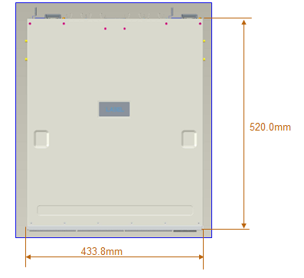

444.5mm

609.6mm

## Top View

The top view of the Open XGS-PON 1RU OLT shows the PCBs and associated components in the system (illustrative only).

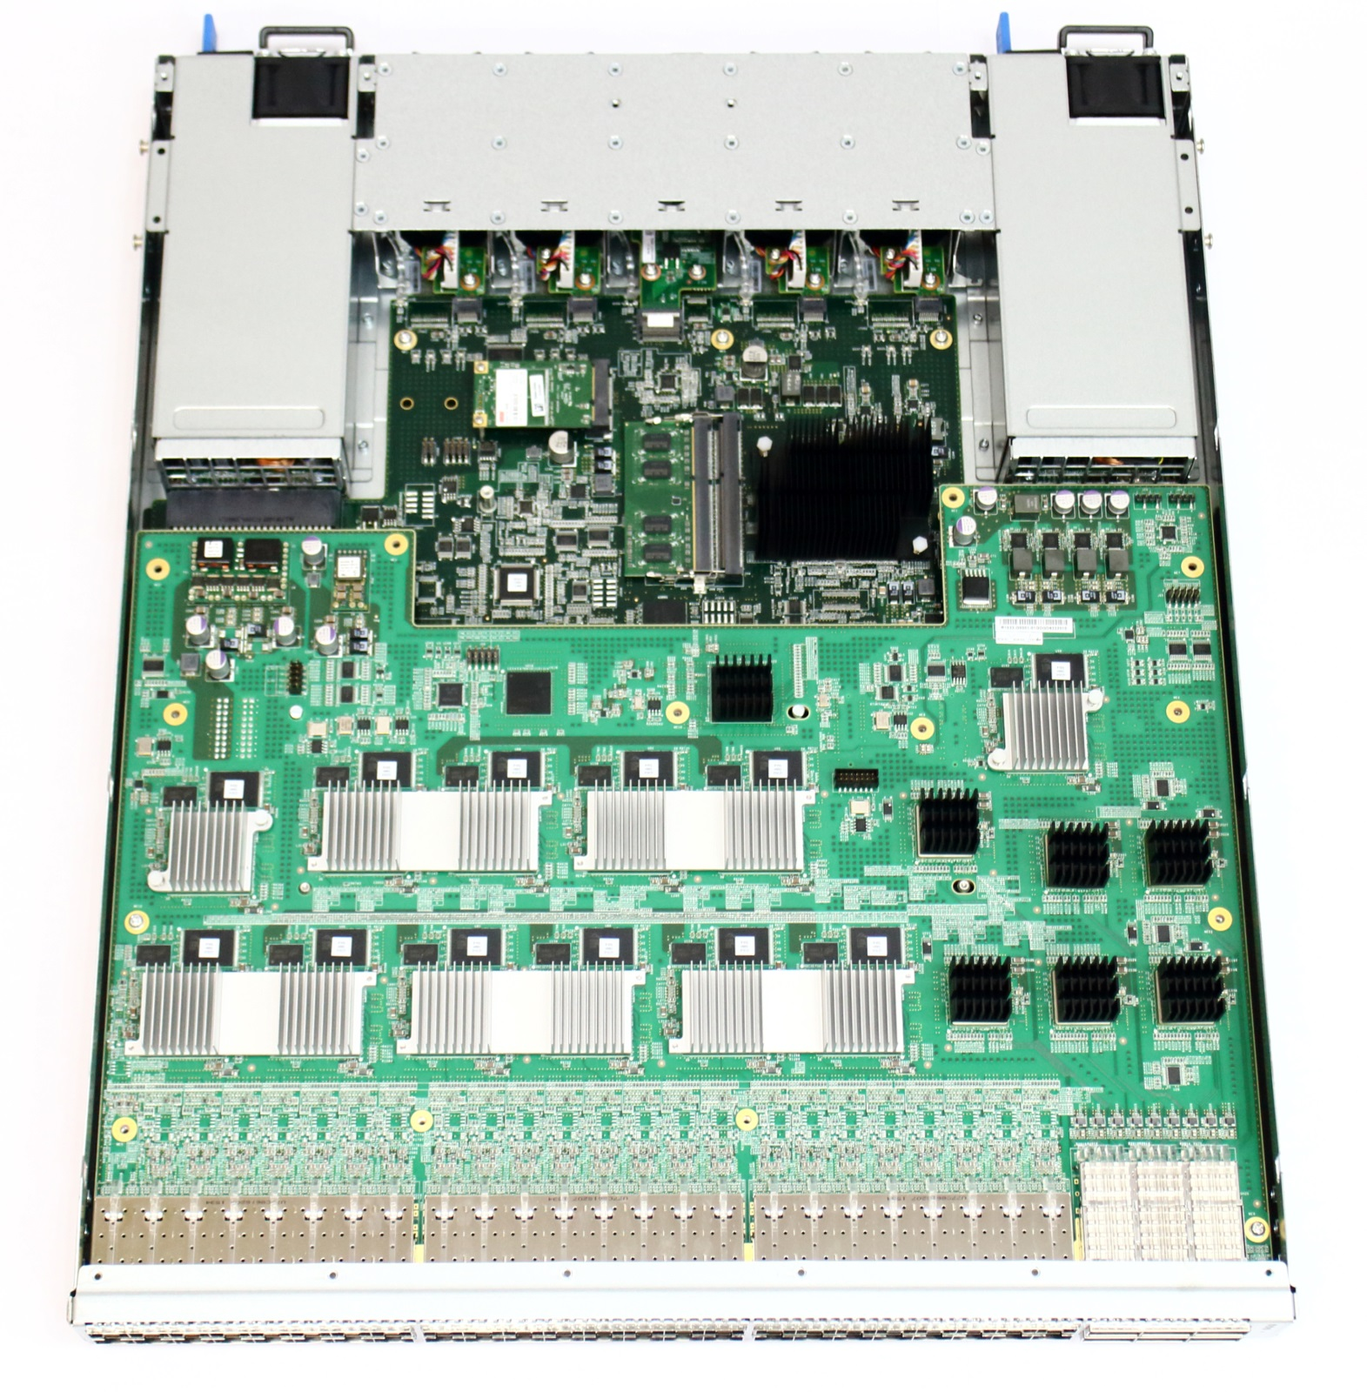

5

4

3

2

1

5

* 1. Hot swappable power supply #1
  2. Hot swappable fan modules
  3. Hot swappable power supply #2
  4. CPU system
  5. 8 XGS-PON devices and 1 aggregating switch – 8 x BCM68620 + 1 x BCM88470

## Front View

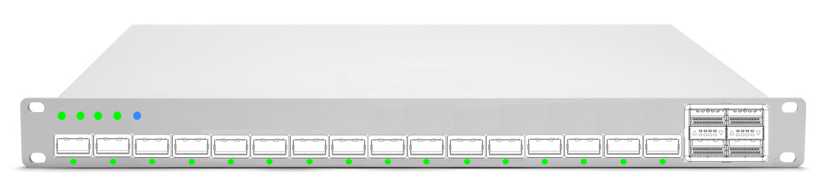

Figure - Front Panel (Illustration only)

* PON Links: 16x XFP ports
* Uplink Ports: 4x QSFP28
  + Each module supports up to 4x 25Gb per link
* LEDs
  + XFP Module status
  + QSFP28 port status
  + System and PSU LED indicators
  + System Finder LED

## Rear View

* Four (3+1) redundant hot swappable fan modules (Including Color coding to indicate airflow direction)
* Two redundant hot swappable power supply modules
  + LED per power supply to indicate status
  + Color coding to indicate airflow direction



Figure 17 - Rear Box (Illustration only)

2

1

## Panel LED Definitions

|  |  |  |
| --- | --- | --- |
| LED Name | Description | State |
| PSU1 | Led to indicate status of Power Supply 1 | Green ‐ Normal  Amber ‐ Fault  Off – No Power |
| PSU2 | Led to indicate status of Power Supply 1 | Green ‐ Normal  Amber ‐ Fault  Off – No Power |
| Diag | LED to indicate system diagnostic test results | Green – Normal  Amber – Fault detected |
| FAN | LED to indicate the status of the system fans | Green – All fans operational  Amber – One or more fan fault |
| LOC | LED to indicate Location of switch in Data Center | Blue Flashing – Set by management to locate switch  Off – Function not active |
| XFP LEDS | LED built into  XFP cage to indicate port status | On Green/Flashing – Port up with active ONTs  Flashing indicates activity  On Amber – Port up with no active ONTs  Off – No Link/Port down |
| QSFP Break out LEDs | Each QSFP28 has four LEDs to indicate status of the individual 10-25G ports | On Green/Flashing – Individual 25G port has link at 25G. (yellow for 10G?)  Flashing indicates activity  Off – No Link |
| OOB LED | LED to indicate link status of 10/100/1000 management port | On Green/Flashing ‐ port has link  Off – No link |

### XFP Interface Module support

|  |  |
| --- | --- |
| 10Gb XGS-PON XFP Modules | Standard 10Gb XGS-PON XFP modules |

### QSFP+ Interface Module Support

|  |  |
| --- | --- |
| 100Gb QSFP28 Optical Modules | Standard 100Gb QSFP28 modules including but not limited to: |
| 40Gb Optical Modules | Standard 40Gb QSFP modules including but not limited to: 40GBASE-SR4, 40GBASE-LR4, 40GBASE-ER, AOC Cables |
| Direct Attach Copper (DAC) | Standard DAC cables including but not limited to: Passive cable up to 5m, Active cable up to 10m |

## Rear Panel



1

2

2

5

3

4

1

The rear view of the Open XGS-PON 1RU vOLT includes the following key components:

1. Two redundant hot swappable power supply modules
   * LED per module to indicate status
   * Color coding to indicate airflow direction
2. Four (3+1) redundant hot swappable fan modules
   * Color coding to indicate airflow direction
3. RJ45 10/100/1000 Ethernet out of band management port
   * Connected to BMC and optional system CPU
   * Optional serial over LAN for virtual console
   * Optional Sync-E reference source
4. Console Port
5. USB Type A port
   * Used for external storage, updates

## Field Replaceable Units

### Power Supply Modules

The Open XGS-PON 1RU vOLT supports two hot swappable PSUs and needs only one to operate. Please use the below as a general guidelines for the PSUs selection:

* The PSU form factor is 40mmx74mmx185mm.
* The system can support different matching PSU types (e.g. AC or DC) which have the same form factor.
* The power supply hot swappable units should be able to support either AC Input (100~240VAC, 50/60 Hz) or DC input (-48V DC).

460W AC PSU (support forward and reversed airflow)

Delta DPS460KBD (F2B)

Delta DPS460KBE (B2F)

* Input: 100~240VAC, 50/60 Hz
* Output: 12V/460W
* AC/DC efficiency: >88%(20%~100% load@230VAC/50Hz)
* Hot-swap FRU
* Load-sharing, 1+1 Redundancy

550W HVDC PSU (support forward airflow)

Delta DPS550AB6A (F2B)

* Input: 100~240VAC, 50/60 Hz
* Input: 180~300VDC
* Output: 12V/550W
* AC/DC efficiency: >90%(20%~100% load@230VAC/50Hz)
* Hot-swap FRU
* Load-sharing, 1+1 Redundancy

550W -48V DC PSU (support forward and reversed airflow)

Acbel R1CD2551A-G (F2B)

Acbel R1CD2551A-* (B2F)

* Input: -40.5~-60VDC
* Output: 12V/550W
* AC/DC efficiency: >85% (20%~100% load@-48V)
* Hot-swap FRU
* Load-sharing, 1+1 Redundancy

800W 12V Power Adapter (forward airflow)

Celestica R0978-F0001-01

* Input: 11.5VDC 13VDC
* Output: 12V upto 800W
* Hot-swap FRU
* I2C/SMBUS/PMBUS support
* Load-sharing, 1+1 Redundancy

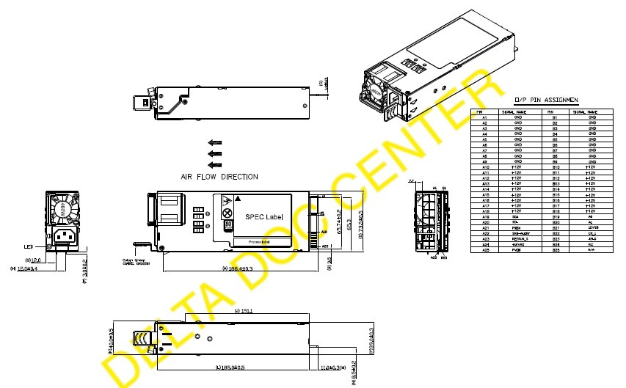

Figure 6 - PSU Specifications

### Fan Modules

The Open XGS-PON 1RU vOLT supports four individual fan modules. Each fan module supports two

40mmx40mmx54mm fans shown below. There are two fan module types, F2B and B2F. Both F2B and

B2F fan module use the same fan, Delta, GFC0412DS‐DC3Y. The only difference is in assembly.

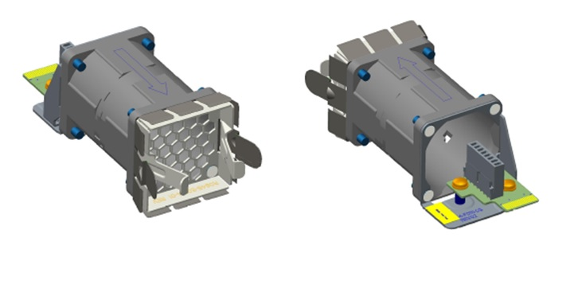

Figure 7 - Fan

Pin assignments of the fan module are shown in the following table.

|  |  |  |
| --- | --- | --- |
| Signal Name | Pin Number | Description |
| 12V | 1,2,3,4,17,18,19 | 12V Power |
| GND | 6,8,9,13,14,15,16 | Ground |
| FAN_n_PRESENT | 5 | Fan module present signal  0: Fan module present  1: Fan module absent |
| FAN_n_F2B | 20 | Indicate Fan air flow  0: B2F  1: F2B |
| FAN_n_TACH | 10 | The TACH signal of the first fan on  the fan module |
| FAN_n_PWM | 7 | The PWM signal of the first fan on  the fan module |
| FAN_n+5_TACH | 11 | The TACH signal of the second fan on  the fan module |
| FAN_n+5_PWM | 12 | The PWM signal of the second fan on  the fan module |

**Table 1 Fan Module Signals Definition**

#### Supporting different Uplink connectivity modes

The Open XGS-PON 1RU vOLT link connectivity and configuration architecture can support various uplink link modes which can be configured differently based on the required BW (e.g. 80G, 100G or 120G). For example -

* For **60G** – the can be configured 6x 10.3G (XFI) mode
* For **80G** – the can be configured 8x 10.3G (XFI) mode
* For **120G** – the can be configured 6x 20.6G mode
* For **160G** – the can be configured 8x 20.6G mode

Figure 18 - vOLT Box Board placement

### XFP Modules placement on the front panel

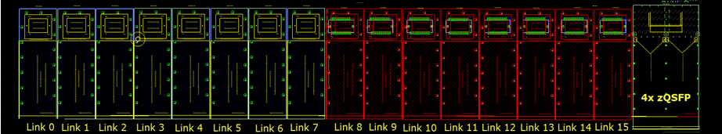This is to illustrate the actual locations of the XFP modules on the front panel (actual layout snapshot)

Figure 19 - Front Panel XFP placement

### PCB Board Set

The Open XGS-PON 1RU vOLT is composed of .

# Optical modules

The Open XGS-PON 1RU vOLT system is designed to support up to 16 PON links. The links will be using XFP modules.

Each BCM68620 device will be connecting to two XFP modules.

* Reference the ITUT standard G.9807.1

# Uplink

The Open XGS-PON 1RU vOLT system is designed to support up to 16 links on the uplink side. All links will be connected directly from the BCM88470 QAX device to the four (2x2) QSFP28 modules placed in the front panel.

The dedicated links from the BCM88470 QAX device towards the QSFP28 modules can be configured to work in different link/SERDES configurations (e.g. 10G, 20G or 25G)

Uplink redundancy is flexible, and uses the QSFP28 modules located on the front panel. Redundancy is managed and controlled by the vOLT application.

# Software Support

The Open XGS-PON 1RU vOLT supports a base software package composed of the following components:

### BMC support

AMI BMC or OpenBMC

### U-Boot (Optional CPU Module)

TBD

### ONIE (Optional CPU Module)

ONIE version 2014.08 or greater will be supported

### Open Network Linux (CPU Module)

See <http://opennetlinux.org/>for latest supported version

### Overall System Software

See http://opencord.org for information and documentation

See <https://github.com/opencord/cord> for software source

# General Specifications

## Power Consumption

The total estimated system power consumption of the AT&T Open XGS-PON 1RU vOLT is ~270 Watts. This is based upon worst case power assumptions for traffic, optics used, and environmental conditions.

|  |  |  |  |  |  |
| --- | --- | --- | --- | --- | --- |
| Main Blocks | Qnt. | Typ. (W) | Max. (W) | Total Typ. (W) | Total Max. (W) |
| 16x BCM68620+ 16x XGS-PON Optics + BCM88470+DDRs | 1 |  |  | <135 | <150 |
| QSFP28 Module | 4 | 3.0 | 3.5 | 12.0 | 14.0 |
| FPGA | 1 | 1.2 | 1.5 | 1.2 | 1.5 |
| PCIe Switch | 1 | 1.5 | 2.0 | 1.5 | 2.0 |
| Timing (DPLL, clocks) | 1 | 0.4 | 0.5 | 0.4 | 0.5 |
| Storage | 1 | 4.0 | 5.0 | 4.0 | 5.0 |
| Fans | 2 | 18.0 | 24.0 | 36.0 | 48.0 |
| CPU + Memory | 1 | 5.0 | 6.0 | 5.0 | 6.0 |
|  |  |  |  | 193.1 | 226.2 |
| Power Supply efficiency (15%-20%) | 1 | 29.0 | 45.2 | 29.0 | 45.2 |
|  |  |  |  |  |  |
| Total estimated Power |  |  |  | 222.0 | 271.4 |

# Specification Requirements

AT&T has established specifications for servers and NFVI communications equipment that are intended to be used in Central Offices. These specs revisit classical NEBs requirements – particularly in the face of new resiliency and availability architectures. Servers that are not a single point of failure for their services (e.g. follow a typical cloud resiliency model) follow ATT-TP-76207. Telco devices that do have or comprise single points of failure for their services including this specification follow ATT-TP-76208. These latter requirements are partially repeated here.

Specifications that require testing must be confirmed by an accredited agency recognized by the National Cooperation for Laboratory Accreditation or ISO/IEC Guide 25 or ISO/IEC 17025.

Note: These specifications are limitations placed on any design. The actual performance of the AT&T Open GPON OLT meets or exceeds these specifications.

## Power Consumption

The total estimated system power consumption must be specified in watts. This is based upon worst case power assumptions for traffic, optics used, and environmental conditions. Typical power consumption should also be provided, as well as heat dissipation.

* ATIS TEER (ATIS-0600015.2009) should be measured and provided (Preferred)
* SPECpower_ssj2008 can be substituted for ATIS TEER (Acceptable)
* US EPA Energy Star Certification is favored.
* Power terminations must be clearly labeled and fully protected with a non-metallic, non-flammable cover.
* ATT-TP-76208 lists additional power requirements for under and over voltage, grounding, and current characteristics.

## Environmental

* Light weight is favored
* 15 to 40°C operating range – de-rated 1°C for every 1000 ft (300 m) above 6000ft (1830m).
* Humidity 5% to 85% non-condensing (operational and storage)
* Vibration – IEC 68-2-36, IEC 68-2-6
* Shock – IEC 68-2-29
* Acoustic Noise Level – Under 78dB in 26 degree C
* Altitude: -200ft (-60 meters) to 6000ft (1830 meters).

## Safety

Fire Spread. Field conditions for telco deployment may require deployment in existing Carrier Communications Spaces that utilize Fire Code Exemptions and do not have automatic fire suppression. NFVI equipment, like the AT&T Open GPON OLT deployed in these locations must meet enhanced fire spread requirements:

Generally, the equipment must meet ATIS-0600319.2014 *Equipment Assemblies – Fire Propagation Risk Assessment Criteria* (see note below).

**Note:** Equipment may conform to this requirement by way of inherent design features that include all four items below:

1. Height of 2 RU or less
2. Horizontally mounted main printed circuit board
3. Metallic 5 sided enclosure with a metallic or non-metallic front cover or faceplate
4. Non-metallic materials shall comply with ATIS-0600307 4.1

For equipment that does not meet the fire spread requirements of ATIS-0600319.2014 by way of inherent design features noted above, the manufacturer must attest that the equipment has successfully passed the burn test as referenced in the ATIS document.

* UL/ Canada
* CB (Issued by TUV/RH)
* China CCC

## Electromagnetic Compatibility

* GR-1089-CORE
* FCC Title 47, Part 15, Subpart B Class A

## ROHS

Restriction of Hazardous Substances (6/6)

Compliance with Environmental procedure 020499-00 primarily focused on Restriction of Hazardous Substances (ROHS Directive 2002/95/EC) and Waste and Electrical and Electronic Equipment (WEEE Directive 2002/96/EC)

1. This type of system is described in ETSI NFV architecture, where it comprises the Infrastructure that supports Network Functions Virtualization – often called NFVI. Additionally, the open software beyond that described in this specification is collected and distributed by the Linux Foundation as part of the CORD project: http://opencord.org