AT&T Open 16 Port
G.fast DPU Specification

Revision 2.0

Authors: Sumithra Bhojan, Thomas Anschutz, Mark Shostak

Acknowledgement
We would like to acknowledge the contribution and partnership of Adtran team led by Fred Chu, Broadcom team led by Jim Muth and Microsemi by Arkadiy Peker in development of this spec. Also to our colleagues at AT&T and at the other Service Providers who provided invaluable insights into how the Open DPU could be used. Lastly, the OCP, without whose support and existence this type of work would not be possible.
-Sumithra, Tom, Mark

Revision History

Revision | Date | Author | Description
1.0 | 11/1/2016 | Tom Anschutz | Initial Release
1.1 | 2/20/2017 | Sumithra Bhojan | Editorial updates
2.0 | 08/31/2017 | Sumithra Bhojan | Detailed design specification of ODPU

Contents
Acknowledgement 2
Revision History 2
Contents 2
Licenses 4
Scope 4
Overview 4
Indoor/Outdoor 5
Twisted Pair and Coax 5
Reverse Power 6
Software Stack 6
G.fast Network Application 7
Physical Overview 10
Maximum Dimensions 10
Top View 10
Front View 10
Panel LED Definitions 12
SFP+ Interface Module support 12
Rear View 13
System Overview 13
Main Block Diagram 13
Functional Hardware Blocks 14
Network Processor 14
G.fast DSP 15
G.fast LD 15
PSU/RPF 15
Figure 9: Reverse Powering Extractor Block Diagram 16
Design Options 16
Bonding 16
Stacking for Greater than 16 Twisted Pair Installations 16
Daisy Chaining 16
Wiring Adaptation Modules 16
Software Support 17
BMC support 17
ONIE (Optional CPU Module) 17
Open Network Linux 18
Overall System Software 18
General Specifications 19
Power Consumption 19
Network Equipment and Power Grounding, Environmental, and Physical Design Requirements 19

Licenses
This specification is contributed under the OCP Contributor Licensing Agreement (OCP-CLA) by AT&T.
Limitations of the OCP CLA license are noted below:
All devices that may be referred to in this specification, or required to manufacture products described in this specification, will be considered referenced only, and no intellectual property rights embodied in or covering such devices shall be licensed as a result of this specification or such references. Notwithstanding anything to the contrary in the OCP-CLA, the licenses set forth therein do not apply to the intellectual property rights included in or related to the devices identified in this specification. For clarity, no patent claim that reads on such semiconductor devices will be considered a “Granted Claim” under the applicable OCP-CLA for this specification.
You can review the signed copies of the OCP-CLA for this specification on the OCP website. http://www.opencompute.org/products/specsanddesign
Usage of this specification is governed by the OCPHL permissive.
You can review this license at http://www.opencompute.org/participate/legal-documents/
Your use of this Specification may be subject to other third-party rights. THIS SPECIFICATION IS PROVIDED "AS IS." The contributors expressly disclaim any warranties (express, implied, or otherwise), including implied warranties of merchantability, non-infringement, fitness for a particular purpose, or title, related to the Specification. The entire risk as to implementing or otherwise using the Specification is assumed by the Specification implementer and user. IN NO EVENT WILL ANY PARTY BE LIABLE TO ANY OTHER PARTY FOR LOST PROFITS OR ANY FORM OF INDIRECT, SPECIAL, INCIDENTAL, OR CONSEQUENTIAL DAMAGES OF ANY CHARACTER FROM ANY CAUSES OF ACTION OF ANY KIND WITH RESPECT TO THIS SPECIFICATION OR ITS GOVERNING AGREEMENT, WHETHER BASED ON BREACH OF CONTRACT, TORT (INCLUDING NEGLIGENCE), OR OTHERWISE, AND WHETHER OR NOT THE OTHER PARTY HAS BEEN ADVISED OF THE POSSIBILITY OF SUCH DAMAGE.

Scope
This document defines the technical specifications for the AT&T Open 16-Port G.fast DPU submitted to the Open Compute Project.

Overview
This document describes the technical specifications of the AT&T Open 16-Port G.fast Distribution Point Unit (ODPU). The system is a physical unit that is self‐contained, and not part of a rack or other physical chassis system. The system is typically deployed in outside plant or in telco closets in multi-dwelling units. The Open 16-Port G.fast DPU is a high-performance access design focused on broadband deployments that support both symmetric and asymmetric speeds with total bandwidth greater than 1Gbps per port with 212MHz. The ODPU is fed using an optical uplink, attached via SFP+ and supporting both Ethernet and PON technologies with Speeds up to 10Gbps.
The ODPU supports 16 customer-facing G. fast ports that can be adapted to either twisted pair or point-to-point coax cables and a single 10Gb upstream SFP+ port.
The Open 16-Port G.fast DPU also allows for power to be supplied by one or more of its customer-facing ports, called reverse power feed, and thus allows the unit to be placed in locations where power is not available. This silicon used in the ODPU provides high throughput at low cost, latency, and power.
Applications of this design include some specific variations and considerations to address a broader market and set of collaborators for this project. Specifically, the set of variations considered include:
- Deployment both indoors and outdoors
- Use of twisted pair or point-to-point coax wiring to the customers
- Including reverse power feed
The three variations are not mutually exclusive, and are now described in more detail.

Indoor/Outdoor

One package is used for the AT&T Open 16-Port G.fast DPU for both indoor and outdoor application. This is designed for deployment in basements, or telco closets in typical MDU locations and as outdoor enclosure, designed for deployment in pedestals, poles, and underground enclosures. This package emphasizes robust weather resistance and environmental robustness, ease of access and modularity of the physical serving interfaces.
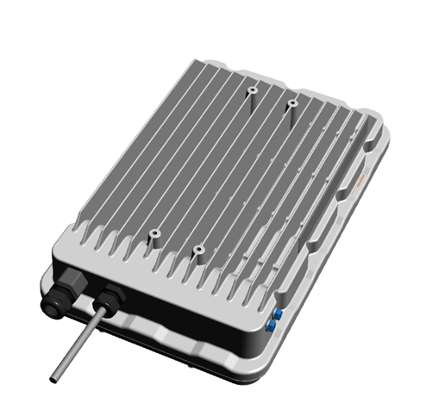

Figure 1 – Indoor/Outdoor ODPU (Source: ADTRAN ©)

Twisted Pair and Coax

This variation for the AT&T Open 16-Port G.fast DPU supports both Twisted Pair and Coax wiring from the ODPU to the customer modem or residential gateway. Coax DPU supports independent Dynamic Time Assignment (iDTA), whereby individual lines can be monitored and controlled that allows each line to have variable TDD frame configuration at each FTU-O as defined in G.9701, amendment 3. iDTA feature enables Service providers to offer maximum bit rate for up/down stream that is nearly equal to the aggregate bit rate.

Reverse Power

Reverse power feed is one of various ODPU powering methods defined in TR-301. Here, the ODPU draws its power from the customer premises via the copper lines between those premises and the ODPU. The reverse power feed capacity and ODPU power consumption need to be such that the ODPU can be fully operational when only a single customer is connected. Any back-up battery would be located in the customer premises. Reverse powering shall have two power splitters (one located at the customer premises and another at the remote node-ODPU) to enable power to be inserted at the customer end of a link and extracted at the remote node-ODPU. Within the remote node -ODPU, if it operates with multiple power-fed lines then there shall be a power extraction and combiner unit. The purpose of this unit is to combine the multiple power feed inputs to produce a single power source output. The power load should be shared amongst the input power sources.

Software Stack

Software to drive the AT&T Open 16-Port G.fast DPU is based on same approach taken for the Open GPON and XGS-PON specs. As shown in Figure 2, and moving from the bottom to the top of the figure, the ODPU has Firmware and a Driver that runs in the silicon and provides a management interface toward a standard management agent called a Persistent Management Agent (PMA). A PMA manages a single ODPU and there is a PMA Aggregator (PMAA) that manages many. In the software stack, we will develop an open scale-out PMA with aggregation included. The ON.Lab VOLTHA project is an open multi-protocol management and control plane agent, and will be used to derive OpenFlow, as well as NETCONF/YANG interfaces to the control plane applications and configuration controllers. From these interfaces upwards, the same applications are used that were developed for GPON and XGS-PON in order to configure and control the G.fast system as part of an access network. This re-use of the networking stack is intentional because GPON and XGS-PON are both popular backhaul technologies for G.fast ODPUs.

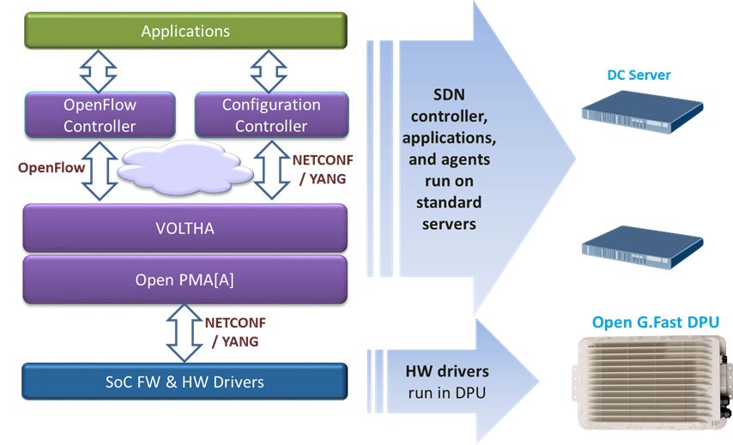
Figure 2 - Software stack for Open 16-Port G.fast DPU

To support this application, the Open 16-Port G.fast DPU minimizes the number of components populated on the system board and leverages external, scalable, available and re‐usable components instead.
This is the most basic and economic instantiation of this design. Management is performed through external processes and is communicated through a virtual LAN that isolates that traffic from customer traffic. Specifically, there is a need to support OOB (out of band management) LAN. The design does still support a variety of power supply options, airflow options, and a baseboard management controller (BMC) to manage these resources.

G.fast Network Application

A G.fast Access network supports customers of various types, including both single and multi-family dwelling units, and including options for one or more customers per ODPU and multiple ODPUs per location. A novel and key feature of G.fast is the ability to reverse-power the ODPU from one or more attached customer ports. This allows placing ODPUs on poles or at the curb where powering is difficult.
Figure 3 shows G.fast Access technology, which is typically deployed in twisted pair or coax loops that are less than 250m, and which support about two gigabits of bandwidth when both directions are added up. The split of bandwidth used for upstream and downstream is configurable, and can be symmetric (e.g. 1Gbpsx1Gbps) or can be asymmetric (e.g. 1.5Gbpsx500Mbps). G.fast can be deployed in various configurations, some of which are shown in Figure 4.
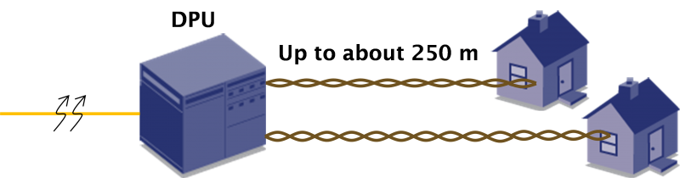
Figure 3 – G.fast Access Technology

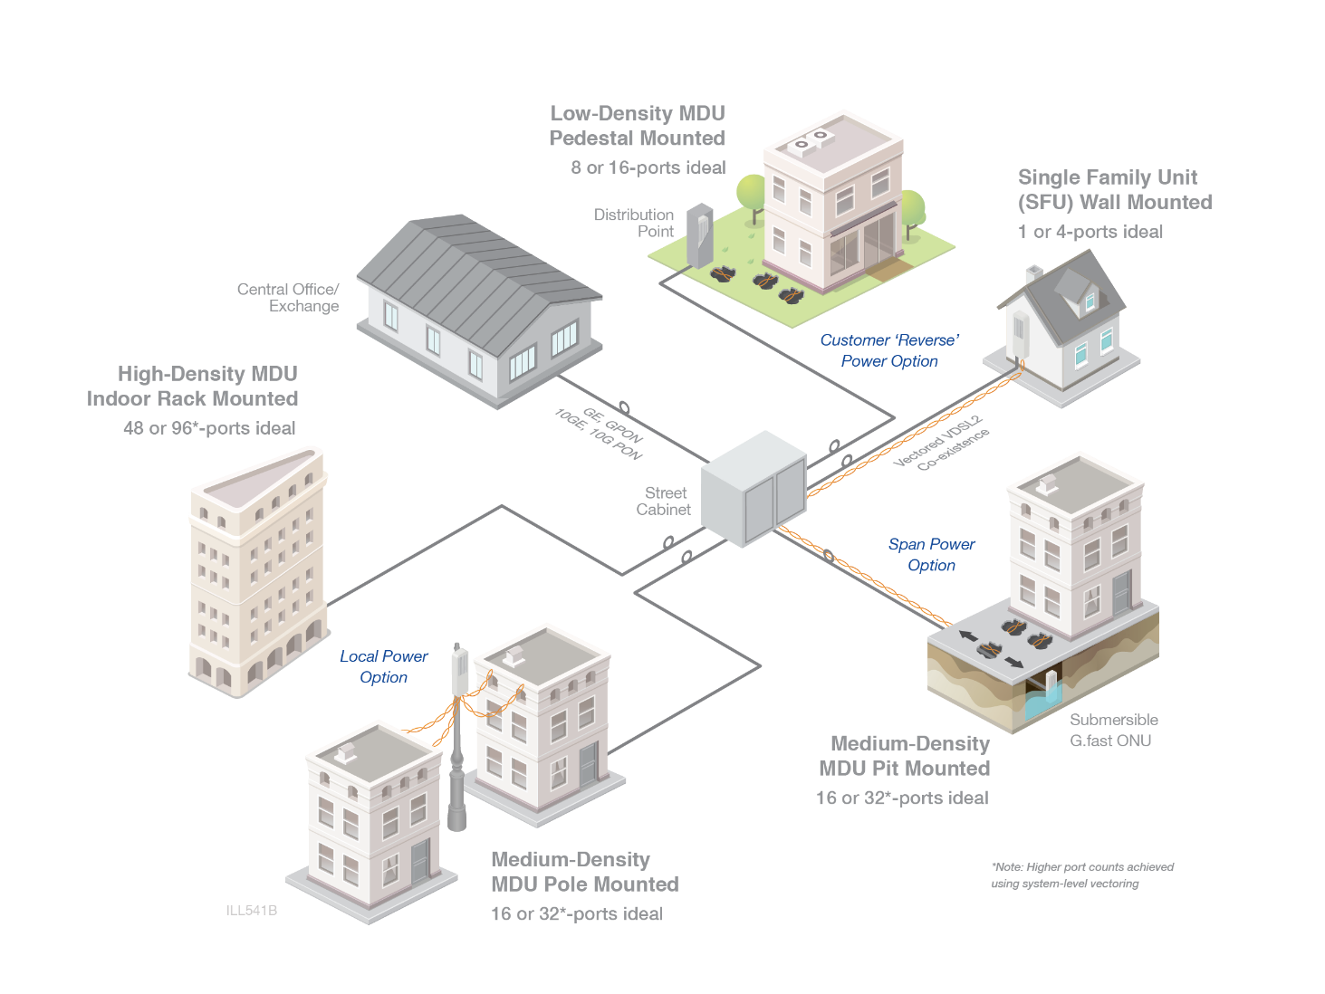
Figure 4 – G.fast Access Network

Physical Overview

Maximum Dimensions

 | Inches | Millimeters
Length - | 20 | 500
Width – | 10 | 250
Height – | 4 | 100

Top View
The top view of the Open 16-Port G.fast DPU shows the PCBs and associated components in the system (illustrative only).

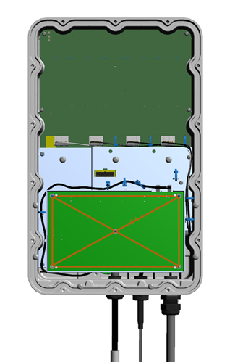

Figure 5 – Top view of 16-Port ODPU (Source: ADTRAN ©)

5

Front View
The front view of the Open 16-Port G.fast DPU shows the access panel for onsite SFP and cable access in the system (illustrative only).

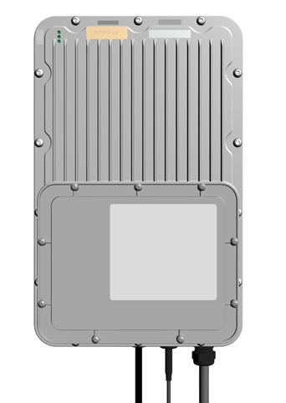

Figure 6: Front view of ODPU (Source: ADTRAN ©)
2
1

Panel LED Definitions
LED | Display | Interpretation
PWR | Off  else  solid Green  else  solid Yellow | Power is off  System is receiving sufficient power  System is receiving insufficient power (Note: For diagnosis purpose only, may not work in all insufficient power condition)
NET | Off  else  slowly Off/Red  else  solid Red  else  fast Red  else  solid Yellow  else  slowly Off/Yellow  else  solid Green  else  slowly Off/Green | Power is off  system is booting  No link to higher order node (HON)  e.g. LOS on GE Uplink, no PON signal or no OMCI on GPON  Future: Initialize DSL port(s) for uplink in CPE mode  Connected to HON, running IP discovery (no valid IP address available)  Connected to HON, valid IP available, connecting to PMA  Connected to and received Hello message from PMA  Updating Flash memory – if possible avoid powering off
CUST | Off  else  slowly Off/Green  else  solid Green  else  solid Red  else  solid Yellow | All subscriber line ports disabled  At least one subscriber line is enabled, but none in Showtime  no fault conditions, no test mode  (incl. in case of CPE mode uplink - future requirement)  At least one subscriber line is in Showtime  no fault conditions, no test mode  (incl. in case of CPE mode uplink - future requirement)  An enabled subscriber line port is experiencing a fault condition  (incl. in case of CPE mode uplink - future requirement)  This shall override any other state of this LED except the test mode.  A subscriber line is in test mode (SELT/DELT/MELT)  This shall override any other state of this LED.

SFP+ Interface Module support

10Gb XGS-PON SFP+ Modules | Standard 10Gb XGS-PON SFP+ modules

Rear View
The rear view of the Open 16-Port G.fast DPU includes the fins for passive cooling.
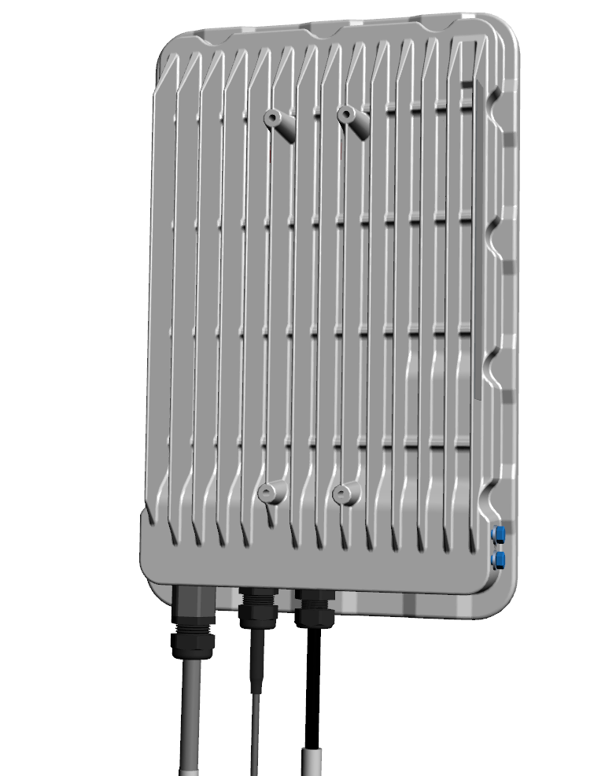

Figure 7: Rear view of ODPU (Source : ADTRAN ©)

System Overview

Main Block Diagram

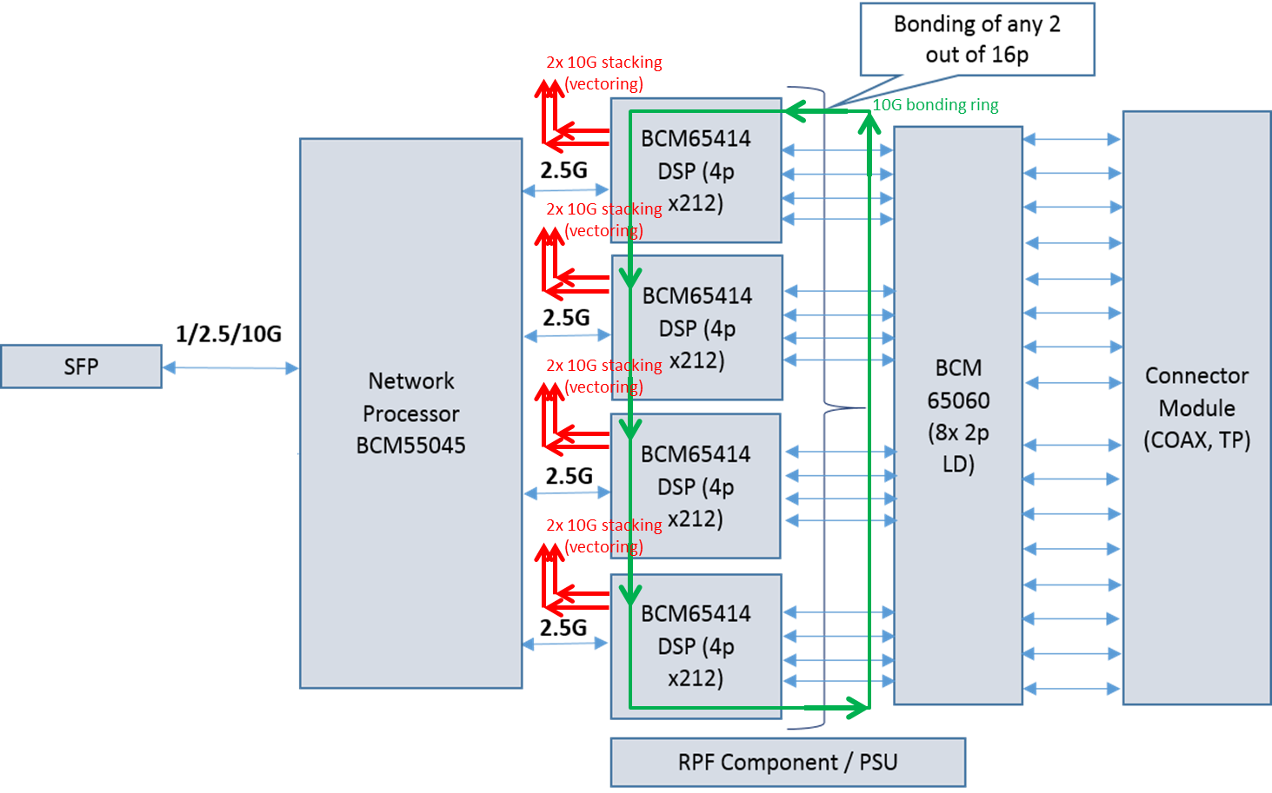
Figure 8 - Main ODPU system Block diagram

The block diagram in Figure 8 shows the high-level block diagram of the ODPU.

- One SFP+ for optical uplink.
- A Network Processor to aggregate the traffic and host the management software.
- Several DSPs as needed to support 16 ports of 212MHz G.fast
- Several Line Driver (LD) chips as needed to support 16 ports of 212MHz G.fast capable of 4dBm/8dBm transmit power
- Reverse Power Feed (RPF) unit comprising of power extraction, sharing and management
- Connector to support several media options

Supporting different Uplink connectivity modes
The Open 16-Port G.fast DPU uplink connectivity and configuration architecture can support various uplink link modes which can be configured differently based on the required bandwidth (e.g. 1G, 2.5G or 10G). For example -
- For 1G – A 1G Ethernet SFP or PON ONT operating at 1G
- For 2.5G – Typically a GPON SFP ONT
- For 10G – A 10G Ethernet SFP+ or PON ONT operating at 10G

Functional Hardware Blocks
The ODPU system consists of the following main HW modules:
Network Processor
The BCM55045 is a highly integrated NPU for NGPON2/XGS-PON/10GEPON/XGPON/1GEPON/GPON.
- Integrated WAN interfaces: NGPON2 ITU-T G.989.3, XGS-PON ITU-T G.9807.1, 10GEPON IEEE 802.3av, XGPON ITU-T G.987.3, 1GEPON IEEE 802.3ah, GPON ITU-T 984.3
- SGMII/HSGMII with support for G999.1, RGMII, XFI
- 10Gbps Layer 2 packet processing, flexible classification and filtering with real time load balancing
- Gen 2 PCIe single lane
- Integrated switching regulators, POR and dying gasp circuitry

G.fast DSP
The BCM65414 integrates both DSP and Analog Front End (AFE) functionalities optimized for four channels of up to Profile 212a G.fast and supporting all ADSL/VDSL profiles up to 35b.
- Standards compliance: ANSI T1.413 Issue I and II, ETSI TR328 and TS101-270, ITU-T G.992.1 (Annex A, B, C, and I), G.992.2, G.992.3 (Annex A, B, J, L, and M), G.992.5 (Annex A, B, J, and M), G.993.2, G.993.5, G.9700/9701, G.996.1, G997.1, G.998.4, and G.999.1
- Dual RGMII, integrated octal 1G, quad 2.5G or single 10G serDes with or without G999.1 support
- NTR, PPS, and ToD support (G993.2 Amendment 7)
- Dual 10G SerDes for line card-level bonding
- Six 10G SerDes for vectoring support at system or board level
- Advanced system-wide power management, including integrated DC/DC controller for 1Vavs
G.fast LD
The BCM65060 is a 4/8dBm capable dual-channel G.fast line driver suitable for profiles up to 212MHz.
- Linear performance up to 212MHz
- Integrated resistors to minimize RBOM
- Single supply operation
- Independent channel bias control
- Low power

Reverse Power Feed (RPF)
Reverse Power Feed unit, as shown in Figure 9, performs start up detection and classification, power conversion, power sharing, monitoring functions. It consists of the following blocks:
- Surge protection circuitry;
- Power Splitter which provides separation of power and GFAST data;
- Diode bridge to provide RPF voltage polarity insensitivity;
- Micro interrupt circuitry to meet WT-301 requirement of 10msec power interruption;
- PD70X01 Front end circuitry controller to facilitate detection and classification according to ETSI TS 101548 MDSU start up protocol;
- DC/DC per port controlled by PD70X01 for power conversion from RPF voltage on the input of DPU to 12V bus;
- RPF PD82000 controller which performs following functions:
- Facilitate current sharing for up to 16 ports;
- I²C Communication with DPU Host;
- Per line current measurement;
- 12 V bus voltage monitoring;
- Supports PGS (Power Good Status) and DDG (DPU Dying Gasp) IRQ signals to host;
- Supports ETSI 101548 Signaling detection from PSE and indication to Host DPU;
- Per line cable disconnect detection;
- Supports LPM (Low Power Mode) to save battery/UPS power on subscriber side.
DPU host should have capability for field upgradability of PD82000 firmware through I2C bus.

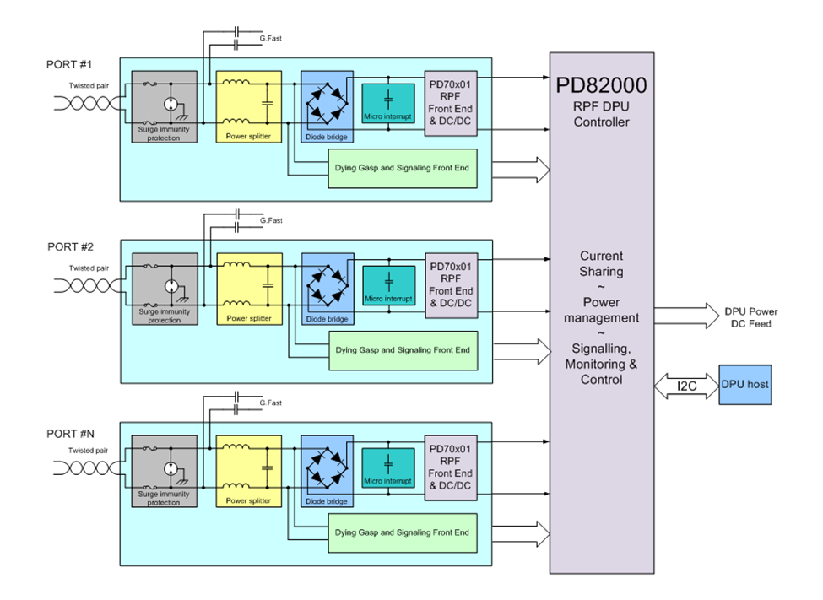

Figure 9: Reverse Powering Extractor Block Diagram

Design Options

Bonding
Any two lines within the ODPU can be bonded, even among lines from different DSPs. When RPF is applicable, bonded CPE modems shall supply power on both pairs.

Stacking for Greater than 16 Twisted Pair Installations
This design option utilizes independent uplinks for each of the ODPU’s that are stacked to increase the capacity. No stacking is required for coax installations as each 16p ODPU is an independent entity. For twisted pair installations, it is optional to have a stacking link between ODPUs to pass vectoring information. This requires 2 QSFPs on each ODPU to enable the DPU stacking option when needed. Note that bonding is not required between ODPU (only within ODPU).

Daisy Chaining
This design option shares a common uplink between 1 or more ODPU’s that are daisy chained. Provisioning, management, discovery and dynamic reconfigurations of the daisy chained device requires challenging systems complexity that are yet to be proven.

Wiring Adaptation Modules
This Specification also supports an optional wiring adaptation module for the AT&T Open 16-Port G.fast DPU to support different wiring from the ODPU to the customer modem or residential gateway. The first option is twisted pair, and the second is coax. Because so much of the ODPU remains unchanged between these options, the design chooses to make the wire termination a modular component of the design, allowing a single ODPU SKU to serve both applications by attaching either a twisted pair or coax module.
Wiring adaptation modules can be connected to the ODPU using a common connector. This module can be inside or outside of the ODPU, most likely an external unit due to challenge with performance on COAX that supports iDTA.

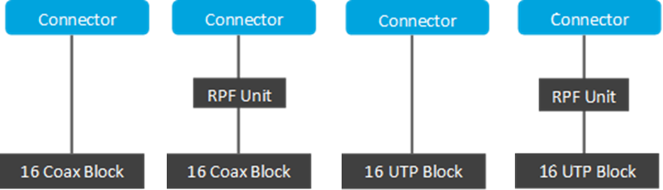
Figure 10 - Wiring Adaptation Module diagram
Figure 10 shows the Wiring adaptation module connected to an ODPU via a common connector to support several media options

- Coax Module
- Coax module with reverse power feed
- Twisted pair module
- Twisted pair module with reverse power feed

Software Support
The Open 16-Port G.fast DPU supports a base software package composed of the following components:

BMC support (Optional)
The BMC allows for managing the ODPU. This can be a software component, OpenBMC, hosted on the network processor to support for system management. The BMC must provide management for the following:
- System, Network Processor, G.fast silicon and RPF module power management
- Temperature monitoring
- Voltage monitoring
- Fan control
- Reset control
- Read the Rx loss and other signals from the SFP+ and G.fast ports
- Host NP Module boot up status
- System Identifier, including ability to set user-defined identifier, as well as control of locator lamp.
- Serial number / unique identifier
- Board revision ID
- I2C interfaces to Host NP, temperature sensors, and voltage controllers.
- Monitoring detect signals

ONIE
ONIE version 2014.08 or greater will be supported for Initialization and firmware updates

Open Network Linux (ONL)
See http://opennetlinux.org/ for latest supported version

Overall System Software
See http://opencord.org/ for information and documentation
See https://github.com/opencord/cord for software source
Below Figure 11, provides a view of software stack including the use of open source for a G.fast ODPU.

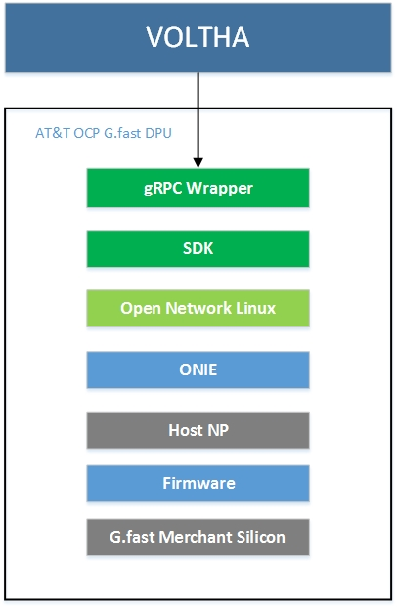
Figure 11 – Software stack for ODPU

General Specifications

Power Consumption
The total estimated system power consumption of the AT&T Open 16-Port G.fast DPU is targeted to be less than ~55 Watts for a fully loaded ODPU (all 16 lines active) and <15W for a single port active ODPU at the ODPU interface FTU-O. This is based upon worst case power assumptions for traffic, optics used, and environmental conditions. Loss of power conversion at various stages need to be considered while designing the ODPU. The requirements for the single port power is based on the SR3 class of the Reverse Power Injector (RPI) at the CPE and deployment distance < 200m.
Below table shows the typical power consumption of fully loaded DPU (all 16 lines active) and with only single port active ODPU of the G.fast system mainboard and provided for reference.

16L ODPU | Full Usage (TYP) | Single Port (TYP)
Active Ports | 16 | 1
System Mainboard Power Consumption (as shown in Block diagram) | 39.0 W | 10.0 W

Network Equipment and Power Grounding, Environmental, and Physical Design Requirements

Equipment must demonstrate conformance to subsets of requirements contained in ATT-TP-76200 depending on the intended application and deployment location(s) of the equipment.

The requirements contained in ATT-TP-76200 apply to equipment systems and assemblies intended for installation in all AT&T network equipment spaces, including, electronic equipment enclosures such as controlled environmental vaults, outside electronic equipment cabinets, and customer locations.

Copies of this document and general information about AT&T’s environmental equipment standards can be found at https://ebiznet.sbc.com/sbcnebs/.

