Agema AGC5648S Switch Specifications
Revision 0.1

Agema System Inc.
Fremont CA

Table of Contents
Table of Contents 2
Version History 4
1. License 5
2. AGC5648S Overview 6
2.1. Features 6
2.2. Main Components 7
2.3. System Block Diagram 8
2.4. Mechanical overview 9
2.4.1. Diemnsion 9
2.4.2. Outline 10
2.5. PCB 11
2.5.1. CPU (TOP) 11
2.5.2. CPU (BOT) 11
2.5.1. SW (TOP) 12
2.5.2. SW (BOT) 12
3. CPU SUBSYSTEM 13
3.1. CPU Subsystem 13
3.2. BMC Subsystem 14
4. SWITCH SUBSYSTEM 15
4.1. Switch Engine 15
4.2. AGC5648S Port Allocation 15
4.2.1. Front Panel Port Number 15
5. SYNC-E & 1588 SUBSYSTEM 16
5.1. System Clock 16
5.1.1. SYNC-E and IEEE1588v2 17
6. PSU SUBSYSTEM 18
6.1. Overview 18
7. MISCELLANEOUS 19
7.1. LED 19
7.1.1. System LED 19
7.1.2. MGMT Port LED 19
7.1.1. PSU LED 19
7.1.1. FAN LED 19
7.1.1.1. SFP28 25G, 10G LED 21
7.1.1.2. QSFP28 100G, 40G, 50G, 25G, 10G LED 21

Version History
Rev | Date | Description | Page | Editor
0.1 | Feb, 2017 | Init |  | WISH.HO

License

This license is based on Open Computer Project Hardware license (Permissive) version 1.0 (“OCP Permissive License”). If you do not agree the terms and conditions of this license, please do not uses,copy, modify, distribute or otherwise utilize this specification. As a recipient of this specification, you are granted (1) the right to use, reproduce, publicly display, and publicly perform this specification which is considered an Improvement under OCP Permissive License, and to modify and prepare derivative works of it, under the copyright owned or controllable by us; and (2) to make, have made, use, offer to sell, sell, import, and otherwise transfer a networking product implementing this specification, under all of our Necessary Claims. If you bring an action (including a cross-claim or counterclaim in a lawsuit) against us or any other recipient of this specification alleging that any product implementing this specification or the use of it directly or contributory infringes any patent, then any licenses granted herein (including copyright and patent licenses) will terminate as of the date such action is brought. For the purpose of this license, the said Improvement does not include an extension or addition of functionality of a Specification, that there is a commercially feasible means of manufacturing it as a separate physical component. Our grant of this license does not prevent any third party from asserting or alleging any infringement of intellectual properties in connection of your implementation or exploitation of this specification. In case of any alleged infringement of any intellectual property, you agree to defend, indemnify and hold harmless us from and against any suits, actions, proceedings, losses, damages, costs, expenses, liabilities and penalties resulting from or arising out of your implementation or exploitation of this specification. This specification is provided“as is”, without any warranties, either express or implied, including, without limitation, non-infringement, merchantability, or fitness for a particular purpose. You are solely responsible for determining the appropriateness of using this specification and assume any risks associated with your exercise of permissions under this license. In no event and under no legal theory, whether in tort, contract, or otherwise, we shall be liable to you for any damages, including any direct, indirect, special, incidental, or consequential damages of any character arising as a result of this license or out of the use or inability to use this specification (including but not limited to damages for loss of goodwill, work stoppage, computer failure or malfunction, or any and all other commercial damages or losses), even if we are advised of the possibility of such damages. All capital words not defined herein shall have the same definitions with OCP Permissive License. The OCP Permissive License supplements this license and the terms and conditions hereunder together with the OCP Permissive License constitute the entire agreement with regard to this license.

As of March 31, 2016, the following persons or entities have made this Specification available under
the Open Web Foundation Final Specification Agreement (OWFa 1.0), which is available
at http://www.openwebfoundation.org/legal/the-owf-1-0-agreements/owfa-1-0:

Agema Systems, Inc.

AGC5648S Overview
The AGC5648S is the next generation carrier switch for Telecommunication Networks. It leverages the 100G technology (4x25G SERDES) to offers 48-port 25G SFP28 and 6-port 100G QSFP28 in a compact 1RU form factor. 2.5 times speed upgrade from current 10Gigabits leaf switch. The 48 ports 25G are backward compatible to 10G and the 100G uplink offer dual speed – 40G and 100G. Total I/O bandwidth upgrade to 1.8T which is 2.5time capacity performance of current 10G downlink and 40G uplink switch (720G). The processor used on AGC5648S is the Intel® Xeon® Processor Broadwell-DE D1548 which is one of the D-1500 product families. There is also one Integrated Remote Management Processor-AST2520 which is a baseboard management controller (BMC).

Features
  - External Serial RS232 port (RJ45 type).
  - Support one USB ports for USB type-A
  - 48 x 25Gbps SFP28 ports and 6 x 100Gbps QSFP28 ports in front.
  - The 25G port support 10G/25G speeds
  - The 100G port support 10G/25G speed by Fanout cable, the port also supports 40G QSFP28 transceiver.
  - 1588 Synchronization
  - SYNC-E Synchronization
  - Front panel 1G Management port. (RJ45 type)
  - Rear panel 1G BMC Management port. (RJ45 type)
  - Front panel LED display for System, FAN and power status indicates.
  - On board high performance CPU system with high density memory, Intel Broadwell-DE D1548
  - Temperature monitoring. (TMP75).
  - Backup BIOS
  - Software readable thermal monitor.
  - RTC time clock support.
  - Hot plugging redundant power supply.
  - Current monitoring for Power management.
  - FAN removable and monitoring.
  - Standard 1U chassis high

Main Components

AGC5648S
CPU | BROADWELL-DE-GP D-1548
BIOS | 32MB NOR FLASH
Memory | 16G DDR4 MODULE *2
Storage | 64GB SLC SSD
MAC | BCM88680CA0KFSBG *2
Packet DRAM | 8G GDDR5 *16
KBP | BCM52311 *2
PHY (OOB Port) | WGI210AT *1  BCM54616S *1
PSU | DPS1600AB13A (1600W AC PSU) *2
DC FAN | MAX 2300 rpm (Front to Rear)
Table 1: Main Components

System Block Diagram W/O SYNCE

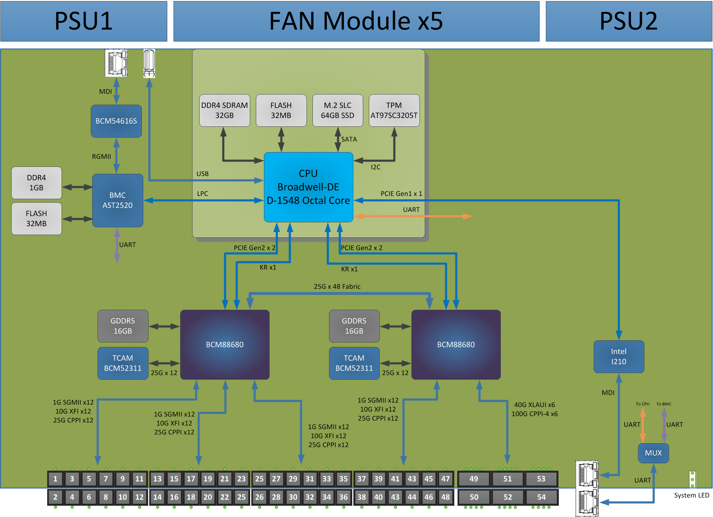

Mechanical overview

Dimension: H(43mm) x W(438.5mm) x L(600mm)
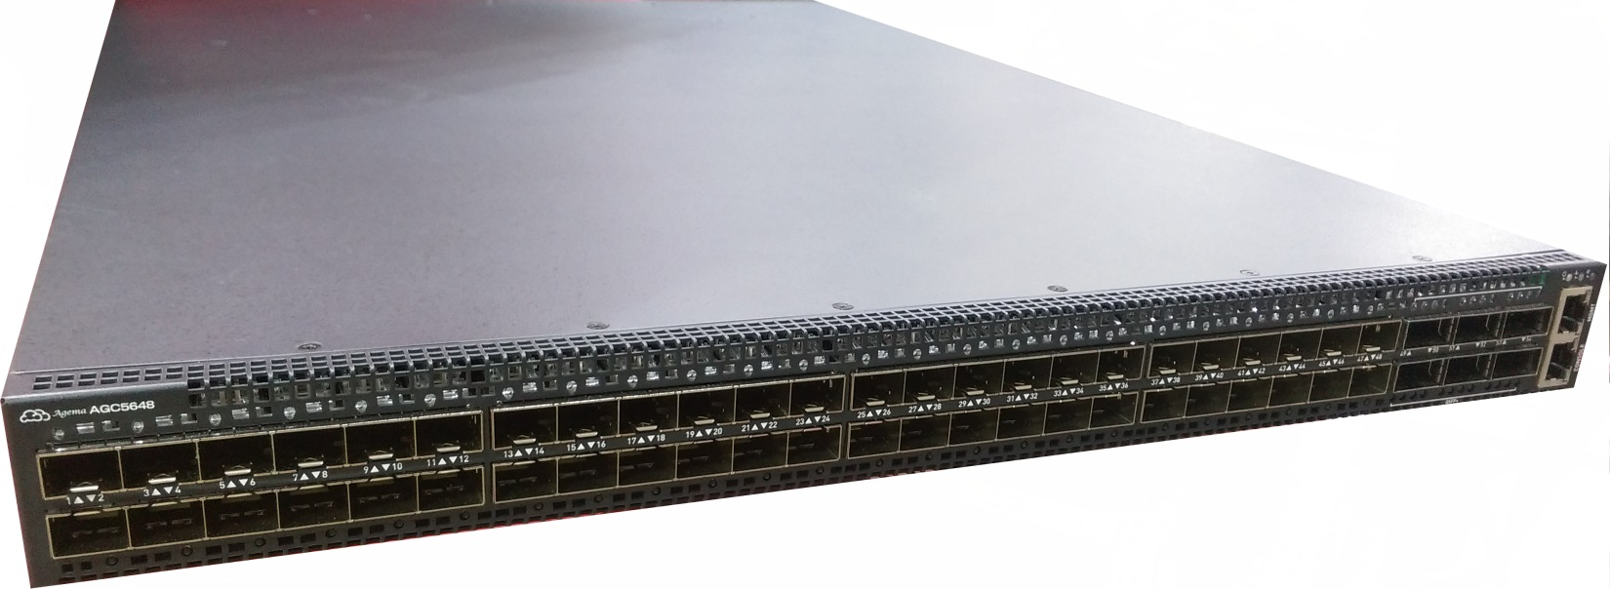

Outline
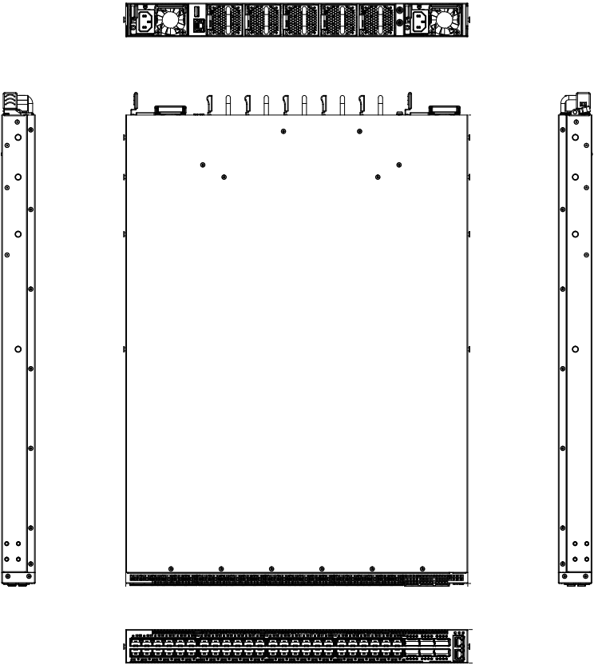

PCB

CPU (TOP)

CPU (BOT)

SW (TOP)

SW (BOT)

CPU SUBSYSTEM

CPU Subsystem
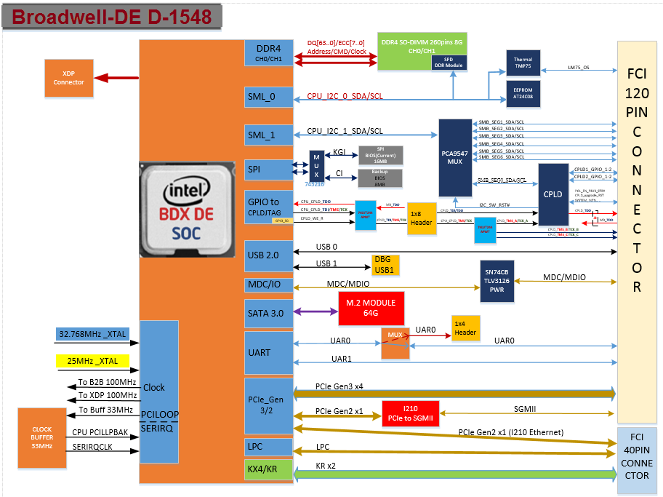
Figure 2: CPU block diagram

BMC Subsystem
A baseboard management controller (BMC) is a specialized service processor that monitors the physical state of a network server or other hardware device using sensors and communicating with the system administrator through an independent connection. The BMC is part of the Intelligent Platform Management Interface (IPMI) and is usually contained in the motherboard or main circuit board of the device to be monitored.

Figure 3: BMC block diagram

SWITCH SUBSYSTEM
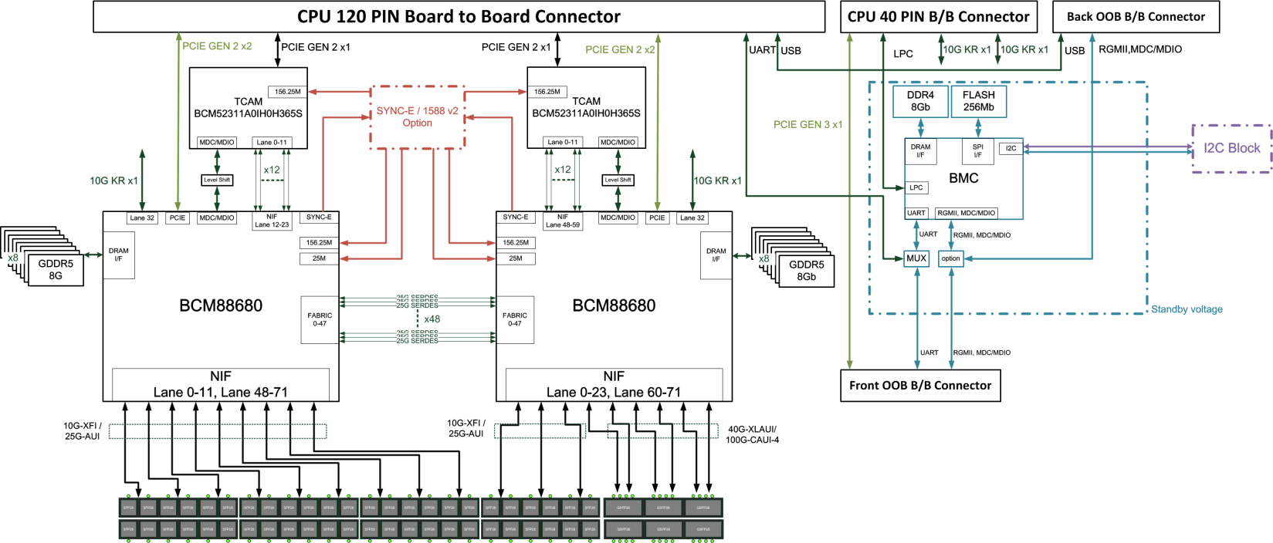
Figure 4: Switch block diagram

Switch Engine
The Broadcom® BCM88680 device process up to 900Gpbs traffic at wire speed, supporting up to nine 100G full-duplex ports at Layer 2 through Layer 4, with integrated deep buffer traffic management capabilities and a fabric interface. The BCM88680 has integrated 1GbE, 10GbE, 25GbE, 40GbE, 50GbE and 100GbE MAC network interface, supporting various port rate combinations.

AGC5648S Port Allocation

Front Panel Port Number

Figure 5: Port Number on front panel

SYNC-E & 1588 SUBSYSTEM

System Clock
Figure 6: SYNC-E & IEEE1588 Block Diagram

SYNC-E and IEEE1588v2
The 82P33714 Synchronization Management Unit (SMU) provides tools to manage timing references, clock sources and timing paths for IEEE1588 / Precision Time Protocol (PTP) and Synchronous Ethernet (SyncE) based clocks. The device supports up to three independent timing paths that control: PTP clock synthesis; SyncE clock generation; and general purpose frequency translation. The device supports physical layer timing with Digital PLLs (DPLLs) and it supports packet based timing with Digitally Controlled Oscillators (DCOs). Input-to- input, input-to-output and output-to-output phase skew can all be precisely managed. The device outputs low-jitter clocks that can directly synchronize lower-rate Ethernet interfaces; as well as CPRI/OBSAI, SONET/SDH and PDH interfaces and IEEE 1588 Time Stamp Units (TSUs).

PSU SUBSYSTEM

Overview
- Features
- Output power: 1600W
- Input: AC 110V~220V
- Output: DC 12V/132A; DC stby 12V/2.1A
- FAN speed: 23000 Rpm
- Air direction: front to rear

- Power Supply Top View
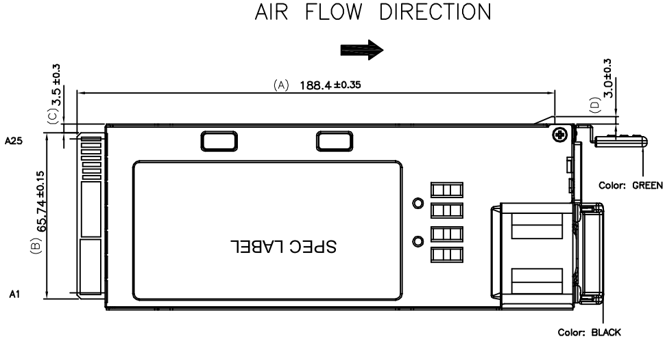
Figure 7: Delta DPS-1600AB-13 A

MISCELLANEOUS

LED

System LED
Feature | Detailed Description | Comment
Power LED | Solid Green – 2 Power Suppliers are supplied to the switch & operating normally  Solid Yellow – Single power supplier is installed and operating.  Blinking Yellow –2 Power Suppliers are installed, but only single power supply is operating.  Off – Power is Disconnected. | At front
System LED | Solid Green – Normal operation  Blinking Green – Booting progress  Solid Red – System is failed  Off – No Power | At front
FAN Status LED | Solid Green – FAN operating normally.  Solid Amber – FAN failed. | At front

MGMT Port LED
Feature | Detailed Description | Comment
CPU 1G OOB Port | Link LED: (on the left side)  Off –No link is established on the port.  Solid Yellow - A valid link at 10/100Mbps is established on the port.  Solid Green – A valid link at 1000/10000Mbps is established on the port.  Act LED: (on the right side)  Off –No link is established on the port.  Blinking green – Activity, transmitting or receiving packet at this port. | At front
BMC 1G OOB Port | Link LED: (on the left side)  Off –No link is established on the port.  Solid Yellow - A valid link at 10/100Mbps is established on the port.  Solid Green – A valid link at 1000Mbps is established on the port.  Act LED: (on the right side)  Off –No link is established on the port.  Blinking green – Activity, transmitting or receiving packet at this port. | At rear

PSU LED
Feature | Detailed Description | Comment
PSU LED | Solid green – Good AC input.  Solid red – NO AC input. | At rear

FAN LED
Feature | Detailed Description | Comment
FAN Status LED | Green – FAN operating normally.  Red – FAN failed. | At rear

SFP28 25G, 10G LED

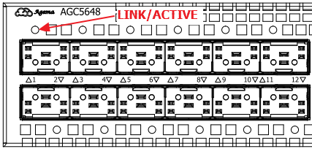

Speed | LED
25G operation | Green
10G operation | Amber

QSFP28 100G, 40G, 50G, 25G, 10G LED

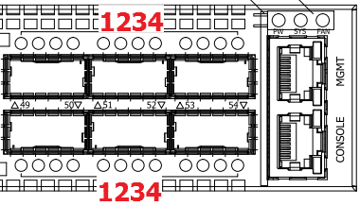

Speed | LED 1 | LED 2 | LED 3 | LED 4
100G operation | Green | Off | Off | Off
40G operation | Amber | Off | Off | Off
50G operation | White | Off | White | Off
25G operation | Blue | Blue | Blue | Blue
10G operation | Purple | Purple | Purple | Purple

~ end of document ~

