General Purpose Enterprise Server Specification
Rev 1.0

Draft for Server Community Review (Read Only)

Author: Alan Chang , Inspur
Author: Jean- Maria Verdun, HPE
Author: Matt , Supermicro
Author: Kevin Hart, Flex

Table of Contents
License 4
OCP Tenets Compliance 5
Openness 5
Efficiency 5
Impact 6
Scale 6
Revision Table 7
Terminology 8
Scope 9
Overview 9
Required Features 10
Future Requirements 11
Rack Compatibility 12
Chassis Dimensions 13
Thermal Considerations 14
Block Diagram 15
Memory Subsystem Requirements 16
I/O Subsystem Requirements 17
OCP 3.0 NIC Interface 17
Network Interface 17
11.11. TPM Support 18
System Requirements 18
Power Delivery 18
Thermal Design 18
Advanced Cooling Compatibility 19
System Initialization Firmware (BIOS) 20
Open System Firmware Binary and Source components 20
System Firmware Source Code Location 20
Open System Firmware licenses 21
Baseboard Management Controller 22
Redfish Interface 22
OCP Profile Support 22
BMC Features 22
BMC Firmware Source Code location 23
Environmental and Regulatory Requirements 24

License
Contributions to this Specification are made under the terms and conditions set forth in Open Compute Project Contribution License Agreement (“OCP CLA”) (“Contribution License”) by:
INSPUR
SUPERMICRO
FLEX
HPE
You can review the signed copies of the applicable Contributor License(s) for this Specification on the OCP website at https://www.opencompute.org/legal-documents
Usage of this Specification is governed by the terms and conditions set forth in Open Compute Project Hardware License – Permissive (“OCPHL Permissive”) ​also known as a “Specification License”.

Note: The following clarifications, which distinguish technology licensed in the Contribution License and/or Specification License from those technologies merely referenced (but not licensed), were accepted by the Incubation Committee of the OCP:
[insert any here]

NOTWITHSTANDING THE FOREGOING LICENSES, THIS SPECIFICATION IS PROVIDED
BY OCP "AS IS" AND OCP EXPRESSLY DISCLAIMS ANY WARRANTIES (EXPRESS,
IMPLIED, OR OTHERWISE), INCLUDING IMPLIED WARRANTIES OF MERCHANTABILITY, NON-INFRINGEMENT, FITNESS FOR A PARTICULAR PURPOSE, OR TITLE, RELATED TO THE SPECIFICATION. NOTICE IS HEREBY GIVEN, THAT OTHER RIGHTS NOT GRANTED AS SET FORTH ABOVE, INCLUDING WITHOUT LIMITATION, RIGHTS OF THIRD PARTIES WHO DID NOT EXECUTE THE ABOVE LICENSES, MAY BE IMPLICATED BY THE IMPLEMENTATION OF OR COMPLIANCE WITH THIS SPECIFICATION. OCP IS NOT RESPONSIBLE FOR IDENTIFYING RIGHTS FOR WHICH A LICENSE MAY BE REQUIRED IN ORDER TO IMPLEMENT THIS SPECIFICATION. THE ENTIRE RISK AS TO IMPLEMENTING OR OTHERWISE USING THE SPECIFICATION IS ASSUMED BY YOU. IN NO EVENT WILL OCP BE LIABLE TO YOU FOR ANY MONETARY DAMAGES WITH RESPECT TO ANY CLAIMS RELATED TO, OR ARISING OUT OF YOUR USE OF THIS SPECIFICATION, INCLUDING BUT NOT LIMITED TO ANY LIABILITY FOR LOST PROFITS OR ANY CONSEQUENTIAL, INCIDENTAL, INDIRECT, SPECIAL OR PUNITIVE DAMAGES OF ANY CHARACTER FROM ANY CAUSES OF ACTION OF ANY KIND WITH RESPECT TO THIS SPECIFICATION, WHETHER BASED ON BREACH OF CONTRACT, TORT (INCLUDING

OCP Tenets Compliance
Please describe how this contribution addresses compliance with three out of the four OCP Tenets.

Note: ​The ideals behind open sourcing stipulate that everyone benefits when we share and work together. Any open source project is designed to promote sharing of design elements with peers and to help them understand and adopt those contributions. There is no purpose in hearing if all parties aren't aligned with that philosophy. The IC will look beyond the contribution for evidence that the contributor is aligned with this philosophy. The contributor actions, past and present, are evidence of alignment and conviction to all the tenets.

Openness

This base specification is jointly contributed by 4x OxM (Inspur, HPE, Supermicro and Flex) , with commitment to have associated products made available to cover the enterprise usage model. The specification requires many of the mature OCP elements as part of the building blocks for the 1U/2U product. GP enterprise service specification also required firmware open source for Openness.

Efficiency
19” 1U/2U form factor as an easy adoption choice for the enterprise community members. We understand that there are many more advanced and efficient designs within the OCP community. However, many of those designs required a much significant change/modification of the existing infrastructure. The goal of the GP Enterprise Server specification is to allow a pathway for end users to adopt many of the mature OCP elements in the conventional 19” form factor so that they can enjoy the outcome/results of the community without taking that “full” step forward of changing their existing infrastructure.

Impact

With at least four OxM signed up for the initial workstream, (Inspur, Supermicro, HPE and Flex) and we anticipate more OxM joined this GP enterprise server discsaision. As a community, we will have a new “baseline” for any future 1U/2U design that makes consuming OCP products (with OCP elements) much easier. All four OxM signed up for the project intent to GTM with an actual product based on this spec in 2021.

Scale

Revision Table

Date | Revision # | Author | Description
2/23 | 0.1 | Alan Chang | initial draft
4/20 | 0.2 | Bill Carter | Format changes, removed vendor specific diagrams and content.
5/26 | 1.0 | Alan Chang

Terminology
Terminology | Definition
Bezel | Aesthetic plastic or metal front-facing cover of a typical computer server.
Cabinet | A freestanding and self-supporting 4-post enclosure for housing electrical and/or electronic equipment. It is usually fitted with access doors and/or side panels, which may or may not be removable.
Chassis | A mechanical structure designed specifically to support associated electrical and electronic components.
EIA-310-D | EIA-310-D is the original document issued by the Electronic Industries Association (renamed the Electronic Alliance in 1997) written to standardize varying features of 19” rack cabinets.
EIA Mounting Flange | The front internal mounting surface within a Cabinet Enclosure or Rack that provides a mounting surface for the server chassis, chassis guides, or slide rails.
Open Units (OU) | An Open Unit, or OU, is 48mm high, and are used instead of Rack Units in Open Rack specifications.
Rack | An open-air structure for mounting electrical or electronic equipment. A Rack is an open Cabinet. There are 2 basic types of Racks, 2-post & 4-post.
Rack Unit (RU) | Equal to 1.75 inches (44.45 millimeters)
Slide Rails | A slide rail is used to mount servers in a 2-post or 4-post rack, and also extend out from the rack for service. There can be sliding, fixed, or tool-less designs.

Scope
This document provides the reference specifications for the General Purpose Enterprise Server of 19” products, detailing the features and functionality of a general purpose 2-socket server board for adoption by the Open Compute Project community. The purpose of this document is to define a common baseline set of features that are most important to general purpose usage by enterprise and private cloud operators. ODM or OEM products will comply with the features sets that are important to “general purpose” usage.

Overview
This product is intended to support usages requiring high storage, compute performance, configuration flexibility, common Redfish-based management, ease of deployment, and supports latest component technologies.

• Fits in a conventional 19” EIA rack.
• Support the highest TDP offering either using air-cooling or advanced cooling.
• Deliver high performance by supporting a minimum of 1 DPC at the highest memory frequency and support a balanced PCIe subsystem.
• Support conventional enterprise storage I/O requirements
• Support the industry standard OCP NIC interface.
• Provide a path for sustainable firmware by making source code available

Required Features
To ensure the delivery of products that can be deployed over a period of time, and assure consistency in the services offered to the client of the cloud data server, certain features must be present in each general purpose server. These features are listed in the following tables

Features | Description
Rack Compatibility | See section 8 for detailed requirements
Processor | Supports up to 2x CPU from any CPU silicon providers.  - 1U system shall support 1 or 2 165W TDP processors  - 2U system shall support 1 or 2 165W TDP processors
Memory | - A Minimum of 1x DPC per CPU  - Support for maximum memory capacity and frequency of silicon of choice.  - Memory protection including ECC, memory mirroring, and memory rank sparing
Storage Requirement | Minimum requirement:  1U Rack: 4* 3.5" and 10* 2.5"  2U Rack : 12* 3.5" and 24* 2.5"
Expansion Slots | Minimum requirement:  1U Rack :  1 * OCP 3.0 slots  1 * M.2 for boot device  2 * PCIe x16 G4 (symmetric)  2U Rack :  1 * OCP 3.0 slots  1 * M.2 for boot device  4 * PCIe x16 G4 slots (symmetric)
Networking | Minimum requirement:  1* 1Gb management port  1* OCP NIC 3.0 slot (with NCSI)
Management | See Section 14
Security Feature | TPM 2.0 (either module or on baseboard)

Future Requirements
Future revisions of this specification may require features below:

Feature | Description
Storage | E.1S as option storage option in additional to the 4 ea 3.5” devices and 10 ea 2.5” devices
Management | Modular DC-SCM, RunBMC as 2022 requirement
Security Feature | Root of Trust (RoT)  Attestation

Rack Compatibility

Requirement | Status
The server chassis SHALL compliant with the EIA-310-D (or later) standard | Required
The server chassis SHALL be designed to fit in racks that are 900mm to 1000mm in depth. | Required
The chassis bezel and pull handles SHALL not extend more than 50mm beyond the EIA Mounting Flange. | Required

Chassis Dimensions
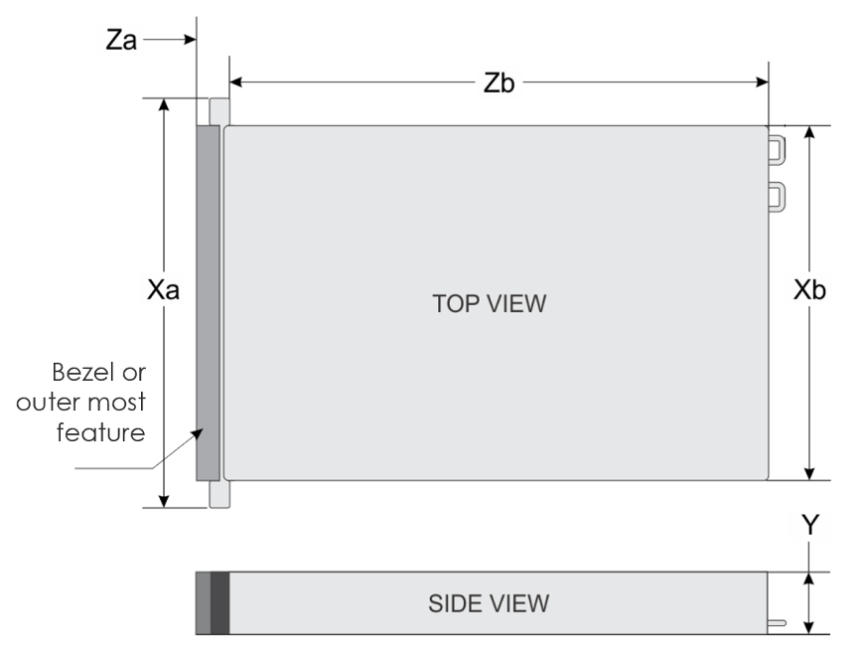
System | Xa | Xb | Y | Za (with bezel) | Zb
2U Chassis | 483.4mm max | 450mm max | 87.9mm max | 50mm max | 848mm max

Requirement | Status
For Za, the bezel, pull handles, or outer most features should not exceed a maximum of 50mm beyond the front mounting flange, which allows for space to the cabinet door and airflow. | Required
The chassis height (Y) should not exceed a maximum of 87.9mm to account for stack-up tolerances, along with chassis sag and bow concerns. | Required
The total chassis length (Za + Zb) should allow space for server cables of about 152mm, and should not exceed a maximum of 748mm for 900mm rack depth, or 848mm for 1000mm rack depth. | Recommended

Thermal Considerations

Requirement | Status
The system should support front to back air flow in air-cooled environments. | Required
Support for liquid cooling should comply with the ACS Project recommendations. | Recommended

Block Diagram
General Purpose Server baseboard supports two processors and a minimum of 1x DPC. The CPUs are interconnected over either UPI or any high speed interconnect link provided by the silicon vendor.

Connected to three onboard PCIe slots via the PCIe bus, the processor supports a maximum of two PCIe Gen4 x16 full-height half-length cards or two PCIe Gen4 x16 half-height half-length cards and one PCIe Gen4 x16 full-height half-length card.

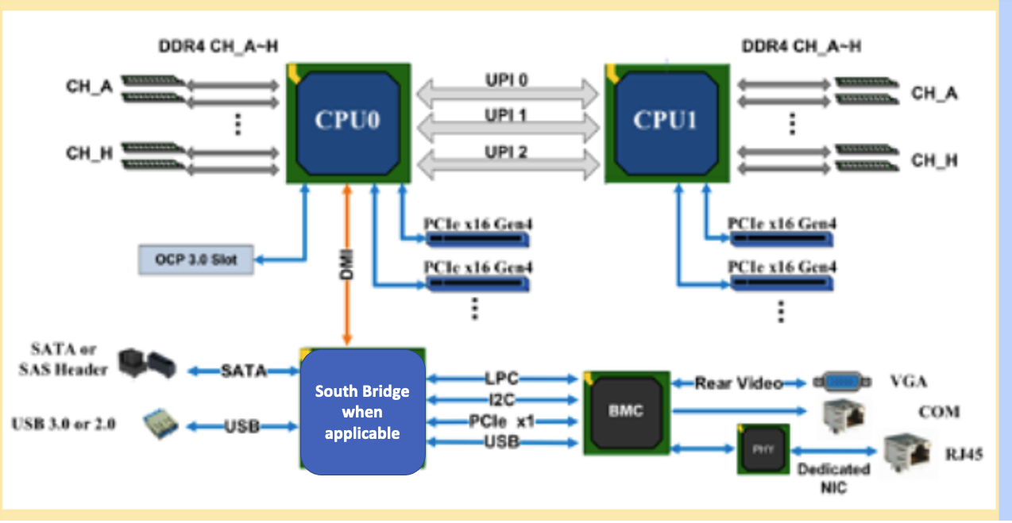
Figure 3: Reference - block diagram motherboard block diagram (alan)

Memory Subsystem Requirements
GP Enterprise Server will call out minimum 1x DPC per CPU. A maximum of two memory slots for each memory channel, DIMM0 & DIMM1 shall have different color code upon OxM choice for user to easy identify

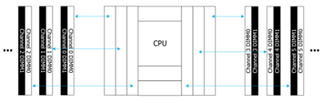

I/O Subsystem Requirements

OCP 3.0 NIC Interface
The OCP GP Server SHALL support one OCP 3.0 module at a transmission rate of 1 Gbit/s, 10 Gbit/s, 25 Gbit/s, 40 Gbit/s, or 100 Gbit/s, which is configurable. The connector pin definition must follow the OCP NIC 3.0 Design Specification
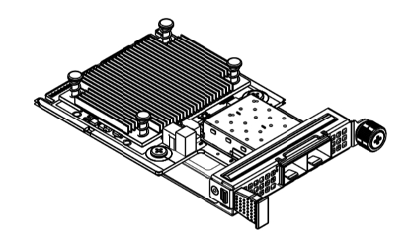

Figure: OCP 3.0 module (reference only)

Network Interface

The General Purpose Enterprise Server system data network shall use a Single or Dual Port OCP 3.0 NIC module .

For the Management network baseboard has two options of management network interface for BMC’s connection.
a) One dedicated RJ45 port for Board management and shares data network’s physical interface, driven by BMC through RMII/NC-SI.
b) One OCP NIC 3.0 shared-NIC, driven by BMC through NCSI.

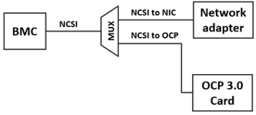

Figure: BMC managerial network topology (reference only)

11.11. TPM Support

Must support TPM module

System Requirements

Power Delivery
The system SHALL support 2 power supplies and support 1+1 redundancy.

Thermal Design
To meet thermal reliability requirements, the thermal and cooling solution should dissipate heat from the components when the system is operating at its maximum thermal power. The thermal solution should be found by setting a high power target for initial design in order to avoid redesign of cooling solution; however, the final thermal solution of the system should be optimized and energy efficient under data center environmental conditions with the lowest capital and operating costs. Thermal solution should not allow any overheating issue for any components in the system. CPU or memory should not throttle due to any thermal issue under the following environment.

- Inlet temperature lower than or equal to 35°C, and 0 inch H2O datacenter pressure with all FANs in each thermal zone running properly
- Inlet temperature lower than or equal to 35°C, and 0.001 inch H2O datacenter pressure with one FAN (or one rotor) in each thermal zone failed

  - Operational Conditions

Altitude: 0 to 914 meters (3000 feet) ; Operating temperature 0 to 35 degrees Celsius
Altitude: 914 to 2133 meters (7000 feet) ; Operating temperature 10 to 32 degrees Celsius

Operating relative humidity: 10%~90% R.H
Storage relative humidity: 10%~93% R.H.

Working temperature: 5~35°C (heat dissipation needs to be clear at (35°C /40°C /45°C)
Storage temperature range: -40~+70°C

Advanced Cooling Compatibility

A system that supports or utilizes liquid cooling using cold plate technology SHALL comply with the ACS Liquid Cooling Cold Plate Requirements document revision 1.0 or later.

A system that supports or utilizes Immersion Cooling SHALL complies with the Immersion Requirements document revision 1.0 or later.

System Initialization Firmware (BIOS)
System System Firmware must comply with the OCP Open System Firmware Checklist (v1.1) or later.
A pdf of the v1.1 checklist on the OSF Wiki: https://www.opencompute.org/wiki/Open_System_Firmware/Checklist​.

Open System Firmware Binary and Source components
For any monolithic servers that receive the OCP Accepted™ or OCP Inspired™ certification mark SHALL conform to ​OCP OSF checklist​ (v1.1) or later. Binary blobs and source artifacts should, at least, be made available on a third-party repo, e.g. Github.

To make it easy for customers to recreate firmware, ODMs SHALL document where the various components are and how to build a complete firmware image. These documents, instructions, and (e.g.) makefiles SHALL be placed in the repos shown below; however, we do not require that the entirety of (e.g.) the source code be copied into these repos.

For example, if an ODM is using coreboot or Linux, source code SHALL be upstreamed to those projects. The OCP repos can then contain configuration files and, almost certainly, a git hash of the version of the software used. Binary artifacts SHOULD be placed in the OCP repos, as well as a link to the source of the binary(ies), and a license document.

System Firmware

All products seeking OCP Accepted™ Product Recognition must complete the Open System Firmware (OSF) Tab in the 2021 Supplier Requirements Checklist.

If based on an open bios (like AMI’s Aptio-OpenEdition), a completed checklist shall be uploaded and made available on the OCP Github.
Note to authors: replace [vendor_name] and [product_name] with actual company name and product identifier.

Baseboard Management Controller

Redfish Interface
The out-of-band manageability interface of the platform SHALL conform to the Redfish Specification v1.2 and above (DMTF DSP0266, ISO/IEC 30115:2018).

The conformance of the platform should be verified by executing the Redfish Service Validator (​https://github.com/DMTF/Redfish-Service-Validator​) and the Redfish Service Conformance Check (​https://github.com/DMTF/Redfish-Service-Conformance-Check​).

14.2 Compliance
All products seeking OCP Inspired™ or OCP Accepted ™ Product Recognition shall comply with the OCP Hardware Management Baseline Profile V1.0 and provide such evidence by completing the Hardware Management Tab in the 2021 Supplier Requirements Checklist.

OCP Profile Support
The platform’s manageability interface SHALL conform to the OCP Hardware Baseline Profile v1.0.0. The platform’s manageability interface MAY conform to the OCP <platform> Profile v1.x.x.

The conformance of the platform should be verified by executing the Redfish Interop Validator (​https://github.com/DMTF/Redfish-Interop-Validator​). The Redfish Interop Validator reads a Profile file as input and will run the tests necessary to verify conformance to the Profile file.

The Profile files mentioned above can be found at https://github.com/opencomputeproject/OCP-Profiles​.

BMC Features
In addition to the requirements described in this section, the BMC must also support the following features:
- IPMI 2.0
- Simple network management protocol (SNMP v1/v2c/v3)
- HTML5/Java remote console (keyboard, mouse, and video)
- Remote virtual media
- Web browser login
- Intelligent fault diagnosis system

BMC Firmware Source Code Availability (If Applicable)

All Products seeking OCP Accepted™ Product Recognition shall have source code and binary blobs submitted for BMC, if applicable.

The BMC management source code shall be uploaded at:
https://github.com/opencomputeproject/Hardware-Management/[vendor_name]/[product_name]

If the BMC is based on an open source BMC (like AMI’s MegaRAC-OpenEdition), the BMC source code shall be uploaded and made available on the OCP Github.

Environmental and Regulatory Requirements

  - Regulations
Region | Certification Item | Certification Logo | Mandatory/  Voluntary
China | 3C |  | Mandatory
 | Environment label |  | Voluntary
 | Energy conservation certification |  | Voluntary
International recognition | CB |  | Voluntary
EU | CE |  | Mandatory
Australia | RCM |  | Voluntary
India | BIS |  | Voluntary
USA | FCC |  | Mandatory
 | UL |  | Voluntary
 | Energy star |  | Voluntary
Russia | CU Certification |  | Voluntary
 | Information security | N/A | Voluntary
 | CU RoHS | N/A | Voluntary
Korea | E-Standby Energy Efficiency Certification |  | Mandatory
 | KC Certification |  | Mandatory

Security
All products seeking OCP Inspired™ or OCP Accepted™ Product Recognition shall have a completed Security Profile in the 2021 Supplier Requirements Checklist. Whether the answer is a yes or no, the profile must be completed. For Additional Security Badges (Bronze/Silver/Gold), please fill out the Security Profile in accordance with the requirements for that level. Security Badges will be reassessed on an annual basis as requirements are subject to change.

Appendix A - Requirements for IC Approval List all the requirements in one summary table with links from the sections.
Requirements | Details | Link to which Section in Spec
Contribution License Agreement | Modified OWF-CLA  Modified OWFa 1.0 Final Spec Agreement | Link to Sec 1
Are All Contributors listed in Sec 1: License? | Yes
Did All the Contributors sign the appropriate license for this spec? Final Spec Agreement/HW License? | Yes
Which 3 of the 4 OCP Tenets are supported by this Spec? | Openness  Efficiency  Impact  Scale | List reasons here.  Link to presentation if separate.
Is there a Supplier(s) that is building a product based on this Spec? (Supplier must be an OCP Solution Provider) | Yes | List Supplier Name(s)  Inspur, Flex, HPE and SuperMicro
Will Supplier(s) have the product available for GENERAL AVAILABILITY within 120 days? | Yes | Please have each Supplier fill out Appendix B.

Appendix B-1 - Inspur Product Requirements
List all the requirements in one summary table with links from the sections.
Requirements | Details | Link to which Section in  Spec
Contact Info: Name/Email
Product Name  SKU#/Model #  Landing Page | Inspur with OCP-inspired - NF5180M6 Intel Icelake Generation
Design Files Contributed (optional) | Inspur | Will provide github with Gerber file, BOM file ..etc
BMC (if applicable) | OpenBMC 1.8 | Github location ..
Rack Compatibility | EIA 19” | Link to Sec 5
System Firmware | Complies with OSF Checklist  (y/n) yes
Management Profile | Redfish | Link to Sec 10
Software Support | N/A | Link to Sec 20
Security | Complies with Security  Checklist (y/n)
Supplier Requirements Checklist | Link
Will they apply for OCP product recognition? | OCP-Inspired

Appendix B-2 - HPE Product Requirements
List all the requirements in one summary table with links from the sections.
Requirements | Details | Link to which Section in  Spec
Contact Info: Name/Email
Product Name
SKU#/Model #
Landing Page
Design Files Contributed (optional) | Inspur | Will provide github with Gerber file, BOM file ..etc
BMC (if applicable) | OpenBMC 1.8 | Github location ..
Rack Compatibility | EIA 19” | Link to Sec 5
System Firmware | Complies with OSF Checklist  (y/n) yes
Management Profile | Redfish | Link to Sec 10
Software Support | N/A | Link to Sec 20
Security | Complies with Security  Checklist (y/n)
Supplier Requirements Checklist | Link
Will they apply for OCP product recognition? | OCP-Inspired

Appendix B-3 - Supermicro Product Requirements
List all the requirements in one summary table with links from the sections.
Requirements | Details | Link to which Section in  Spec
Contact Info: Name/Email
Product Name
SKU#/Model #
Landing Page
Design Files Contributed (optional) | Supermicro | Will provide github with Gerber file, BOM file ..etc
BMC (if applicable) | OpenBMC 1.8 | Github location ..
Rack Compatibility | EIA 19” | Link to Sec 5
System Firmware | Complies with OSF Checklist  (y/n) yes
Management Profile | Redfish | Link to Sec 10
Software Support | N/A | Link to Sec 20
Security | Complies with Security  Checklist (y/n)
Supplier Requirements Checklist | Link
Will they apply for OCP product recognition? | OCP-Inspired

Appendix B-4 - Flex, Inc. Product Requirements
List all the requirements in one summary table with links from the sections.
Requirements | Details | Link to which Section in  Spec
Contact Info: Name/Email
Product Name
SKU#/Model #
Landing Page
Design Files Contributed (optional) | Flex | Will provide github with Gerber file, BOM file ..etc
BMC (if applicable) | AMI OpenEdition | Github location ..
Rack Compatibility | EIA 19” | Link to Sec 5
System Firmware | Complies with OSF Checklist  (y/n) yes | For AMI OpenEdition
Management Profile | DMTF Redfish v1.3x | Link to Sec 10
Software Support | N/A | Link to Sec 20
Security | Complies with Security  Checklist
Supplier Requirements Checklist | Link
Will they apply for OCP product recognition? | TBD

