AT&T Open 16 Port
G.Fast DPU Specification

Revision 1.0

Authors: Thomas Anschutz

Revision History

Revision | Date | Author | Description
1.0 | 11/1/2016 | Tom Anschutz | Initial Release

Contents
Revision History 2
Contents 2
Licenses 4
Scope 4
Overview 4
Indoor/Outdoor 5
Twisted Pair and Coax 5
Triplexers 6
Reverse Power 6
Software Stack 6
G.Fast Network Application 7
Physical Overview 8
Maximum Dimensions 8
Top View 8
Front View 8
Panel LED Definitions 8
SFP+ Interface Module support 9
Rear View 9
Wiring Adaptation Modules 9
Twisted Pair Module 9
Twisted Pair Module with reverse power feed 9
Coax Module 10
Coax Module with Triplexers 10
System Overview 10
Main Block Diagram 10
Functional Hardware Blocks 11
Software Support 12
BMC support 12
ONIE (Optional CPU Module) 12
Open Network Linux 12
Overall System Software 12
General Specifications 13
Power Consumption 13
Specification Requirements 14
Safety 14
Electromagnetic Compatibility 14
ROHS 14

Licenses
All devices that may be referred to in this specification, or required to manufacture products described in this specification, will be considered referenced only, and no intellectual property rights embodied in or covering such devices shall be licensed as a result of this specification or such references. Notwithstanding anything to the contrary in the Open Compute Project Contributor License Agreement or the Open Web Foundation Final Specification Agreement (OWFa 1.0), the licenses set forth therein do not apply to the intellectual property rights included in or related to the devices identified in this specification. For clarity, no patent claim that reads on such semiconductor devices will be considered a “Granted Claim” under the applicable Open Web Foundation Final Specification Agreement (OWFa 1.0) for this specification.

To the extent of AT&T’s authorship in this specification, AT&T submits this specification to the Open Compute Project Foundation as a Contribution under the Open Compute Project Contributor License Agreement (July 13, 2014 version, available at the time of this writing, March 4, 2016, at https://rightsignature.com/forms/OMMUS-72474399-v1-db5554/token/27cfcf4a00d. AT&T agrees to make such specification available under the Open Web Foundation Final Specification Agreement (OWFa 1.0), which is available at http://www.openwebfoundation.org/legal/the-owf-1-0-agreements/owfa-1-0.
Your use of this specification may be subject to other third party rights. THIS SPECIFICATION IS PROVIDED "AS IS." No support of any kind will be provided by the contributors. The contributors expressly disclaim any warranties (express, implied, or otherwise), including implied warranties of merchantability, non-infringement, fitness for a particular purpose, completeness or title, related to the specification. The entire risk as to implementing or otherwise using the specification is assumed by the specification implementer and user. IN NO EVENT WILL ANY PARTY BE LIABLE TO ANY OTHER PARTY FOR LOST PROFITS OR ANY FORM OF INDIRECT, SPECIAL, INCIDENTAL, OR CONSEQUENTIAL DAMAGES OF ANY C H A R A C T E R FROM ANY CAUSES OF ACTION OF ANY KIND WITH RESPECT TO THIS SPECIFICATION OR ITS GOVERNING AGREEMENT, WHETHER BASED ON BREACH OF CONTRACT, TORT (INCLUDING NEGLIGENCE), OR OTHERWISE, AND WHETHER OR NOT THE OTHER PARTY HAS BEEN ADVISED OF THE POSSIBILITY OF SUCH DAMAGE.

Scope
This document defines the technical specifications for the AT&T Open 16-Port G.Fast DPU submitted to the Open Compute Project.

Overview
This document describes the technical specifications of the AT&T Open 16-Port G.Fast Distribution Point Unit (DPU). The system is a physical unit that is self‐contained, and not part of a rack or other physical chassis system. The system is typically deployed in outside plant or in telco closets in multi-dwelling units. The Open 16-Port G.Fast DPU is a high-performance access design focused on broadband deployments that support both symmetric and asymmetric speeds with a total bandwidth per port up to 1Gbps. The DPU is fed using an optical uplink, attached via SFP and supporting both Ethernet and PON technologies with Speeds up to 10Gbps.
The DPU supports 16 customer-facing G.Fast ports that can be adapted to either twisted pair or coax cables and a single 10Gb upstream SFP+ port.
The Open 16-Port G.Fast DPU also allows for power to be supplied by one or more of its customer-facing ports, called reverse power feed, and thus allows the unit to be placed in locations where power is not available. This silicon used in the DPU provides high throughput at low cost, latency, and power.
Applications of this design include some specific variations and considerations in order to address a broader market and set of collaborators for this project. Specifically, the set of variations considered include:
- Deployment both indoors and outdoors.
- Use of twisted pair or coax wiring to the customers
- Including triplexers to combine other video signals on the coax lines
- Including reverse power feed.
The four variations are not mutually exclusive, and are now described in more detail.

Indoor/Outdoor

The first variation is largely in packaging for the AT&T Open 16-Port G.Fast DPU. Two packaging options are provided for the system.
The first in an indoor package, designed for deployment in basements, or telco closets in typical MDU locations. This package emphasizes ease of access and modularity of the physical serving interfaces.

Figure 1 – Indoor DPU

The second package is an outdoor enclosure, designed for deployment in pedestals, poles, and underground enclosures. This package emphasizes robust weather resistance and environmental robustness.
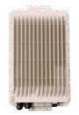
Figure 2 – Outdoor DPU

Twisted Pair and Coax

This variation for the AT&T Open 16-Port G.Fast DPU supports different wiring from the DPU to the customer modem or residential gateway. The first option is twisted pair, and the second is coax. Although the wiring type differs, the signal and electrical properties are nearly identical, with a simple balun allowing adapting one or the other – or allowing interworking in the wiring system.
Because so much of the DPU remains unchanged between these options, the design chooses to make the wire termination a modular component of the design, allowing a single DPU SKU to serve both applications by attaching either a twisted pair or coax module.

Triplexers

In some applications where coax cables are used, there is a desire to deliver both broadband data as well as video from satellite or cable systems. This is accomplished by including triplexers on the coax module for the DPU. Video signals are attached to the triplexers and delivered in concert with the broadband data.

Reverse Power

The final variation is for reverse-powering the AT&T Open 16-Port G.Fast DPU. Like the triplexer option, the reverse power option is provided as a variation on the modular wiring unit. An alternate module for twisted pair allows inclusion of the reverse power feed circuitry.

Software Stack

Software to drive the AT&T Open 16-Port G.Fast DPU is based on same approach taken for the Open GPON and XGS-PON specs. As shown in Figure 3, and moving from the bottom to the top of the figure, the DPU has Firmware and a Driver that runs in the silicon and provides a management interface toward a standard management agent called a Persistent Management Agent (PMA). A PMA manages a single DPU and there is a PMA Aggregator (PMAA) that manages many. In the software stack, we will develop an open scale-out PMA with aggregation included. The ON.Labs VOLTHA project is an open multi-protocol management and control plane agent, and will be used to derive OpenFlow, as well as NETCONF/YANG interfaces to the control plane applications and configuration controllers. From these interfaces upwards, the same applications are used that were developed for GPON and XGS-PON in order to configure and control the G.Fast system as part of an access network. This re-use of the networking stack is intentional because GPON and XGS-PON are both popular backhaul technologies for G.Fast DPUs.

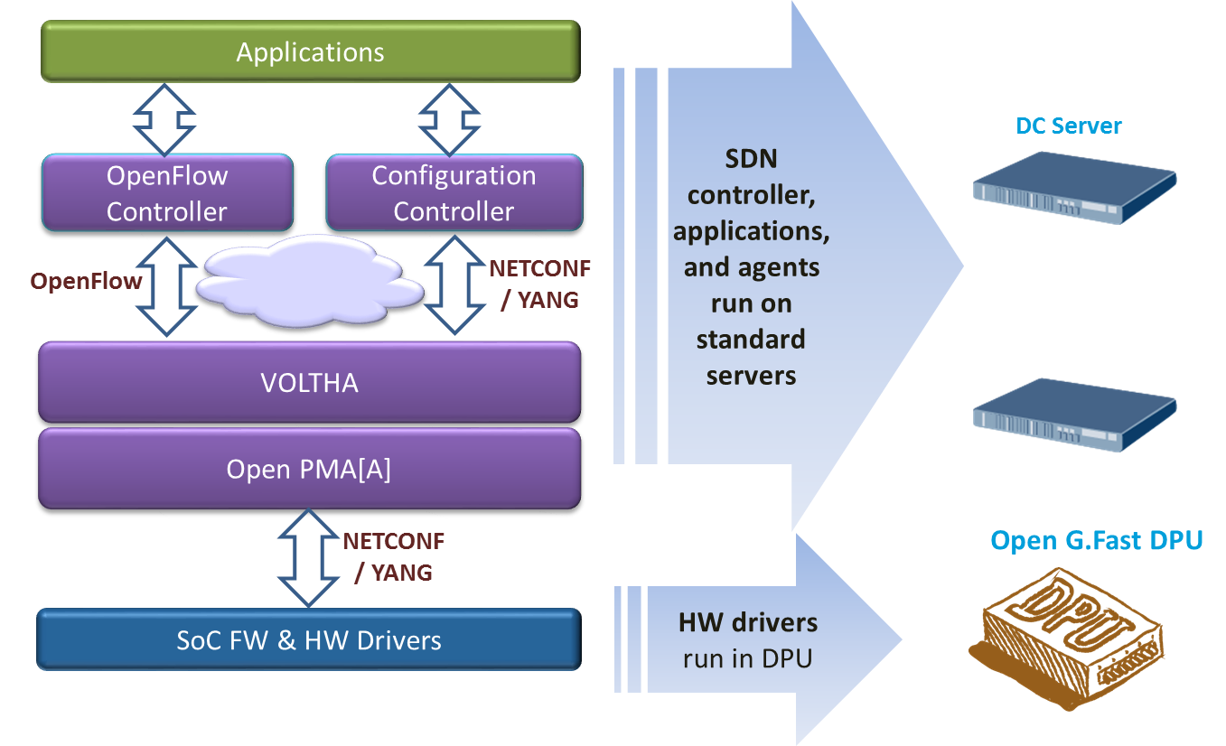
Figure 3 - Software stack for Open 16-Port G.Fast DPU

To support this application, the Open 16-Port G.Fast DPU minimizes the number of components populated on the system board and leverages external, scalable, available and re‐usable components instead.
This is the most basic and economic instantiation of this design. Management is performed through external processes and is communicated through a virtual LAN that isolates that traffic from customer traffic. Specifically, there is a need to support OOB (out of band management) LAN. The design does still support a variety of power supply options, airflow options, and a baseboard management controller (BMC) to manage these resources.

G.Fast Network Application

A G.Fast Access network supports customers of various types, including both single and multi-family dwelling units, and including options for one or more customers per DPU and multiple DPUs per location. A novel and key feature of G.Fast is the ability to reverse-power the DPU from one or more attached customer ports. This allows placing DPUs on poles or at the curb where powering is difficult.
Some key features include:

Figure 4 shows G.Fast Access technology, which is typically deployed in twisted pair or coax loops that are less than 500m, and which support about a gigabit of bandwidth when both directions are added up. The split of bandwidth used for upstream and downstream is configurable, and can be symmetric (e.g. 500x500M) or can be asymmetric (e.g. 750Mx250M). G.Fast can be deployed in various configurations, some of which are shown in Figure 5.
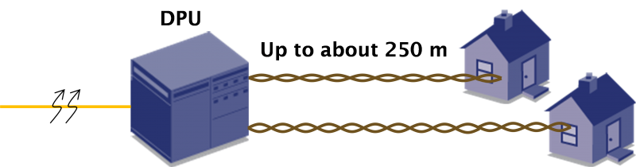
Figure 4 – G.Fast Access Technology

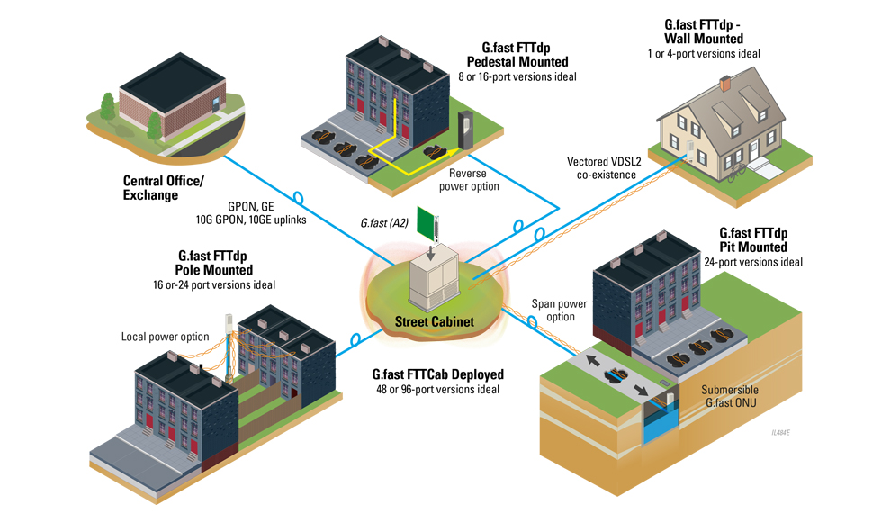
Figure 5 – G.Fast Access Network

Physical Overview

Maximum Dimensions

 | Inches | Millimeters
Length -
Width –
Height –

Top View
The top view of the Open 16-Port G.Fast DPU shows the PCBs and associated components in the system (illustrative only).

5

Front View
The front view of the Open 16-Port G.Fast DPU shows the external connectors and associated components in the system (illustrative only).

2
1

Panel LED Definitions

LED Name | Description | State
Diag | LED to indicate system diagnostic test results | Green – Normal  Amber – Initializing  Red – Fault detected
SFP+ Speed LED | LED built into  XFP cage to indicate port speed | Green 3 blinks/pause – 10G  Green 2 blinks/pause – 2.5G  Green 1 blink/pause – 1G  Off – No Link/Port down
SFP+ Enable LED | LED built into  XFP cage to indicate SFP status | On Green – SFP installed and active Flashing indicates activity  On Amber– SFP installed, but has a fault  Off – No SFP installed or Administered down

SFP+ Interface Module support

10Gb XGS-PON XFP Modules | Standard 10Gb XGS-PON XFP modules

Rear View

The rear view of the Open 16-Port G.Fast DPU includes the following key components:

Wiring Adaptation Modules
Wiring adaptation modules are connected to the DPU using a common connector. The connector is an XXXXX

Signal Name | Pin Number | Description

Table 1 Wiring Adaptation Module Signals Definition

Twisted Pair Module
This module supports attachment of twisted pair wiring to the DPU.

Figure 5 – Twisted Pair Module

Twisted Pair Module with reverse power feed
This module supports attachment of twisted pair wiring to the DPU and also provides for powering the DPU from one or more access ports.

Figure 6 – Twisted Pair Module with Reverse Power

Coax Module
This module supports attachment of coaxial cable wiring to the DPU.

Figure 7 – Coax Module

Coax Module with Triplexers
This module supports attachment of coaxial cable wiring to the DPU and also includes triplexers to allow combining G.Fast signals with video signals on the serving cable.

Figure 8 – Coax Module with Triplexers

System Overview

Main Block Diagram

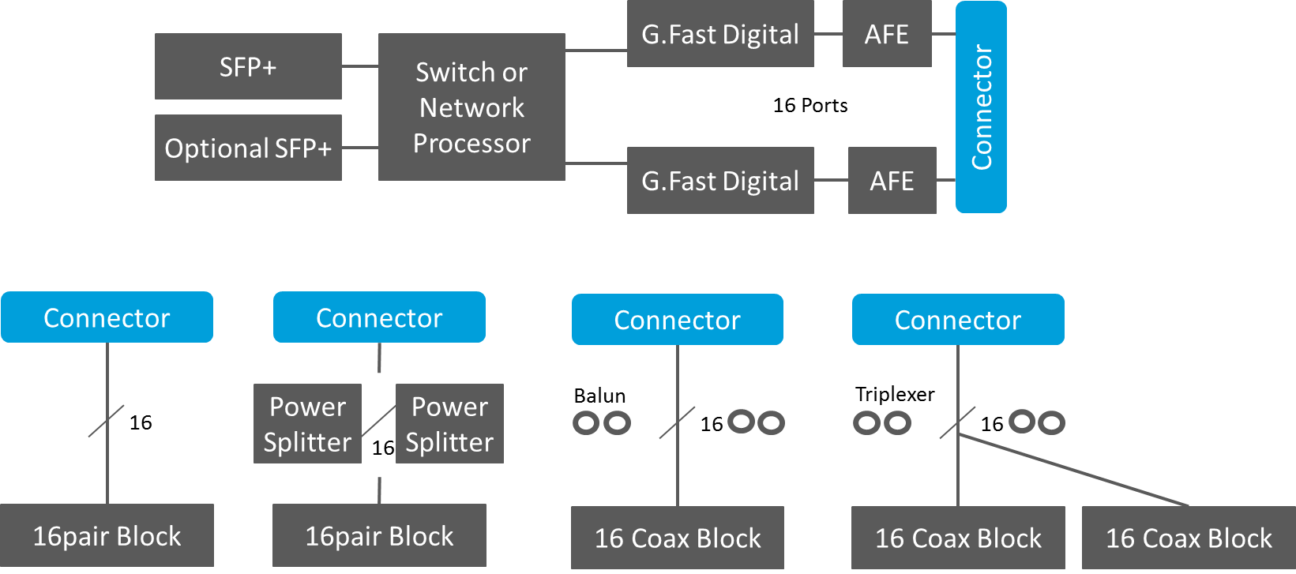
Figure 9 - Main system Block diagram

The block diagram in Figure 9 shows the high level block diagram of the DPU.

- One and an optional second SFP+ for backhaul and or daisy chaining.
- A Switch + Processor, or combo device to aggregate the traffic and host the management software.
- Several ASIC as needed to support 16 ports of G.Fast
- Several Analog Front End (AFE) chips as needed to support 16 ports of G.Fast
- A common connector to support several media options – each shown across the bottom of the figure.
- Twisted pair module.
- Twisted pair module with reverse power feed.
- Coax Module
- Coax module with triplexers

Supporting different Uplink connectivity modes
The Open 16-Port G.Fast DPU uplink connectivity and configuration architecture can support various uplink link modes which can be configured differently based on the required BW (e.g. 1G, 2.5G or 10G). There is also an option for a second uplink port. For example -
- For 1G – A 1G Ethernet SFP or PON ONT operating at 1G
- For 2.5G – Typically a GPON SFP ONT
- For 10G – A 10G Ethernet SFP+ or PON ONT operating at 10G
The optional second SFP+ port is intended as a general purpose port. It can be used as redundant or auxiliary backhaul, or as a daisy chain to a second DPU, or as a local access port.

Functional Hardware Blocks

Software Support
The Open 16-Port G.Fast DPU supports a base software package composed of the following components:

BMC support
OpenBMC Is there a desire for IPMI or a true BMC?

ONIE (Optional CPU Module)
Initialization and firmware updates

Open Network Linux
See http://opennetlinux.org/ for latest supported version (Is this desired?)

Overall System Software
See Error! Hyperlink reference not valid.for information and documentation
See https://github.com/opencord/cord for software source

General Specifications

Power Consumption
The total estimated system power consumption of the AT&T Open 16-Port G.Fast DPU is ~16 Watts. This is based upon worst case power assumptions for traffic, optics used, and environmental conditions.
Main Blocks | Qnt. | Typ. (W) | Max. (W) | Total Typ. (W) | Total Max. (W)
Total estimated Power

Specification Requirements
Environmental placement requirements differ for the outdoors and indoors units.

Safety
- UL/ Canada
- CB (Issued by TUV/RH)
- China CCC

Electromagnetic Compatibility
- GR-1089-CORE
- FCC Title 47, Part 15, Subpart B Class A

ROHS
Restriction of Hazardous Substances (6/6)
Compliance with Environmental procedure 020499-00 primarily focused on Restriction of Hazardous Substances (ROHS Directive 2002/95/EC) and Waste and Electrical and Electronic Equipment (WEEE Directive 2002/96/EC)

