Open Rack V3 IT Gear Input Connector
Rev: 0.04 (Preliminary Draft)

Author:
Brian Costello TE Connectivity
License OCP CLA Option
Contributions to this Specification are made under the terms and conditions set forth in Open Compute Project Contribution License Agreement (“OCP CLA”) (“Contribution License”) by:

[Contributor Name(s) or Company name(s)]
You can review the signed copies of the applicable Contributor License(s) for this Specification on the OCP website at http://www.opencompute.org/products/specsanddesign
Usage of this Specification is governed by the terms and conditions set forth in Open Web Foundation Final Specification Agreement (“OWFa 1.0”).
You can review the applicable Specification License(s) executed by the above referenced contributors to this Specification on the OCP website at http://www.opencompute.org/participate/legal-documents/
Note: The following clarifications, which distinguish technology licensed in the Contribution License and/or Specification License from those technologies merely referenced (but not licensed), were accepted by the Incubation Committee of the OCP:

[insert “None” or a description of the applicable clarifications].
NOTWITHSTANDING THE FOREGOING LICENSES, THIS SPECIFICATION IS PROVIDED BY OCP "AS IS" AND OCP EXPRESSLY DISCLAIMS ANY WARRANTIES (EXPRESS, IMPLIED, OR OTHERWISE), INCLUDING IMPLIED WARRANTIES OF MERCHANTABILITY, NON-INFRINGEMENT, FITNESS FOR A PARTICULAR PURPOSE, OR TITLE, RELATED TO THE SPECIFICATION. NOTICE IS HEREBY GIVEN, THAT OTHER RIGHTS NOT GRANTED AS SET FORTH ABOVE, INCLUDING WITHOUT LIMITATION, RIGHTS OF THIRD PARTIES WHO DID NOT EXECUTE THE ABOVE LICENSES, MAY BE IMPLICATED BY THE IMPLEMENTATION OF OR COMPLIANCE WITH THIS SPECIFICATION. OCP IS NOT RESPONSIBLE FOR IDENTIFYING RIGHTS FOR WHICH A LICENSE MAY BE REQUIRED IN ORDER TO IMPLEMENT THIS SPECIFICATION. THE ENTIRE RISK AS TO IMPLEMENTING OR OTHERWISE USING THE SPECIFICATION IS ASSUMED BY YOU. IN NO EVENT WILL OCP BE LIABLE TO YOU FOR ANY MONETARY DAMAGES WITH RESPECT TO ANY CLAIMS RELATED TO, OR ARISING OUT OF YOUR USE OF THIS SPECIFICATION, INCLUDING BUT NOT LIMITED TO ANY LIABILITY FOR LOST PROFITS OR ANY CONSEQUENTIAL, INCIDENTAL, INDIRECT, SPECIAL OR PUNITIVE DAMAGES OF ANY CHARACTER FROM ANY CAUSES OF ACTION OF ANY KIND WITH RESPECT TO THIS SPECIFICATION, WHETHER BASED ON BREACH OF CONTRACT, TORT (INCLUDING NEGLIGENCE), OR OTHERWISE, AND EVEN IF OCP HAS BEEN ADVISED OF THE POSSIBILITY OF SUCH DAMAGE.

Table of Contents
1. Scope 4
2. Overview 4
3. Electrical 4
4. Mechanical 4
4.1 Geometry 4
4.2 Mating to the Busbar 5
5. Environmental Requirements: 8
6. Test Busbar Mechanical Requirements 8
7. Quality 9
8. Regulatory 11
9. Ordering Part Numbers 11
10. Revisions 11

Scope
This document defines the technical specifications for an Open Rack V3 IT Gear 48V Input Connector used in the Open Compute Project.

Overview
This interconnection is the power interface between Open Rack V3 IT Gear equipment and the Open Rack V3 48V bus bar.

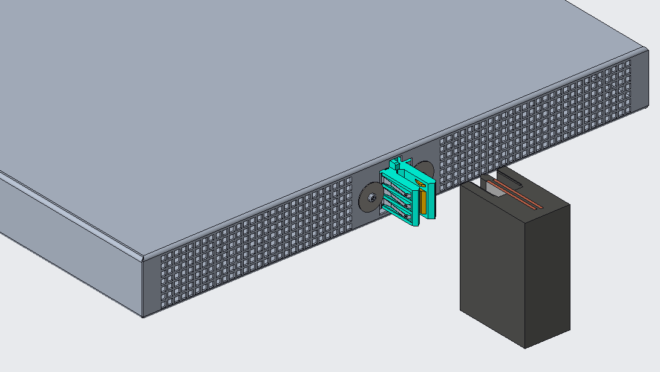
Figure 1: IT Gear Chassis and ORv3 Busbar

Electrical
- Voltage range: 46.0V – 52.0V DC
- Power Contact Max current continuous: 100A DC
- Chassis Ground Contact Max Current for 2 min duration: 64A total
- Max temperature rise: 30°C (with busbar connected, as specified on ORv3 busbar Spec)
- Max voltage drop: 55mV @ 100A

Mechanical

4.1 Geometry
The connector shall fit within the maximum height of a 1 Rack Unit (44.45mm) including ±3.0mm vertical connector float (as defined in section 4.2).

The connector shall support a panel thickness of 0.90 to 1.32 mm.

The connector MAY use tools to attach the connector to the IT Gear equipment or shelf.
Torque range for applicable mounting hardware shall be 0.4-0.6 N-m.

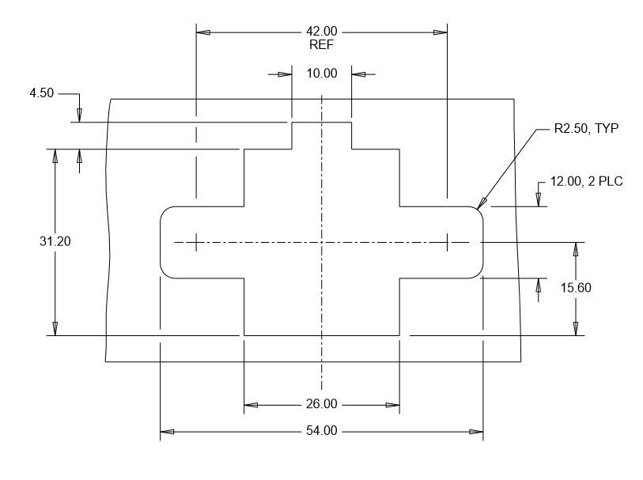
Figure 2: Panel Cutout for Screw Mounted Connector

Wires shall resist pullout from the connector of 15kgf.

4.2 Mating to the Busbar

The connector shall support blind-mate installation of the IT Gear onto the 48V busbar (figure 4) as defined in the Open Compute Specification Revision 3.0.

Connector shall support +/-3mm float horizontally and vertically.
Connector shall enable 6.4mm side to side gather ability
Connector chassis ground contacts shall provide a connection to the busbar cage and carry 64A current for a maximum duration of 2 minutes.
Connector to have a sense contact on each side of the connector that mates a minimum of 1mm after the 48V power contact mates.
Sense contact to carry a minimum of 1.5A current with a temperature rise of no more than 30°C
Connector shall support 4.7mm of wipe for the sense contact at worst case chassis tolerance.

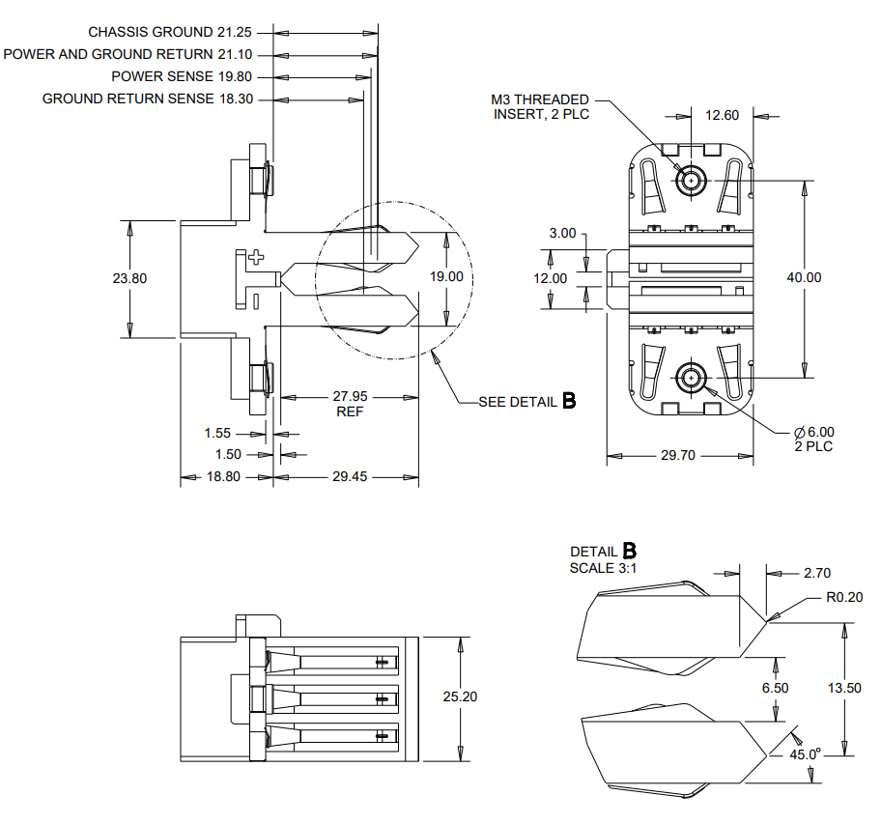
Figure 3: IT Gear Connector Detail, Screw Mounted

The ORv3 48V Busbar is defined in OCP spec XXXX. The following detail is provided for reference only:

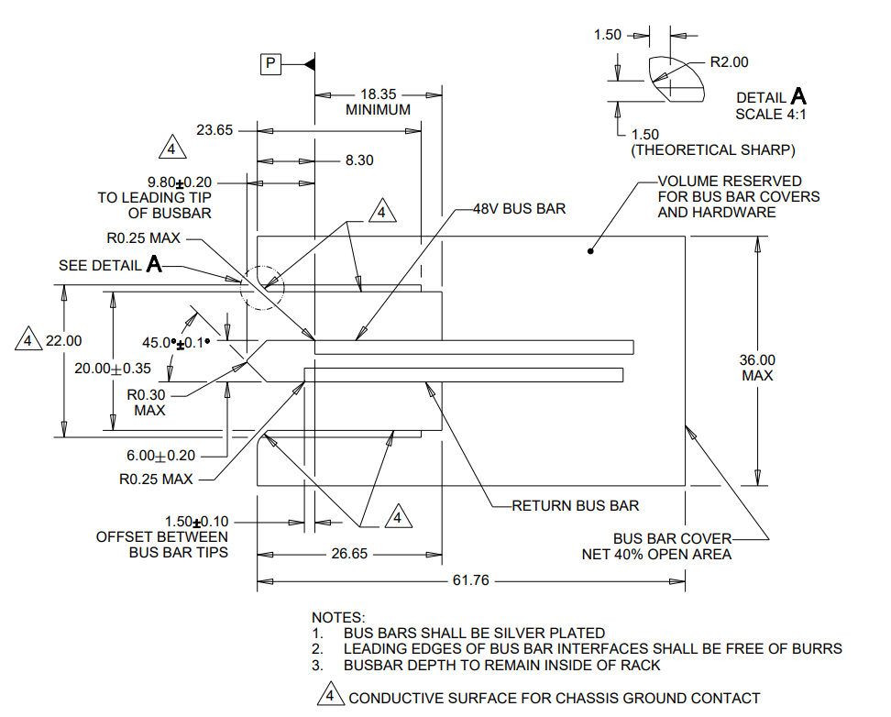
Figure 4: ORv3 Busbar Mechanical Detail

The max rate of the IT Gear insertion into the rack will be 1 m/s.

The mating force of the connector onto the busbar shall be less than 100N.

The power shelf will ship within the rack while connected to the rack busbar. The connector solution shall prevent damage of the power shelf and the rack busbar during the following packaged, rack-level tests (ASTM 4169 details below) while meeting the voltage drop requirements per section 6.0 and show no exposed copper of either the power shelf connector or rack busbar under SEM analysis of the interfaces.

The rack is tested in the shipping packaging for transportation Shock and Vibration per ASTM 4169-16 Schedule E - Vehicle Vibration for 2hrs on vertical axis only for 80 minutes low level, 30 minutes medium level and 10 minutes high level.

Airflow

Connector shall be rated for continuous current in still air (no airflow).

Environmental Requirements:
- Operating Ambient Temperature at connector location: 15°C to 70°C
- Long-term Storage: -40C to 50C and 5-95% RH
- Short-term Storage: -20C to 65C and 10-80% RH
- Operating Humidity: 20-90%, 5C dew point minimum
- Lifetime: 5 years

Test Busbar Mechanical Requirements
- IT Gear test busbar to meet requirements as outlined below
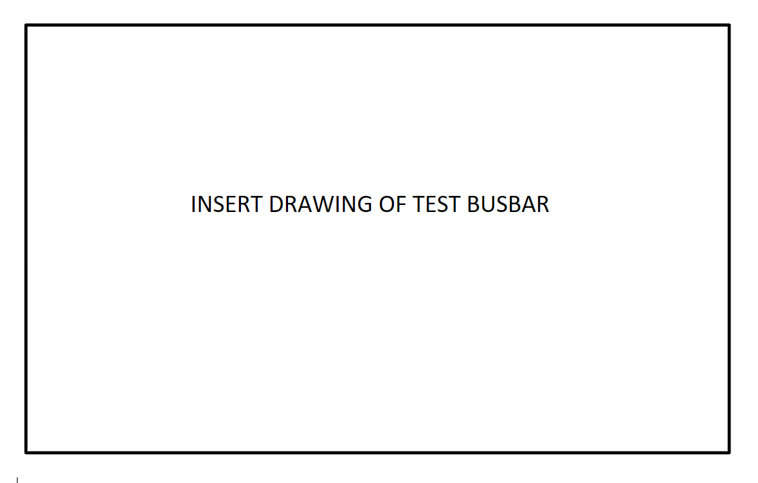
Figure 5: ORv3 Test Busbar Mechanical Detail

Quality
The following tests will be conducted with three samples each per Table 1.
Table 1: Testing Detail
Test | Test Standard | Test Condition/ Method | Pass/Fail Criteria | Additional Data to Collect for Review
Low level contact resistance (LLCR) | EIA-364-23 | Subject mated specimens to 100 milliamperes maximum current and 20 millivolts maximum open circuit voltage. | 10 milliohms maximum (initial)  20 milliohms maximum (final)
Contact resistance at rated current (CRRC) | EIA-364-6 | Resistance should be measured after the clip has reached thermal equilibrium, after carrying Rated load at 25°C ambient temperature. | 0.55 milliohms maximum (initial and final)
Withstanding voltage | EIA-364-20, Condition I | 1000 volts AC at sea level for power contacts. 1 minute duration. Test between adjacent contacts of specimens. | No breakdown or flashover
Durability | EIA-364-09 | Mate and un-mate specimens with mating cable assembly for 50 cycles at a maximum rate of 500 cycles per hour. | LLCR before and after  Post test surface wear examination: no exposed nickel or copper
Contact Retention | EIA-364-29, Method A | 15kgf pull force, both axial and at 45degrees, for a minimum of 6 seconds | No visible contact to housing displacement | N/A
Vibration | EIA-364-28 Test condition VII, Test condition E | 15 minutes duration in each of the three mutually perpendicular direction | No discontinuities of 1 microsecond or longer duration.  No plastic deformation or contact dislodging.  In addition: LLCR before and after | post test contact wear optical examination,  SEM/EDX optional
Shock | EIA-364-27, Method A | Subject mated specimens to 50G’s half-sine shock pulses of 11 milliseconds duration.  Three shocks in each direction applied along 3 mutually perpendicular planes, 18 total shocks. | No discontinuities of 1 microsecond or longer duration.  No plastic deformation or contact dislodging. | post test contact wear optical examination,  SEM/EDX optional
Mating Force | EIA-364-13 | Measure force necessary to mate specimens at a maximum rate of 12.7 mm [.5 in] per minute. | 100 N maximum per receptacle cable assembly
Un-mating force | EIA-364-13 | Measure force necessary to un-mate specimens at a maximum rate of 12.7 mm [.5 in] per minute. | 12 N minimum per receptacle cable assembly
Temperature Life | EIA-364-17, Method A, Condition 5. | Subject mated specimens to 125°C for 500 hours. | LLCR before and after | monitor contact voltage drop during test
Thermal Shock | EIA-364-32, Method A | Test condition VII: -55C to 85C for 10 cycles with 30 minute dwell time | LLCR before and after | N/A
Humidity | EIA-364-31, Class III | Subject mated specimens to 10 cycles (10days) between 25 and 65°C at 80 to 98% RH | LLCR before and after  Dielectric withstand voltage before and after | N/A
Salt Spray | EIA-364-26C | Subject mated specimens to test for 48 hours, with a 5% solution salt spray, 35 +1/-2°C | LLCR before and after | N/A
Temperature rise vs. current | EIA-364-70, Method II | Attach connector to test busbar according to section X. Stabilize at a single current level until 3 readings at 5 minute intervals are within 1°C. | Lower than 30°C | N/A

Regulatory
The connector shall comply with the latest edition, revision, and amendment of the following Standards:
- IEC 62368-1, Audio/video, information and communication technology equipment – Part 1: Safety requirements (applicable to meet anticipated effective date of December 20, 2020 for North America and Europe.)
- Halogen Free per JEDEC JS709C
- RoHS 2011/65/EU (RoHS 2)
- Material flammability: All materials shall be UL94 V-0 rated.
- Connectors shall be UL1977 recognized.

Ordering Part Numbers

Vendor | Description | P/N
TE Connectivity | ORv3 100A 48V BB Cable, No Sense Contact | XXXXXXX-1
TE Connectivity | ORv3 100A 48V BB Cable, 48V Sense Contact | XXXXXXX-2
TE Connectivity | ORv3 100A 48V BB Cable, Ground Sense Contact | XXXXXXX-3
TE Connectivity | ORv3 100A 48V BB Cable, 48V & Ground Sense Contacts | XXXXXXX-4

Revisions
Rev | Date | Author | Changes
0.00 | 12 Feb 2021 | Brian Costello | Preliminary Draft 0
0.01 | 1 Mar 2021 | Brian Costello | Preliminary Draft 1
0.02 | 9 Mar 2021 | Brian Costello | Preliminary Draft 2
0.03 | 11 Mar 2021 | Brian Costello | Preliminary Draft 3
0.04 | 15 Mar 2021 | Brian Costello | Preliminary Draft 4

