PCB Design (IL, RL, NEXT and FEXT)
Board design should follow the criteria from chip vendor to achieve proper operation of the high-speed signals. This table list below, refer to PAM4 as a reference. For different interface supported, it is good to consult with chip vendor.
Parameter | Min. | Typ. | Max. | Notes
Impedance | 81 ohm | 90 ohm | 99 ohm
SDD11(22) | - | - | -15 dB | DC~(BitRate/3), Note.1
SDC11(22) | - | - | -25 dB | DC~(BitRate/3)
SDD21 |  |  | -30 dB | Note.2
Intra-skew | - | - | 0.5 ps
Inter-skew | Note.3
NEXT | - | - | -55 dB | TX->RX, RX->TX
FEXT | - | - | -45 dB | RX->RX, TX->TX

Note 1: PAM4 BitRate = 56Gbps, the DC~18.6GHz
Note 2: To control the total channel loss (included die+package of chip) under -30dB at 14.025GHz.
Assume the die+package loss is under -8dB at 14.025GHz. ODM can optimize the channel trace
length and the material to meet loss criteria.
Note 3: It should compliant with related protocol requirements.

Layout Guideline
This layout recommendations are for achieving proper operation of the high-speed signals. Good to compare this guideline with chip vendor’s rule to have better signal integrity.

Trace Impedance
In the UBB board, the TX and RX links have target impedance of 90 ohm+/-10%

Stackup Design And Single-Ended / Differential Pair Geometry
Following PCB stackup should be followed for UBB design. Each vendor needs to fine tune the width/spacing design based on material target and impedance control table below. The loss per inch of PCB material should meet loss criteria -0.58dB/-0.88dB and -0.96dB at 8GHz/14GHz and 16 GHz.
- Loss comparison with different PP/Core design based on the same diff-pair (target to 90ohm impedance) with ultra-low-loss material
Case | Core/PP  (mil) | Board thickness (mil) | Width/Spacing  (mil) | Loss/inch  @16GHz (dB) | Comparison  Vs. Case 1 | Note
1 | 3.0/6.0 | 129.4 | 4.3/6.7 | -0.979 | NA
2 | 4.0/5.0 | 128.4 | 4.8/6.2 | -0.914 | 6.64%
3 | 4.0/7.0 | 144.4 | 5.1/5.9 | -0.89 | 9.09% | *Note1

*Note1: To be confirmed with vendor if Backdrill tech. implemented into this board thickness.

Table 1: 22L Stackup Design
Layer | Plane Description |  |  | Copper (OZ) |  | Thickness (mil)
 |  | Solder mask |  |  | 0.5
L1 | Top | Signal/PWR | 0.5oz + plating |  | 1.9
 |  | PrePreg |  |  | 2.6
L2 | GND1 | Ground | 1.0 |  | 1.2
 |  | Core (1/1) |  |  | 4
L3 | IN1 | Signal/PWR | 1.0 |  | 1.2
 |  | PrePreg |  |  | 5
L4 | GND2 | Ground | 1.0 |  | 1.2
 |  | Core (1/1) |  |  | 4
L5 | IN2 | Signal/PWR | 1.0 |  | 1.2
 |  | PrePreg |  |  | 5
L6 | GND3 | Ground | 1.0 |  | 1.2
 |  | Core (1/1) |  |  | 4
L7 | IN3 | Signal/PWR | 1.0 |  | 1.2
 |  | PrePreg |  |  | 5
L8 | GND4 | Ground | 1.0 |  | 1.2
 |  | Core (1/1) |  |  | 4
L9 | IN4 | Signal/PWR | 1.0 |  | 1.2
 |  | PrePreg |  |  | 5
L10 | GND5 | Ground | 1.0 |  | 1.2
 |  | Core (1/2) |  |  | 4
L11 | VCC1 | Power | 2.0 |  | 2.4
 |  | PrePreg |  |  | 12
L12 | VCC2 | Power | 2.0 |  | 2.4
 |  | Core (1/2) |  |  | 4
L13 | GND6 | Ground | 1.0 |  | 1.2
 |  | PrePreg |  |  | 5
L14 | IN5 | Signal/PWR | 1.0 |  | 1.2
 |  | Core (1/1) |  |  | 4
L15 | GND7 | Ground | 1.0 |  | 1.2
 |  | PrePreg |  |  | 5
L16 | IN6 | Signal/PWR | 1.0 |  | 1.2
 |  | Core (1/1) |  |  | 4
L17 | GND8 | Ground | 1.0 |  | 1.2
 |  | PrePreg |  |  | 5
L18 | IN7 | Signal/PWR | 1.0 |  | 1.2
 |  | Core (1/1) |  |  | 4
L19 | GND9 | Ground | 1.0 |  | 1.2
 |  | PrePreg |  |  | 5
L20 | IN8 | Signal/PWR | 1.0 |  | 1.2
 |  | Core (1/1) |  |  | 4
L21 | GND10 | Ground | 1.0 |  | 1.2
 |  | PrePreg |  |  | 2.6
L22 | BOT | Signal/PWR | 0.5oz + plating |  | 1.9
 |  | Solder Mask |  |  | 0.5
 |  | Total  Table 2: The Single-Ended and Diff-Pair Geometry | 128.4 mil (with +/- 10% tolerance)

Trace Width  (mil) | Air Gap Spacing (mil) |  |  | Impedance Type | Layer |  | Impedance Target  (ohm) |  |  | Tolerance  (+/- %)
6.0 |  |  | Single |  |  | 1,22 |  | 45 | 10%
5.3 |  |  | Single |  |  | 1,22 |  | 50 | 10%
5.3 |  | 5.6 | Differential |  |  | 1,22 |  | 85 | 10%
4.8 |  | 6.1 | Differential |  |  | 1,22 |  | 90 | 10%
5.8 |  |  | Single |  |  | 3,5,7,9,14,16,18,20 |  | 45 | 10%
5.0 |  |  | Single |  |  | 3,5,7,9,14,16,18,20 |  | 50 | 10%
5.7 |  | 5.2 | Differential |  |  | 3,5,7,9,14,16,18,20 |  | 85 | 10%
5.0 |  | 5.8 | Differential |  |  | 3,5,7,9,14,16,18,20 |  | 90 | 10%

Fiber Weave Effect
To avoid P/N pair skew difference in the received differential signals, the following guidelines to minimize the weave effect:
- Choose spread glass material such as the weave types: 1035, 1067, 1078, and 1086.
- Use two-ply spread glass for each layer instead of one-ply.
- Other options:
- Use the Zig-Zag routing to route the signals in 10 to 15 degrees angles.
- Rotate the board design by 10 to 15 degrees with respect to the panel. Should be confirmed the design size versus panel size effect.

Routing Layer
Differential signals must be routed in stripline and two solid GND reference planes both near-end and far-end reference.

Trace Clearances & Length Matching Requirement (H = the thickness between signal to the nearest reference plane)
- Pair to pair spacing on breakout region: TBD
- Pair to pair spacing of the same group on open field: 6H
- TX/RX group to group spacing: 6H
- Intra-pair length matching of DP/DN pair: 1 mil
- Lane to Lane length mismatch of TX or RX group: < 3 inch

Others Requirement:
- Must to have Backdrill technology to minimize via stub length
- The non-function pads of all signals and ground must be removed

Fanout Design Recommendation
- Break-out and anti-pad for different pair north routing recommendation
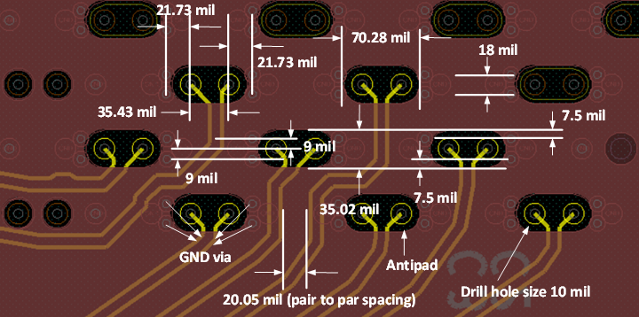
Figure 1: Fanout routing of via-in-pads on Top layer

- The upper layer routing (Top/L3/L5/L7/L9) can refer to oblong anti-pad from Top to Bottom layer as Fig 1 to get better impedance controlled.

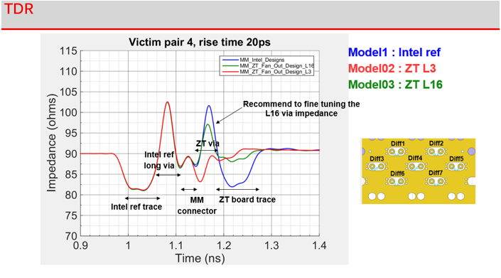
Figure 2: TDR Result of L3/L16 routing layer

- From figure 2, the TDR result of L16 is 97.5 ohm if keep the same anti-pad design with upper layer routing. Recommend making anti-pad modification to get better impedance controlled as Fig 3, the impedance will be 92.5 ohm as Fig 4.

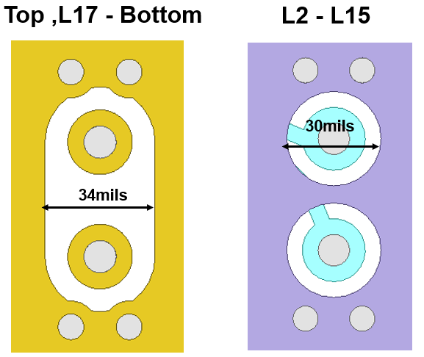
Figure 3: Recommendation of L16 routing layer anti-pad

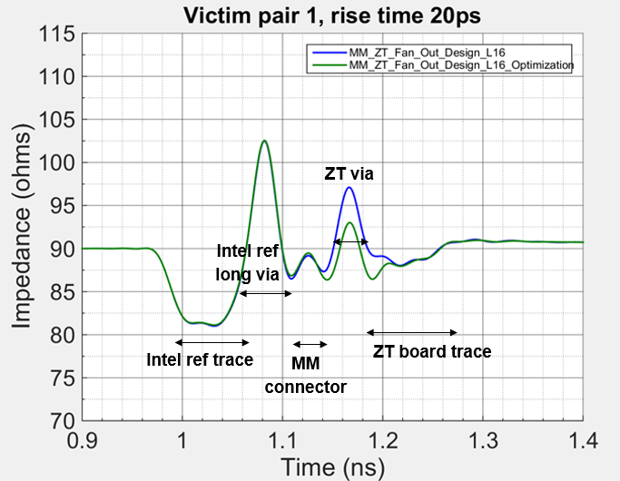
Figure 4: TDR result of anti-pad optimization on L16 routing

2.1 Test Procedure & Environment Setting Recommendation
- UBB design is tested using 4-port Vector Network Analyzer (VNA) up to 50GHz.
- To get total channel loss from OAM1 to OAM2 by using Molex test fixture.
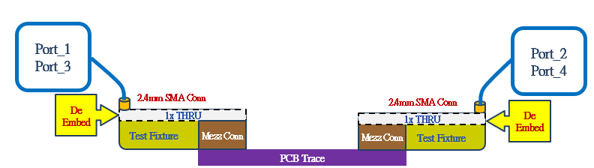
Figure 5: UBB with test fixture topology

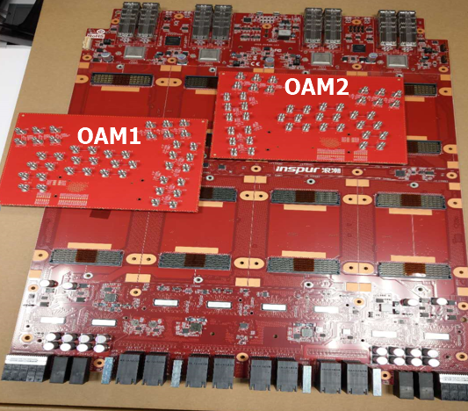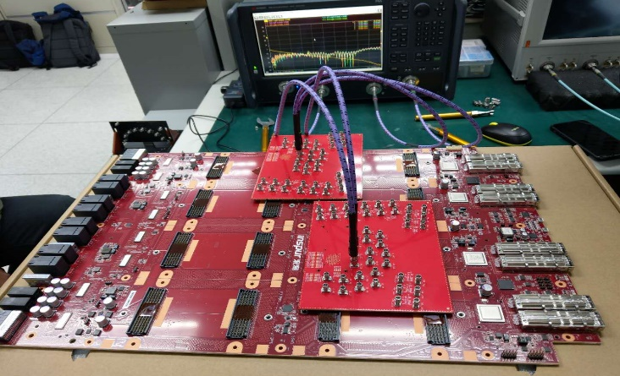
Figure 6: UBB Measurement Setting

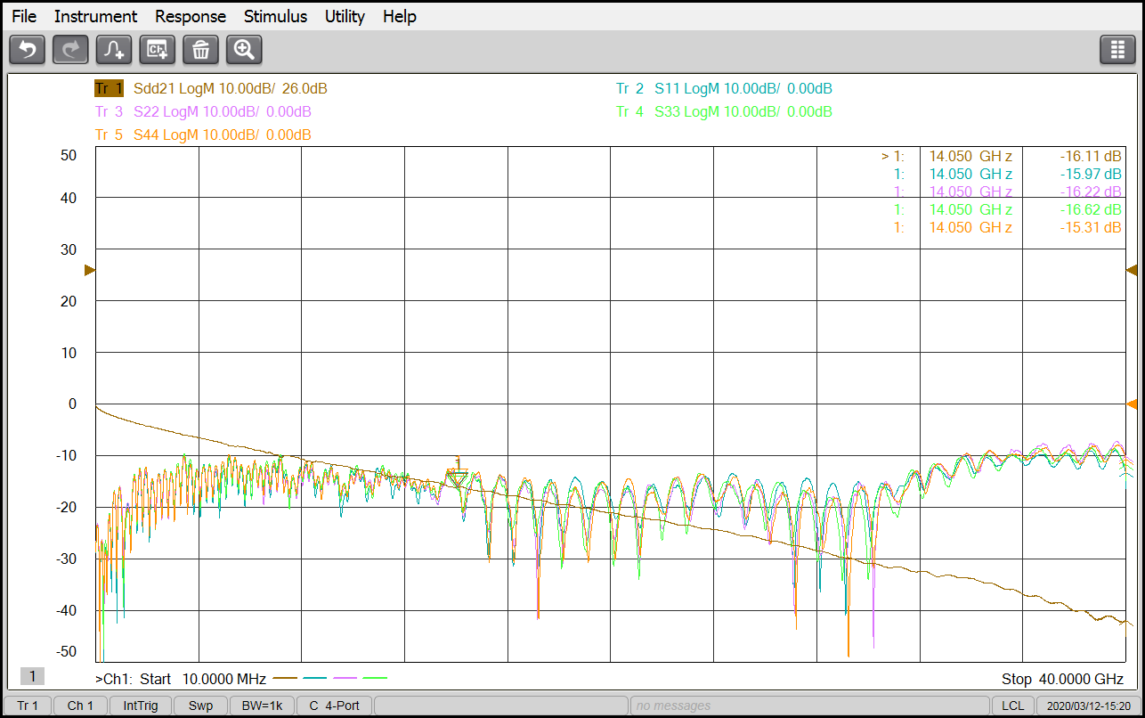
Figure 7: Channel IL of UBB board (with test fixture)

- Insertion Loss Measurement Data of 2X Thru Design
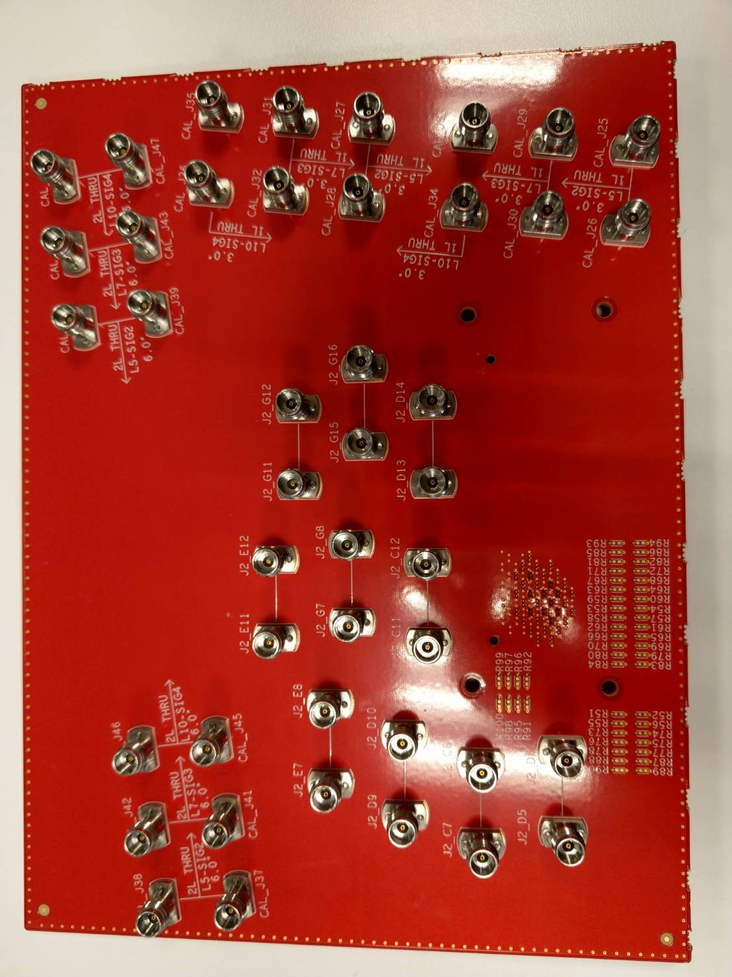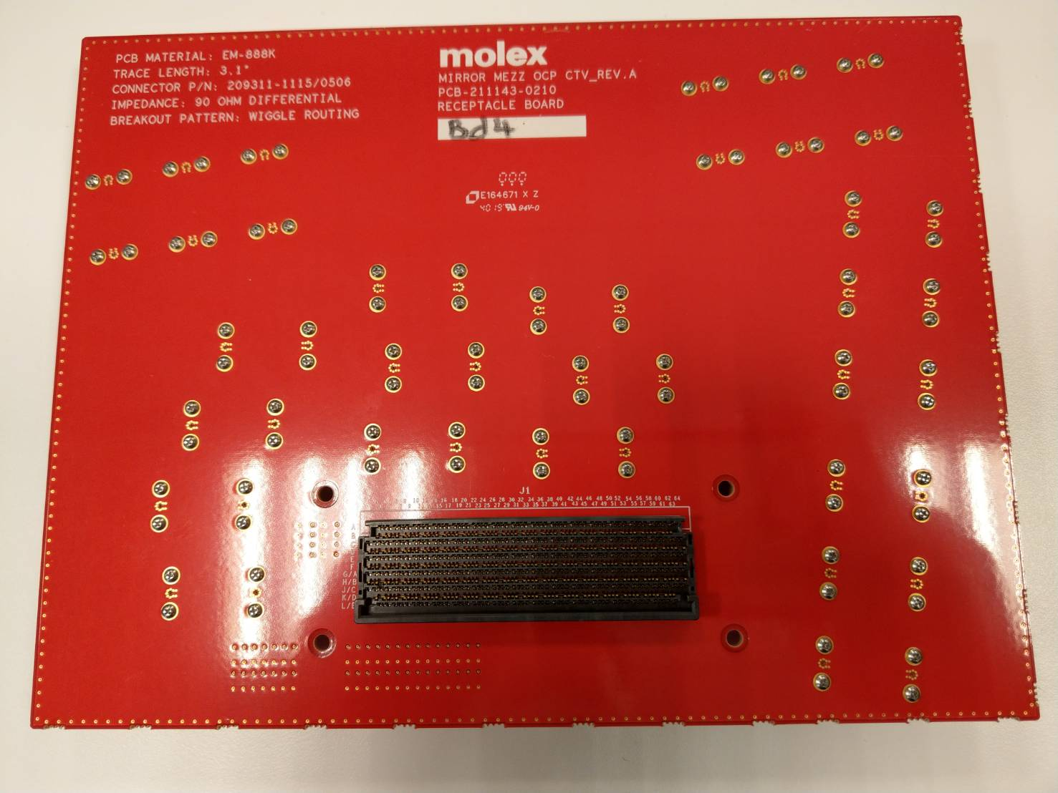
Figure 8: Top View
Figure 9: Bottom View
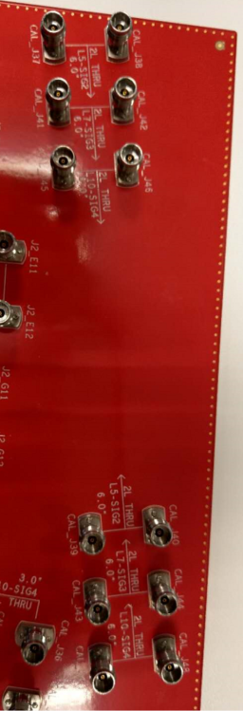
Figure 10: 2X Thru
2X_THRU

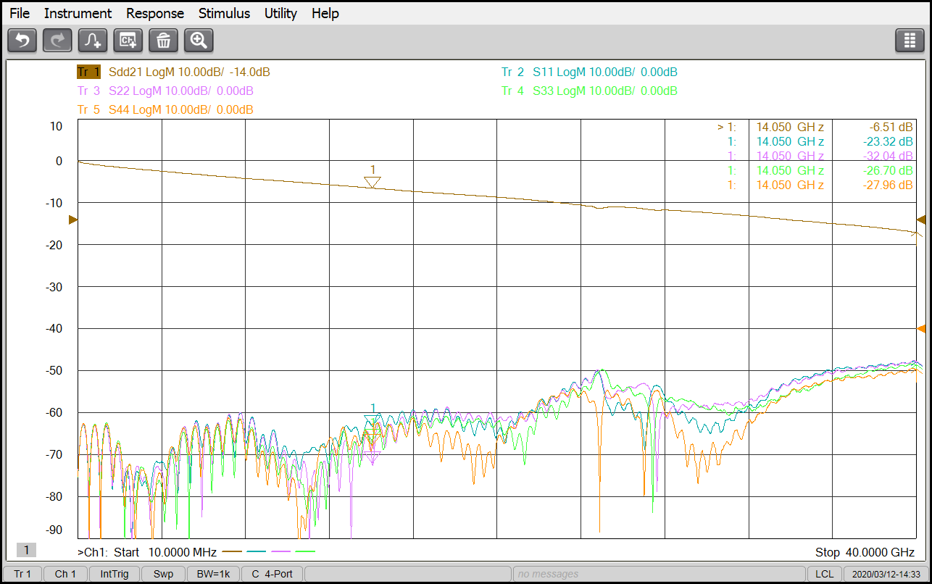
Figure 11: 2X Thru IL Measurement

- De-embedding the test fixture to get the IL of UBB board.
(Ps. This data is included 2 Mirror Mezz Connector)
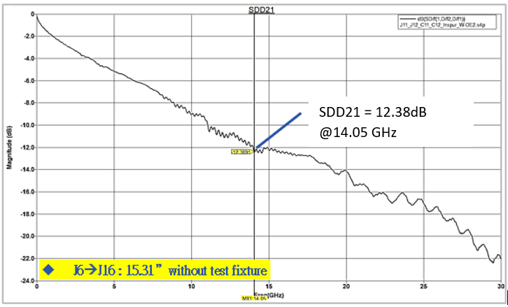
Figure 12: The IL result of UBB board with test fixture de-embedding

