QuantaGrid D51B-1U
Revision 1.0
2015/11/4

Contributed by : Alan Chang. Quanta Computer Inc.

Revision History:
Revision | Date | Description
1.0 | 2015-11-04 | Release for Open Compute Project

Table of Contents
1 INTRODUCTION 4
2 PRODUCT ARCHITECTURE OVERVIEW 5
2.1 PRODUCT ARCHITECTURE BLOCK DIAGRAM 7
2.2 BASEBOARD PLACEMENT 8
2.3 BASEBOARD Diemesion 9
3 PRODUCT FEATURES 10
3.1 PROCESSOR 10
3.2 MEMORY 10
3.2.1 DIMM NOMENCLATURE 10
3.3 PCH 11
3.3.1 PCH GPIOs 12
3.4 BMC 18
3.4.1 AST2400 (Default) 18
3.5 CLOCKS 18
3.6 SATA 19
3.6.1 SATA PORT CONNECTIVITY 19
3.7 USB 20
3.8 PCIe BUS 21
3.8.1 PCIe PORT CONNECTIVITY 21
3.9 PCIe Interface 22
3.9.1 Riser Slot PINOUT 23
3.10 LAN ON MOTHERBOARD (LOM) 34
3.10.1 DEDICATED NIC (MANAGEMENT RJ45 Port) 34
3.11 LPC BUS 34
3.12 TPM 34
3.13 SERIAL PORT 34
3.14 FANs 35
3.15 Jumper Definition 36
3.16 DEBUG header Information 40
3.16.1 XDP SUPPORT 40
3.16.2 SMB Debug Header (JP7) 40
3.16.3 BMC Debug Header (JP2 and J19) 40
3.17 PRODUCT SENSORS 41
3.18 SMBUS 42
3.18.1 SMBUS ARCHITECTURE 42
3.19 POWER 43
3.19.2 Power supply PINOUT 44
4 PRODUCT SYSTEM REQUIREMENTS 47
4.1 Chassis Overview 47
4.2 LED behavior 49
4.2.1 Front Panel LED Function and Behavior 49

INTRODUCTION
The S2B will be IA-64 based dual-socket servers that support the Grantley –EP processors in combination with the Wellsburg PCH (PCH) to provide a balanced feature set between technology leadership and cost. Quanta Grantley will be 24 DIMM and three x16 risers,

The intended audiences for this document are the Grantley platform technical leads, software team, validation team, and board design engineers that need to utilize a comprehensive package. This document will provide the S2B Design Teams the product specific features that are required to be implemented on the boards. Product feature requirements and block diagrams will be provided.

Links to reference documents that dive into the implementation for the software stack, common-core solution, server management architecture, fan-speed control architecture, chassis, power budget, and thermal requirements are provided.

PRODUCT ARCHITECTURE OVERVIEW
The S2B 24 DIMMs Server board will be Quanta Grantley server product. The silicon ingredients and features are as follows list:
Table 2-1. Grantley Enterprise Server S2B Feature List
Board Name | Grantley Server Baseboard
Form Factor | 2U Rack (X2M chassis)/ 720mm x 430mm x 87.5mm/ 28.34" x 16.92" x 3.4"  1U Rack (X1S chassis) / 720mm x 430mm x 43.5mm/ 28.34" x 16.92" x 1.7"
Baseboard size | 16.7” x 16”, 8 layer, 2.4mm, 24 DIMMs
CPU | Intel Haswell E5-2600V3, -R3 Socket
Max Processor Wattage | 145W, Optimized power delivery for 95W, VRD 12.5
QPI Speed | 9.6 GT/s, 8.0GT/s, 6.4GT/s
Chipset | Intel (R) C610 series chipset (Wellsburg)
Memory | ECC RDIMM/ LRDIMM slots  Up to 768GB (32Gx24) of memory for LRDIMM  Up to 768GB (32Gx24) of memory for RDIMM
PCIe Expansion Slot | 1U Chassis  (1) PCIe x16 G3 riser slot for low-profile card (By Riser1)  (1) PCIe x16 G3 riser slot for full height card (By Riser2)  (1) PCIe x8 G3 OCP mezzanine card slot  2U Chassis  - PCIe x8 G3 riser slot for low-profile card + (1) PCIe x8 G3 Linking slot for  low-profile card (By Riser1, Default)  - PCIe x16 G3 riser slot for low-profile card + (1) PCIe x8 G3 riser slot for  low-profile card (By Riser1, Option)  - PCIe x16 G3 riser slot for full height card + (1) PCIe x8 G3 riser slot for  Full height card (By Riser2)  (1) PCIe x8 G3 OCP mezzanine card slot
Rear IO | (2) USB 3.0 ports  (1) VGA port (BMC AST2400 SKU only)  (1) RS232 serial port  (2) GbE or 10G BASE-T RJ45 ports  (1) GbE RJ45 management port  (1) ID LED  (1) Port80 Debug Port (option)
Front IO | Power/ID/Reset Buttons, LEDs  (2) USB 2.0 ports
Network | Powerville Dual GbE: (2 MACs and 2 PHYs Integrated)  Twinville Dule 10GbE (Option)  PHY RTL8211 to BMC for delicate management NIC port.
Storage | (24) 2.5" or (12) 3.5" SATA/SAS hot-plug drives (2U Chassis)  (10) 2.5" or (4) 3.5" SATA/SAS hot-plug drives (1U Chassis)  (2) SATADOM (optional)  (2) 2.5" hot-plug SAS or PCIe SSDs (optional)
USB | Two USB3.0 ports on Rear  Two USB2.0 ports on Front panel (Option)
Video | ASPEED AST2400 8MB DDR3 video memory
Series Port | One external serial port on Rear  One internal serial port (Option)
FAN | 1U 6 dual-rotor FAN connectors from HDD backplane.  2U 4 dual-rotor FAN connectors on motherboard
ACPI | ACPI compliance, S0, S5 support. (* No S1 and S3 support.)
TPM | Yes (Option)
Power-Supply | (2) 1100W high efficiency redundant PSU, 100-240VAC 50/60Hz (2U Chassis)  Or (2) 750W high efficiency redundant PSU, 100-240VAC 50/60Hz (1U Chassis)
Chassis | 1U system / 2U system

PRODUCT ARCHITECTURE BLOCK DIAGRAM

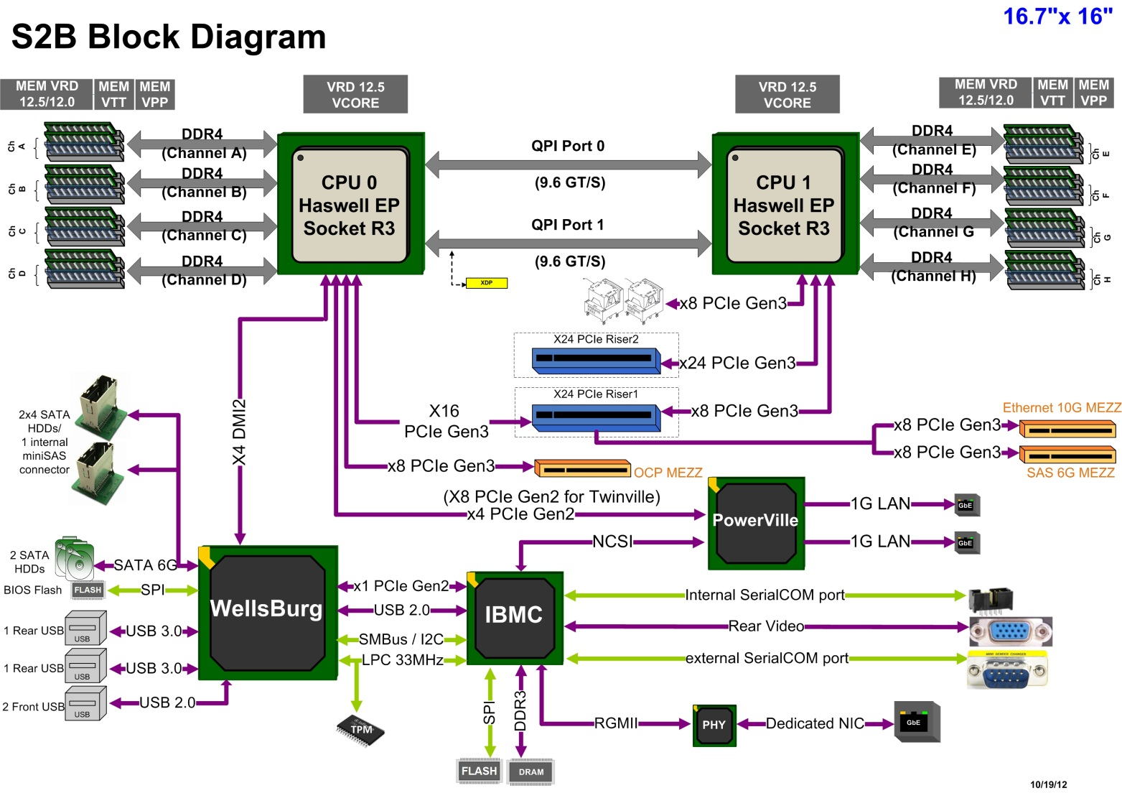
Figure 2-1 Grantley Enterprise Rack S2B Configuration

BASEBOARD PLACEMENT

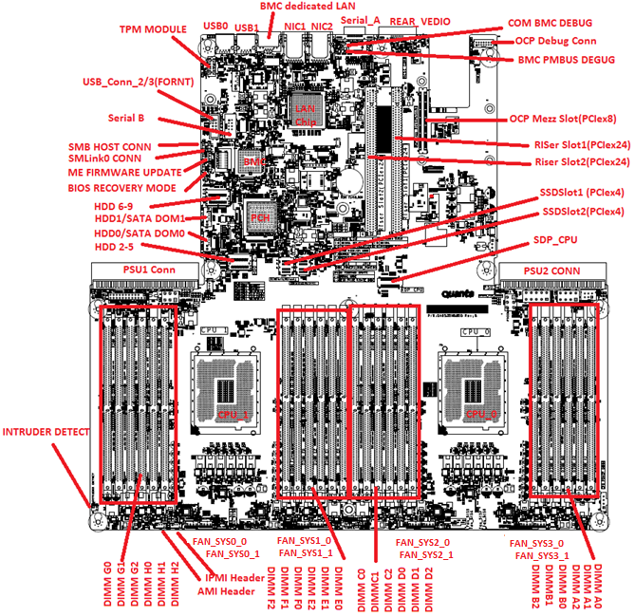
Figure 2-2: Quanta Grantley 2S 24-DIMM S2B Baseboard Placement

BASEBOARD Diemesion

W 425mm (16.7 “) x L 406mm (16”)
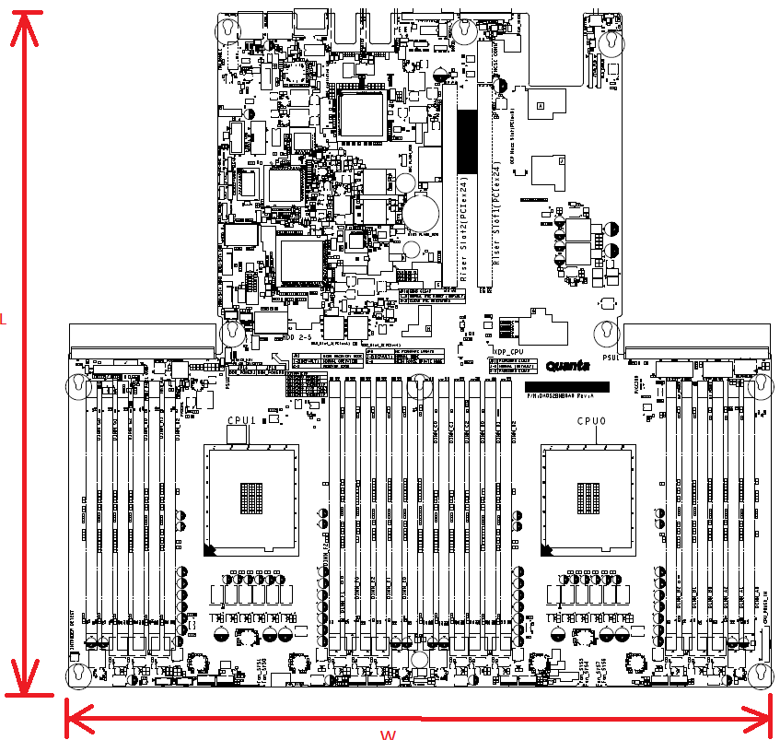
Figure 2-3: Quanta Grantley 2S 24-DIMM S2B BaseBoard Dimension

PRODUCT FEATURES

PROCESSOR
The Processor’s core name of Grantley platform is named “Haswell EP Processor- E5-2600V3”. It is 22nm process Processor with new Microarchitecture and New Instructions (including AVX 2.0). And the processor supports 4 DDR4 Memory channels. The QPI bus speed has improved up to 9.6GT/s. In this generation, the processor has internal voltage regulator (IVR), IVR integrates legacy power delivery onto processor package/die. So IVR enables power management benefits and simplified platform power design.

MEMORY
Quanta Grantley Server board S2B support total 24 DDR4 DIMMs.

DIMM NOMENCLATURE
DIMMs are organized into physical slots on DDR4 memory channels that belong to processor sockets. The memory channels from Socket 0 (CPU-0) are identified as Channel A, B, C, D. The memory channels from Socket 1 (CPU-1) are identified as Channel E, F, G and H.

The DIMM identifiers on the silkscreen on the board provide information about the channel, and therefore the processor, to which they belong. For example, DIMM_A0 is the first slot on Channel A of processor 0; DIMM_E0 is the first DIMM socket on Channel A of processor 1.

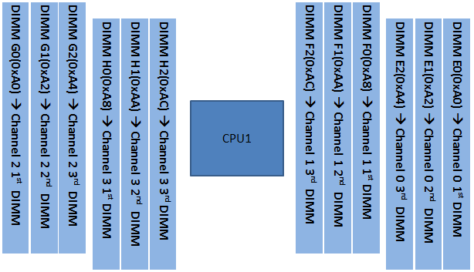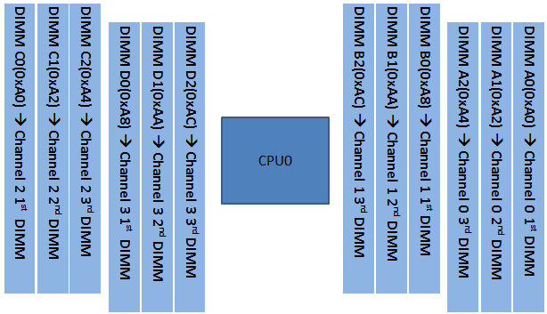
Figure 3-1 processor SKU list

PCH
The PCH’s core name of Grantley platform is named “Wellsburg”.
Wellsburg Key Features:
  - Optimized and Validated to work with Haswell Server CPUs
  - Integrated system clocks w/ support for ext. clock buffers
  - Reduced TDP / Average Power/ Package (vs. Patsburg)
  - Intel® SVT / Dengate* support capable
  - USB3 XHCI Debug Device required for Windows8
  - Flexible Management Infrastructure focused on Run Time
  - Support for MCTP Protocol and End Points
  - Support for Management traffic over DMI
  - Embedded Platform SW Services capability
  - 6x SMBus; 1@ 1MHz bus support for LAN or BMC
  - SPI Enhancements (large enough address space for 2 BIOS)
  - Continued support for GSX (GPIO Expansion slots)
  - 10 SATA ports capable of 6Gb/s
  - Up to 6 ports of USB3; 8 ports of USB2
  - Up to 8 x1 PCIe G2
  - Intel ® Node Manager 3.0 (with BE, EE options)
  - vPro/AMT
  - RSTe SW RAID (optional DSS SSD caching capability)

PCH GPIOs
Table 3-3. PCH GPIOs List
Item | Pin Name | Signal Name | Usage | Strapping | In/Out
GPIO0 | BMBUSY_N_GPIO0 | PU_PCH_GPIO0 | No used and PU to P3V3 |  | In
GPIO1 | TACH1_GPIO1 | REVISION_ID1 | REVISION_ID1 |  | In
GPIO2 | PIRQE_N_GPIO2 | FM_CPU_ERR0_CO_N | Error seen signaling from CPU |  | In
GPIO3 | PIRQF_N_GPIO3 | FM_ERR1_DLY_N | Error seen signaling from CPLD (Delay) |  | In
GPIO4 | PIRQG_N_GPIO4 | PU_PIRQG_N | No used and PU to P3V3 |  | In
GPIO5 | PIRQH_N_GPIO5 | IRQ_CPU_CATERR_DLY | CATERR_N RC delay |  | In
GPIO6 | TACH2_GPIO6 | TP_BOARD_ID0 | NA |  | In
GPIO7 | TACH3_GPIO7 | TP_BOARD_ID1 | NA |  | In
GPIO8 | GPIO8 | IRQ_BMC_PCH_NMI_N_MUX | NMI form BMC | Integrated Clock Chip Enable / Disable  0 = Enable Integrated Clock Chip mode.  1 = Disable Integrated Clock Chip mode.[Default] | In
GPIO9 | OC5_N_GPIO9 | FP_PWR_LED_N | Turn on PWR LED on FP |  | Out
GPIO10 | OC6_N_GPIO10 | FM_TPM_PRSNT_N | Detect TPM |  | In
GPIO11 | SMBALERT_N_GPIO11 | RST_PCIE_CPU_N |  |  | Out
GPIO12 | LAN_PHY_PWR_CTRL_GPIO12 | IRQ_IBMC_PCH_SMI_LPC_N | SMI from BMC |  | In
GPIO13 | GPIO13 | FM_IBMC_PCH_SCI_LPC_N | SCI from BMC |  | In
GPIO14 | OC7_N_GPIO14 | PU_USB_OC7_R_N | No used and PU to P3V3_AUX |  | In
GPIO15 | GPIO15 | FM_PCH_SATA_RAID_KEY | SATA RAID KEY |  | In
GPIO16 | SATA4GP_GPIO16_MGPIO9 | FM_THROTTLE_N | THROTTLE |  | Out
GPIO17 | TACH0_GPIO17 | REVISION_ID0 | REVISION_ID0 |  | In
GPIO18 | GPIO18 | PU_PCH_GPIO18 | No used and PU to P3V3 |  | In
GPIO19 | SATA1GP_GPIO19 | RST_PCIE_PCH_N | Reset PCIE | Boot BIOS Strap bit 0  Bit1 Bit0 Boot BIOS Destination  0 1 Reserved  1 0 RSVD  1 1 SPI [Default]  0 0 LPC | In
GPIO20 | GPIO20_SMI_N | PU_PCH_GPIO20 | No used and PU to P3V3 |  | Out
GPIO21 | SATA0GP_GPIO21 | PD_SATA0GP_GPIO21 | No used and PD to GND |  | In
GPIO22 | SCLOCK_GPIO22 | SGPIO_SATA_CLOCK_R | SGPIO SATA CLOCK |  | Out
GPIO23 | LDRQ1_N_GPIO23 | TP_PCH_LDRQ1_N | No used and TP |  | In
GPIO24 | GPIO24_MGPIO0 | PU_PCH_GPIO24 | No used and PU to P3V3_AUX |  | In
GPIO25 | GPIO25 | FM_PCH_LAN0_DISABLE_N | DISABLE LAN |  | Out
GPIO26 | GPIO26 | PU_PCH_GPIO26 | No used and PU to P3V3_AUX |  | In
GPIO27 | GPIO27_MGPIO6 | FM_VIDEO_DISABLE_N | Video output enable/disable  indicate from PCH |  | Out
GPIO28 | GPIO28_MGPIO7 | FM_USB_EN_N | Enable USB PWR |  | Out
GPIO29 | SLP_WLAN_N_GPIO29_MGPIO3 | PU_PCH_GPIO29 | No used and PU to P3V3_AUX |  | In
GPIO30 | SUSWARN_N_GPIO30_MGPIO1 | PU_PCH_GPIO30 | No used and PU to P3V3_AUX |  | In
GPIO31 | GPIO31_MGPIO2 | IRQ_SML1_PMBUS_ALERT_N | PMBus Alert from PSU1 and PSU2 |  | In
GPIO32 | GPIO32 | PU_PCH_GPIO32 | No used and PU to P3V3 |  | In
GPIO33 | GPIO33 | FM_QPI_SLOW_MODE_N | QPI SLOW MODE SELECT | DMI TX Termination  0 = DMI TX is terminated to VSS.  1 = DMI TX is terminated to VCC. [Default] | In
GPIO34 | GPIO34 | OCP_MEZZA_PRSNT_N | Detect OCP MEZZA |  | In
GPIO35 | GPIO35_NMI_N | FM_NMI_EVENT_2_N | Inform BMC NMI EVENT |  | In
GPIO36 | SATA2GP_GPIO36 | FM_BIOS_ADV_FUNCTIONS | BIOS ADVANCED FUNCTIONS | DMI RX Termination  0 = DMI RX is terminated to VSS.  1 = DMI RX is terminated to common mode. [Default] | In
GPIO37 | SATA3GP_GPIO37 | PU_ADR_TRIGGER_N | TLS CONFIDENTIALITY ENABLE | TLS Confidentiality  0 = Disable Intel ME Crypto Transport Layer Security (TLS) cipher suite (no confidentiality)  1 = Enable Intel ME Crypto Transport Layer Security (TLS) cipher suite (with confidentiality) [Default] | In
GPIO38 | SLOAD_GPIO38 | SGPIO_SATA_LOAD_R | SGPIO SATA LOAD |  | Out
GPIO39 | SDATAOUT0_GPIO39 | SGPIO_SATA_DATAOUT0_R | SGPIO SATA DATAOUT0 |  | Out
GPIO40 | OC1_N_GPIO40 | FM_USB_OC1_BP_R_N | USB OVER CURRENT |  | In
GPIO41 | OC2_N_GPIO41 | PU_USB_OC2_R_N | No used and PU to P3V3_AUX |  | In
GPIO42 | OC4_N_GPIO42 | ROMA<0> | Disable BMC |  | Out
GPIO43 | OC4_N_GPIO43 | FM_USB_OC4_FP_R_N | USB OVER CURRENT |  | In
GPIO44 | GPIO44 | FM_PCH_LAN1_DISABLE_N | DISABLE LAN |  | Out
GPIO45 | GPIO45 | RST_PCH_IBMC_N | RST BMC |  | Out
GPIO46 | GPIO46 | FM_BIOS_POST_CMPLT_N | For BIOS to indicate POST status to BMC |  | In
GPIO47 | GPIO47 | FM_BMC_READY_N | BMC ready indicate to PCH |  | In
GPIO48 | SDATAOUT1_GPIO48 | SGPIO_SATA_DATAOUT1_R | SGPIO SATA DATAOUT1 |  | Out
GPIO49 | SATA5GP_GPIO49_MGPIO10 | FM_CPU_PROCHOT_N | Detect CPU PROCHOT |  | In
GPIO50 | GPIO50_GSXCLK | FM_RISER2_CFG1 | Riser2 PCIE configuration |  | In
GPIO51 | GPIO51_GSXDOUT | PD_SGPIO_GSX_DOUT | No used and PD to GND | Boot BIOS Strap bit 1  Bit1 Bit0 Boot BIOS Destination  0 1 Reserved  1 0 RSVD  1 1 SPI [Default]  0 0 LPC | In
GPIO52 | GPIO52_GSXSLOAD | FM_RISER2_CFG0 | Riser2 PCIE configuration |  | In
GPIO53 | GPIO53_GSXDIN | PD_SGPIO_GSX_MUX_DIN | No used and PD to GND | DMI AC Coupling  0= Configures DMI for AC coupling mode.  1 = Configures DMI for DC coupling mode. [Default] | In
GPIO54 | GPIO54_GSXSRESET_N | FM_RISER1_CFG0 | Riser1 PCIE configuration |  | In
GPIO55 | GPIO55 | PU_PCH_GPIO55 | No used and PU to P3V3 | Top-Block Swap Override  0 = Enable “Top-Block Swap” mode - PCH will invert A16 for cycles going to the upper two 64 KB blocks in the FWH or appropriate address lines (A16, A17, A18, A19 or A20) as selected in BIOS Boot-Block size soft strap for SPI.  1 = Disable “Top-Block Swap” mode.. [Default] | In
GPIO56 | GPIO56 | FM_BIOS_RCVR_BOOT_N | BIOS RECOVERY MODE |  | In
GPIO57 | GPIO57_MGPIO5 | FM_ME_RCVR_N | ME FIRMWARE UPDATE |  | in
GPIO58 | SML1CLK_GPIO58_MGPIO11 | SMB_3V3SB_PMBUS_CLK_R | SM bus CLK |  | Out
GPIO59 | OC0_N_GPIO59 | PU_USB_OC0_R_N | No used and PU to P3V3 |  | In
GPIO60 | SML0ALERT_N_GPIO60_MGPIO4 | IRQ_SML0ALERT_N | SM bus Alert to BMC |  | Out
GPIO61 | SUS_STAT_N_GPIO61 | PU_PCH_GPIO61 | CPLD JTAG TDI |  | Out
GPIO62 | SUSCLK_GPIO62 | CLK_33K_SUSCLK | CLK 33MHZ | PLL On-Die Voltage Regulator Enable  0 = Disable PLL On-Die voltage regulator.  1 = Enable PLL On-Die voltage regulator.[Default] | Out
GPIO63 | SLP_S5_N_GPIO63 | PU_SLP_S5_N | No used and reserve a PU to P3V3_AUX |  | Float
GPIO64 | CLKOUTFLEX0_GPIO64 | FM_RISER1_CFG1 | Riser1 PCIE configuration |  | In
GPIO65 | CLKOUTFLEX1_GPIO65 | SLOT3_PRESENT_N | Detect SLOT3 |  | In
GPIO66 | CLKOUTFLEX2_GPIO66 | SLOT2_PRESENT_N | Detect SLOT2 |  | In
GPIO67 | CLKOUTFLEX3_GPIO67 | SLOT1_PRESENT_N | Detect SLOT1 |  | In
GPIO68 | TACH4_GPIO68 | TP_BOARD_ID2 | NA |  | In
GPIO69 | TACH5_GPIO69 | TP_BOARD_ID3 | NA |  | In
GPIO70 | TACH6_GPIO70 | TP_BOARD_ID4 | NA |  | In
GPIO71 | TACH7_GPIO71 | TP_BOARD_ID5 | NA |  | In
GPIO72 | GPIO72 | PU_PCH_GPIO72 | No used and PU to P3V3_AUX |  | In
GPIO73 | GPIO73 | PU_PCH_GPIO73 | No used and PU to P3V3_AUX |  | In
GPIO74 | SML1ALERT_N_PCHHOT_N_GPIO74_MGPIO8 | FM_PCH_BMC_THERMTRIP_N | PCH HOT indicate |  | Out
GPIO75 | SML1DATA_GPIO75_MGPIO12 | SMB_3V3SB_PMBUS_DAT_R | SM bus DATA |  | Bi
HDA_SDO | HDA_SDO | AUD_AZA_SDO | Reserve PU to P3V3_AUX | Flash Descriptor Security Override  0 = Enable security measures defined in the Flash Descriptor. [default]  1 = Disable Flash Descriptor Security (override). | Out
INTVRMEN | INTVRMEN | PU_PCH_INTVRMEN | Enable internal VRM | Integrated VRM Enable  0 = Disable  1 = Enable [Default] | In
DSWVRMEN | DSWVRMEN | PU_PCH_DSWODVREN | Deep Sx Well On-Die Voltage Regulator Enable | Deep Sx Well On-Die Voltage Regulator Enable  0 = Disable Integrated DeepSx Well (DSW) On-Die Voltage  Regulator.  1 = Enable DSW 3.3V-to-1.05V Integrated DeepSx Well (DSW) On-Die Voltage Regulator. [Default] | In
SPKR | SPKR | SPEAKER_PCH | Control speaker | No Reboot  0 = Disable “No Reboot” mode.  1 = Enable “No Reboot” mode. [Default] | Out
MEXP_SMBDATA0 | MEXP_SMBDATA_0 | SMB_MEXP_SMBDATA_0 | SMB SDA | ADR Timer Hold off  0 = Enable  1 = Disable [Default] | I/OD
MEXP_SMBDATA1 | MEXP_SMBDATA_1 | PU_MEXP_SMBDATA_1 | SMB SDA | LT Key Downgrade  0 = Enable  1 = Disable [Default] | I/OD

BMC
There are 2 BMC options on the S2B Mainboard – AST2400 which include VGA interface.

AST2400 (Default)

The Server’s Board Management Controller (AST2400) is a highly integrated single-chip solution, integrating several devices typically found on servers.

CLOCKS
The Grantley platform has two different clock architectures, external clock architecture (exCLK) and integrated system clock (isCLK) architecture. The Wellsburg PCH is capable of providing both exCLK and isCLK. S2B will use Hybrid clock mode. The external clock generator is not needed. There is a clock generator is from PCH internal and an external clock buffer.

Figure 3-4: Grantley Product System Clock Diagram

SATA
The Wellsburg PCH supports total 10 SATA-III 6Gbs ports. The PCH contains three SATA controller modes, while IDE, ACHI and Raid mode.
The project supports 6 SATAIII ports, while two 7 pins SATA ports on baseboard, 4 SATA ports connect to internal miniSAS Connector for system HDD backplane connection.

SATA PORT CONNECTIVITY

Figure 3-6: S2B SATA Diagram

USB
The Wellsburg PCH supports total 14 USB ports, 6 USB 2.0 ports and 8 USB 3.0 ports. The USB port distribution of Quanta Grantley product is as follows:
- ASPEED BMC AST2400 consumes 2 USB 2.0 ports (one 1.1 and one 2.0)
- 2 Rear USB3.0 ports are needed for this project
- 2 Front-panel USB2.0 ports are needed for 1U 3.5” SKU and 2U chassis
The USB ports on the products are not required to be powered from STBY.

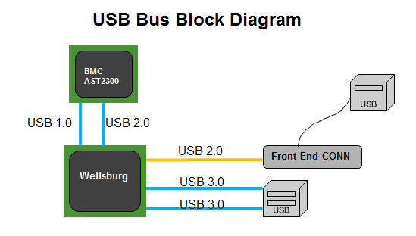
Figure 3-7: Grantley USB Ports

PCIe BUS
PCI Express* Gen1, Gen2 and Gen 3 are dual-simplex point-to point serial differential low-voltage interconnects. The signaling bit rate is 2.5 Gb/s one direction per lane for Gen1 (8b/10b encoding), 5.0 Gbit/s one direction per lane for Gen2 (8b/10b encoding) and 8.0 Gb/s one direction per lane for Gen3 (128b/130b encoding). Each port consists of a transmitter and receiver pair. A link between the ports of two devices is a collection of lanes (x1, x2, x4, x8, x16, etc.).

PCIe PORT CONNECTIVITY
The following diagram lists the usage of the Grantley-EP and Wellsburg PCIe bus segments in S2B project.

Figure 3-8 Quanta Grantley S2B PCIe block diagram

PCIe Interface
There are multi types of Riser boards and Mezzanine boards for this project. Also we will have PCIe SSD Backplane connected to motherboard via Cable. The follow table lists the detail request of this project.

Table 3-8. Riser and Mezzanine list
Description
1U | 1 Slot Riser1 | Support (1) PCIe Gen3 x8 Add-on Card
 | 1 Slot Riser2 | Support (1) PCIe GEN3 x16 Add-on Card
 | Linking Riser1 | Support (1) PCIe Gen3 x8  Link to Quanta LAN MEZZ Card (NCSI interface support)
2U | Riser1 – (2) Slot | Support  (1) PCIe Gen3 x16 Add-on Card  (1) PCIe Gen3 x8 Add-on Card
 | Riser1 - (2) Slot +(1) linking | Support  - PCIe Gen3 x8 linking slot (NCSI interface support)  - PCIe Gen3 x8 Add-on Card
 | Riser2 - (2) Slot | Support  - PCIe Gen3 x16 slot  - PCIe Gen3 x8 Add-on Card
OCP  Mezz |  | PCIe x8 Connector  NCSI interface support
PCIe SSD |  | Support  (2) PCIe Gen3 x4 port for PCIe SSD Drive

Riser Slot PINOUT

Riser 1 PINOUT Definition
Table 3-9. PIN definition of PCIe Riser 1
Riser 1
Name | PIN |  | Name
P12V | B1 | A1 | GND
P12V | B2 | A2 | P12V
P12V | B3 | A3 | P12V
GND | B4 | A4 | P12V
P3V3 | B5 | A5 | GND
P3V3 | B6 | A6 | P3V3
P3V3 | B7 | A7 | P3V3
P3V3 | B8 | A8 | P3V3
GND | B9 | A9 | P3V3
P3V3_AUX | B10 | A10 | P3V3
IRQ_LVC3_WAKE_N | B11 | A11 | GND
P12V_STBY | B12 | A12 | RST_PERST0_N
SMB_PCI_3V3SB_CLK | B13 | A13 | SLOT1_PRESENT_N
SM B_PCI_3V3SB_DAT_SLOT1 | B14 | A14 | FM_RISER1_CFG0
GND | B15 | A15 | FM_RISER1_CFG1
CLK_100M_PE1_DP | B16 | A16 | GND
CLK_100M_PE1_DN | B17 | A17 | CLK_100M_PE2_DP
GND | B18 | A18 | CLK_100M_PE2_DN
CLK_100M_PE3_DP | B19 | A19 | GND
CLK_100M_PE3_DN | B20 | A20 | P3E_CPU1_PCIE3_RX_DP7
GND | B21 | A21 | P3E_CPU1_PCIE3_RX_DN7
P3E_CPU1_PCIE3_TX_C_DP7 | B22 | A22 | GND
P3E_CPU1_PCIE3_TX_C_DN7 | B23 | A23 | GND
GND | B24 | A24 | P3E_CPU1_PCIE3_RX_DP6
GND | B25 | A25 | P3E_CPU1_PCIE3_RX_DN6
P3E_CPU1_PCIE3_TX_C_DP6 | B26 | A26 | GND
P3E_CPU1_PCIE3_TX_C_DN6 | B27 | A27 | GND
GND | B28 | A28 | P3E_CPU1_PCIE3_RX_DP5
GND | B29 | A29 | P3E_CPU1_PCIE3_RX_DN5
P3E_CPU1_PCIE3_TX_C_DP5 | B30 | A30 | GND
P3E_CPU1_PCIE3_TX_C_DN5 | B31 | A31 | GND
GND | B32 | A32 | P3E_CPU1_PCIE3_RX_DP4
GND | B33 | A33 | P3E_CPU1_PCIE3_RX_DN4
P3E_CPU1_PCIE3_TX_C_DP4 | B34 | A34 | GND
P3E_CPU1_PCIE3_TX_C_DN4 | B35 | A35 | GND
GND | B36 | A36 | P3E_CPU1_PCIE3_RX_DP3
GND | B37 | A37 | P3E_CPU1_PCIE3_RX_DN3
P3E_CPU1_PCIE3_TX_C_DP3 | B38 | A38 | GND
P3E_CPU1_PCIE3_TX_C_DN6 | B39 | A39 | GND
GND | B40 | A40 | P3E_CPU1_PCIE3_RX_DP2
GND | B41 | A41 | P3E_CPU1_PCIE3_RX_DN2
P3E_CPU1_PCIE3_TX_C_DP2 | B42 | A42 | GND
P3E_CPU1_PCIE3_TX_C_DN2 | B43 | A43 | GND
GND | B44 | A44 | P3E_CPU1_PCIE3_RX_DP1
GND | B45 | A45 | P3E_CPU1_PCIE3_RX_DN1
P3E_CPU1_PCIE3_TX_C_DP1 | B46 | A46 | GND
P3E_CPU1_PCIE3_TX_C_DN1 | B47 | A47 | GND
GND | B48 | A48 | P3E_CPU1_PCIE3_RX_DP0
GND | B49 | A49 | P3E_CPU1_PCIE3_RX_DN0
P3E_CPU1_PCIE3_TX_C_DP0 | B50 | A50 | GND
P3E_CPU1_PCIE3_TX_C_DN0 | B51 | A51 | GND
GND | B52 | A52 | P3E_CPU0_PCIE2_RX_DP15
GND | B53 | A53 | P3E_CPU0_PCIE2_RX_DN15
P3E_CPU0_PCIE2_TX_C_DP15 | B54 | A54 | GND
P3E_CPU0_PCIE2_TX_C_DN15 | B55 | A55 | GND
GND | B56 | A56 | P3E_CPU0_PCIE2_RX_DP14
GND | B57 | A57 | P3E_CPU0_PCIE2_RX_DN14
P3E_CPU0_PCIE2_TX_C_DP14 | B58 | A58 | GND
P3E_CPU0_PCIE2_TX_C_DN14 | B59 | A59 | GND
GND | B60 | A60 | P3E_CPU0_PCIE2_RX_DP13
GND | B61 | A61 | P3E_CPU0_PCIE2_RX_DN13
P3E_CPU0_PCIE2_TX_C_DP13 | B62 | A62 | GND
P3E_CPU0_PCIE2_TX_C_DN13 | B63 | A63 | GND
GND | B64 | A64 | P3E_CPU0_PCIE2_RX_DP12
GND | B65 | A65 | P3E_CPU0_PCIE2_RX_DN12
P3E_CPU0_PCIE2_TX_C_DP12 | B66 | A66 | GND
P3E_CPU0_PCIE2_TX_C_DN12 | B67 | A67 | GND
GND | B68 | A68 | P3E_CPU0_PCIE2_RX_DP11
GND | B69 | A69 | P3E_CPU0_PCIE2_RX_DN11
P3E_CPU0_PCIE2_TX_C_DP11 | B70 | A70 | GND
P3E_CPU0_PCIE2_TX_C_DN11 | B71 | A71 | GND
GND | B72 | A72 | P3E_CPU0_PCIE2_RX_DP10
GND | B73 | A73 | P3E_CPU0_PCIE2_RX_DN10
P3E_CPU0_PCIE2_TX_C_DP10 | B74 | A74 | GND
P3E_CPU0_PCIE2_TX_C_DN10 | B75 | A75 | GND
GND | B76 | A76 | P3E_CPU0_PCIE2_RX_DP9
GND | B77 | A77 | P3E_CPU0_PCIE2_RX_DN9
P3E_CPU0_PCIE2_TX_C_DP9 | B78 | A78 | GND
P3E_CPU0_PCIE2_TX_C_DN9 | B79 | A79 | GND
GND | B80 | A80 | P3E_CPU0_PCIE2_RX_DP8
GND | B81 | A81 | P3E_CPU0_PCIE2_RX_DN8
P3E_CPU0_PCIE2_TX_C_DP8 | B82 | A82 | GND
P3E_CPU0_PCIE2_TX_C_DN8 | B83 | A83 | GND
GND | B84 | A84 | P3E_CPU0_PCIE2_RX_DP7
GND | B85 | A85 | P3E_CPU0_PCIE2_RX_DN7
P3E_CPU0_PCIE2_TX_C_DP7 | B86 | A86 | GND
P3E_CPU0_PCIE2_TX_C_DN7 | B87 | A87 | GND
GND | B88 | A88 | P3E_CPU0_PCIE2_RX_DP6
GND | B89 | A89 | P3E_CPU0_PCIE2_RX_DN6
P3E_CPU0_PCIE2_TX_C_DP6 | B90 | A90 | GND
P3E_CPU0_PCIE2_TX_C_DN6 | B91 | A91 | GND
GND | B92 | A92 | P3E_CPU0_PCIE2_RX_DP5
GND | B93 | A93 | P3E_CPU0_PCIE2_RX_DN5
P3E_CPU0_PCIE2_TX_C_DP5 | B94 | A94 | GND
P3E_CPU0_PCIE2_TX_C_DN5 | B95 | A95 | GND
GND | B96 | A96 | P3E_CPU0_PCIE2_RX_DP4
GND | B97 | A97 | P3E_CPU0_PCIE2_RX_DN4
P3E_CPU0_PCIE2_TX_C_DP4 | B98 | A98 | GND
P3E_CPU0_PCIE2_TX_C_DN4 | B99 | A99 | GND
GND | B100 | A100 | P3E_CPU0_PCIE2_RX_DP3
GND | B101 | A101 | P3E_CPU0_PCIE2_RX_DN3
P3E_CPU0_PCIE2_TX_C_DP3 | B102 | A102 | GND
P3E_CPU0_PCIE2_TX_C_DN3 | B103 | A103 | GND
GND | B104 | A104 | P3E_CPU0_PCIE2_RX_DP2
GND | B105 | A105 | P3E_CPU0_PCIE2_RX_DN2
P3E_CPU0_PCIE2_TX_C_DP2 | B106 | A106 | GND
P3E_CPU0_PCIE2_TX_C_DN2 | B107 | A107 | GND
GND | B108 | A108 | P3E_CPU0_PCIE2_RX_DP1
GND | B109 | A109 | P3E_CPU0_PCIE2_RX_DN1
P3E_CPU0_PCIE2_TX_C_DP1 | B110 | A110 | GND
P3E_CPU0_PCIE2_TX_C_DN1 | B111 | A111 | GND
GND | B112 | A112 | P3E_CPU0_PCIE2_RX_DP0
GND | B113 | A113 | P3E_CPU0_PCIE2_RX_DN0
P3E_CPU0_PCIE2_TX_C_DP0 | B114 | A114 | GND
P3E_CPU0_PCIE2_TX_C_DN0 | B115 | A115 | GND

Riser 2 PINOUT Definition
Table 3-10. PIN definition of PCIe Riser 2
Riser 2
Name | PIN |  | Name
P12V | B1 | A1 | GND
P12V | B2 | A2 | P12V
P12V | B3 | A3 | P12V
GND | B4 | A4 | P12V
P3V3 | B5 | A5 | GND
P3V3 | B6 | A6 | P3V3
P3V3 | B7 | A7 | P3V3
P3V3 | B8 | A8 | P3V3
GND | B9 | A9 | P3V3
P3V3_AUX | B10 | A10 | P3V3
IRQ_LVC3_WAKE_N | B11 | A11 | GND
TP_SLOT2_B12 | B12 | A12 | RST_PERST1_N
SMB_PCI_3V3SB_CLK | B13 | A13 | SLOT2_PRESENT_N
SM B_PCI_3V3SB_DAT_SLOT2 | B14 | A14 | FM_RISER2_CFG0
GND | B15 | A15 | FM_RISER2_CFG1
CLK_100M_PE4_DP | B16 | A16 | GND
CLK_100M_PE4_DN | B17 | A17 | CLK_100M_PE5_DP
GND | B18 | A18 | CLK_100M_PE5_DN
CLK_100M_PE6_DP | B19 | A19 | GND
CLK_100M_PE6_DN | B20 | A20 | P3E_CPU1_PCIE3_RX_DP8
GND | B21 | A21 | P3E_CPU1_PCIE3_RX_DN8
P3E_CPU1_PCIE3_TX_C_DP8 | B22 | A22 | GND
P3E_CPU1_PCIE3_TX_C_DN8 | B23 | A23 | GND
GND | B24 | A24 | P3E_CPU1_PCIE3_RX_DP9
GND | B25 | A25 | P3E_CPU1_PCIE3_RX_DN9
P3E_CPU1_PCIE3_TX_C_DP9 | B26 | A26 | GND
P3E_CPU1_PCIE3_TX_C_DN9 | B27 | A27 | GND
GND | B28 | A28 | P3E_CPU1_PCIE3_RX_DP10
GND | B29 | A29 | P3E_CPU1_PCIE3_RX_DN10
P3E_CPU1_PCIE3_TX_C_DP10 | B30 | A30 | GND
P3E_CPU1_PCIE3_TX_C_DN10 | B31 | A31 | GND
GND | B32 | A32 | P3E_CPU1_PCIE3_RX_DP11
GND | B33 | A33 | P3E_CPU1_PCIE3_RX_DN11
P3E_CPU1_PCIE3_TX_C_DP11 | B34 | A34 | GND
P3E_CPU1_PCIE3_TX_C_DN11 | B35 | A35 | GND
GND | B36 | A36 | P3E_CPU1_PCIE3_RX_DP12
GND | B37 | A37 | P3E_CPU1_PCIE3_RX_DN12
P3E_CPU1_PCIE3_TX_C_DP12 | B38 | A38 | GND
P3E_CPU1_PCIE3_TX_C_DN12 | B39 | A39 | GND
GND | B40 | A40 | P3E_CPU1_PCIE3_RX_DP13
GND | B41 | A41 | P3E_CPU1_PCIE3_RX_DN13
P3E_CPU1_PCIE3_TX_C_DP13 | B42 | A42 | GND
P3E_CPU1_PCIE3_TX_C_DN13 | B43 | A43 | GND
GND | B44 | A44 | P3E_CPU1_PCIE3_RX_DP14
GND | B45 | A45 | P3E_CPU1_PCIE3_RX_DN14
P3E_CPU1_PCIE3_TX_C_DP14 | B46 | A46 | GND
P3E_CPU1_PCIE3_TX_C_DN14 | B47 | A47 | GND
GND | B48 | A48 | P3E_CPU1_PCIE3_RX_DP15
GND | B49 | A49 | P3E_CPU1_PCIE3_RX_DN15
P3E_CPU1_PCIE3_TX_C_DP15 | B50 | A50 | GND
P3E_CPU1_PCIE3_TX_C_DN15 | B51 | A51 | GND
GND | B52 | A52 | P3E_CPU1_PCIE2_RX_DP0
GND | B53 | A53 | P3E_CPU1_PCIE2_RX_DN0
P3E_CPU0_PCIE2_TX_C_DP0 | B54 | A54 | GND
P3E_CPU0_PCIE2_TX_C_DN0 | B55 | A55 | GND
GND | B56 | A56 | P3E_CPU1_PCIE2_RX_DP1
GND | B57 | A57 | P3E_CPU1_PCIE2_RX_DN1
P3E_CPU0_PCIE2_TX_C_DP1 | B58 | A58 | GND
P3E_CPU0_PCIE2_TX_C_DN1 | B59 | A59 | GND
GND | B60 | A60 | P3E_CPU1_PCIE2_RX_DP2
GND | B61 | A61 | P3E_CPU1_PCIE2_RX_DN2
P3E_CPU0_PCIE2_TX_C_DP2 | B62 | A62 | GND
P3E_CPU0_PCIE2_TX_C_DN2 | B63 | A63 | GND
GND | B64 | A64 | P3E_CPU1_PCIE2_RX_DP3
GND | B65 | A65 | P3E_CPU1_PCIE2_RX_DN3
P3E_CPU0_PCIE2_TX_C_DP3 | B66 | A66 | GND
P3E_CPU0_PCIE2_TX_C_DN3 | B67 | A67 | GND
GND | B68 | A68 | P3E_CPU1_PCIE2_RX_DP4
GND | B69 | A69 | P3E_CPU1_PCIE2_RX_DN4
P3E_CPU0_PCIE2_TX_C_DP4 | B70 | A70 | GND
P3E_CPU0_PCIE2_TX_C_DN4 | B71 | A71 | GND
GND | B72 | A72 | P3E_CPU1_PCIE2_RX_DP5
GND | B73 | A73 | P3E_CPU1_PCIE2_RX_DN5
P3E_CPU0_PCIE2_TX_C_DP5 | B74 | A74 | GND
P3E_CPU0_PCIE2_TX_C_DN5 | B75 | A75 | GND
GND | B76 | A76 | P3E_CPU1_PCIE2_RX_DP6
GND | B77 | A77 | P3E_CPU1_PCIE2_RX_DN6
P3E_CPU0_PCIE2_TX_C_DP6 | B78 | A78 | GND
P3E_CPU0_PCIE2_TX_C_DN6 | B79 | A79 | GND
GND | B80 | A80 | P3E_CPU1_PCIE2_RX_DP7
GND | B81 | A81 | P3E_CPU1_PCIE2_RX_DN7
P3E_CPU0_PCIE2_TX_C_DP7 | B82 | A82 | GND
P3E_CPU0_PCIE2_TX_C_DN7 | B83 | A83 | GND
GND | B84 | A84 | P3E_CPU1_PCIE2_RX_DP8
GND | B85 | A85 | P3E_CPU1_PCIE2_RX_DN8
P3E_CPU0_PCIE2_TX_C_DP8 | B86 | A86 | GND
P3E_CPU0_PCIE2_TX_C_DN8 | B87 | A87 | GND
GND | B88 | A88 | P3E_CPU1_PCIE2_RX_DP9
GND | B89 | A89 | P3E_CPU1_PCIE2_RX_DN9
P3E_CPU0_PCIE2_TX_C_DP9 | B90 | A90 | GND
P3E_CPU0_PCIE2_TX_C_DN9 | B91 | A91 | GND
GND | B92 | A92 | P3E_CPU1_PCIE2_RX_DP10
GND | B93 | A93 | P3E_CPU1_PCIE2_RX_DN10
P3E_CPU0_PCIE2_TX_C_DP10 | B94 | A94 | GND
P3E_CPU0_PCIE2_TX_C_DN10 | B95 | A95 | GND
GND | B96 | A96 | P3E_CPU1_PCIE2_RX_DP11
GND | B97 | A97 | P3E_CPU1_PCIE2_RX_DN11
P3E_CPU0_PCIE2_TX_C_DP11 | B98 | A98 | GND
P3E_CPU0_PCIE2_TX_C_DN11 | B99 | A99 | GND
GND | B100 | A100 | P3E_CPU1_PCIE2_RX_DP12
GND | B101 | A101 | P3E_CPU1_PCIE2_RX_DN12
P3E_CPU0_PCIE2_TX_C_DP12 | B102 | A102 | GND
P3E_CPU0_PCIE2_TX_C_DN12 | B103 | A103 | GND
GND | B104 | A104 | P3E_CPU1_PCIE2_RX_DP13
GND | B105 | A105 | P3E_CPU1_PCIE2_RX_DN13
P3E_CPU0_PCIE2_TX_C_DP13 | B106 | A106 | GND
P3E_CPU0_PCIE2_TX_C_DN13 | B107 | A107 | GND
GND | B108 | A108 | P3E_CPU1_PCIE2_RX_DP14
GND | B109 | A109 | P3E_CPU1_PCIE2_RX_DN14
P3E_CPU0_PCIE2_TX_C_DP14 | B110 | A110 | GND
P3E_CPU0_PCIE2_TX_C_DN14 | B111 | A111 | GND
GND | B112 | A112 | P3E_CPU1_PCIE2_RX_DP15
GND | B113 | A113 | P3E_CPU1_PCIE2_RX_DN15
P3E_CPU0_PCIE2_TX_C_DP15 | B114 | A114 | GND
P3E_CPU0_PCIE2_TX_C_DN15 | B115 | A115 | GND

OCP MEZZ PINOUT Definition
Table 3-11. PIN definition of PCIe OCP Mezz connector
OCP Mezz
PIN | Name | PIN | Name
61 | P12V | 1 | MEZZ_PRSNT1_N
62 | P12V | 2 | P5V_AUX
63 | P12V | 3 | P5V_AUX
64 | GND | 4 | P5V_AUX
65 | GND | 5 | GND
66 | P3V3_AUX | 6 | GND
67 | GND | 7 | P3V3_AUX
68 | GND | 8 | GND
69 | P3V3 | 9 | GND
70 | P3V3 | 10 | P3V3
71 | P3V3 | 11 | P3V3
72 | P3V3 | 12 | P3V3
73 | GND | 13 | P3V3
74 | PU_SMB_LAN_ALERT_N_MEZZ | 14 | NCSI_OCP_RCSDV
75 | SMB_PCI_3V3SB_CLK | 15 | NCSI_OCP_RCLK
76 | SMB_PCI_3V3SB_DAT_MEZZ_R | 16 | NCSI_OCP_TXEN
77 | IRQ_LVC3_WAKE_N | 17 | RST_PERST0_N
78 | NCSI_OCP_RXER | 18 | TP_OCP_MEZZ_18
79 | GND | 19 | TP_OCP_MEZZ_19
80 | NCSI_OCP_TXD0 | 20 | GND
81 | NCSI_OCP_TXD1 | 21 | GND
82 | GND | 22 | NCSI_OCP_RXD0
83 | GND | 23 | NCSI_OCP_RXD1
84 | CLK_100M_OCP_MEZZA_DP | 24 | GND
85 | CLK_100M_OCP_MEZZA_DN | 25 | GND
86 | GND | 26 | CLK_100M_OCP_MEZZB_DP
87 | GND | 27 | CLK_100M_OCP_MEZZB_DN
88 | P3E_CPU0_PCIE3_TX_C_DP7 | 28 | GND
89 | P3E_CPU0_PCIE3_TX_C_DN7 | 29 | GND
90 | GND | 30 | P3E_CPU0_PCIE3_RX_DP7
91 | GND | 31 | P3E_CPU0_PCIE3_RX_DN7
92 | P3E_CPU0_PCIE3_TX_C_DP6 | 32 | GND
93 | P3E_CPU0_PCIE3_TX_C_DN6 | 33 | GND
94 | GND | 34 | P3E_CPU0_PCIE3_RX_DP6
95 | GND | 35 | P3E_CPU0_PCIE3_RX_DN6
96 | P3E_CPU0_PCIE3_TX_C_DP5 | 36 | GND
97 | P3E_CPU0_PCIE3_TX_C_DN5 | 37 | GND
98 | GND | 38 | P3E_CPU0_PCIE3_RX_DP5
99 | GND | 39 | P3E_CPU0_PCIE3_RX_DN5
100 | P3E_CPU0_PCIE3_TX_C_DP4 | 40 | GND
101 | P3E_CPU0_PCIE3_TX_C_DN4 | 41 | GND
102 | GND | 42 | P3E_CPU0_PCIE3_RX_DP4
103 | GND | 43 | P3E_CPU0_PCIE3_RX_DN4
104 | P3E_CPU0_PCIE3_TX_C_DP3 | 44 | GND
105 | P3E_CPU0_PCIE3_TX_C_DN3 | 45 | GND
106 | GND | 46 | P3E_CPU0_PCIE3_RX_DP3
107 | GND | 47 | P3E_CPU0_PCIE3_RX_DN3
108 | P3E_CPU0_PCIE3_TX_C_DP2 | 48 | GND
109 | P3E_CPU0_PCIE3_TX_C_DN2 | 49 | GND
110 | GND | 50 | P3E_CPU0_PCIE3_RX_DP2
111 | GND | 51 | P3E_CPU0_PCIE3_RX_DN2
112 | P3E_CPU0_PCIE3_TX_C_DP1 | 52 | GND
113 | P3E_CPU0_PCIE3_TX_C_DN1 | 53 | GND
114 | GND | 54 | P3E_CPU0_PCIE3_RX_DP1
115 | GND | 55 | P3E_CPU0_PCIE3_RX_DN1
116 | P3E_CPU0_PCIE3_TX_C_DP0 | 56 | GND
117 | P3E_CPU0_PCIE3_TX_C_DN0 | 57 | GND
118 | GND | 58 | P3E_CPU0_PCIE3_RX_DP0
119 | GND | 59 | P3E_CPU0_PCIE3_RX_DN0
120 | OCP_MEZZA_PRSNT_N | 60 | GND

PCIe SSD 0 Pinout Definition
Table 3-12. PIN definition of PCIe SSD0 Connector
PCIe SSD0
PIN | Name | PIN | Name
A1 | SMB_PCI_3V3SB_CLK | C1 | CLK_100M_PE7_DP
A2 | SMB_PCI_3V3SB_DAT_PESSD0 | C2 | CLK_100M_PE7_DN
A3 | GND | C3 | GND
A4 | P3E_CPU1_PCIE1_RX_DP1 | C4 | P3E_CPU1_PCIE1_TX_C_DP1
A5 | P3E_CPU1_PCIE1_RX_DN1 | C5 | P3E_CPU1_PCIE1_TX_C_DN1
A6 | GND | C6 | GND
A7 | P3E_CPU1_PCIE1_RX_DP3 | C7 | P3E_CPU1_PCIE1_TX_C_DP3
A8 | P3E_CPU1_PCIE1_RX_DN3 | C8 | P3E_CPU1_PCIE1_TX_C_DN3
A9 | GND | C9 | GND
B1 | RST_PERST1_N | D1 | SMB_LVC3_PE_HP_SCL_R1
B2 | HP_LVC3_PESSD0_PWRGD | D2 | SMB_LVC3_PE_HP_SDA_R1
B3 | GND | D3 | GND
B4 | P3E_CPU1_PCIE1_RX_DP0 | D4 | P3E_CPU1_PCIE1_TX_C_DP0
B5 | P3E_CPU1_PCIE1_RX_DN0 | D5 | P3E_CPU1_PCIE1_TX_C_DN0
B6 | GND | D6 | GND
B7 | P3E_CPU1_PCIE1_RX_DP2 | D7 | P3E_CPU1_PCIE1_TX_C_DP2
B8 | P3E_CPU1_PCIE1_RX_DN2 | D8 | P3E_CPU1_PCIE1_TX_C_DN2
B9 | GND | D9 | GND
G1 | GND | G3 | GND
G2 | GND | G4 | GND

PCIe SSD 1 Pinout Definition
Table 3-13. PIN definition of PCIe SSD1 Connector
PCIe SSD0
PIN | Name | PIN | Name
A1 | SMB_PCI_3V3SB_CLK | C1 | CLK_100M_PE8_DP
A2 | SMB_PCI_3V3SB_DAT_PESSD1 | C2 | CLK_100M_PE8_DN
A3 | GND | C3 | GND
A4 | P3E_CPU1_PCIE1_RX_DP5 | C4 | P3E_CPU1_PCIE1_TX_C_DP5
A5 | P3E_CPU1_PCIE1_RX_DN5 | C5 | P3E_CPU1_PCIE1_TX_C_DN5
A6 | GND | C6 | GND
A7 | P3E_CPU1_PCIE1_RX_DP7 | C7 | P3E_CPU1_PCIE1_TX_C_DP7
A8 | P3E_CPU1_PCIE1_RX_DN7 | C8 | P3E_CPU1_PCIE1_TX_C_DN7
A9 | GND | C9 | GND
B1 | RST_PERST1_N | D1 | SMB_LVC3_PE_HP_SCL_R2
B2 | HP_LVC3_PESSD1_PWRGD | D2 | SMB_LVC3_PE_HP_SDA_R2
B3 | GND | D3 | GND
B4 | P3E_CPU1_PCIE1_RX_DP4 | D4 | P3E_CPU1_PCIE1_TX_C_DP4
B5 | P3E_CPU1_PCIE1_RX_DN4 | D5 | P3E_CPU1_PCIE1_TX_C_DN4
B6 | GND | D6 | GND
B7 | P3E_CPU1_PCIE1_RX_DP6 | D7 | P3E_CPU1_PCIE1 TX_C_DP6
B8 | P3E_CPU1_PCIE1_RX_DN6 | D8 | P3E_CPU1_PCIE1 TX_C_DN6
B9 | GND | D9 | GND
G1 | GND | G3 | GND
G2 | GND | G4 | GND

LAN ON MOTHERBOARD (LOM)
The baseboards will use the Intel® I350 code named Powerville Dual 10/100/1000 integrated MAC and PHY controller. The Powerville LAN controller requires a PCIe x4 Gen2 upstream interface. The Powerville controller also requires the use of the Wellsburg SMBus interface during Sleep states S5 as well as for ME Firmware. The Powerville LAN controller will be on standby power so that Wake on LAN and manageability functions can be supported. Powerville will be used in conjunction with the BMC for out of band Management traffic. The BMC will communicate with Powerville over a NC-SI interface (RMII physical). Powerville will be on standby power so that the BMC can send management traffic over the NC-SI interface to the network during sleep states S5.

DEDICATED NIC (MANAGEMENT RJ45 Port)
Motherboards will support embedded version of the Dedicated NIC. The Dedicated NIC feature provides a dedicated 1G/100M/10Mb Ethernet interface for remote management features. The Dedicated NIC consists of a 1G/100M/10MbE PHY device which interfaces to the primary NC-SI port 0 (RGMII mode) out of the AST2400 integrated BMC, to offer a dedicated management 1G/100M/10MbE port. Because of the limited distance the RGMII signals can travel, the recommended placement for this connector is to be as close as possible to the AST2400 IBMC.

LPC BUS
The PCH implements an LPC interface as described in the Low Pin Count Interface Specification, Revision 1.1. The PCH LPC bus is used to connect to the BMC and to an optional TPM device.

TPM
The PCH supports TPM specification 1.2 level2 revisions 103. The Baseboard will not be populated with a TPM device except for special deals that require a TPM.

SERIAL PORT
There are two serial ports provided. One is external serial port on rear. One is internal serial port. The usage is either debug or for a terminal concentrator. Since the serial port does not exist in the IO panel, the user will need to use a cable and chassis knock out for a DB9 connector. The cable will connect to a standard 10 pin serial port header. Note that the choice of RS232 transceivers is limited by the absence of a -12V rail.

FANs
The board supports a total 8 FANs. Fan signals are made available via a consolidated header. The FAN control and FAN speed monitor are from BMC chip. BMC will have FAN Tachometer and PWM function. Note that all fans will operate at the same speed.

Jumper Definition
Below table is Jumper definition of board.
Table 4-7 BIOS/BMC Jumper Setting
JUMPER LOCATION |  | DEFAULT SETTING. | FUNCTION
PASSWORLD CLEAR | JP11 | 1-2 | 1-2 : HOLD (DEFAULT)  2-3 : CLEAR
RECOVER BIOS JUMPER | JP1 | 1-2 | 1-2 : HOLD (DEFAULT)  2-3 : RECOVER BIOS
CLR RTC_RST | JP10 | 1-2 | 1-2 : HOLD (DEFAULT)  2-3 : CLR RTC_RST
ME FIRMWARE UPDATE | JP8 | 1-2 | 1-2 : HOLD (DEFAULT)  2-3 : ME IN FORCE UPDATE MODE
BMC Disable/Enable | J19 | 1-2 | Open: HOLD (DEFAULT)  1-2: Disable BMC
SOL Enable | J7 | 1-2 | Open: HOLD (DEFAULT)  1-2: Enable BMC
Intruder Enable | J57 | 1-2 | Open: HOLD (DEFAULT)  1-2: Chassis Top Covered
SMB_SML0 debug header | JP24 | Pin1  Pin3 | Pin1: Smb_Sml0_3V3sb_Clk  Pin3: Smb_Sml0_3V3sb_Dat
SMB Host debug header | JP7 | Pin1  Pin3 | Pin1: Smb_Host_3V3sb_Clk  Pin3: Smb_Host_3V3sb_Dat
SMB_PMbus Debug Header | JP2 | Pin1  Pin3 | Pin1: Smb_3V3sb_Pmbus_Clk  Pin3: Smb_3V3sb_Pmbus_Dat

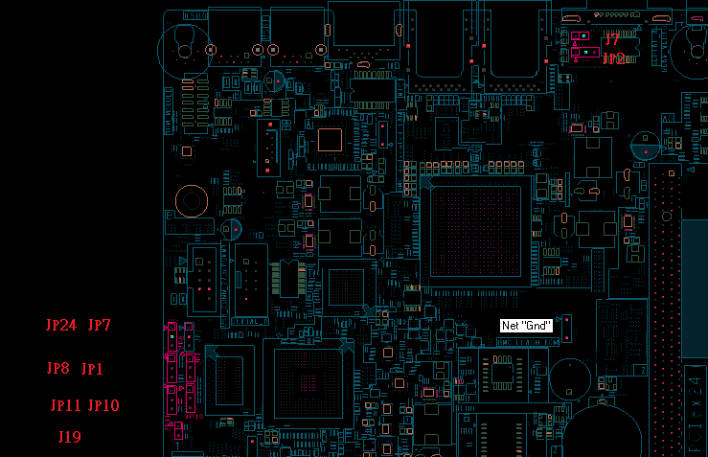
Figure 3-18: Jumper Location

Password Clear
The user sets this 3-pin jumper to clear the password. The pin should be strapped LOW when the password needs to be reset.
Table 4-8 Password Clear Jumper
Jumper Position | Mode of Operation | Note
1-2 | Normal | FM_PASSWORD_CLEAR_N pin is pulled HIGH. Default position.
2-3 | Clear Password | FM_PASSWORD_CLEAR_N pin is pulled LOW.

DEBUG header Information

XDP SUPPORT
Standard XDP header for Grantley-EP Processors (XDP 0) will be provided, the XDP connector will be depopulated in production, please indicate parts that can be safely removed for production in the schematic.

SMB Debug Header (JP7)
SMB Debug Header is a SMB debug header which was connected to PCH’s HOST channel and BMC SMB channel 4.
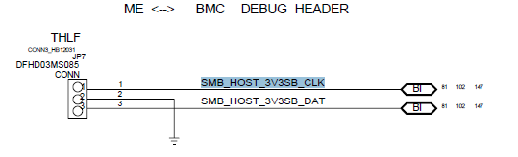
Figure 3-19: S2B SMB debug Header

BMC Debug Header (JP2 and J19)

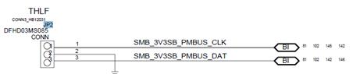
Figure 3-20: S2B PMBUS debug Header
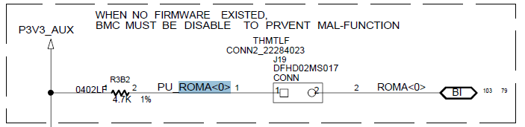
Figure 3-21: S2B BMC Desiable Header

PRODUCT SENSORS

Table 3-15. Baseboard Sensor list
 | Description
TMP75_0 | Temperature sensor on middle of board | PCI_Inlet_Temp2
TMP75_1 | Temperature sensor close to OCP Mezz | PCI_Inlet_Temp1
TMP75_2 | Temperature sensor close to dedicated NIC | Exhaust_Temp
AST2400 (BMC) | Monitor CPU core voltage and system voltage

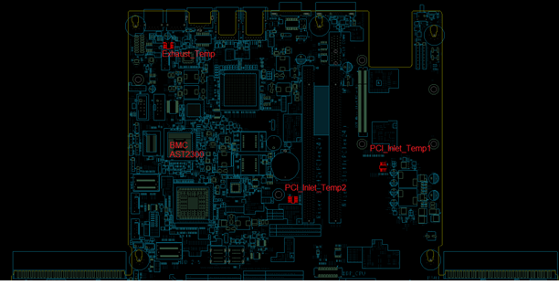
Figure 3-22: S2B Temperature sensor

SMBUS
The products must comply with the Grantley Platform common-core SMBUS architecture in order to maximize BIOS, Wellsburg ME Firmware, and BMC firmware. This is a requirement in an order to minimize BIOS and Firmware code development efforts and improve validation and product board
stability and debugging.

Figure 3-23: Grantley BMC SMBUS Block Diagram

POWER
These are max values (where available) for board VR design purposes. From a system power supply budgeting or thermal standpoint it's recommended to apply a derating factor. TDP power estimate for the main components are provided in below table as well.

LED Behavior of POWER SUPPLY

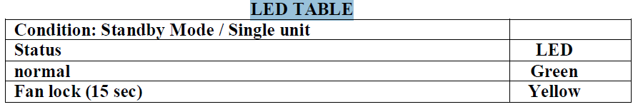

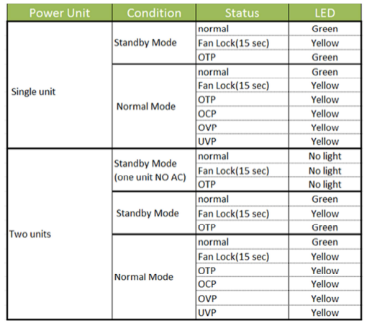
Table 3-17. LED Behavior of PSU

Power supply PINOUT
Table 3-17. PIN definition of Power Supply 0
Power Supply 0
Name | PIN |  | Name
P12V | 64 | 1 | P12V
P12V | 63 | 2 | P12V
P12V | 62 | 3 | P12V
P12V | 61 | 4 | P12V
P12V | 60 | 5 | P12V
P12V | 59 | 6 | P12V
P12V | 58 | 7 | P12V
P12V | 57 | 8 | P12V
P12V | 56 | 9 | P12V
P12V | 55 | 10 | P12V
P12V | 54 | 11 | P12V
P12V | 53 | 12 | P12V
GND | 52 | 13 | GND
GND | 51 | 14 | GND
GND | 50 | 15 | GND
GND | 49 | 16 | GND
GND | 48 | 17 | GND
GND | 47 | 18 | GND
GND | 46 | 19 | GND
GND | 45 | 20 | GND
GND | 44 | 21 | GND
GND | 43 | 22 | GND
GND | 42 | 23 | GND
GND | 41 | 24 | GND
PSU_REMOTE_SENSE_P | 40 | 25 | TP_TACH
P12V_STBY | 39 | 26 | PSU_REMOTE_SENSE_N
PSU_A0 | 38 | 27 | TP_VIN_GOOD
PWROK0 | 37 | 28 | CSHARE
GND | 36 | 29 | FM_PS_EN_PSU_N
SMB_3V3SB_PMBUS_CLK | 35 | 30 | PS_KILL_0
PSU_PRESENT0_N | 34 | 31 | RESET_PS_0
SMB_3V3SB_PMBUS_DAT | 33 | 32 | IRQ_SML1_PMBUS_ALERT_N

Table 3-18. PIN definition of Power Supply 1
Power Supply 1
Name | PIN |  | Name
P12V | 64 | 1 | P12V
P12V | 63 | 2 | P12V
P12V | 62 | 3 | P12V
P12V | 61 | 4 | P12V
P12V | 60 | 5 | P12V
P12V | 59 | 6 | P12V
P12V | 58 | 7 | P12V
P12V | 57 | 8 | P12V
P12V | 56 | 9 | P12V
P12V | 55 | 10 | P12V
P12V | 54 | 11 | P12V
P12V | 53 | 12 | P12V
GND | 52 | 13 | GND
GND | 51 | 14 | GND
GND | 50 | 15 | GND
GND | 49 | 16 | GND
GND | 48 | 17 | GND
GND | 47 | 18 | GND
GND | 46 | 19 | GND
GND | 45 | 20 | GND
GND | 44 | 21 | GND
GND | 43 | 22 | GND
GND | 42 | 23 | GND
GND | 41 | 24 | GND
PSU_REMOTE_SENSE_P | 40 | 25 | TP_TACH
P12V_STBY | 39 | 26 | PSU_REMOTE_SENSE_N
PSU_A1 | 38 | 27 | TP_VIN_GOOD
PWROK1 | 37 | 28 | CSHARE
GND | 36 | 29 | FM_PS_EN_PSU_N
SMB_3V3SB_PMBUS_CLK | 35 | 30 | PS_KILL_1
PSU_PRESENT1_N | 34 | 31 | RESET_PS_1
SMB_3V3SB_PMBUS_DAT | 33 | 32 | IRQ_SML1_PMBUS_ALERT_N

PRODUCT SYSTEM REQUIREMENTS
1U and 2U chassis will be enabled to complement the board offering. A new chassis development is expected in order to accommodate the marketing requirements of a spread-core form factor and the docking power supplies.

Chassis Overview
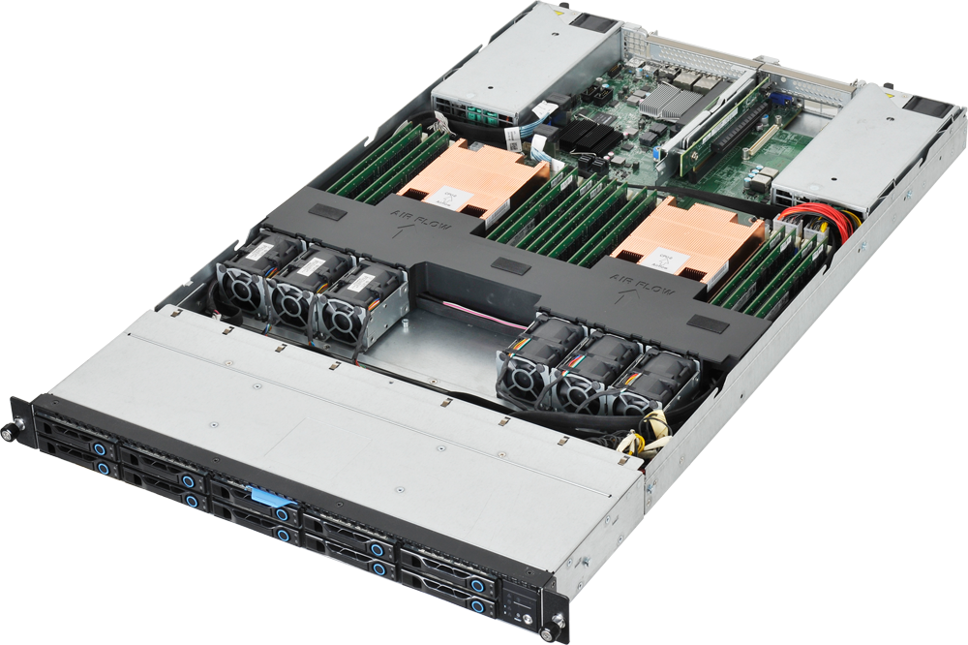
Figure 4-1 1U Chassis

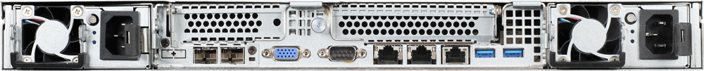

Figure 4-2 1U Chassis Front and Rear View

LED behavior

Front Panel LED Function and Behavior

2U System
Table 4-1. LED behavior of 2U system
Mark | Name | Color | Condition | Behavior | Voltage | Owner
 | Power LED | Blue | On | S0 System Power On | 5VSB | BMC
 |  |  | OFF | S5 System Power Off
 | ID LED | Blue | Blinking | Unit selected for Identification | 5VSB | BMC
 |  |  | OFF | No Identificaiton requested
 | Fault LED | Amber | Blinking | Critical Failure: FAN /Temp/ Voltage | 5VSB | BMC
 |  |  |  | Non Critical Failure:
 |  |  | OFF | SEL Cleared
 |  |  |  | Last pending warning or Error has been deleted
 | HDD Activity | Blue | Blinking | HDD access (SATA Onboard Only) | 5V | PCH
 |  |  | OFF
 | LAN1 LED | Blue | ON | Link | 3V3AUX | LAN1
 |  | Blue | Blinking | LAN Access
 | LAN2 LED | Blue | ON | Link | 3V3AUX | Lan2
 |  | Blue | Blinking | LAN Access

