AT&T Open
XGS-PON

MicroOLT Specification

Revision 1.0

Revision History

Revision | Date | Author | Description
1.0 | Mar 3, 2016 | Mike Meche | Initial Release

Revision History 1
Licenses 5
Scope 6
Introduction 6
Today’s OLT platforms 7
Evolution of the OLT Architecture 7
Virtual OLT 8
Architectures 9
Aggregated Networks 9
Next Generation OLT 10
Network Function Virtualization 11
Interfacing to the MicroPlug OLT module 12
I2C Interface 12
In-band Management 12
Control Plane 12
Management SVLAN 12
Ethernet OAM 12
Security 13
Protection 13
Physical Overview 14
High Density OLT MicroPlug Dimensions 14
Symmetric OLT MicroPlug Dimensions 15
Specifications 16
Features 16
Power Consumption 16
Environmental 16
Laser Safety 16
EMI 17
ROHS 17
Thermal Performance 18
Heat Dissipation 18
Thermal Simulations 18
A. Appendix: vOLT Equipment Physical Design Standards 21
A.1 Safety Requirements 21
R1-1: Equipment Type 21
R1-2: Electromagnetic Interference 21
R1-3: Conducted Emissions 21
R1-4: Immunity 21
R1-5: Lightning and AC Power Faults 21
R1-6: Steady State Power Induction 21
R1-7: Electrical Safety Criteria 21
R1-8: DC Potential Difference 22
R1-9: Electrostatic Discharge (ESD) Immunity Criteria 22
R1-10: Special Requirements and Maintenance Information 22
R1-11: Electrical Fast Transient (EFT) 22
R1-12: Bonding and Grounding Requirements 22
R1-13: Fire Spread 22
A.2 Minimum Infrastructure Operating Requirements 23
A.2.1 Environmental 23
R2-1: Temperature and Humidity Operating 23
R2-2: Altitude 23
R2-3: Energy Efficiency 24
R2-4: Equipment Air Flow 24
R2-5: Acoustic Noise 24
R2-6: Equipment Units Design 25
A.2.2 Alarms and Indicators 25
R2-7: Alarms 25
R2-8: Unit Indicator 25
R2-9: Alarm Interconnections 25
A.2.3 Power 25
R2-10: AC and DC Power 25
R2-11: AC Powered 25
R2-12: DC Power – Nominal -48Vdc 25
R2-13: DC Battery Return Configuration 25
R2-14: DC Power - Terminations General 25
R2-15: DC Power - Redundant Power Feeds 26
R2-16: DC Power - Battery Return Conductor 26
R2-17: DC Connectors 26
R2-18: Equipment DC Power Protection 27
R2-19: Filtered Battery 27
R2-20: Special PDU 27
R2-21: Visual Power Alarms and Status Indicator 27
R2-22: Steady-State Input DC Voltage Requirements 28
R2-23: Undervoltage Requirements 28
R2-24: Minimum Operating Voltage 28
R2-25: DC Power Current Drains 28
R2-26: Overvoltage Requirements 28
R2-27: Overvoltage Transient Requirement 29
R2-28: Protective Device Operation Transient 29
R2-29: Electrical Noise Requirements 29
A.2.4 Airborne Contaminants 29
R2-30: Fan Filter Requirements 29
A.2.5 Shock and Vibration 30
R2-31: Seismic - Vibration 30
R2-32: Positive Latching 30
R2-33: Office Vibrations 30
A.2.6 Fiber 30
R2-34: Fiber Optic Cabling and Connectors 30
R2-35: Fiber Optic Cable 30
R2-36: Fiber Connector Boots 30
R2-37: Overall Fiber Connector and Boot Length 30
R2-38: Fiber Bend Radius 30
R2-38: Minimum Distance Between Connector Housing and 90 Degree Bend 31
R2-38: Space Between Door/Panel and Fiber Connector 31
R2-38: Standard Fiber Connector 31

Licenses
To the extent of AT&T’s authorship in this specification, AT&T submits this specification to the Open Compute Project Foundation as a Contribution under the Open Compute Project Contributor License Agreement (July 13, 2014 version, available at the time of this writing, March 4, 2016, at https://rightsignature.com/forms/OMMUS-72474399-v1-db5554/token/27cfcf4a00d. AT&T agrees to make such specification available under the Open Web Foundation Final Specification Agreement (OWFa 1.0), which is available at http://www.openwebfoundation.org/legal/the-owf-1-0-agreements/owfa-1-0.

Your use of this specification may be subject to other third party rights. THIS SPECIFICATION IS PROVIDED "AS IS." No support of any kind will be provided by the contributors. The contributors expressly disclaim any warranties (express, implied, or otherwise), including implied warranties of merchantability, non-infringement, fitness for a particular purpose, completeness or title, related to the specification. The entire risk as to implementing or otherwise using the specification is assumed by the specification implementer and user. IN NO EVENT WILL ANY PARTY BE LIABLE TO ANY OTHER PARTY FOR LOST PROFITS OR ANY FORM OF INDIRECT, SPECIAL, INCIDENTAL, OR CONSEQUENTIAL DAMAGES OF ANY C H A R A C T E R FROM ANY CAUSES OF ACTION OF ANY KIND WITH RESPECT TO THIS SPECIFICATION OR ITS GOVERNING AGREEMENT, WHETHER BASED ON BREACH OF CONTRACT, TORT (INCLUDING NEGLIGENCE), OR OTHERWISE, AND WHETHER OR NOT THE OTHER PARTY HAS BEEN ADVISED OF THE POSSIBILITY OF SUCH DAMAGE.

Scope
This document outlines the technical specifications for the AT&T Open 10G PON MicroOLT solution submitted to the Open Compute Foundation.

Introduction
The MicroOLT is a PON optics module with an embedded Ethernet Bridge with PON MAC/PHY layer in SFP+ form factor. The MicroOLT is a component building block of a virtual OLT platform. Tibit is a vendor of a MicroOLT optics module branded as a MicroPlug. Tibit’s XGS-PON OLT MicroPlug is a hot-pluggable SFP+ optical transceiver with a built-in 10G Ethernet-to-NG-PON2 OLT MAC Bridge IC. It uses 10G XGS optics to enable the NG-PON2 solution at a fraction of the cost of tunable DWDM optics.

This 10G OLT plugs into low-cost Ethernet Switches or other Ethernet-enabled networking equipment with SFP+ sockets instantaneously enabling them to be part of a 10G PON network. The SFP+ OLT is suited for Software Defined Networking (SDN) and Network Function Virtualization (NFV) by enabling a virtual OLT (vOLT).

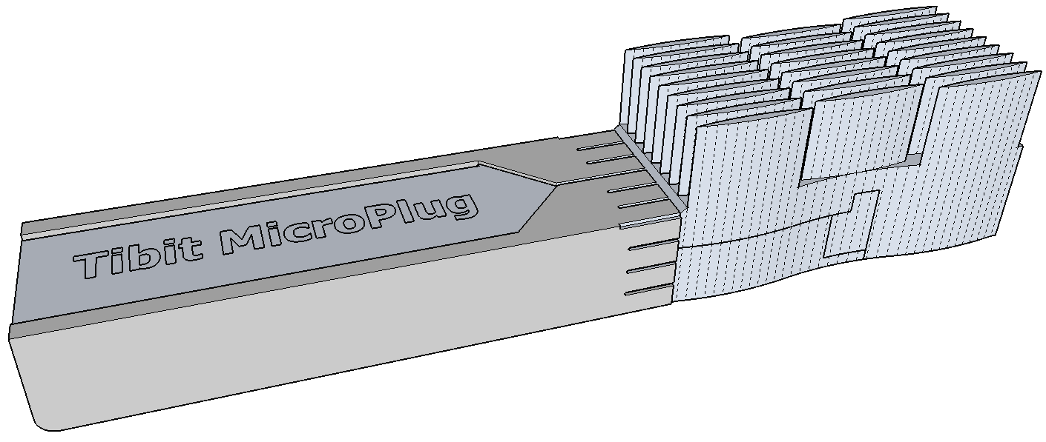
Figure 1. Tibit OLT MicroPlug

MicroPlug OLT modules can be used in the design of a next generation OLT. MicroPlug OLT modules can be used to create higher density or more flexible versions of today’s integrated solutions. The MicroOLT module is also suited to create Virtual OLT (vOLT) system solutions. In all cases, the MicroOLT module provides the application specific portion of an OLT in a single pluggable form factor.

A PON access system can be created by combining the MicroOLT module with a Network Function Virtualization Software layer, Ethernet Routers, Ethernet Switches, and other white box solutions. Existing OLT blades can achieve higher density and greater flexibility by using the MicroOLTs locally or remotely. The MicroOLT does not require or dictate a particular architecture. The MicroOLT allows the operator to flexibly select the architecture that fits their requirements.

An integrated Ethernet-to-PON Bridge allows the MicroOLT module to connect a PON Network to a point-to-point Ethernet SFP+ socket that is commonly found on Ethernet Switches, Routers, and many other optical networking devices. The MicroOLT module contains an embedded processor to allow for in-band module control and configuration locally or remotely over an Ethernet switching infrastructure. The PON MAC and PHY interface provide standard compliant interfaces that allow for compatibility with many readily available ONUs on the market.

Since the microOLT embeds Ethernet-to-PON Bridge functionality in the module it effectively terminates PON burst signals within it and provides a continuous point-to-point connection to the Ethernet Switch. The termination of the PON MAC and PHY in the optics module using a MicroOLT solution allows the use of less expensive PCB materials in the Ethernet Switches. A specialized version of the Ethernet Switch is not required to support burst operation.

Today’s OLT platforms
The Optical Line Terminal (OLT) provides an integrated access box for Passive Optical Networks. The OLTs are created with multiple layers of switching and traffic management. A PON line card has a traffic management Ethernet switch with PON MACs and PON transceiver sockets. A secondary switch provides line card aggregation to the Ethernet uplinks. OLTs are often a mixture of Layer 2 and Layer 3 switching with traffic shaping on a per-customer, per-service basis.

Figure 2: Functionality in today’s OLT platform

The OLTs are often managed by a proprietary Network Management System (NMS) for most TELCO applications.

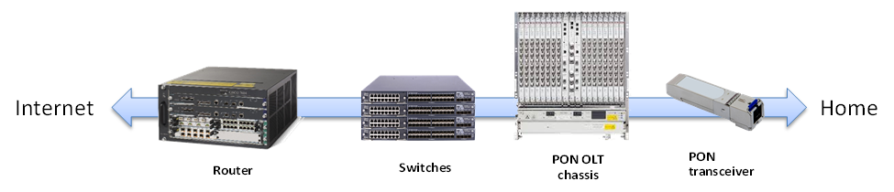
Figure 3: Traditional switching and access network for PON

From a functional point of view, the OLT has control software, Layer 2/3 switching, the PON MAC layer, and the PON Physical layer (optics). Behind the OLT, the network would normally contain Ethernet Switches for aggregation and a router to the internet.

Evolution of the OLT Architecture
Data centers have benefited from the emerging Software Defined Networking (SDN) and Network Function Virtualization (NFV) movements. High performance systems based on x86 processors and specialized software allow for flexible and low cost devices. Low cost Ethernet switches continue to dominate the market with many flavors of port count and speed. If access systems could utilize these devices, they could have lower cost and benefit from the significant investment. Additionally, if the complex functions could be serviced directly from the data center, the operator could significantly decrease the cost and improve the overall system performance.

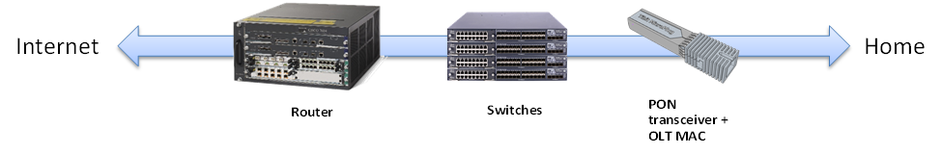
Figure 4: Evolving PON access system

The functionality of the OLT can be split into multiple pieces to align with the generic network functions and isolate the PON access system specific pieces. The microOLT contains the PON specific functions including Bridging, MAC Layer, and Physical Layer Optics. The rest of the system can be generic functions of Layer 2 switching for aggregation and Layer 3 switching with traffic management and routing. These generic devices can be leveraged from the data center and use SDN for orchestration.

Significant flexibility can be achieved by selecting PON or point-to-point Ethernet on a port by port basis. The MicroOLT eliminates chassis or “pizza-box” based OLT solutions while using less power and requiring less space. Sizable cost savings can be achieved by removing the application specific hardware and replacing it with best in class Ethernet Switches.

Virtual OLT
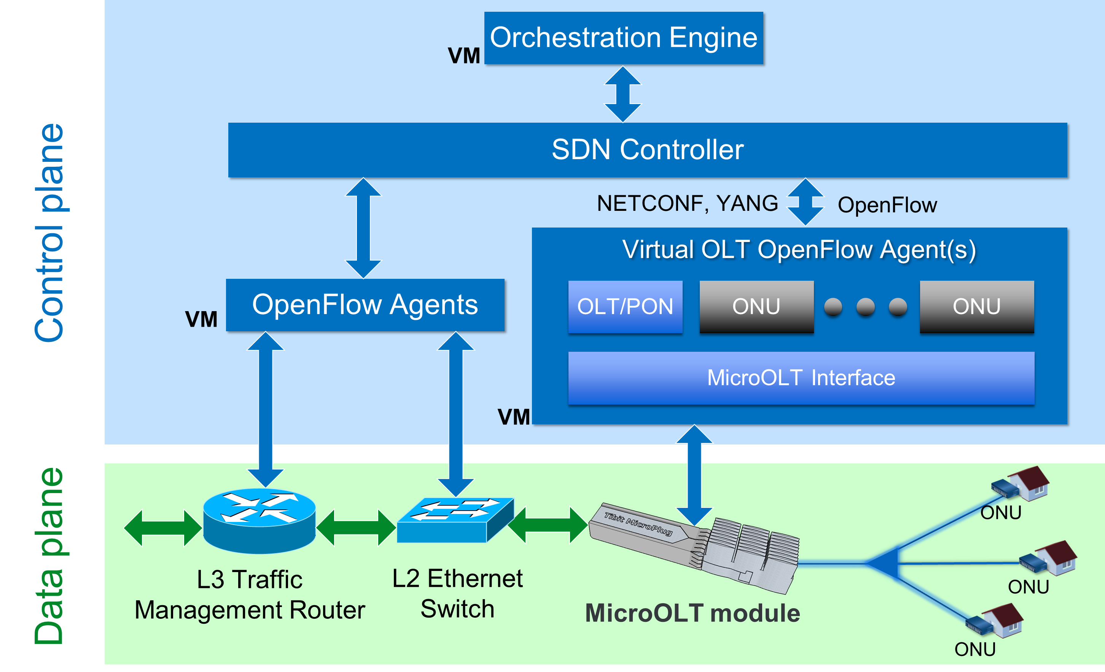
Figure 5: Virtual OLT software architecture

The MicroOLT module can provide a single PON port of a Virtual OLT. Switches and Routers can provide the data plane for the OLT while a software function is required to merge the single OLT ports and numerous ONUs into a logical OLT system and tie it together with the other data plane devices. The Virtual OLT software communicates to the OLT modules and ONUs over Layer 2 Ethernet OAM. The north bound interface from the Virtual OLT could be a TELCO EMS, or SDN (NETCONF, RESTAPI, etc.) interfaces. The Micro OLT provides the embedded firmware for translating the Ethernet OAM to OLT MAC configuration and management. The Virtual OLT software can be run on the hosting switch/router or on a server centralized in the network. The Virtual OLT software communicates to the MicroOLT modules to configure and manage the subscribers and the ONUs. The virtual OLT software could be developed internally by system vendors, licensed from third party software companies, or provided as open source software.

Architectures

Aggregated Networks

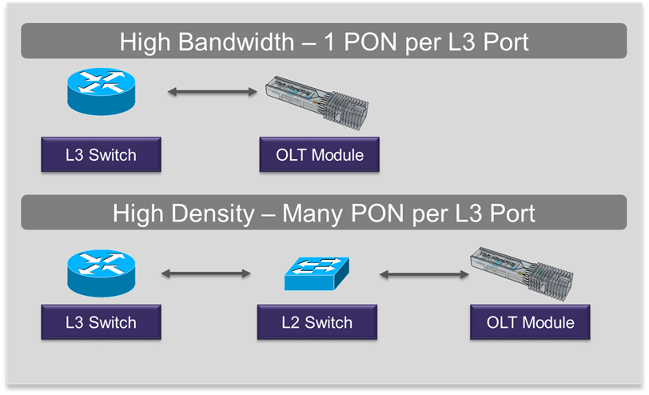
Figure 6: High Bandwidth or High Density network options

An operator can directly connect a MicroOLT module to the router/traffic manager for a high bandwidth solution. In many scenarios, the operator will aggregate more than a single PON worth of subscribers into the router/traffic manager port. In this case, the MicroOLT modules are connected into a Layer 2 switch to aggregate the PON ports into fewer ports or a higher speed link. The Layer 2 switch provides a more cost effective solution for high densities of subscribers than traditional OLTs or a large number of ports on the traffic management box.

To support MicroOLT modules, the SFP+ port needs to support the power and thermal requirements of the module (see
Specifications later in this document). Additionally, the switch needs to support SVLAN switching for isolating the management channels and the user data pipes.

The I2C interface on the SFP port are needed for the switch to detect the optical module and determine the type. The information on the I2C interface is stored in the module’s Flash.

The location of the Virtual OLT NFV software is up to the system vendor and operator. In some cases, it makes sense to place this software on the switch to provide a single box solution for a PON access box. In the outside plant switch, the management software could be placed in a remote server or system box to minimize the power and complexity outside of the central office or headend.

Next Generation OLT

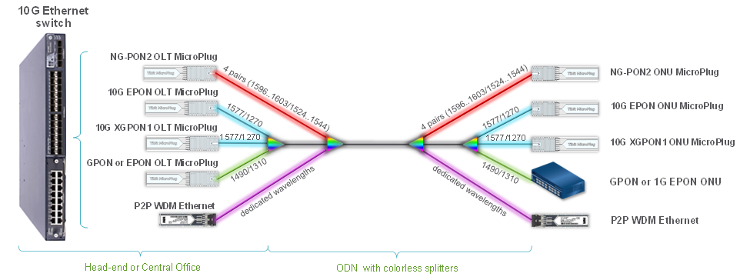
Figure 7: Pluggable Next Generation optical termination

The Next Generation OLT is an Ethernet switching platform with per-port flexibility. By plugging in the appropriate MicroOLT module or other optical module, an operator can pick between multiple access technologies. The fiber plant can be shared by overlaying different wavelengths together with a mixture of PON and Point-to-Point WDM. The Ethernet Switch hosting the modules can be very simple or a fully integrated Layer 3 traffic management switch based on the operator needs.

Many Ethernet Switches can be used to host MicroOLT modules. Example set of suitable Leaf Switch designs are available at the Open Compute Project Networking site (see Figure 8. OCP Networking Specs and Designs below).

http://www.opencompute.org/wiki/Networking/SpecsAndDesigns

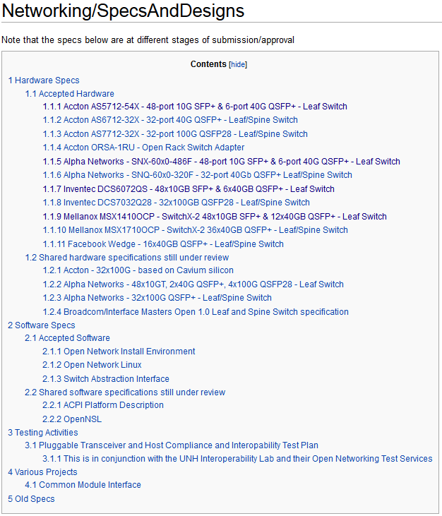
Figure 8. OCP Networking Specs and Designs

Network Function Virtualization
The goal of network function virtualization is generic hardware with software applications for personalization. While many of the OLT functions can be virtualized, the virtualization of some functions are either not possible, not efficient, or not cost effective. The table below gives a summary of the functions that are handled by virtualization versus the Tibit OLT MicroPlug module.

OLT Function | Virtualized Portion | MicroOLT Portion
PON Physical layer | None | All
PON MAC layer | None | All
Security/Encryption | Optional 802.1ae | Optional Hardware Encryption
Security/Authentication | 802.1x | Stores information in Flash
Downstream Switching | All switching decisions with mapping to VLANs | VLANs to PON Links
Upstream Switching | Configure classification in ONU to PON Links. VLAN termination, packet inspection, and redirecting | PON Links to VLANs
Downstream Traffic Management | Traffic shaped into VLANs | Optional ONU port shaping
Upstream Traffic Management | Configure OLT DBA | OLT DBA upstream shaping
Network Monitoring | SNMP termination | Statistic gathering and alarms
Table 1: Virtualized functions

Interfacing to the MicroPlug OLT module

I2C Interface
The I2C interface on the SFP interface provides the MSA required registers for the optics module and a port for initial configuration of the module. It does not provide the management and control for the module. The management, monitoring, and control are handled by the in-band OAM messages.

In-band Management
The MicroOLT modules are managed by Ethernet Layer 2 OAM. The message definitions can be found in the SIEPON (IEEE 1904.1 and IEEE 1904.2) specifications.

Control Plane

Management SVLAN
The safest way to manage a MicroOLT is through a dedicated Management SVLAN. The SVLAN allows the system to isolate subscriber traffic from the management traffic for network security. It is recommended that a filter rule is added to the upstream of the OLT to drop any frame with the Management VLAN to prevent users from sending into the channel. A single management SVLAN can service many MicroOLT modules on a layer network. The 802.1 Link Layer Discovery Protocol can be used to configure the module with the Management VLAN at power up.

Ethernet OAM
The Tibit MicroPlug uses a simple Ethernet OAM defined in IEEE 1904 to configure and manage the OLT module ports from the NFV software controller. The MicroOLT ports are not directly addressed by IP. The MicroOLTs and ONUs are addressed by their MAC address on the Layer 2 Ethernet OAM frame. The use of Layer 2 MAC address allows for higher reliability and more scalability for large port count systems. After OAM discovery, OAM heartbeat will be sent every second between the OLT modules and ONUs to the NFV software controller.

For configuration and control of the ONUs, the Ethernet OAM provides a simple transport from the NFV software to the PON OLT module. For GPON based PONs, the Ethernet OAM provides a simple encapsulation for the OMCI messages. The Ethernet DA will be addressed to the ONU. The OLT module will receive the frame and strip the Ethernet OAM encapsulation and blindly pass the frames in GPON encapsulation to the ONUs. Because of the generic encapsulation, the MicroOLT module doesn’t restrict the messages that can be passed to an ONU.

The transport of OAM Ethernet frames to the NFV software will increase the delay for communicating at the OAM layer. In most cases, the default timeout is long enough for transport over the switched network in addition to the PON network. Since the transmission of OAM is initiated by the OLT, it can increase the time out delay to the ONU after determining the delay to the OLT module. There are a few select functions such as firmware download where the Tibit OLT module needs to act as a proxy to speed up the transport and handle the additional delay.

Security
PON has typically supported encryption at the link layer due to the broadcast nature of the downstream and shared passive fiber infrastructure. The MicroOLT modules should support link layer encryption. After registration, the NFV software can enable the link layer encryption to the ONU. The MicroOLT will provide the encryption of the data frames and perform the periodic key exchange with the ONUs. The NFV software is only required to enable, configure, and disable the encryption function.

Protection
Multiple modules can be plugged into a single switch or multiple switches to provide optical module protection. The MicroOLT can be pre-configured with PON ranging delays, ONUs, and SLAs so the system quickly restores service. When configured with a protection module, the NFV software should duplicate configuration to the backup module. A high speed heart beat can be enabled between the protected modules. If the heart beat is lost, the modules will alert the NFV software that forces the protection or the modules can automatically enable the protect link.

Physical Overview

High Density OLT MicroPlug Dimensions

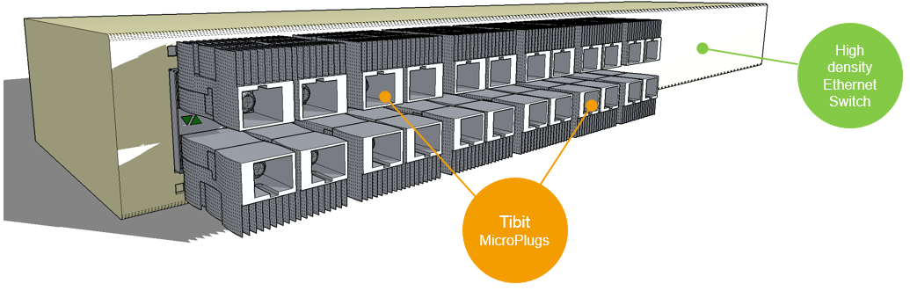
Figure 9. MicroOLTs in high density Leaf Switch

In applications such as Leaf Switches with stacked SFP+ cages and front panel air flow following high efficiency MicroPlug OLT can be used:

 | Millimeters | Comments
Overall Length | 80.5 | -
Heatsink Length | 33.0 | -
Width | 13.7 | SFP MSA compliant
Overall Height | 8.7 | SFP MSA compliant
Heatsink Height | 7.0 | -

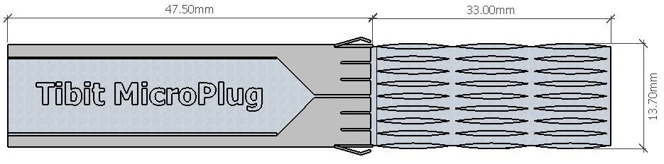
Figure 10. High efficiency heatsink OLT MicroPlug dimensions (top)

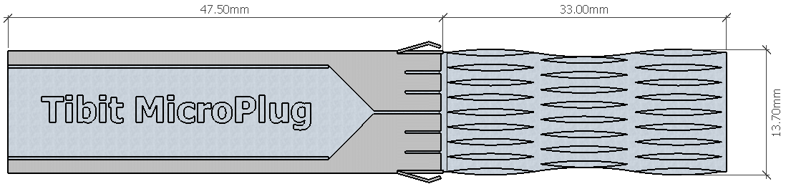
Figure 11. Low pressure heatsink OLT MicroPlug dimensions (top)

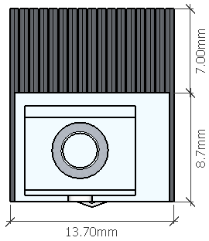
Figure 12. High density OLT MicroPlug dimensions (front)

Symmetric OLT MicroPlug Dimensions
In application where air flow is not available and SFP+ cages are not stacked following MicroPlug OLT can be used:

 | Millimeters | Comments
Overall Length | 80.5 | -
Heatsink Length | 33.0 | -
Width | 15.4 | MT-RJ compliant
Height | 12.6 | MT-RJ compliant

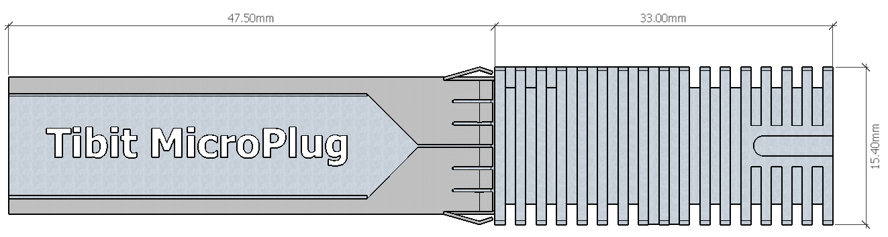
Figure 13. Symmetric OLT MicroPlug dimensions (top)

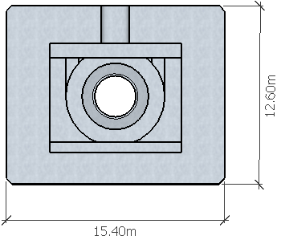
Figure 14. Symmetric OLT MicroPlug dimensions (front)

Specifications

Features
- 10G optical transceiver with embedded Ethernet-to-PON OLT Bridge
- Hot-Pluggable SFP+ footprint
- Supports symmetric 10G/10G mode of operation
- Compliant with ITU-T G.989 and G.9807.1 specifications
- In-band management via Ethernet OAM
- IEEE 1588 transport
- Jumbo Packets support
- Class N1/N2 XGS optics:
  - 1577nm EML DFB laser (10G)
  - 1270nm APD/TIA burst receiver (10G)
- Integrated Digital Diagnostics and Monitoring (SFF-8472, burst RSSI)
- Single fiber SC receptacle
- SFI local interface
- Enhanced jitter performance
- Low power
- Commercial and Enhanced Temperature

Power Consumption
 | Typical [W] | Max [W] ¹
Power Consumption | 2.2W | 2.8W
Table 2. OLT MicroPlug Power Consumption
Notes:
- based upon worst case power assumptions for traffic, optics used, ICs, and environmental conditions

Environmental
- Operating case temperature range:
  - -20C to 75C for Class N1 (enhanced)
  - 0C to 70C for Class N2 (commercial)
- -40C to 85C storage temperate range
- Humidity 0% to 95% non-condensing (operational and storage)

Laser Safety
- (US) FDA 21CFR1040.10, and IEC 60825-2 Class 1

EMI
- (US) FCC 47 CFR Part 15, Class B, (Europe) CENELEC EN55022, (Canada) Class B (CISPR 22A), and (Japan) VCCI Class A

ROHS
- Restriction of Hazardous Substances (6/6)

Thermal Performance

Heat Dissipation
Per MSA SFF-8431 Rev 4.1 specification maximum power dissipation at Power Level III is 2.0W. MicroOLT dissipates some of the generated heat outside the cage/switch enclosure without violating internal 2.0W power limit.

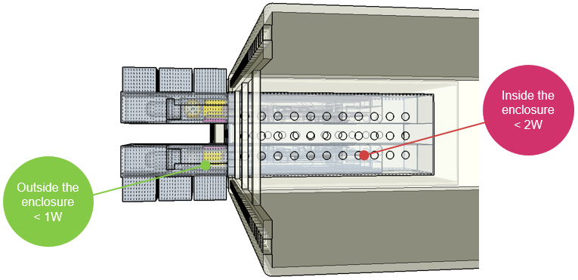
Figure 15. Heat dissipation outside and inside Ethernet Switch enclosure

Thermal Simulations
Thermal simulations showed that in high density applications using stacked SFP+ cages Tibit OLT MicroPlug with minimal airflow can operate in ambient temperature range of -40C to 65C while maintaining its case temperature between -20C and 75C. Below shows simulation for worst case high temperature with total power consumption of 10 MicroPlugs equal 30W and airflow of 12.9CFM front to back.

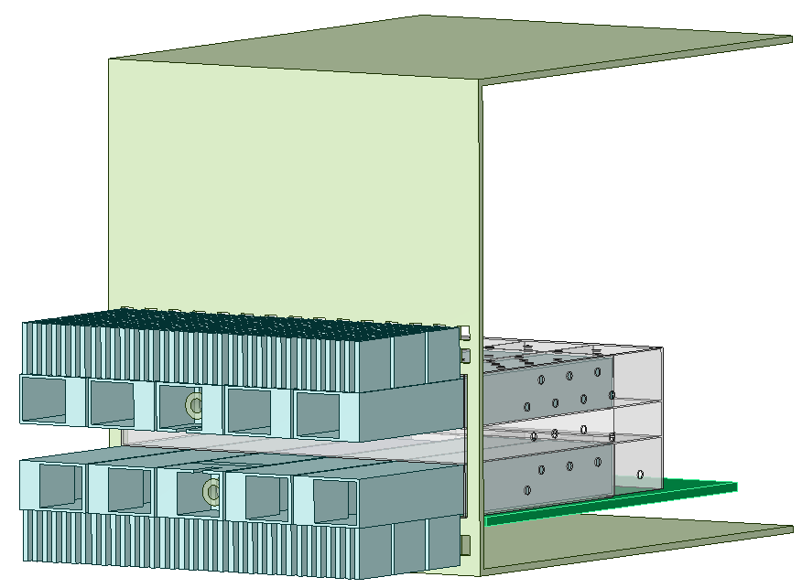
Figure 16. Tibit MicroPlugs stacked in 2x5 SFP+ configuration simulation model

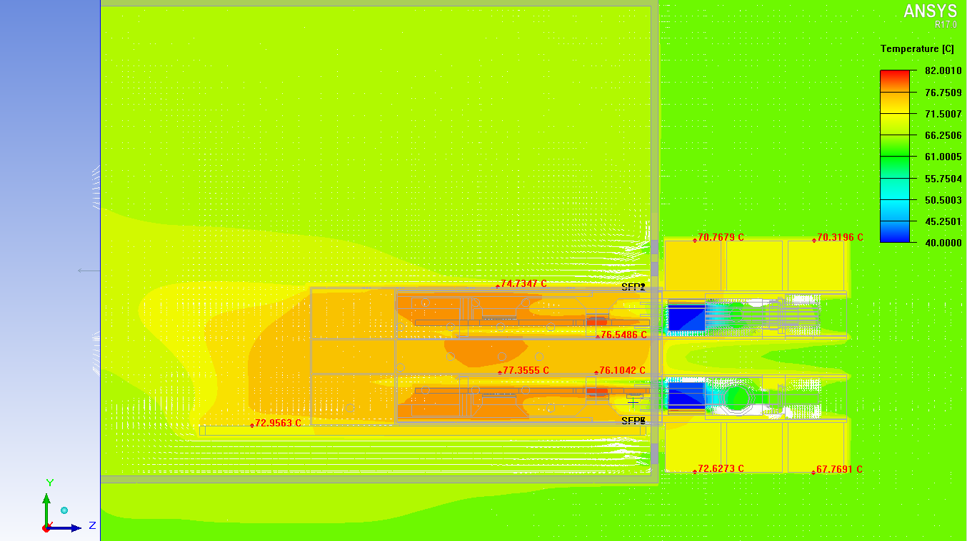
Figure 17. Tibit MicroPlugs stacked 2x5 thermals simulation (Ta=65C, CFM=12.9, P=3.0W x 10)

For environmentally hardened applications Tibit OLT MicroPlug can operate in ambient temperature range of -40C to 55C (no air flow) while maintaining its case temperature between -20C and 75C.

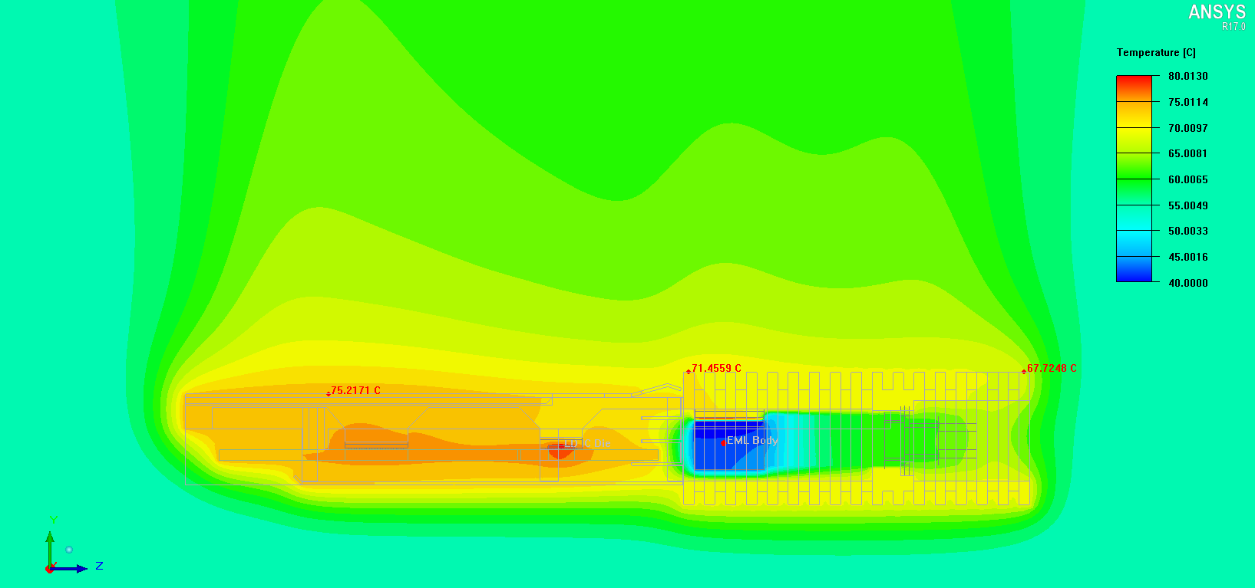
Figure 18. Tibit OLT MicroPlug thermal simulation (Ta=55C, CFM=0, P=2.8W)

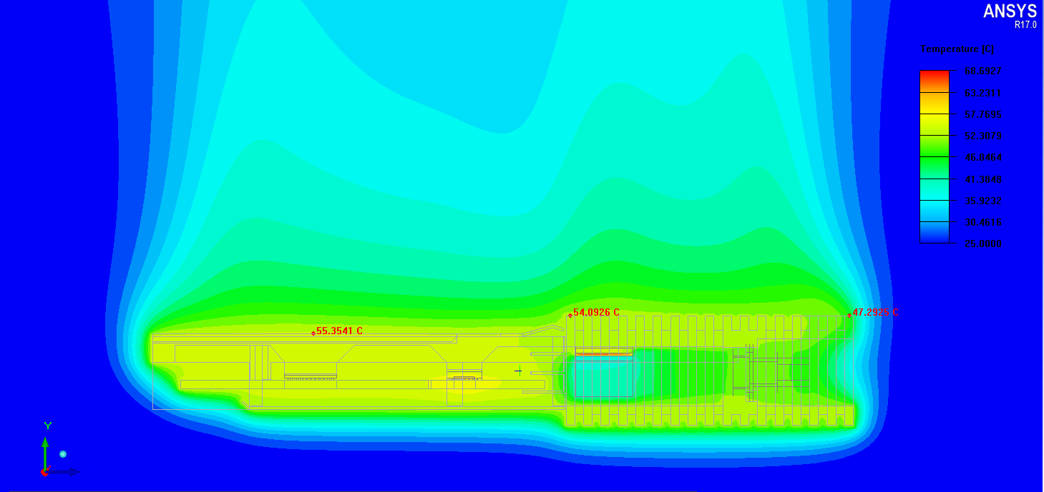
Figure 19. Tibit OLT MicroPlug thermal simulation (Ta=25C, CFM=0, P=2.2W)

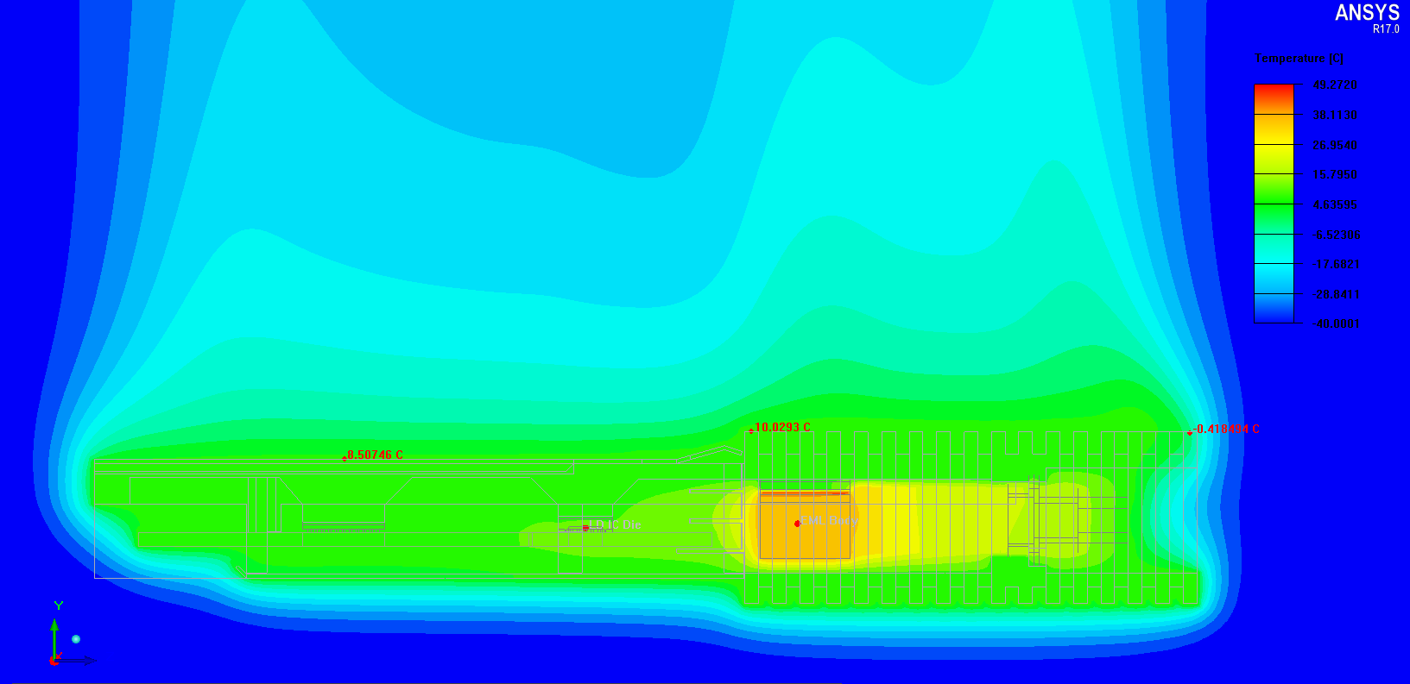
Figure 20. Tibit OLT MicroPlug thermal simulation (Ta=-20C, CFM=0, P=1.4W)

- Appendix: vOLT Equipment Physical Design Standards

Safety Requirements
The electromagnetic compatibility and electrical safety requirements for Carrier Grade equipment are primarily stated in Telcordia publication GR-1089-CORE Electromagnetic Compatibility and Electrical Safety Generic Criteria for Network Telecommunications Equipment.

R1-1: Equipment Type
The equipment supplier shall determine the Equipment Type and record the appropriate numerical equipment. To determine the Equipment Type, refer to GR-1089-CORE, Appendix B for all equipment. GR-1089-CORE provides guidelines for applying the aforementioned electromagnetic compatibility requirements. Application of the various criteria is a function of the type of equipment under consideration, its connection to the telecommunications network and the intended location of the equipment.

R1-2: Electromagnetic Interference
Equipment shall meet the radiated emission requirements stated in section 3.2 of GR-1089-CORE. Equipment deployed in outside plant locations shall meet the radiated emission requirements stated in section 5.2.3 of GR-3108-CORE.

R1-3: Conducted Emissions
Equipment shall meet the conducted emission requirements stated in section 3.2 of GR-1089-CORE. Equipment deployed in outside plant locations shall meet the conducted emission requirements stated in section 5.2.3 of GR-3108-CORE.

R1-4: Immunity
Equipment shall meet the immunity requirements stated in section 3.3 of GR-1089-CORE. Equipment deployed in outside plant locations shall meet the immunity requirements stated in section 5.2.3 of GR-3108-CORE.

R1-5: Lightning and AC Power Faults
Equipment shall meet the applicable lightning and ac power fault requirements stated in sections 4 of GR-1089-CORE. Equipment deployed in outside plant locations shall meet the applicable lightning and ac power fault requirements stated in section 5.2.4 of GR-3108-CORE. The equipment’s Port Type shall be determined using GR-1089, Appendix B.

R1-6: Steady State Power Induction
Equipment shall meet the steady state power induction requirements stated in section 5 of GR-1089-CORE. Equipment deployed in outside plant locations shall meet the steady state power induction requirements stated in section 5.2.5 of GR-3108-CORE.

R1-7: Electrical Safety Criteria
Equipment shall meet the electrical safety requirements stated in section 7 of GR-1089-CORE. Equipment deployed in outside plant locations shall meet the steady state power induction requirements stated in section 5.2.7 of GR-3108-CORE.

R1-8: DC Potential Difference
Equipment shall meet the dc potential difference requirements stated in section 6 of GR-1089-CORE. Equipment deployed in outside plant locations shall meet the dc potential difference requirements stated in section 5.2.6 of GR-3108-CORE.

R1-9: Electrostatic Discharge (ESD) Immunity Criteria
Equipment shall meet the ESD immunity criteria requirements for normal operation and be tested for installation and repair objectives according to section 2.1.2 (ESD Immunity Criteria) of Telcordia's GR-1089-CORE, document. All tests shall be conducted as described in section 2.1.4 of GR-1089 and IEC Publication 61000-4-2.

R1-10: Special Requirements and Maintenance Information
Any additional equipment-specific requirements in paragraph 2.1.2.4 of GR-1089-CORE shall be described in the report.

R1-11: Electrical Fast Transient (EFT)
Equipment deployed in carrier communications locations and/or outside plant locations shall be tested in accordance with section 2.2 of Telcordia’s GR-1089-CORE, document with tests conducted as described in section 2.2.1.

R1-12: Bonding and Grounding Requirements
Structures, equipment and power systems submitted for evaluation shall meet applicable Bonding and Grounding requirements of section 9 of GR-1089-CORE. For Ancillary reviews, only the short circuit test data of section 9.10 is required.

R1-13: Fire Spread
Field conditions for AIC deployment may require deployment in existing Carrier Communications Spaces that utilize Fire Code Exemptions and do not have automatic fire suppression. Store and compute equipment deployed in these locations shall meet the enhanced fire spread requirement below.

Equipment shall meet ATIS-0600319.2014 Equipment Assemblies – Fire Propagation Risk Assessment Criteria (see note below).

Note: Equipment may conform to this requirement by way of inherent design features that include all items below:
- Height of 2 RU or less
- Horizontally mounted main printed circuit board
- Metallic 5 sided enclosure with a metallic or non-metallic front cover or faceplate
- Non-metallic materials shall comply with ATIS-0600307 4.1

For equipment that does not meet the fire spread requirements of ATIS-0600319.2014 by way of inherent design features noted above, the manufacturer shall attest that the equipment has successfully passed the burn test as referenced in the ATIS document.

Equipment deployed in outside plant locations with Class 2, 3 and 4 environments shall comply with the fire resistance criteria of Telcordia GR-3108-CORE, Section 6.5.

Minimum Infrastructure Operating Requirements

Minimum infrastructure operating requirements state that the equipment works as intended and can be installed efficiently. New equipment is required to integrate into the network seamlessly (fit, form and finish), without the impact or cost pressure to compensate for the product introduction. This supports the goal of having a “homogeneous” network that does not require special practices/procedures to accommodate each new equipment installation.

Environmental

R2-1: Temperature and Humidity Operating Requirements
Equipment shall be designed and verified to meet the following requirements:

Table 2-1 Data Center Temperature and Humidity Limits Conditions
Conditions | Limits
Operating Temperature | 15°C to 40°C
Operating Temperature Short-term* | -5°C to 50°C
Rate of Temperature Change | 30°C / hr
Operating Relative Humidity | 5% to 85%
Dew Point | 17°C

Notes:
* Short-term refers to a time period of not greater than 96 consecutive hours, and a total of not more than 360 hours per year.

Equipment deployed in outside plant locations shall conform to the applicable requirements in GR-3108-CORE, Sections 4.1, 4.2, 4.3, 4.4, 4.5, and 4.6.

R2-2: Altitude
Altitude conformance shall be stated by the manufacture via documentation containing specific product information and company identification information (logo). Typical forms of documentation are Product Data Sheets, Product Manuals or Letters of Attestation. Formal testing documentation from third party testing labs is an acceptable alternative.
- The equipment shall function within the limits established in R2-1 for altitudes between 60 meters (200 ft) below sea level through 1830 meters (6000 ft) above sea level.
- The maximum temperature limit stated in R2-1 may be de-rated 1°C for every 300 meters (1000 ft) segment above 1830 meters (6000 ft) but below 3960 meters (13,000 ft) above sea level. Operation above 3960 meters do not require confirmation.
Equipment deployed in outside plant locations shall conform to Telcordia publication GR-3108-CORE, Section 4.7.

R2-3: Energy Efficiency
When equipment is eligible for the United States Environmental Protection Agency (EPA) Energy Star® certification for Computer Servers, the supplier shall report if the equipment is EPA Energy Star® certified (Yes / No). If Yes, a copy of the written certification by a Certification Body recognized by the EPA for Computer Servers shall be provided. Eligibility criteria can be found at www.energystar.gov/specifications.

When applicable, the Alliance for Telecommunications Industry Solutions (ATIS) Telecommunications Energy Efficiency Requirements rating (TEER) shall be measured and reported. Reference ATIS-0600015.2009 and supplemental standard ATIS-0600015.01.2014, Energy Efficiency for Telecommunication Equipment, Methodology for Measurement and Reporting – Server Requirements, www.atis.org/docstore/default.aspx.

If the ATIS TEER rating is unknown, the latest SPECpower_ssj2008 server rating and output test document may be substituted. This benchmark is available from the Standard Performance Evaluation Corporation, 6685 Merchant Place, Suite 100, Warrenton, VA 20187. www.spec.org

R2-4: Equipment Air Flow
Establishing consistent air flow patterns for all network elements supports the efficient design and use of infrastructure cooling technologies.

Air cooled equipment shall be designed and verified to utilize a cold aisle air inlet and a hot aisle exhaust. This is commonly known as front aisle air intake and rear aisle air exhaust. The nomenclature for the individual products may differed based on the equipment faces the manufacture calls “front” and ”rear”. The intake equipment face shall be orientated toward the cold aisle and the exhaust equipment face shall be orientated to the hot aisle.

Front/Cold
Aisle
Air Intake
Rear/Hot
Aisle
Air Exhaust

Equipment deployed in outside plant locations shall also conform to Telcordia publication GR-3108 Section 4.2.1.3.

R2-5: Acoustic Noise
Manufacturer shall report the measured acoustic noise of equipment. It is a strong preference and an objective that equipment not exceed an operating acoustic noise level of 78 dB sound power at 26°C, as measured according to ANSI ASA S12.10-2010, or a comparable industry standard. . Equipment deployed in Outside Plant locations shall conform to Section 6.6 of Telcordia GR-3108.

R2-6: Equipment Units Design
Equipment physical design shall:
- Incorporate the use of holes or closed slots in mounting hardware for attachment to equipment framework mounting surfaces
- Be designed for 19” framework mounting
- Accommodate mounting in equipment frameworks using a 1-3/4 x 19 inch mounting hole pattern.

Alarms and Indicators

R2-7: Alarms
An amber or red LED, located on the faceplate of the network element, shall be used to indicate the current status of any alarm. The LED shall be lit indicating that an alarm condition exists. The alarm LED is extinguished when all active alarms clear.

R2-8: Unit Indicator
It is preferred, but not required, that equipment provide a remotely activated blue LED on the faceplate and/or backplane of the Network Element to function as a unit indicator.

R2-9: Alarm Interconnections
Each NE in a bay shall produce its own unique set of alarm outputs. The interface for TL1/SNMP interconnection may be Ethernet RJ45, DB25 or RS422/449 (37 Pin). The interface for E2A Serial or Discrete interconnections may be wire-wrap pins or other non-proprietary connector.

Power

R2-10: AC and DC Power
Field conditions may be either AC or DC powered. It is strongly preferred that all equipment be available for purchase in AC and DC versions.

R2-11: AC Powered
AC powered equipment shall accommodate a voltage range from 110V to 240V.

R2-12: DC Power – Nominal -48Vdc
Nominal -48Vdc is the preferred and standard platform for power delivery to network equipment. If the equipment uses a DC voltage other than -48Vdc, it shall be provided with internal DC-DC converters to meet the intent of this requirement. The design criterion of the nominal -48Vdc power is based on a normal operating voltage between -50V to -56.7Vdc, with nominal rating of -48Vdc and low voltage of -40Vdc measured at the input terminals of the network equipment.

R2-13: DC Battery Return Configuration
Equipment battery return configuration shall be DC-I. Equipment configured with the battery return and chassis ground bonded together (DC-C) shall not be deployed in the network. The DC-C configuration cannot be utilized with dual plant equipment operation.

R2-14: DC Power - Terminations General
- Power terminations shall be located on the rear of the chassis.
- All power connections shall be clearly labeled and fully protected with a non-metallic, non-flammable cover.

R2-15: DC Power - Redundant Power Feeds
Redundant power feeders are required for all network equipment. Each element/shelf/circuit pack, whichever is the smallest independent load device of the equipment, shall obtain power from at least two power feeds.

R2-16: DC Power - Battery Return Conductor
Each power feeder shall have its own battery return conductor. This design concept shall also carry through directly to each piece of equipment.

R2-17: DC Connectors
Connectors used to attach the product to external power cabling shall conform to the following requirements (Refer to Table 2-2 for acceptable connectors):
- 8 AWG and Larger Stranded Power Cable: Power input cable that will accept # 8 AWG or larger connector terminations shall use dual threaded post (stud) termination able to accept the appropriate two-hole crimp connection. The two post termination may be either 1’,3/4”, 5/8” or 1/2“ on centers
- 16 AWG to 10 AWG Stranded Power Cable: For applications where the size of wire supplying or distributing power to/from the equipment is 16 AWG to 10 AWG stranded power cable, pressure crimped ring type connectors shall be used on the power cable
  - Equipment surface terminations shall accept crimp connections that meet the following specifications for 16 AWG and larger stranded power cable:
    - UL486A Wire Connectors and Soldering Lugs for Use with Copper
    - UL467 Grounding and Bonding Equipment Conductors
    - UL 486C Splicing Wire Connectors
    - SAE-AS25036 (Insulated Copper Ring Crimped Terminal - Dimensions)
    - SAE-AS7928 (Copper Ring Crimped Terminal – Specifications)
  - Equipment submitted for approval should provide a UL listed (power) termination strip designed and designated as “field wireable” to insure product compliance with the UL listing of the product. This termination or barrier strip should be able to accommodate a ring lug connectors that comply with the UL, CSA and Mil Spec listings
- 18 AWG Power Cable and Smaller: For applications where the size of wire supplying power to the equipment is 18 AWG power cable or smaller, mechanical connectors may be used.
- The connectors shall be listed by a Nationally Recognized Test Laboratory for its intended use.
- The connector shall be tested to assure long-term tightness and reliability. The following tests are acceptable for this requirement; IEC 60068-2-6, Basic Environmental Test Procedures, Part 2: Test Fc and Guidance: Vibration (sinusoidal); EIA Specifications 364-27B (Mechanical Shock Test Procedure for Electrical Connectors), 364-28D (Vibration Test Procedure for Electrical Connectors and Sockets), Telcordia GR-63-CORE and Telcordia GR-1089- CORE. Other vibration test procedures demonstrating long-term reliability will be considered for evaluation.
- The product supplier shall provide documentation of routine maintenance (if any) associated with the supplied connector.
- Wago type pressure spring connectors, connectors that crush the wire with a screw and snap-on type power connections are not approved for use and will be denied compliance.
- Connecting hardware (bolts, nuts and washers) shall be Durium or silicon- bronze per ASTM B99. The Ny-Loc type nuts are not approved for use and will result in non-compliance.

Table 2-2 Temperature and Humidity Limits Conditions
 | Acceptable termination | Associated Listings
22 AWG – 18 AWG | Mechanical; American Standard UNC threads (Class 2 fit) | Listed by NRTL, IEC 60068-2-6, EIA SPEC  364-27B, 364-28D
16 AWG – 10 AWG | One or Two hole crimp connection. American Standard UNC threads (Class 2 fit) | UL467, UL486A, UL486C, SAE-AS25036, SAE-AS7928
8 AWG – 1AWG  1/0-4/0  250MCM –  750MCM | Two hole crimp connection. American Standard UNC threads (Class 2 fit) | UL467, UL486A, UL486C, SAE-AS25036, SAE-AS7928

R2-18: Equipment DC Power Protection
All fuses and circuit breakers shall meet Quality Level III as defined by Telcordia SR-332.

R2-19: Filtered Battery
All equipment requiring “Filtered Battery” shall provide the filtering within the equipment.

R2-20: Special PDU
Even though not recommended, some equipment designed by various manufacturers require specific PDUs that are considered part of the system or equipment being evaluated which may include unique characteristics needed to serve their specific network device. These “special PDUs” must meet all the same design criteria identified in this document. If accepted, this “special PDU” would be listed as part of the equipment approval, purely as an integral part of the package and its approval is exclusive to the associated equipment. Furthermore, this “special PDU” should be reviewed to insure its integrity

R2-21: Visual Power Alarms and Status Indicator
The equipment shall provide visual power alarm and status indications by indicator devices mounted directly on the equipment and preferably at the top of the equipment bay. The equipment shall also be capable of transmitting alarm signals to an office alarm circuit and to sending circuits for remote surveillance using dry loop relay contacts or other means. Power alarm and status reporting information must be provided in the supplier's response documentation to be in compliance with this item

R2-22: Steady-State Input DC Voltage Requirements
The telecommunications load equipment shall meet its operational requirements at any input voltage of the correct polarity between and including the minimum and maximum values specified in Tables 1 in ATIS-0600315.

R2-23: Undervoltage Requirements
Equipment shall operate properly when exposed to steady state undervoltage conditions and shall comply with the conformance criteria as described in ATIS-0600315. The equipment supplier shall provide a report containing the test methods and results for the above requirement.

R2-24: Minimum Operating Voltage
Specify the minimum voltage at which the equipment remains fully operational and verify the equipment will recover to a fully operational state after losing power.

R2-25: DC Power Current Drains
Battery return and current path information must be provided in the supplier's response documentation to be in compliance with this item. List 1, 1X, 2 and 2X drains shall be provided in the ESP Forms documentation.

List 1 Current Drain – The List 1 current drain, for a maximum configuration of cards and shelves, shall be provided in amperes on the appropriate ESP form. List 1 drain is the average busy-hour current at normal voltage and operating conditions. List 1 current drains are used to size batteries and rectifiers. The cumulative List 1 current drain is the current consumed on both the A and B supplies.

List 1X Current Drain - The current that will flow in one side of a dual powered circuit when the other supply circuit has failed and the power plant feeding the remaining circuit is at the normal operating voltage (float voltage).

List 2 Current Drain – The List 2 current drain, for a maximum configuration of cards and shelves, shall be provided in amperes on the appropriate ESP form. List 2 drain is the peak current during emergency operating limits of the EUT and with normal operating conditions (no short circuits or other malfunctions). This value is based on manufacturer-supplied data, and calculated to the AT&T minimum -42.64 Vdc engineering design level and equipment configuration.
List 2X Current Drain - The current that will flow in one side of a dual powered circuit if the other supply circuit is failed and the power plant feeding the remaining circuit is at 42.64Vdc, engineering design level, or the total power consumption of the network equipment in watts divided by 42.64Vdc.

R2-26: Overvoltage Requirements
Telecommunications load equipment shall not be permanently damaged or permanently have its performance degraded when an input voltage of correct polarity, with a value between 0 V and the maximum voltage level for each nominal voltage plant specified in Tables 1 of ATIS-0600315 is applied for any period of time.
Equipment shall operate properly when exposed to steady state overvoltage conditions, shall comply with the conformance and test results shall be recorded in a test report as described in ATIS-0600315.

R2-27: Overvoltage Transient Requirement
Equipment shall operate properly when exposed to an overvoltage transient condition, shall comply with the conformance criteria and test results shall be recorded in a test report as described in ATIS-0600315.

R2-28: Protective Device Operation Transient
Equipment shall operate properly when exposed to transient conditions, shall comply with the conformance criteria and test results shall be recorded in a test report as described in ATIS-0600315. Testing methods shall be utilized to ensure prevention of malfunction or damage.

R2-29: Electrical Noise Requirements
Noise immunity – Equipment shall operate properly when exposed to electrical noise, shall comply with the conformance criteria and test results shall be recorded in a test report as described in ATIS-0600315. Voiceband noise shall only apply to equipment with analog voiceband ports effective with GR-1089-CORE.
Noise returned by the telecommunications load equipment – Equipment shall not return excessive noise onto the DC power system, the equipment shall comply with the conformance criteria and test results shall be recorded in a test report as described in ATIS-0600315. Requirement 5.6.2.1, Voice Frequency Noise Requirements are no longer required effective with GR-1089-CORE Issue 6.

Airborne Contaminants
Equipment shall meet the Airborne Contaminants requirements for indoor equipment as stated in section 4.5 of GR-63-CORE and shall conform to the MFG test performed for 14 days as detailed in Telcordia GR-63, Issue 3.

R2-30: Fan Filter Requirements
- Equipment larger than 1U shall conform to the fan filter requirements contained in GR-63-CORE
- Equipment 1U or smaller will be accepted without fan filters.
- GR-63-CORE, Objective 04-25 for fan filter alarms shall be a requirement.
Equipment deployed in outside plant locations inside GR-487 compliant cabinets in a:
- GR-3108 Class 1 compliant environment shall be equipped with fan filters that meet or exceed the requirements of Telcordia GR-63-CORESection 4.1.5.2 requirements for air filters. GR-63-CORE, Objective 04-25 for fan filter alarms shall be a requirement.
- GR-3108 Class 2 compliant environment shall not be equipped with fan filters.
- GR-3108 Class 3 compliant environment shall not be equipped with fan filters.
- GR-3108 Class 4 compliant environment is not applicable.

Shock and Vibration

R2-31: Seismic - Vibration
Equipment shall be designed for service in high seismic risk locations. Equipment shall demonstrate conformance to Telcordia GR-63-CORE, or ATIS-0600329 earthquake requirements by having equipment assembly tested on shake table and submitting documentation of successful test results.

R2-32: Positive Latching
All network equipment shall have circuit pack latches or retainers to prevent pack and module walkout. Ejectors are not retainers and should not be used for that purpose.

R2-33: Office Vibrations
Equipment shall be designed for operation under office vibration conditions specified in Telcordia document GR-63-CORE.

Fiber

R2-34: Fiber Optic Cabling and Connectors
All references to SingleMode fiber shall be considered Bend Insensitive Fiber (BIF). All references to MultiMode fiber shall be considered Laser Optimized OM4.

R2-35: Fiber Optic Cable
Equipment shall be designed such that all fiber optic cables/jumpers/patch cords utilized shall adhere to Telcordia Standards as defined in GR-409, Generic Requirements for Premises Fiber Optic Cable and GR-326, Generic Requirements for Singlemode Optical Connectors and Jumper assemblies or equivalent TIA or ITU standards.

R2-36: Fiber Connector Boots
Equipment shall be designed to operate with fiber connector boots that are straight and NOT angled.

R2-37: Overall Fiber Connector and Boot Length
Equipment utilizing SC or LC fiber connectors shall be designed to operate with connector/boot assemblies that have a maximum overall dimension not exceeding 42mm (1.65 Inches) from tip of ferrule to rear of flexible boot.

R2-38: Fiber Bend Radius
Equipment shall provide fiber management facilities that maintain a minimum fiber bend radius of 1inch. See Figure 5-1
Figure 5-1: Bend Radius
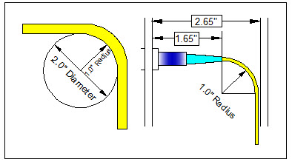

R2-38: Minimum Distance Between Connector Housing and 90 Degree Bend
Equipment shall be designed such that it allows a minimum distance between connector housing and 90 degree fiber bend of 2.65 inches while maintaining a minimum fiber bend radius of 1inch. See Figure 5-1

R2-38: Space Between Door/Panel and Fiber Connector
To avoid pinching or reduction of minimum fiber bend radius, equipment shall be designed to accommodate a minimum distance between the fiber connector end face and any door/panel cover of 2.65 inches. See Figure 5-1

R2-38: Standard Fiber Connector
Equipment shall be designed operate with industry standard Singlemode or Multimode, SC-UPC, LC-UPC or MPO connectors. Application of connector type shall be determined by equip design or manufacturer.

