AT&T Open Single Port
G.Fast DPU Specification

Revision 1.0

Authors: Sumithra Bhojan, Mark Shostak

Revision History

Revision | Date | Author | Description
1.0 | 2/20/2017 | Sumithra Bhojan, Mark Shostak | Initial Release

Contents
Revision History 2
Contents 2
Licenses 4
Scope 4
Overview 4
Outdoor 5
Twisted Pair and Coax 5
Reverse Power 5
Software Stack 5
G.Fast Network Application 6
Physical Overview 8
Maximum Dimensions 8
Top View 8
Front View 8
Panel LED Definitions 8
SFP+ Interface Module support 9
Rear View 9
System Overview 9
Main Block Diagram 9
Functional Hardware Blocks 10
Software Support 11
BMC support 11
ONIE (Optional CPU Module) 11
Open Network Linux 11
Overall System Software 11
General Specifications 12
Power Consumption 12
Specification Requirements 13
Safety 13
Electromagnetic Compatibility 13
ROHS 13

Licenses
All devices that may be referred to in this specification, or required to manufacture products described in this specification, will be considered referenced only, and no intellectual property rights embodied in or covering such devices shall be licensed as a result of this specification or such references. Notwithstanding anything to the contrary in the Open Compute Project Contributor License Agreement or the Open Web Foundation Final Specification Agreement (OWFa 1.0), the licenses set forth therein do not apply to the intellectual property rights included in or related to the devices identified in this specification. For clarity, no patent claim that reads on such semiconductor devices will be considered a “Granted Claim” under the applicable Open Web Foundation Final Specification Agreement (OWFa 1.0) for this specification.
To the extent of AT&T’s authorship in this specification, AT&T submits this specification to the Open Compute Project Foundation as a Contribution under the Open Compute Project Contributor License Agreement (July 13, 2014 version, available at the time of this writing, March 4, 2016, at https://rightsignature.com/forms/OMMUS-72474399-v1-db5554/token/27cfcf4a00d. AT&T agrees to make such specification available under the Open Web Foundation Final Specification Agreement (OWFa 1.0), which is available at http://www.openwebfoundation.org/legal/the-owf-1-0-agreements/owfa-1-0.
Your use of this specification may be subject to other third party rights. THIS SPECIFICATION IS PROVIDED "AS IS." No support of any kind will be provided by the contributors. The contributors expressly disclaim any warranties (express, implied, or otherwise), including implied warranties of merchantability, non-infringement, fitness for a particular purpose, completeness or title, related to the specification. The entire risk as to implementing or otherwise using the specification is assumed by the specification implementer and user. IN NO EVENT WILL ANY PARTY BE LIABLE TO ANY OTHER PARTY FOR LOST PROFITS OR ANY FORM OF INDIRECT, SPECIAL, INCIDENTAL, OR CONSEQUENTIAL DAMAGES OF ANY C H A R A C T E R FROM ANY CAUSES OF ACTION OF ANY KIND WITH RESPECT TO THIS SPECIFICATION OR ITS GOVERNING AGREEMENT, WHETHER BASED ON BREACH OF CONTRACT, TORT (INCLUDING NEGLIGENCE), OR OTHERWISE, AND WHETHER OR NOT THE OTHER PARTY HAS BEEN ADVISED OF THE POSSIBILITY OF SUCH DAMAGE.

Scope
This document defines the technical specifications for the AT&T Open Single-Port G.Fast DPU submitted to the Open Compute Project.

Overview
This document describes the technical specifications of the AT&T Open Single Port G.Fast Distribution Point Unit (ODPU). The system is a physical unit that is self‐contained, and not part of a rack or other physical chassis system. The single port ODPU can provide up to 1Gbps of symmetrical broadband service by extending GPON network and enables service providers to utilize existing twisted pair or coax wiring within the customer premises.
The customer-facing G.Fast ports on the ODPU can be adapted to either twisted pair or coax cabling. This design allows for power to be supplied by the customer-facing ports, called reverse power feed, and thus allows the unit to be placed in locations where power is not available.
Applications of this design include some specific variations and considerations in order to address a broader market and set of collaborators for this project. Specifically, the set of variations considered include:
- Outdoor enclosure/NID, integrated with GPON ONT
- Use of twisted pair or coax wiring to the customers
- Including triplexers to combine other video signals on the coax lines
- Including reverse power feed

Outdoor

This is designed for an outdoor enclosure, for deployment on walls, on side of the homes. This package emphasizes robust weather resistance and environmental robustness.

Figure 1 – Outdoor DPU

Twisted Pair and Coax

The AT&T Open Single G.Fast DPU supports different wiring from the ODPU to the customer modem or residential gateway. The first option is twisted pair, and the second is coax. Although the wiring type differs, the signal and electrical properties are nearly identical, with a simple balun allowing adapting one or the other – or allowing interworking in the wiring system.

Reverse Power

Reverse power feed is one of various ODPU powering methods defined in TR-301. Here, the ODPU draws its power from the customer premises via the copper lines between those premises and the ODPU. The reverse power feed capacity and ODPU power consumption need to be such that the ODPU can be fully operational when only a single customer is connected. Any back-up battery would be located in the customer premises. Reverse powering shall have two power splitters (one located at the customer premises and another at the remote node-ODPU) to enable power to be inserted at the customer end of a link and extracted at the remote node-ODPU. Within the remote node -ODPU, if it operates with multiple power-fed lines then there shall be a power extraction and combiner unit. The purpose of this unit is to combine the multiple power feed inputs to produce a single power source output. The power load should be shared amongst the input power sources.

Software Stack

Software to drive the AT&T Open Single-Port G.Fast DPU is based on same approach taken for the Open GPON and XGS-PON specs. As shown in Figure 2, and moving from the bottom to the top of the figure, the ODPU has Firmware and a Driver that runs in the silicon and provides a management interface toward a standard management agent called a Persistent Management Agent (PMA). A PMA manages a single ODPU and there is a PMA Aggregator (PMAA) that manages many. In the software stack, we will develop an open scale-out PMA with aggregation included. The ON.Lab VOLTHA project is an open multi-protocol management and control plane agent, and will be used to derive OpenFlow, as well as NETCONF/YANG interfaces to the control plane applications and configuration controllers. From these interfaces upwards, the same applications are used that were developed for GPON and XGS-PON in order to configure and control the G.Fast system as part of an access network. This re-use of the networking stack is intentional because GPON and XGS-PON are both popular backhaul technologies for G.Fast ODPUs.
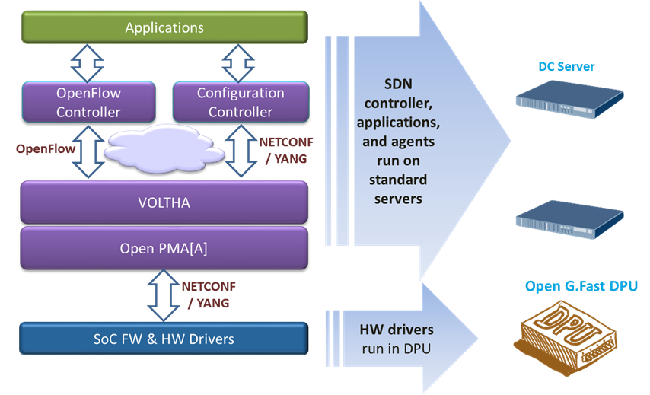

Figure 2 - Software stack for Open 16-Port G.Fast DPU

To support this application, the Open Single-Port G.Fast DPU minimizes the number of components populated on the system board and leverages external, scalable, available and re‐usable components instead.
This is the most basic and economic instantiation of this design. Management is performed through external processes and is communicated through a virtual LAN that isolates that traffic from customer traffic. Specifically, there is a need to support OOB (out of band management) LAN. The design does still support a variety of power supply options, airflow options, and a baseboard management controller (BMC) to manage these resources.

G.Fast Network Application

A G.Fast Access network supports customers of various types, including both single and multi-family dwelling units, and including options for one or more customers per ODPU and multiple ODPUs per location. A novel and key feature of G.Fast is the ability to reverse-power the ODPU from one or more attached customer ports. This allows placing ODPUs on poles or at the curb where powering is difficult.
Some key features include:

Figure 3 shows G.Fast Access technology, which is typically deployed in twisted pair or coax loops that are less than 500m, and which support about a gigabit of bandwidth when both directions are added up. The split of bandwidth used for upstream and downstream is configurable, and can be symmetric (e.g. 500x500M) or can be asymmetric (e.g. 750Mx250M). G.Fast can be deployed in various configurations, some of which are shown in Figure 4.
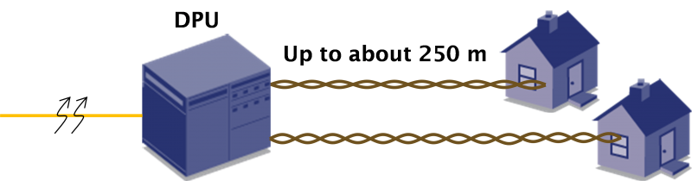
Figure 3 – G.Fast Access Technology

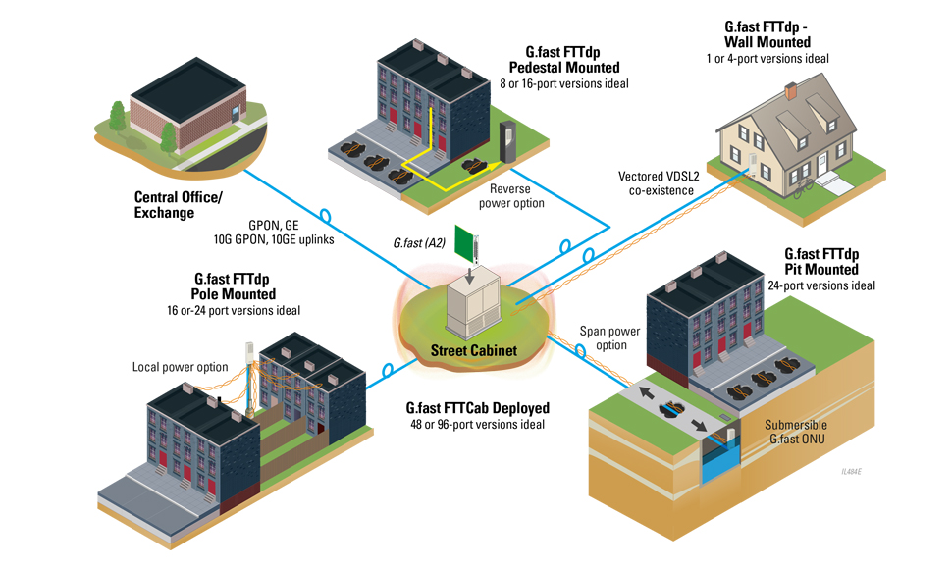
Figure 4 – G.Fast Access Network

Physical Overview

Maximum Dimensions

 | Inches | Millimeters
Length -
Width –
Height –

Top View
The top view of the Open Single-Port G.Fast DPU shows the PCBs and associated components in the system (illustrative only).

5

Front View
The front view of the Open Single-Port G.Fast DPU shows the external connectors and associated components in the system (illustrative only).

2
1

Panel LED Definitions

LED Name | Description | State
Diag | LED to indicate system diagnostic test results | Green – Normal  Amber – Initializing  Red – Fault detected  Off – No Power
SFP+ Speed LED | LED built into  SFP+ cage to indicate port speed | Green 3 blinks/pause – 10G  Green 2 blinks/pause – 2.5G  Green 1 blink/pause – 1G  Off – No Link/Port down
SFP+ Enable LED | LED built into  SFP+ cage to indicate SFP status | On Green – SFP installed and active Flashing indicates activity  On Amber– SFP installed, but has a fault  Off – No SFP installed or Administered down
G.fast | LED to indicate G.Fast port status | Green – Normal  Amber – Initializing  Red – Fault detected  Off – No Link/Port down

SFP+ Interface Module support

10Gb SFP+ Modules | Standard 10Gb Ethernet modules, as well as XGS-PON SFP+ ONT modules, as well as 2.5G GPON SFP ONT modules.

Rear View

The rear view of the Open Single-Port G.fast DPU includes the following key components:

System Overview

Main Block Diagram

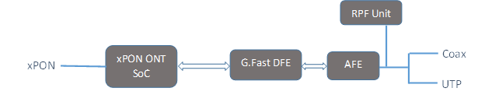

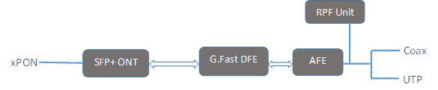

Figure 5 - Main system Block diagram

Figure 5 shows the high level block diagram of the ODPU using xPON ONT SoC integrated with the G.fast components and SFP+ ONT plugin option.

- xPON optics for uplink
- xPON ONT SoC or SFP+ ONT
- DFE of G.Fast
- Analog Front End (AFE) of G.Fast
- RPF Power extractor at the DPU side
- Twisted pair and Coax connector

Hardware Components
The G.fast modem is comprised of two primary components, the DFE and the AFE.
DFE – The Digital Front End (DFE) is the heart of the modem, and is responsible for all of the signal processing and “baseband” type functions, up to and including the Ethernet interface to the uplink.
AFE – The Analog Front End (AFE) is digitally coupled to the DFE, and is primarily responsible for converting the digital signals from the DFE into electrical waveforms that are emitted by the ODPU onto the transmission media, as well as receiving electrical waveforms from the transmission media, converting them into their digital analogs, and sending them to the DFE for decoding.

Supporting different Uplink connectivity modes
The Open Single-Port G.Fast DPU uplink connectivity and configuration architecture can support various uplink link modes which can be configured differently based on the required bandwidth (e.g. 1G, 2.5G or 10G). For example -
- For 1G – PON ONT operating at 1G
- For 2.5G – Typically a GPON SFP ONT operating at 2.5G x 1.25G
- For 10G – xPON ONT operating at 10G

Functional Hardware Blocks

Software Support
The Open Single-Port G.Fast DPU supports a base software package composed of the following components:

BMC support
OpenBMC Is there a desire for IPMI or a true BMC?

ONIE (Optional CPU Module)
Initialization and firmware updates

Open Network Linux
See http://opennetlinux.org/ for latest supported version (Is this desired/feasible?)

Overall System Software
See http://opencord.org for information and documentation
See https://github.com/opencord/cord for software source

General Specifications

Power Consumption
The total estimated system power consumption of the AT&T Open Single-Port G.Fast DPU is ~x Watts. This is based upon worst case power assumptions for traffic, optics used, and environmental conditions.
Main Blocks | Qnt. | Typ. (W) | Max. (W) | Total Typ. (W) | Total Max. (W)
Total estimated Power

Specification Requirements
Environmental placement requirements differ for the outdoors and indoors units.

Safety
- UL/ Canada
- CB (Issued by TUV/RH)
- China CCC

Electromagnetic Compatibility
- GR-1089-CORE
- FCC Title 47, Part 15, Subpart B Class A

ROHS
Restriction of Hazardous Substances (6/6)
Compliance with Environmental procedure 020499-00 primarily focused on Restriction of Hazardous Substances (ROHS Directive 2002/95/EC) and Waste and Electrical and Electronic Equipment (WEEE Directive 2002/96/EC)

